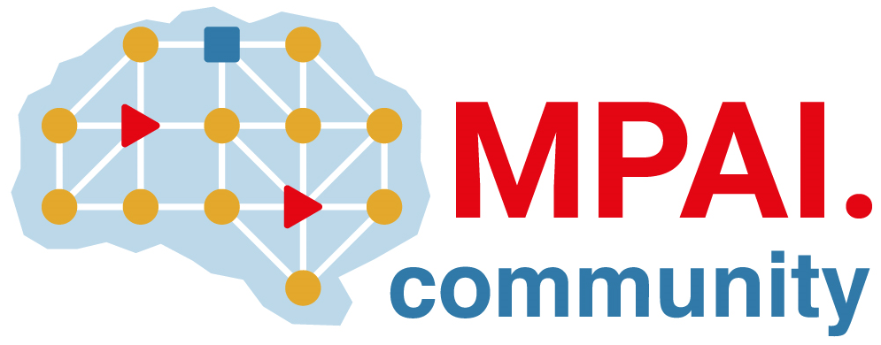 | Moving Picture, Audio and Data Coding by Artificial Intelligence  www.mpai.community

N30 | 2020/10/21
Source | General Assembly (MPAI-1)
Title | MPAI Timeline
Target | MPAI Members

NB1 | Dates in italic indicate estimated dates
NB2 | The UC-FR date refers to the date the GA promotes an area to Functional Requirements stage, etc.
NB3 | .. in a date indicate that only the month is estimated

Acronym | Title | UC-FR | FR-CR | CR-CT | CT-SD | CT-MS
MPAI-AIF | AI Framework | 20/10/21 | 20/11/18 | 20/12/16 | 21/01.. | 21/07..
MPAI-CAE | Context-based Audio Enhancement | 20/09/09
MPAI-GSA | Integrative AI-based Analysis of Genomic/Sensor Experiments | 20/10/21
MPAI-EVC | AI-Enhanced Video Coding | 20/10/21
MPAI-SPG | Server-based Predictive Multiplayer Gaming | 20/10/21
MPAI-MMC | Multi-Modal Conversation | 20/10/21

