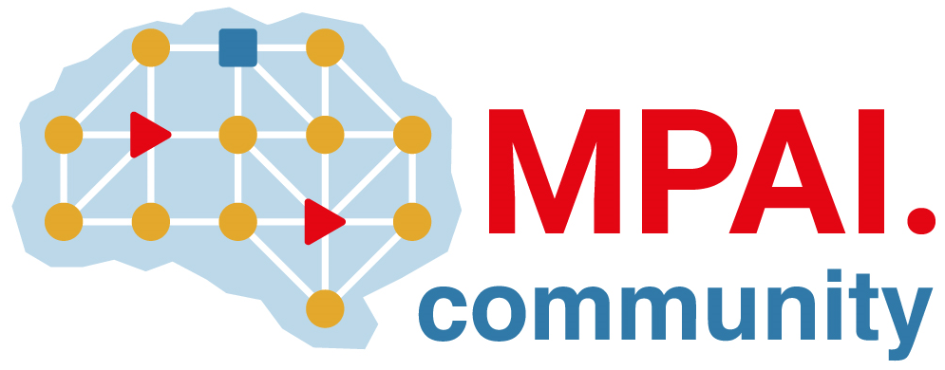 | Moving Picture, Audio and Data Coding by Artificial Intelligence  www.mpai.community

N4 | 2020/09/30
Source | MPAI Constitutive General Assembly (CGA)
Title | MPAI Press Release at CGA
Target | Media

A new organisation dedicated to
data compression standards based on Artificial Intelligence
2020/09/30

Geneva, 30 September 2020. Today, Moving Picture, Audio and Data Coding by Artificial Intelligence – MPAI – has been established as an international non-profit organisation in Geneva, Switzerland, at a conference call attended by 33 members from 15 countries.

One driving force behind MPAI is the need to have an organisation responsive to industry needs that develops data coding standards for a range of applications with Artificial Intelligence (AI) as its core enabling technology. In the past, the sheer reduction of the amount of data – i.e. compression – has been the success factor for a variety of businesses that range from broadcasting, to telecommunication, information technology and related manufacturing industries.

In response to the demand for more compression MPAI intends to develop AI-enabled standards that further improve the coding efficiency of data types that have already benefited from compression and bring the benefits of coding to new data types. An example of AI-enabled coding is to “bring out” aspects of the data semantics relevant to an application.

MPAI believes that, to ensure the success of its standards in the fast-evolving AI field, it must leverage its connection with academia and industrial research – some 40% of the current MPAI members are academic and research institutions.

Another motivation to create MPAI is to overcome the limitations of the Fair, Reasonable and Non-Discriminatory (FRAND) licensing declarations, a burning issue for many standard developing organisations and their industries. MPAI plans to develop, for each MPAI standard, a “framework licence”, i.e. the business model, without values, dates and percentages, that standard essential patent holders intend to use to monetise their patents eventually adopted in the standard.

MPAI has been moving fast. In the past two nonths, a large group of interested people have collaborated to create a set of use cases, some to become standard projects soon, now that MPAI is established. A project that is quickly taking shape is Context-based Audio Enhancement (MPAI-CAE) to improve the user experience in a variety of contexts of practical interest. Multiuser games, AI-assisted driving, and typical “big data” fields such as financial and genomics are also fast-maturing use cases.

Experts from industry, science and academia are invited to join MPAI and help promote data-driven applications through AI-enabled standards.

About MPAI
MPAI is a non-profit, unaffiliated association whose goal is to develop AI enabled digital data compression specifications with clear IPR licensing frameworks.

Any entity, such as corporation and individual firm, partnership, university, governmental body or international organisation supporting the mission of MPAI may apply for membership, provided that it is able to contribute to the development of technical specifications for the efficient use of data.

Contact
For further information, please see http://mpai.community/ for openly accessible documents or contact secretariat@mpai.community. Information on MPAI-CAE can be found here. The list of use cases being considered can be found here.

