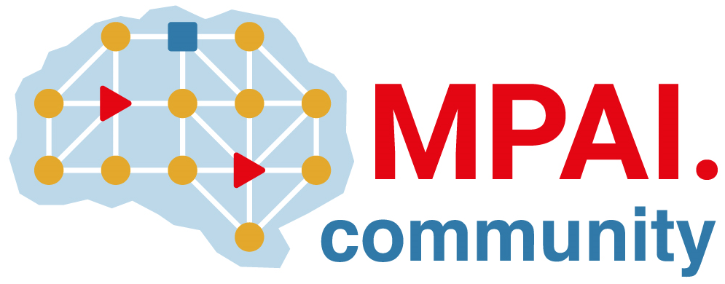 | Moving Picture, Audio and Data Coding by Artificial Intelligence  www.mpai.community

N46 | 2020/10/21
Source | MPAI Communication
Title | MPAI Press Release at the 1st meeting
Target | For public release

MPAI launches 6 standard projects on audio, genomics, video, AI framework, multiuser online gaming and multimodal conversation

Geneva, Switzerland – 21 October 2020. The Geneva-based international Moving Picture, Audio and Data Coding by Artificial Intelligence (MPAI) has concluded its first operational General Assembly adopting 6 areas of work, due to become standardisation projects.
MPAI-CAE – Context-based Audio Enhancement is an area that uses AI to improve the user experience for a variety of uses such as entertainment, communication, teleconferencing, gaming, post-production, restoration etc. in such contexts as in the home, in the car, on-the-go, in the studio etc. allowing a dynamically optimized user experience.
MPAI-GSA – Integrative Genomic/Sensor Analysis is an area that uses AI to understand and compress the results of high-throughput experiments combining genomic/proteomic and other data - for instance from video, motion, location, weather, medical sensors. The target use cases range. from personalised medicine to smart farming.
MPAI-SPG – Server-based Predictive Multiplayer Gaming uses AI to minimise the audio-visual and gameplay disruptions during an online real-time game caused by missing information at the server or at the client because of high latency and packet losses.
MPAI-EVC – AI-Enhanced Video Coding plans on using AI to further reduce the bitrate required to store and transmit video information for a variety of consumer and professional applications. One user of the MPAI-EVC standard is likely to be MPAI-SPG for improved compression and higher quality of cloud-gaming content.
MPAI-MMC – Multi-Modal Conversation aims to use AI to enable human-machine conversation that emulates human-human conversation in completeness and intensity
MPAI-AIF – Artificial Intelligence Framework is an area based on the notion of a framework populated by AI-based or traditional Processing Modules. As this is a foundational standard on which other planned MPAI standards such as MPAI-CAE, MPAI-GSA and MPAI-MMC, will be built, MPAI intends to move at an accelerated pace: Functional Requirements ready in November 2020, Commercial Requirements ready in December 2020 and Call for Technologies issued in January, 2021. The MPAI-AIF standard is planned to be ready before the summer holidays in 2021.
You can find more information about MPAI standards.
MPAI covers its Commercial Requirements needs with Framework Licences (FWL). These are the set of conditions of use of a license of a specific MPAI standard without the values, e.g. currency, percentages, dates, etc. MPAI expects that FWLs will accelerate the practical use of its standards.
MPAI develops data coding standards for a range of applications with Artificial Intelligence (AI) as its core enabling technology. Any legal entity that supports the MPAI mission may join MPAI if it is able to contribute to the development of Technical Specifications for the efficient use of Data.
Visit the MPAI home page and contact the MPAI secretariat for specific information.

