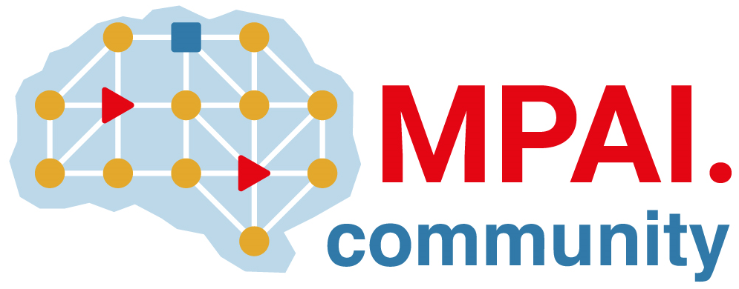 | Moving Picture, Audio and Data Coding by Artificial Intelligence  www.mpai.community

 | Public Document
N605 | 2022/03/23
Source | Requirements (EEV)
Title | Requirements (EEV) progress report and plans
Target | MPAI-17

Requirements (EEV) is currently constructing robust reference software, including re-training the OpenDVC from scratch and adding novel motion compensation networks. The software coordinator and other participants are expecting the first coding tool development and its coding performances. In addition, the shared common test conditions are discussed by both EVC and EEV, including tests sequences, training dataset, prediction structure, metrics, and other data that are needed to be reported.

The coordinator has been dedicating in the OpenDVC reference software reproduction and the partial results are obtained, including BD-rate performances using PSNR metric against the original OpenDVC software, the BD-rate performances on different GOP sizes, and the BD-rate performances on the common test sequences.

