Moving Picture, Audio and Data Coding by Artificial Intelligence
www.mpai.community

Public document
N29 | 2020/10/21
Source | General Assembly (MPAI-1)
Title | MPAI workplan
Target | Public document

Introduction
MPAI develops its standard using a 6-stage workflow

# | Acr | Name | Description
1 | UC | Use cases | Proposals of use cases, their description and merger of compatible use cases
2 | FR | Functional Reqs | Identification of the functional requirements that the standard should satisfy
3 | CR | Commercial Reqs | Development and approval of the framework licence of the standard
4 | CfT | Call for Technologies | Preparation and publication of a document calling for technologies supporting the requirements
5 | SD | Standard development | Development of the standard in a specific Development Committee (DC)
6 | MS | MPAI standard | The standard has been successfully completed and all Members have made the appropriate declarations

Areas at stage 2 (FR)

MPAI-AIF
Artificial Intelligence Framework (MPAI-AIF) is a potential common standardisation area sharing the notion of a framework populated by AI-based or traditional Processing Modules. MPAI-CAE, MPAI-GSA and MPAI-MMC envisage the use of MPAI-AIF.
Requirements of MPAI-AIF will be developed jointly for the said standards and possibly others as the work progresses. If insufficient commonalities will be identified, standard-specific frameworks may be developed.

Figure 1 – Initian diagram of the MPAI AI Framework

MPAI-CAE
Context-based Audio Enhancement (MPAI-CAE) intends to use AI, to improve the user experience for a variety of uses such as entertainment, communication, teleconferencing, gaming, post-production, restoration etc. in a variety of contexts such as in the home, in the car, on-the-go, in the studio etc.
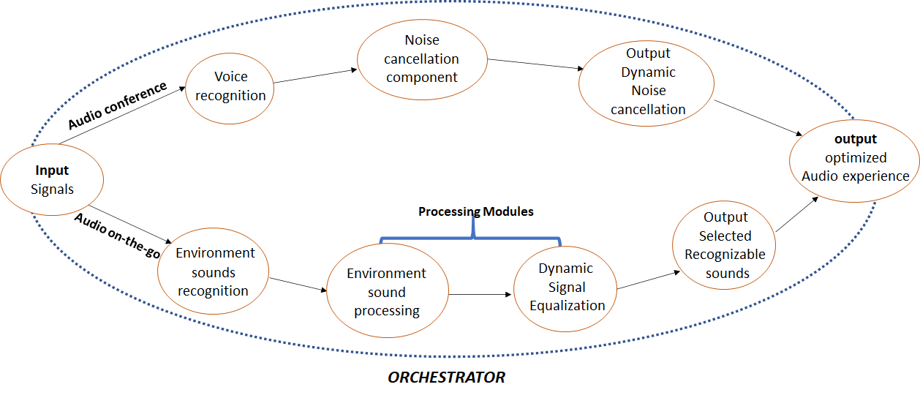
Figure 2 – Instances of MPAI-CAE

MPAI-GSA
Integrative Genomic/Sensor Analysis (MPAI-GSA) uses AI to understand and compress the results of high-throughput experiments combining genomic/proteomic and other data - for instance from video, motion, location, weather, medical sensors. The proposed use cases range from personalised medicine to smart farming.
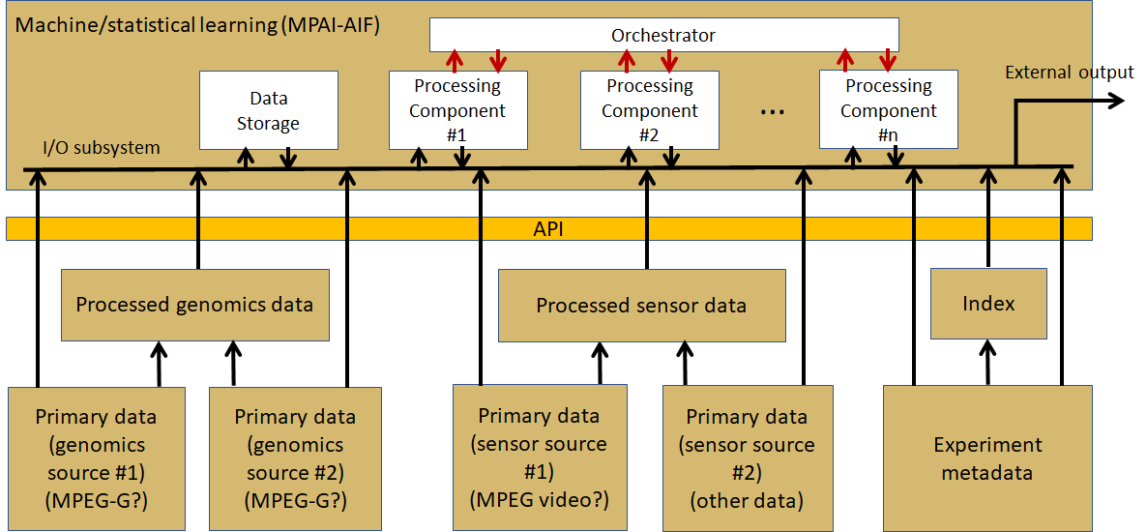

Figure 3 – MPAI-GSA reference diagram

MPAI-EVC
AI-Enhanced Video Coding (MPAI-EVC) is a video compression standard that substantially enhances the performance of a traditional video codec by improving or replacing traditional tools with AI-based tools. Two possibilities are envisaged
- Horizontal Hybrid approach which introduces AI based algorithms combined with traditional image video codec, trying to replace one block of the traditional schema with a machine learning-based one
- Vertical Hybrid: an AVC/HEVC/EVC/VVC base layer plus an enhanced machine learning-based layer.
The former case can be described by Figure 4 where green circles represent tools that can be replaced or enhnaced with their AI-based equivalent.

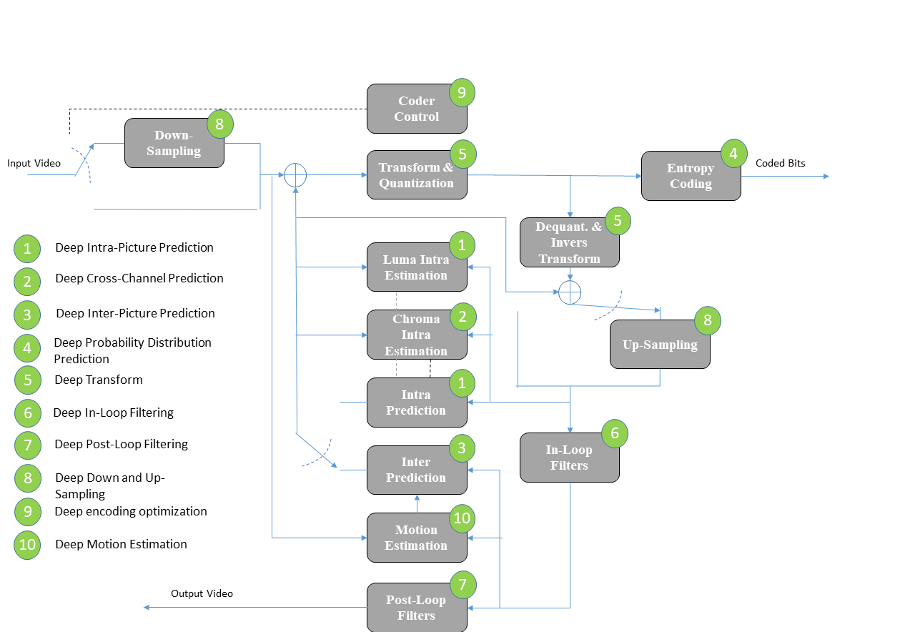
Figure 4 – A reference diagram for the Horizontal Hybrid approach

The latter case is represented by Figure 5.

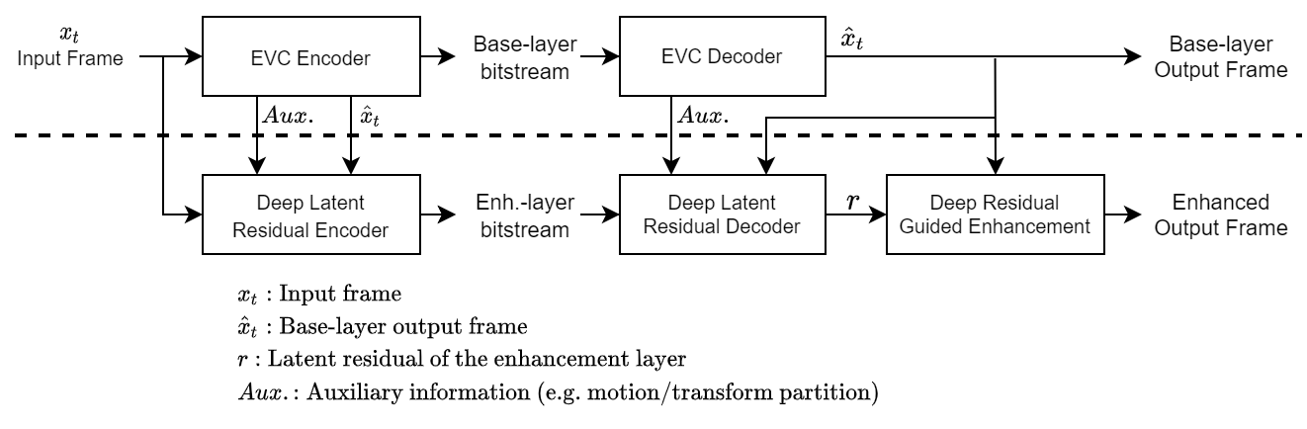
Figure 5 – A reference diagram for the Vertical Hybrid approach

MPAI-SPG
Server-based Predictive Multiplayer Gaming (MPAI-SPG) aims to minimise the audio-visual and gameplay discontinuities caused by high latency or packet losses during an online real-time game. In case information from a client is missing, the data collected from the clients involved in a particular game are fed to an AI-based system that predicts the moves of the client whose data are missing.

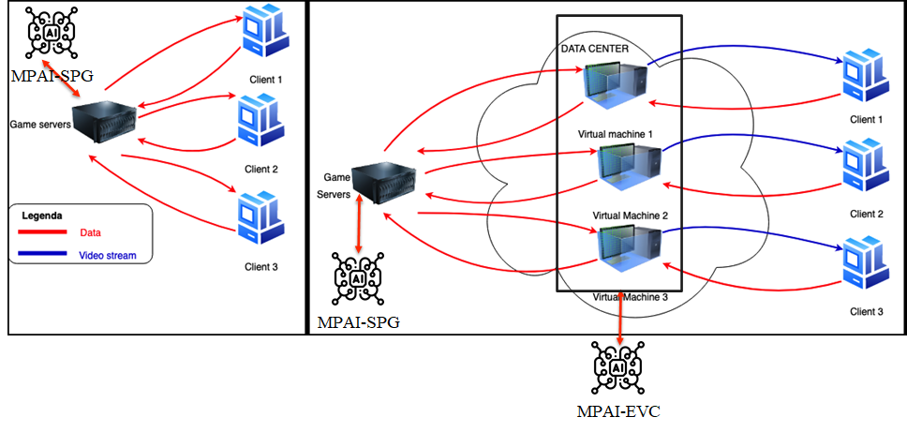

MPAI-MMC
Multi-modal conversation (MPAI-MMC) aims to enable human-machine conversation that emulates human-human conversation in completeness and intensity by using AI.
Figure 6 depicts a specific configuration of Processing Modules focused on emotion detection.

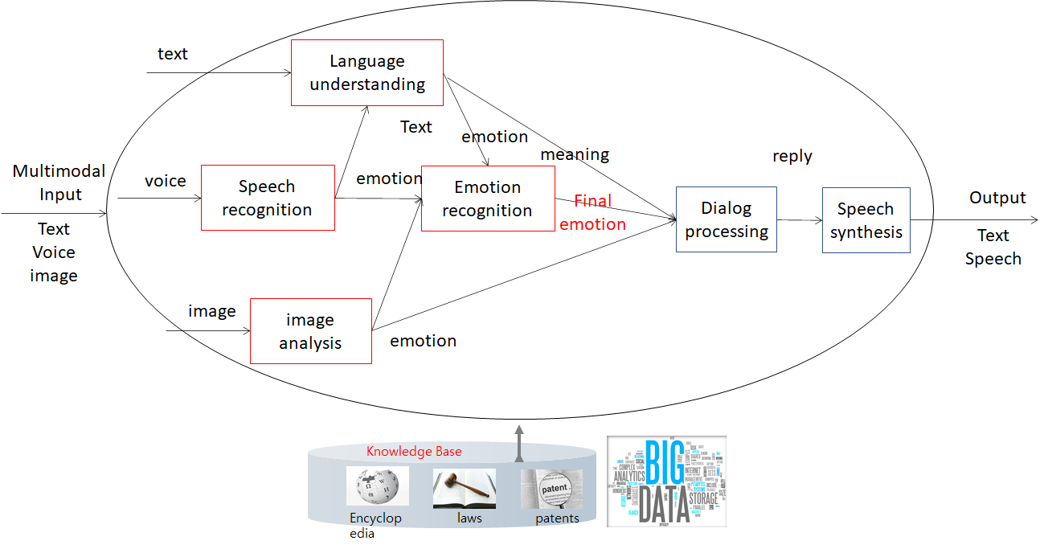
Figure 6 – An instance of MPAI-MMC

Areas at stage 1 (UC)

MPAI-CUI
Compression and understanding of industrial data (MPAI-CUI) aims to enable AI-based filtering and extraction of key information from the flow of data that combines 1) data produced by companies from: i) internally generated data or ii) generated because of regulation compliance (e.g., financial and organizational data); 2) data received from the outside (e.g., data on vertical risks as seismic, etc.)
MPAI-CUI requires standardisation of all data formats to be fed into an AI machine to extract information that is relevant to the intended use. Because the data formats are so diverse, an intermediate format to which any type of data generated by companies in different industries and different countries need to be converted seems to be the only practical solution.
This is depicted in Figure 6.

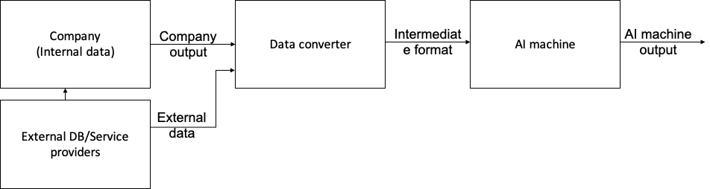

Figure 6 – A reference diagram for MPAI-CUF

Other possible areas

Visual object and scene description
This area addresses the “scene description” components of several use cases (Multiplayer online gaming ME.MP-09, Person matching ME.MP-11, Tracking game player’s movements ME.MP-12, AI-assisted driving TP.MP-01, Correct Posture HC.MP-02, Integrative genomic/video experiments ST.OD-06). Scene description includes the usual description (language) of objects and their attributes in a scene and the semantic description of the objects.
Unlike proprietary solutions that address the needs of the use cases but lack interoperability or force all users to adopt a single technology or application, a standard representation of the objects in a scene allows for better satifaction of the requirements.

Anomalous service access
A machine that has learnt "typical" service access values for a particular service provider can detect attempts beyond "typical" values.

Anomalous vibrations
A machine learns from the data generated by inertial sensors (accelerometer with gyroscope) to distinguish between regular and anomalous vibrations.

