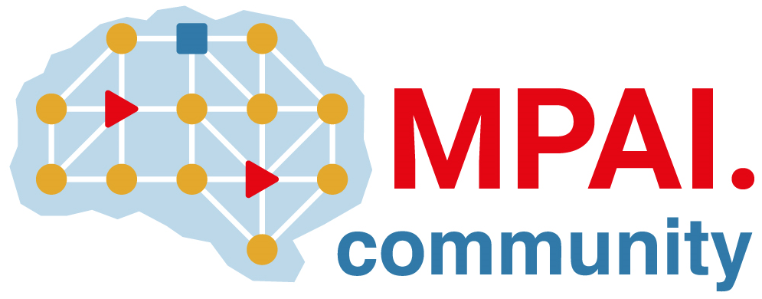 | Moving Picture, Audio and Data Coding by Artificial Intelligence  www.mpai.community

N50 | 2020/11/18
Source | MPAI Communication
Title | MPAI Press Release at the 2nd meeting
Target | For public release

MPAI commences development of the Framework Licence
for the MPAI AI Framework

Geneva, Switzerland – 18 November 2020. The Geneva-based international Moving Picture, Audio and Data Coding by Artificial Intelligence (MPAI) has concluded its second General Assembly making a major step toward the development of its first standard called MPAI AI Framework, acronym MPAI-AIF.

MPAI-AIF has been designed to enable creation and automation of mixed processing and inference workflows made of Machine Learning, Artificial Intelligence and traditional Data Processing components.

MPAI wishes to give as much information as possible to users of its standards. After approving the Functional Requirements, MPAI is now developing the Commercial Requirements, to be embodied in the MPAI-AIF Framework Licence. This will collect the set of conditions of use of the eventual licence(s), without values, e.g. currency, percentage, dates etc.

An optimal implementation of the MPAI use cases requires a coordinated combination of processing modules. MPAI has assessed that, by standardising the interfaces of Processing Modules, to be executed in the MPAI AI-Framework, horizontal markets of competing standard implementations of processing modules will emerge.

The MPAI-AIF standard, that MPAI plans on delivering in July 2021, will reduce cost, promote adoption and incite progress of AI technologies while, if the market develops incompatible implementations, costs will multiply, and adoption of AI technologies will be delayed.

MPAI-AIF is the first of a series of standards MPAI has in its development pipeline. The following three work areas, promoted to Functional Requirements stage, will build on top of MPAI-AIF:
- MPAI-CAE – Context-based Audio Enhancement uses AI to improve the user experience for a variety of uses such as entertainment, communication, teleconferencing, gaming, post-production, restoration etc. in the contexts of the home, the car, on-the-go, the studio etc. allowing a dynamically optimised user experience.
- MPAI-GSA – Integrative Genomic/Sensor Analysis uses AI to understand and compress the results of high-throughput experiments combining genomic/proteomic and other data - for instance from video, motion, location, weather, medical sensors. The target use cases range from personalised medicine to smart farming.
- MPAI-MMC – Multi-Modal Conversation uses AI to enable human-machine conversation that emulates human-human conversation in completeness and intensity.
The MPAI web site provides more information about other MPAI standards: MPAI-EVC uses AI to improve the performance of existing video codecs, MPAI-SPG to improve the user experience of online multiplayer games and MPAI-CUI to compress and understand industrial data.

MPAI seeks the involvement of companies who can benefit from international data coding standards and calls for proposals of standards. In a unique arrangement for a standards organisations, MPAI gives the opportunity, even to non-members, to accompany a proposal through the definition of its goals and the development of functional requirements. More details here.

MPAI develops data coding standards for a range of applications with Artificial Intelligence (AI) as its core enabling technology. Any legal entity that supports the MPAI mission may join MPAI if it is able to contribute to the development of Technical Specifications for the efficient use of Data.
Visit the MPAI home page and contact the MPAI secretariat for specific information.

