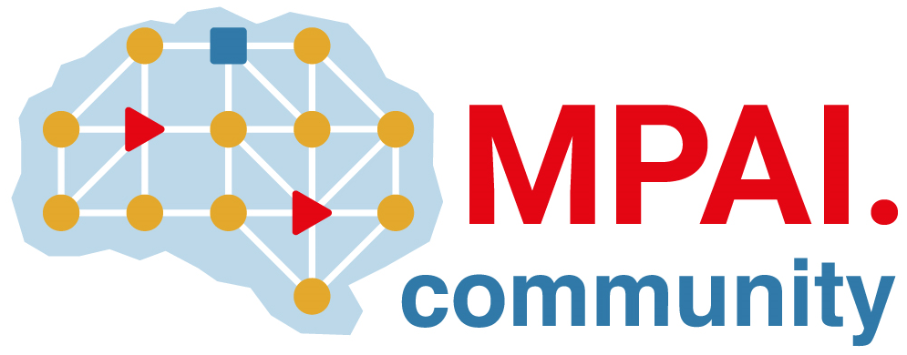 | Moving Picture, Audio and Data Coding by Artificial Intelligence  www.mpai.community

N67 | 2020/11/18
Source | MPAI-2
Title | Proposal for Template for MPAI technical submission documents
Target | MPAI Members

For responses to Call for Technologies
<Company/Member> submits this technical document in response to MPAI Call for Technologies for MPAI project MPAI-XYZ (MPAI document Nijk).

<Company/Member> explicitly agrees to the steps of the MPAI standards development process defined in Annex 1 to the MPAI Statutes, in particular <Company/Member> declares that <Company/Member> or its successors will make available the terms of the Licence related to its Essential Patents according to the Framework Licence of MPAI-XYZ (MPAI document Nmnp), alone or jointly with other IPR holders after the approval of the MPAI-XYZ Technical Specification by the General Assembly and in no event after commercial implementations of the MPAI-XYZ Technical Specification become available on the market.

In case of Company add
If (a part of) this submission is identified for inclusion in a specification, <Company> understands that <Company> will be requested to immediately join MPAI and that, if <Company> elects not to join MPAI, this submission will be discarded.

For general technical submissions
<Member> submits this document to MPAI Development Committee XYZ as a contribution to the development of the MPAI-XYZ Technical Specification.

<Member> explicitly agrees to the steps of the MPAI standards development process defined in Annex 1 to the MPAI Statutes, in particular <Company> declares that <Company> or its successors will make available the terms of the Licence related to its Essential Patents according to the Framework Licence of MPAI-XYZ (MPAI document Nmnp), alone or jointly with other IPR holders after the approval of the MPAI-XYZ Technical Specification by the General Assembly and in no event after commercial implementations of the MPAI-XYZ Technical Specification become available on the market.

