Moving Picture, Audio and Data Coding by Artificial Intelligence
www.mpai.community

N72 | 2020/11/18
Source | Paolo Ribeca
Title | Proposal for MPAI-GSA Functional Requirements work programme
Target | MPAI Members

Introduction
Moving Picture, Audio and Data Coding by Artificial Intelligence (MPAI) is an international association with the mission to develop AI-enabled data coding standards. AI technologies have shown that data coding with AI-based technologies is more efficient than with existing technologies.

The MPAI approach to AI data coding standards is by defining Processing Modules (PM) with standard interfaces that are combined and executed within an MPAI-specified AI-Framework. With its standards, MPAI intends to promote the development of horizontal markets of competing proprietary solutions tapping from and further promoting AI innovation.

This document describes the current plan to develop “Integrative Genomic/Sensor Analysis” (MPAI-GSA), an MPAI area of work that uses AI to understand and compress the results of data-rich experiments combining genomic/proteomic and other data, e.g. from video, motion, location, weather, medical sensors.

Chapter 2 explains the MPAI-GSA features, Chapter 3 provides summary information on the advanced IT environment that will execute MPAI-GSA applications and Chapter 4 identifies the items that will likely be the object of the MPAI-GSA standard.

MPAI-GSA features
Integrative Genomic/Sensor Analysis uses AI to understand and compress the results of high-throughput experiments combining genomic/proteomic and other data - for instance from video, motion, location, weather, medical sensors.

The framework consists of an API providing access to data and a protocol to specify a computation (or application) based on the data. Data can be:
- primary, i.e. the original unprocessed high-throughput content (such as sequencing or video data)
- secondary, i.e. the results of the pre-processing of primary data (such as gene expression estimates or features extracted from video) – applications will typically use these as input rather than primary data
- metadata specifying additional information about the biological sample or experiment (such as sample content, cell types and barcodes, collection time and place).
The API provides uniform access to data; in particular, it standardises the definition of the semantics of the different data sources.

So far, the following application areas, ranging from personalised medicine to smart farming, have been considered:
- Medical genomics – sequencing and variant-calling workflows. It consists of applications relevant to modern personalised medicine, such as determining the list and significance of the small variants present in an individual’s genome.
- Integrative analysis of ‘omics datasets. It consists of complex experimental protocols combining different sources of genomic/proteomic information.
- Correlating high-throughput biological data with phenotypic or spatial data. It consists of applications whereby genomic or proteomic data is combined with information on the source of the biological sample (such as single-cell RNA-sequencing or spatial metabolomics).
- Experiments correlating genomic data with microscopic or macroscopic behaviour. It consists of protocols whereby sensor/video/MRI data is used to automatically monitor properties of lab animals (such as their macroscopic behaviour, or the functional/dynamic workings of their neural networks) and correlated with the animal’s genotype.
- Smart farming. It consists of applications combining genomic and sensor data (monitoring features such as plant/livestock phenotype or growth) in order to optimise farming yield and management.

AI Framework
Most MPAI applications considered so far can be implemented as a set of AIMs – AI/ML and even traditional data processing based units with standard interfaces assembled in suitable topologies to achieve the specific goal of an application and executed in an MPAI-defined AI Framework. MPAI is making all efforts to identify processing modules that are re-usable and upgradable without necessarily changing the inside logic.

MPAI plans on completing the development of a 1st generation AI Framework called MPAI-AIF in July 2021.

The MPAI-AIF Architecture is given by
Figure 1

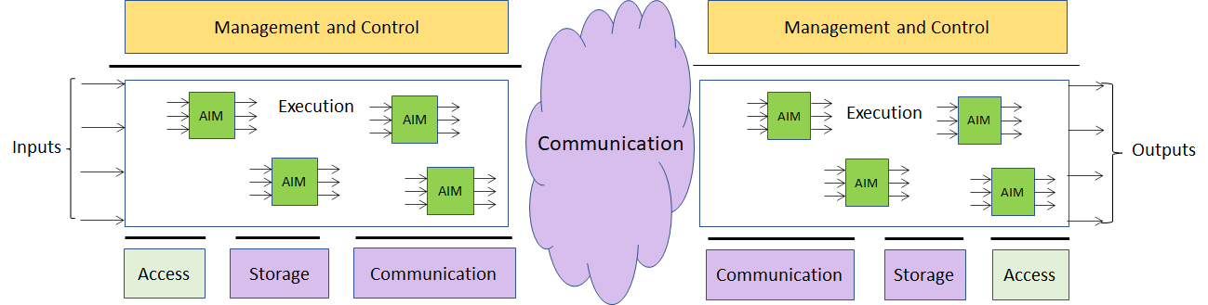

Figure 1 –The MPAI-AIF Architecture
Where
- Management and Control manages and controls the AIMs, so that they execute in the correct order and at the time when they are needed.
- Execution is the environment in which combinations of AIMs operate. It receives external inputs and produces the requested outputs both of which are application specific interfacing with Management and Control and with Communication, Storage and Access.
- AI Modules (AIM) are the basic processing elements receiving processing specific inputs and producing processing specific
- Communication is required in several cases and can be implemented, e.g. by means of a service bus and may be used to connect with remote parts of the framework
- Storage encompasses traditional storage and is used to e.g. store the inputs and outputs of the individual AIMs, data from the AIM’s state and intermediary results, shared data among AIMs.
- Access represents the access to static or slowly changing data that are required by the application such as domain knowledge data, data models, etc.

MPAI-GSA work plan
In this chapter, 5 application areas and the AI Modules (AIMs) required by the specific areas are identified. A first level of definition of the interfaces is also provided.

It should be noted that we separate primary modules, for which only data access is provided, from secondary modules – the latter implement full API and computational access.

Genomics, ‘omics and metadata
5-line description + usage example figure

Figure 2 – A usage example of genomics, ‘omics and metadata

K-mer based analysis

Compute k-mer frequency (P)
Function | Derive the distribution of k-mer frequencies from sequencing reads
Primary inputs | FASTA/FASTQ (reads)
Primary outputs | CSV (list of k-mer, frequency)
Notes | Only access and metadata supported

Genome assembly and annotation

De-novo assembly (P)
Function | Derive a new reference for the species/individual by assembling sequencing reads
Primary inputs | FASTA/FASTQ (reads)
Primary outputs | FASTA (assembly), graph formats (assembly)
Notes | Only access and metadata supported

De-novo annotation (P)
Function | Derive a genomic annotation for a newly assembled genome
Primary inputs | FASTA (reads, reference), GFF/GTF3 (genome annotation)
Primary outputs | GFF/GTF3 (genome reannotation)
Notes | Only access and metadata supported

Genome re-sequencing

Variant calling (P)
Function | Determine (“call”) genomic variants for an individual (i.e. differences between the reference genome for the species and the genome of an individual)
Primary inputs | FASTQ (reads), FASTA (reference)
Primary outputs | VCF (deduced variants)
Notes | Only access and metadata supported

(Single-cell) RNA-sequencing, expression (P)
Function | Derive a list of expression values for all (reannotated) genes/isoforms for each condition
Primary inputs | FASTQ (reads), CSV (metadata), FASTA (reference), GFF/GTF3 (genome annotation)
Primary outputs | CSV (expression), BigWig (tracks)
Notes | Only access and metadata supported

Single-cell RNA-sequencing, clustering (S)
Function | Derive a clustering for the cells studied during the experiment (possibly informed by position)
Secondary inputs | CSV (expression, high-dimensional plots)
Secondary outputs | CSV (cell clustering)

BS-sequencing (P)
Function | Derive a signal (“track”) describing the level of methylation along the genome
Primary inputs | FASTQ (reads), CSV (metadata), FASTA (reference), GFF/GTF3 (genome annotation)
Primary outputs | BigWig (tracks)
Notes | Only access and metadata supported

ChIP-sequencing (P)
Function | Derive a signal (“track”) describing the level of interaction between the target protein and DNA along the genome
Primary inputs | FASTQ (reads), CSV (metadata), FASTA (reference), GFF/GTF3 (genome annotation)
Primary outputs | BigWig (tracks)
Notes | Only access and metadata supported

HiC, contact matrices (P)
Function | Derive information on spatial connections between different regions of the genome
Primary inputs | FASTQ (reads), CSV (metadata), FASTA (reference), GFF/GTF3 (genome annotation)
Primary outputs | Matrix formats such as MatrixMarket (position-to-position links)
Notes | Only access and metadata supported

Personalised genomics

Determine variant significance (S)
Function | Correlate individual variants with databases of variants with known clinical significance
Secondary inputs | VCF (known variants), VCF (deduced variants)
Secondary outputs | CSV (list of significant variants, clinical significance)

Integrative analysis

Determine differential expression/signals (S)
Function | Determine differential signals in RNA-, ChIP-, BS-sequencing experiments, cluster genes/samples accordingly
Secondary inputs | Corresponding primary outputs (expression values as CSV, genome tracks as BigWig)
Secondary outputs | CSV

Perform pathway/enrichment/network analysis (S)
Function | Determine clusters/pathways of enriched genes, and their functional connection
Secondary inputs | Corresponding primary outputs ([SC] RNA-sequencing)
Secondary outputs | CSV, graph formats

Combine different primary sources (S)
Function | Combine signal tracks or expression values for the same sample coming from different sequencing protocols; cluster genes/samples accordingly
Secondary inputs | Corresponding primary inputs (expression values as CSV, genome tracks as BigWig)
Secondary outputs | BigWig, CSV

Study time series (S)
Function | Combine signal tracks or expression values for the same biological system coming from different time points; cluster genes/samples accordingly
Secondary inputs | Corresponding primary inputs (expression values as CSV, genome tracks as BigWig)
Secondary outputs | BigWig, CSV

Automated Analysis of Animal Behaviour
5-line description + usage example figure

Figure 3 – A usage example of Automated Analysis of Animal Behaviour

Animal dynamics

Function | To detect the animal and its spatial motion within the observation field, possibly within a specified ROI
Primary inputs | Video signal as stream or file, ROI
Primary outputs/Secondary inputs | Distance, (average) velocity, acceleration, time spent, time spent near walls, trajectories, turning speed (everywhere and/or in ROI)

Area and perimeter

Function | To detect areas where the animal preferentially dwells during the observed time
Primary inputs | Video signal as stream or file
Primary outputs/Secondary inputs | Coordinates, area and perimeter

ID Tracker

Function | To detect and track a specific animal, alone or among many (unsupervised or based on tracking devices)
Primary inputs | Video signal as stream or file
Primary outputs/Secondary inputs | Identification of animal (everywhere and/or in ROI)

Behaviour detection

Function | To analyse and detect the behaviour of one specified, or more, of the animals present within the observation field
Primary inputs | Video signal as stream or file
Primary outputs/Secondary inputs | Bites, persecution, sexual behaviour, angle of turn, grooming, jump, walk, immobilization, and touch

Smart Farming
During the past few years, there has been an increasing interest in data-rich techniques to optimise livestock and crop production (so called “smart farming”). The range of techniques is constantly expanding, but the main ideas are to combine molecular techniques (mainly high-throughput sequencing and derived protocols, such as RNA-sequencing, ChIP-sequencing, HiC, etc.; and mass-spectrometry – as per the ‘omics case at point 2) and monitoring by images (growth rate under different conditions, sensor data, satellite-based imaging) for both livestock species and crops. So this use case can be seen as a combination of cases 2 and 4. Primary sources would be genomic data and images; secondary data would be vectors of values for a number of genomic tags and features (growth rate, weight, height) extracted from images; metadata would be information about environmental conditions, spatial position, etc. A growing number of companies are offering services in this area – again, having the possibility of deploying them as MPAI-GSA applications would open up a large arena where academic or commercial providers would be able to meet the needs of a number of customers in a well-defined way.

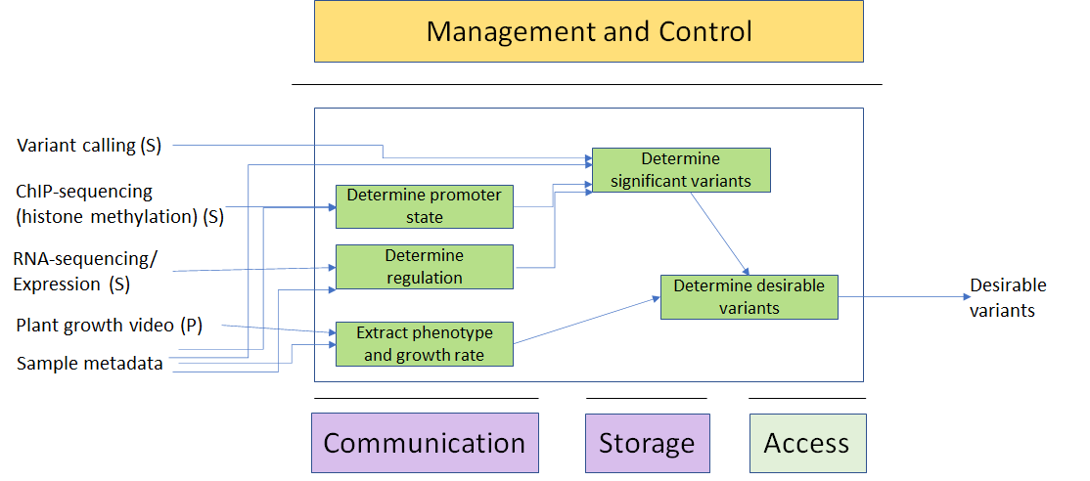

Figure 4 – A usage example of Smart Farming

Determine promoter state
Function
Primary inputs
Primary outputs/Secondary inputs

Determine regulation
Function
Primary inputs
Primary outputs/Secondary inputs

Extract phenotype and growth rate
Function
Primary inputs
Primary outputs/Secondary inputs

Determine significant variants
Function
Primary inputs
Primary outputs/Secondary inputs

Determine desirable variants
Function
Primary inputs
Primary outputs/Secondary inputs

Conclusions
The document in its current form is work in progress. MPAI intends to add more details to the existing and to add more usage examples to be covered by the future MPAI-GSA standard.

When the document will be considered sufficiently mature, MPAI will issue a Call for Technologies requesting MPAI members and the industry to submit proposals for:
- Data formats suitable as inputs and outputs of the identified Processing Modules
- Possible alternative partitioning of the Processing Modules implementing the example cases providing
  - Arguments in support of the proposed partitioning
  - Detailed specifications of the inputs and outputs of the proposed Processing Modules
- New usage examples fully described as in the future version of this document.

Respondents will be asked to state in their submissions their intention to adhere to the Framework Licence developed for MPAI-MMC when licencing their technologies if included in the MPAI-MMC standard. Please note that “a Framework Licence is the set of conditions of use of a licence without the values, e.g. currency, percent, dates etc.”. The Framework Licence will give the MPAI-MMC standard a clear IPR licensing framework.

The MPAI-MMC Framework Licence will be developed, as for all other MPAI Framework Licences, in compliance with the generally accepted principles of competition law.

