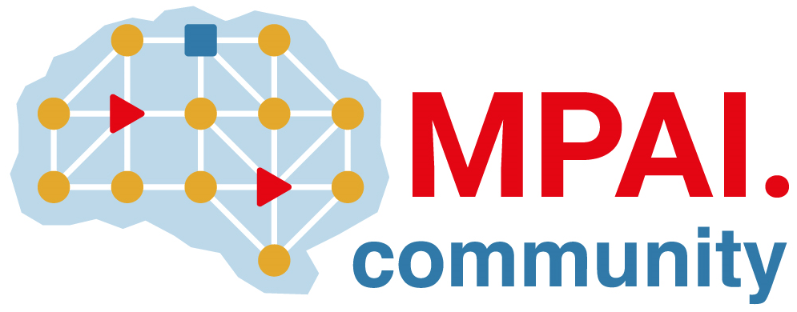 | Moving Picture, Audio and Data Coding by Artificial Intelligence  www.mpai.community

N75 | Public Document
 | 2020/11/18
Source | MPAI General Assembly #2
Title | Invitation to contribute proposals of AI-based data coding standards to MPAI
Target | For public release

Moving Picture, Audio and Data Coding by Artificial Intelligence (MPAI), an international not-for-profit organisation with the mission to develop AI enabled digital data compression specifications with clear IPR licensing frameworks, invites you to contribute proposals of AI-based data coding standards.

The MPAI Statutes define two classes of membership: Principal Members with the right to vote and Associate Members with the right to participate in the development of MPAO technical specifications. However, MPAI encourages non-members to propose new MPAI standards and participate in meetings dealing with proposals of new standards and their functional requirements.

Since a few months, MPAI has collected and documented use cases proposed by members and non-member in the MPAI Use Cases document, now at version 2.0. Combinations of some of the use cases proposed has led MPAI to initiate the development of several standards:
MPAI-CAE – Context-based Audio Enhancement: uses AI to improve the user experience for entertainment, teleconferencing etc. contexts such as home, on-the-go etc.
MPAI-GSA – Integrative Genomic/Sensor Analysis uses AI to understand and compress the combination of genomic experiments and other data for personalised medicine to smart farming.
MPAI-MMC – Multi-Modal Conversation uses AI to enable human-machine conversation that emulates human-human conversation in completeness and intensity.
MPAI-SPG – Server-based Predictive Multiplayer Gaming uses AI to minimise the audio-visual and gameplay disruptions during an online real-time game caused by missing information.
MPAI-EVC – AI-Enhanced Video Coding uses AI to further reduce the video bitrate for a variety of consumer and professional applications.
MPAI-CUI – Compression and Understanding of Industrial Data uses AI to filter and extract key information from the flow of data generated by companies.
MPAI-AIF – Artificial Intelligence Framework is a foundational standard specifying a processing environment of Intelligent Modules on which the MPAI standards mentioned above will be built.
MPAI invites interested parties to submit proposals of practical use cases that benefit from the capability of AI technologies to compress digital data and/or to bring out information embedded in the data. Any company, organisation or individual, irrespective of its membership in MPAI, is entitled to submit a written contribution proposing use cases and participate in MPAI meetings until Functional Requirements are finalised. Participation in subsequent stages of standard development requires MPAI membership for participation.

Contributions, drafted using the template defined below should be sent to the MPAI secretariat: secretariat@mpai.community:

Template of MPAI use case proposal

Title: Concise title of use case

Proponent: Proponent’s name and affiliation

Description: Explains and delimits the scope of the use case

Comments: General comment on why and how AI can support the use case

Examples: Illustrate how the use case can cover different contexts, especially if the use case has a broad coverage

Requirements: Preliminary requirements to clarify the use case (full requirements identification is part of the subsequent Functional Requirements stage)

Object of standard: Provides general identification of what is normative in the proposed use case if a standard will be developed

Benefits: Advantages offered by the standard over existing solutions and new opportunities offered to industry and/or end users

Bottlenecks: Technical issues that may limit use of the standard or whose passing over will facilitate use of the standard

Social aspects: Cases where using the standard may have social impacts (optional)

Success criteria: Proposed measures of the standard’s success. These should include outcomes (short term) and impact (longer term)

