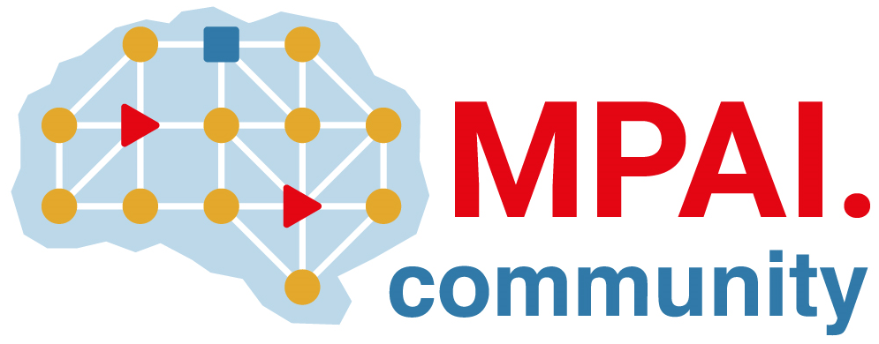 | Moving Picture, Audio and Data Coding by Artificial Intelligence  www.mpai.community

Public Document
N101 | 2020/12/16
Source | Board of Directors
Title | MPAI-AIF Framework Licence
Target | MPAI Members

Coverage
The MPAI AI Framework (MPAI-AIF) standard as will be defined in document Nxyz of Moving Picture, Audio and Data Coding by Artificial Intelligence (MPAI).
MPAI-AIF specifies a generic execution environment possibly integrating Machine Learning, Artificial Intelligence and legacy Data Processing components implementing application areas such as
- Context-based Audio Enhancement (MPAI-CAE)
- Integrative Genomic/Sensor Analysis (MPAI-GSA)
- AI-Enhanced Video Coding (MPAI-EVC)
- Server-based Predictive Multiplayer Gaming (MPAI-SPG)
- Multi-Modal Conversation (MPAI-MMC)
- Compression and Understanding of Industrial data (MPAI-CUI)
The six application areas are expected to become MPAI standards.

Definitions
Term | Definition
Data | Any digital representation of a real or computer-generated entity, such as moving pictures, audio, point cloud, computer graphics, sensor and actuator. Data includes, but is not restricted to, media, manufacturing, automotive, health and generic data.
Development Rights | Licence to use MPAI-AIF Essential IPRs to develop Implementations
Enterprise | Any commercial entity that develops or implements the MPAI-AIF standard
Essential IPR | Any Proprietary Rights, (such as patents) without which it is not possible on technical (but not commercial) grounds, to make, sell, lease, otherwise dispose of, repair, use or operate Implementations without infringing those Proprietary Rights
Framework Licence | A document, developed in compliance with the generally accepted principles of competition law, which contains the conditions of use of the Licence without the values, e.g., currency, percent, dates etc.
Implementation | A hardware and/or software reification of the MPAI-AIF standard serving the needs of a professional or consumer user directly or through a service
Implementation Rights | Licence to reify the MPAI-AIF standard
Licence | This Framework Licence to which values, e.g., currency, percent, dates etc., related to a specific Intellectual Property will be added. In this Framework Licence, the word Licence will be used as singular. However, multiple Licences from different IPR holders may be issued
Profile | A particular subset of the technologies that are used in MPAI-AIF standard and, where applicable, the classes, subsets, options and parameters relevant to the subset

Conditions of use of the Licence
- The Licence will be in compliance with generally accepted principles of competition law and the MPAI Statutes
- The Licence will cover all of Licensor’s claims to Essential IPR practiced by a Licencee of the MPAI-AIF standard.
- The Licence will cover Development Rights and Implementation Rights
- The Licence will apply to a baseline MPAI-AIF profile and to other profiles containing additional technologies
- Access to Essential IPRs of the MPAI-AIF standard will be granted in a non-discriminatory fashion.
- The scope of the Licence will be subject to legal, bias, ethical and moral limitations
- Royalties will apply to Implementations that are based on the MPAI-AIF standard
- Royalties will not be based on the computational time nor on the number of API calls
- Royalties will apply on a worldwide basis
- Royalties will apply to any Implementation
- An MPAI-AIF Implementation may use other IPR to extend the MPAI-AIF Implementation or to provide additional functionalities
- The Licence may be granted free of charge for particular uses if so decided by the licensors
- The Licences will specify
  - a threshold below which a Licence will be granted free of charge and/or
  - a grace period during which a Licence will be granted free of charge and/or
  - an annual in-compliance royalty cap applying to total royalties due on worldwide revenues for a single Enterprise
- A preference will be expressed on the entity that should administer the patent pool of holders of Patents Essential to the MPAI-AIF standard
- The total cost of the Licences issued by IPR holders will be in line with the total cost of the licences for similar technologies standardised in the context of Standard Development Organisations
- The total cost of the Licences will take into account the value on the market of the AI Framework technology Standardised by MPAI.

