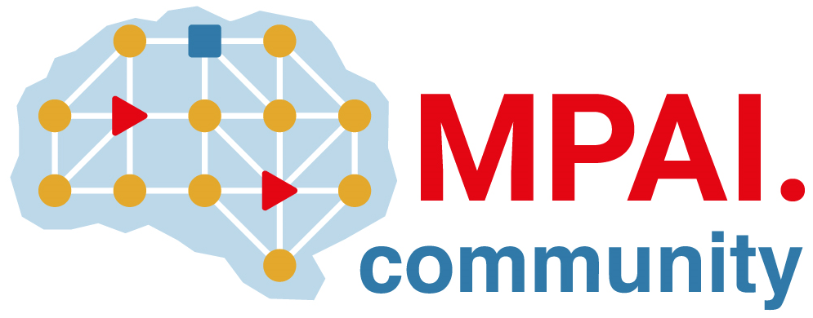 | Moving Picture, Audio and Data Coding by Artificial Intelligence  www.mpai.community

Public Document
N84 | 2020/12/16
Source | Leonardo Chiariglione
Title | Proposal for Press Release of MPAI-3
Target | Communication AC

MPAI issues a Call for Technologies supporting its AI Framework standard

Geneva, Switzerland – 16 December 2020. Moving Picture, Audio and Data Coding by Artificial Intelligence (MPAI), an international unaffiliated standards association, has approved a Call for Technologies (CfT) for publication at its 3rd General Assembly MPAI-3. The CfT concerns technologies for MPAI-AIF, acronym of the MPAI AI Framework standard.

The goal of MPAI-AIF is to enable set up and execution of mixed processing and inference workflows made of Machine Learning, Artificial Intelligence and legacy Data Processing components called AI Modules (AIM).

The MPAI AI Framework standard will facilitate integration of AI and legacy data processing components through standard interfaces and methods. MPAI experts have already validated MPAI’s innovative approach in a sample micro controller-based implementation that is synergistic with MPAI-AIF standard development.

In line with its statutes, MPAI has developed the Framework Licence associated with the MPAI-AIF standard. Responses to the CfT shall be in line with the requirements laid down in the CfT and shall be supported by a statement that the respondent will licence their technologies, if adopted in the standard, according to the framework licence.

MPAI is also working on a range of standards for AIM input/output interfaces used in several application areas. Two candidate standards have completed the definition of Functional Requirements and have been promoted to the Commercial Requirements stage.

The two candidates are
- MPAI-CAE – Context-based Audio Enhancement uses AI to improve the user experience for a variety of uses such as entertainment, communication, teleconferencing, gaming, post-production, restoration etc. in the contexts of the home, the car, on-the-go, the studio etc. allowing a dynamically optimised user experience.
- MPAI-MMC – Multi-Modal Conversation uses AI to enable human-machine conversation that emulates human-human conversation in completeness and intensity.

MPAI adopts a light approach in the definition AIMs standardisation. Different implementors can produce AIMs of different performance still exposing the same standard interfaces. MPAI AIMs with different features from a variety of sources will promote horizontal markets of AI solutions that tap from and further promote AI innovation.

The MPAI web site provides more information about other MPAI standards: MPAI-CUI uses AI to compress and understand industrial data, MPAI-EVC to improve the performance of existing video codecs, MPAI GSA to to understand and compress the results of combining genomic experiments with those produced by related devices, e.g. video, motion, location, weather, medical sensors, and MPAI-SPG to improve the user experience of online multiplayer games.

MPAI develops data coding standards for applications that have AI as core enabling technology. Any legal entity that supports the MPAI mission may join MPAI if it is able to contribute to the development of standards for the efficient use of Data.
Visit the MPAI home page and contact the MPAI secretariat for specific information.

