Moving Picture, Audio and Data Coding by Artificial Intelligence
www.mpai.community

Public document
N123 | 2021/01/20
Source | General Assembly (MPAI-4)
Title | MPAI workplan
Target | Public document

Introduction
MPAI’s standards development is based on projects evolving through a workflow extending on 6 + 1 stages.

# | Acr | Name | Description
0 | IC | Interest Collection | Collection and harmonisation of use cases proposed
1 | UC | Use cases | Proposals of use cases, their description and merger of compatible use cases
2 | FR | Functional Reqs | Identification of the functional requirements that the standard should satisfy
3 | CR | Commercial Reqs | Development and approval of the framework licence of the standard
4 | CfT | Call for Technologies | Preparation and publication of a document calling for technologies supporting the requirements
5 | SD | Standard development | Development of the standard in a specific Development Committee (DC)
6 | MS | MPAI standard | The standard has been successfully completed and all Members have made the appropriate declarations

A project progresses from one stage to the next by resolution of the General Assembly.
The currently active MPAI projects are graphically represented by Figure 1

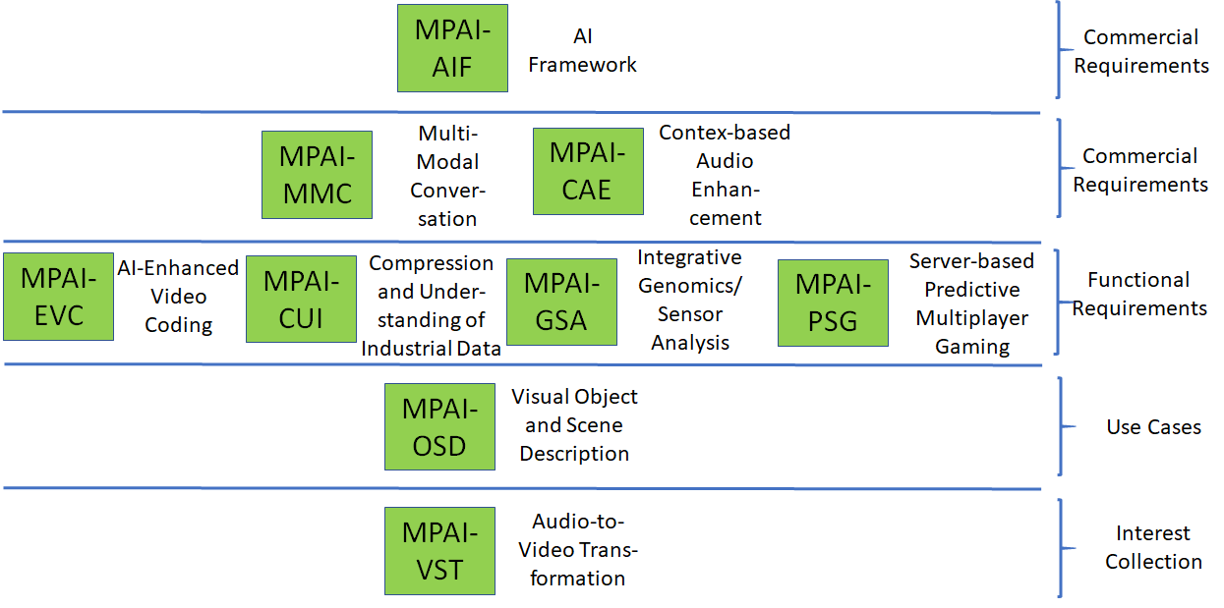
Figure 1 – Snapshot of MPAI work plan

Areas at stage 4 (CT)

MPAI-AIF
Artificial Intelligence Framework (MPAI-AIF) enables creation and automation of mixed ML-AI-DP processing and inference workflows for the application areas work currently considered at stages 1, 2 and 3 of the MPAI work plan. MPAI-AIF will be extended to support new applications areas if the need will arise.
The said areas of work share the notion of an environment (the Framework) that includes 6 components – Management and Control, Execution, AI Modules (AIM), Communication, Storage and Access. AIMs are connected in a variety of topologies and executed under the supervision of Management and Control. AIMs expose standard interfaces that make them re-usable in different applications. Figure 2 shows the general MPAI-AIF Reference Model.

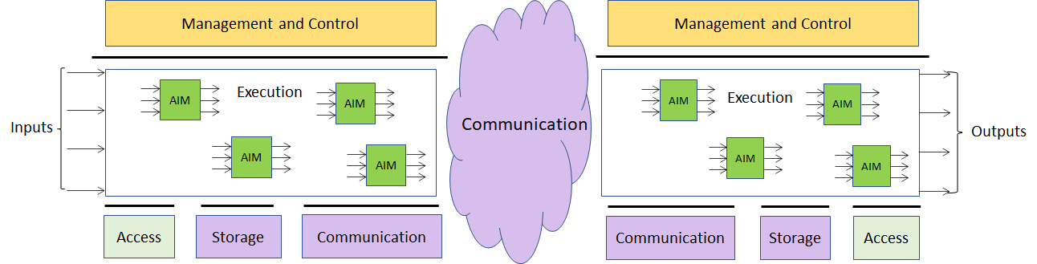

Figure 2 – Reference model of the MPAI AI Framework

MPAI documents supporting the MPAI-AIF project at the current stage are:
- Use Cases & Functional Requirements of MPAI-AIF, N74 [1] - https://mpai.community/standards/mpai-aif/#Requirements
- MPAI-AIF Call for Technologies, N100 [2] - https://mpai.community/standards/mpai-aif/#Technologies
- MPAI-AIF Framework Licence, N101 [3] - https://mpai.community/standards/mpai-aif/#Licence
- Assessment of submissions to MPAI-AIF CfT, N137 [4] - https://mpai.community/standards/mpai-aif/#Assessment
Responses to the MPAI-AIF Call for Technologies are due 2021/02/15.

Areas at stage 3 (CR)

MPAI-CAE
Context-based Audio Enhancement (MPAI-CAE) improves the user experience for several audio-related applications including entertainment, communication, teleconferencing, gaming, post-production, restoration etc. in a variety of contexts such as in the home, in the car, on-the-go, in the studio etc. using context information to act on the input audio content using AI, processing such content via AIMs, and may deliver the processed output via the most appropriate protocol.
So far, MPAI-CAE has been found applicable to 11 usage examples, for 4 of which the definition of AIM interfaces is at an advanced stage: Emotion enhanced speech, Audio Recording Preservation, Enhanced Audioconference Experience and Audio-on-the-go. Figure 3 addresses the Emotion enhanced speech Use Case.

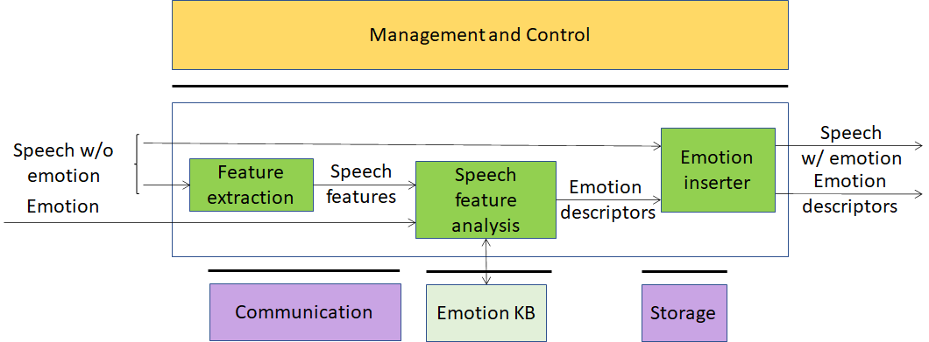
Figure 3 – An MPAI-CAE Use Case: Emotion-enhanced speech

MPAI documents supporting the MPAI-CAE project at the current stage are:
- Draft MPAI-CAE Use Case and Functional Requirements, N131 [5] - https://mpai.community/standards/mpai-cae/#UCFR
- Daft MPAI-CAE Call for Technologies, N132 [6] - https://mpai.community/standards/mpai-cae/#Technologies
MPAI plans on publishing the MPAI-CAE Use Cases and Requirements and the MPAI-CAE Call for Proposals at MPAI-5 (2020/02/17).

MPAI-MMC
Multi-modal conversation (MPAI-MMC) aims to enable human-machine conversation that emulates human-human conversation in completeness and intensity by using AI.
So far, 3 Use Cases have been identified for MPAI-MMC: Conversation with emotion, Multimodal Question Answering (QA) and Personalized Automatic Speech Translation.
Figure 4 addresses the Conversation with emotion Use Case.

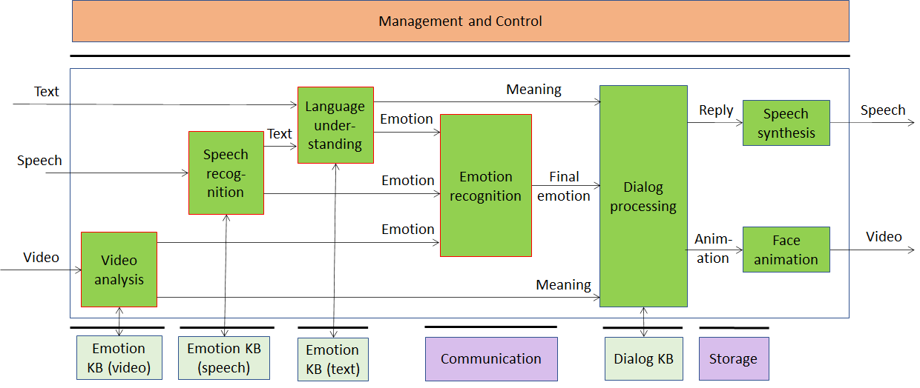
Figure 4 – An MPAI-MMC Use Case: Conversation with emotion

MPAI documents supporting the MPAI-MMC project at the current stage are:
- Draft MPAI-MMC Use Case and Functional Requirements, N133 [7] - https://mpai.community/standards/mpai-mmc/#UCFR
- Daft MPAI-MMC Call for Technologies, N134 [8] - https://mpai.community/standards/mpai-mmc/#Technologies
MPAI plans on publishing the MPAI-MMC Use Cases and Requirements and the MPAI-MMC Call for Proposals at MPAI-5 (2020/02/17)

Areas at stage 2 (FR)

MPAI-CUI
Compression and understanding of industrial data (MPAI-CUI) aims to enable AI-based filtering and extraction of key information from the flow of data that combines data produced by companies and external data (e.g., data on vertical risks such as seismic, cyber etc.)
MPAI-CUI requires standardisation of all data formats to be fed into an AI machine to extract information that is relevant to the intended use. Converted data undergo a further conversion and are then fed to specific neural networks. This is depicted in Figure 5.

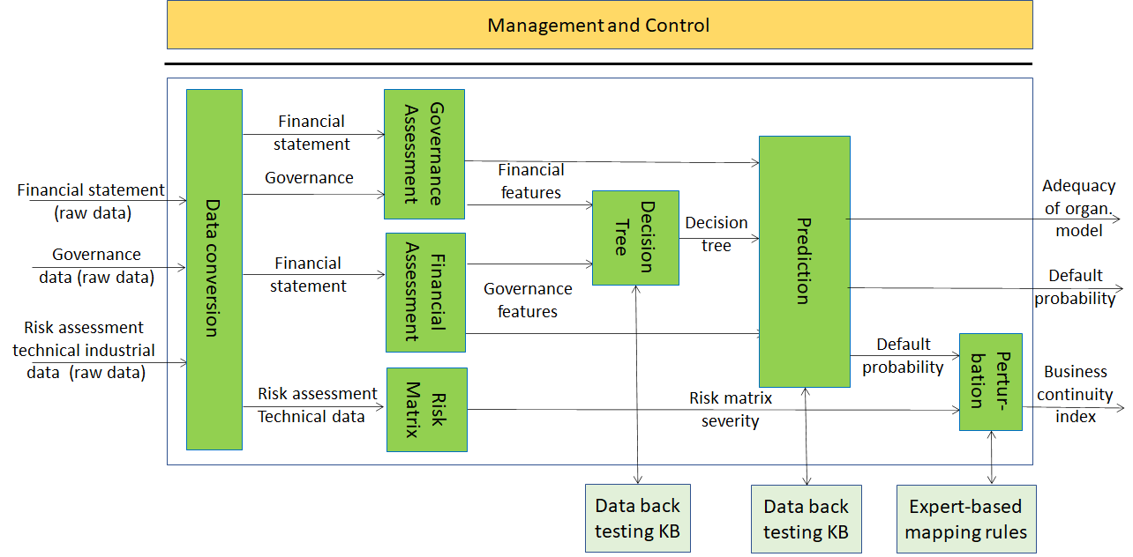
Figure 5 – The MPAI-CUI Use Case

MPAI documents supporting the MPAI-CUI project at the current stage are:
- Draft MPAI-CUI Use Cases and Functional Requirement, N135 [9] - https://mpai.community/standards/mpai-cui/
MPAI plans on publishing the MPAI-CUI Use Cases and Requirements and the MPAI-CUI Call for Proposals at MPAI-6 (2020/03/17)

MPAI-GSA
Integrative Genomic/Sensor Analysis (MPAI-GSA) uses AI to understand and compress the results of high-throughput experiments combining genomic/proteomic and other data, e.g. from video, motion, location, weather, medical sensors.
So far, MPAI-GSA has been found applicable to 4 Use Areas (collections of compatible Use Cases):
- Integrative analysis of ‘omics datasets
- Smart Farming
- Genomics and phenotypic/spatial data
- Genomics and behaviour
Figure 6 addresses the Use Case Smart Farming.

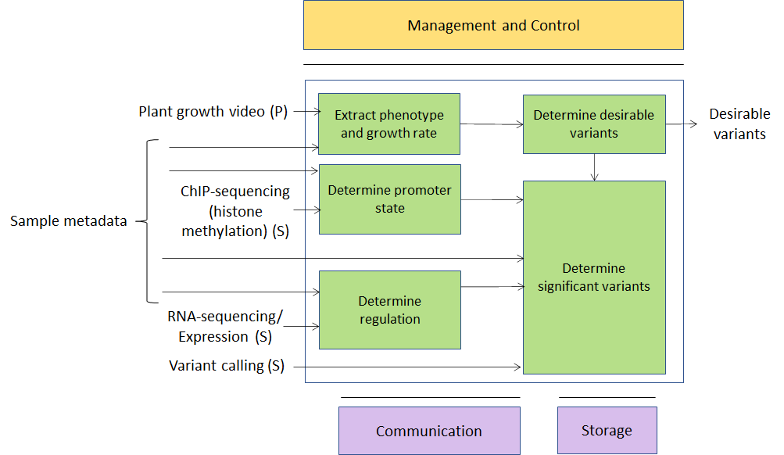
Figure 6 – An MPAI-GSA Use Case: Smart Framing

MPAI documents supporting the MPAI-GSA project at the current stage are:
- Draft MPAI-GSA Use Cases and Functional Requirement, N136 [10] - https://mpai.community/standards/mpai-gsa/#Requirements
MPAI plans on publishing the MPAI-GSA Use Cases and Requirements and the MPAI-CUI Call for Proposals at MPAI-6 (2020/03/17)

MPAI-EVC
AI-Enhanced Video Coding (MPAI-EVC) is a video compression standard that substantially enhances the performance of a traditional video codec by improving or replacing traditional tools with AI-based tools. Two approaches – Horizontal Hybrid and Vertical Hybrid – are envisaged. The Horizontal Hybrid approach introduces AI based algorithms combined with traditional image/video codec, trying to replace one block of the traditional schema with a machine learning-based one. This case can be described by Figure 7 where green circles represent tools that can be replaced or enhanced with their AI-based equivalent.
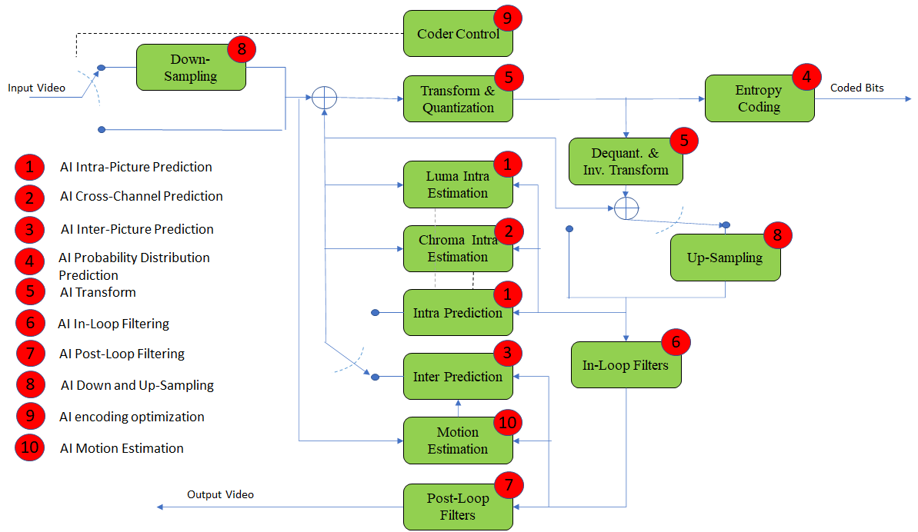
Figure 7 – A reference diagram for the Horizontal Hybrid approach

The Vertical Hybrid approach envigaes an AVC/HEVC/EVC/VVC base layer plus an enhanced machine learning-based layer. This case can be represented by Figure 8.

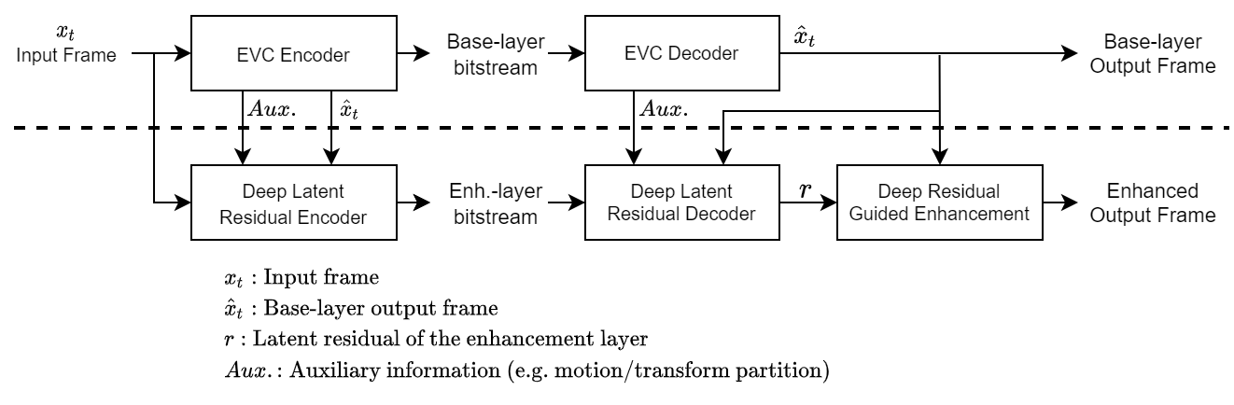
Figure 8 – A reference diagram for the Vertical Hybrid approach

MPAI is engaged in the MPAI-EVC Evidence Project seeking to find evidence that AI-based technologies provide sufficient improvement to the Horizontal Hybrid approach. A second project on the Vertical Hybrid approach is being considered.
Approved MPAI documents supporting the MPAI-EVC work area are:
- MPAI Application Note #3 R1 - MPAI-EVC, N61 [11] - https://mpai.community/standards/mpai-evc/#Application
- MPAI-EVC Use Cases and Requirements, N92 [12] - https://mpai.community/standards/mpai-evc/#Requirements
- Collaborative Evidence Conditions for MPAI-EVC Evidence Project Rev.1, N69 [13] - https://mpai.community/wp-content/uploads/2020/11/N69-Collaborative-Evidence-Conditions-for-MPAI-EVC-Evidence-Project-R1.docx
- Operational Guidelines for MPAI-EVC Evidence Project, N70 [14] - https://mpai.community/wp-content/uploads/2020/11/N70-Operational-Guidelines-for-MPAI-EVC-Evidence-Project.docx

MPAI-SPG
Server-based Predictive Multiplayer Gaming (MPAI-SPG) aims to minimise the audio-visual and gameplay discontinuities caused by high latency or packet losses during an online real-time game. In case information from a client is missing, the data collected from the clients involved in a particular game are fed to an AI-based system that predicts the moves of the client whose data are missing.
Figure 9 depicts a model being considered for MPAI-SPG.

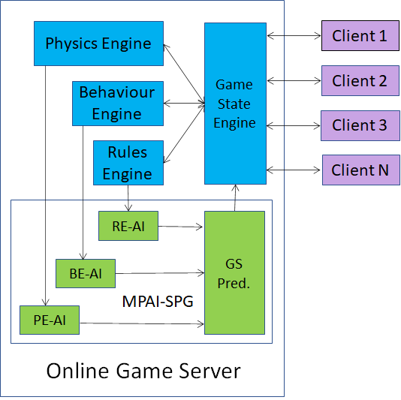

Figure 9 – Identification of MPAI-SPG standardisation area

Approved MPAI document supporting the MPAI-EVC work area is
- MPAI Application Note #5 R1 - MPAI-SPG, N62 - https://mpai.community/standards/mpai-spg/

Areas at stage 1 (UC)

MPAI-OSD
Visual object and scene description addresses the “scene description” components of several use cases (Multiplayer online gaming ME.MP-09, Person matching ME.MP-11, Tracking game player’s movements ME.MP-12, AI-assisted driving TP.MP-01, Correct Posture HC.MP-02, Integrative genomic/video experiments ST.OD-06). Scene description includes the usual description of objects and their attributes in a scene and the semantic description of the objects.
Unlike proprietary solutions that address the needs of the use cases but lack interoperability or force all users to adopt a single technology or application, a standard representation of the objects in a scene allows for better satifaction of the requirements.
Approved MPAI document supporting the MPAI-OSD work area is:
- MPAI Application Note #8 - MPAI-OSD, N93 - https://mpai.community/standards/mpai-osd/.

Areas at stage 0 (IC)

Vision-to-Sound Transformation
It is possible to give a spatial representation of an image that visually impaired people can hear with two headphones as a localization and description medium. It is a conversion (compression) technique from one space to a different interpretation space.

Other possible areas
Several potential areas for standardisation are likely to emerge from [17].

Anomalous service access
A machine that has learnt "typical" service access values for a particular service provider can detect attempts beyond "typical" values.

Anomalous vibrations
A machine learns from the data generated by inertial sensors (accelerometer with gyroscope) to distinguish between regular and anomalous vibrations.

References
- Use Cases & Functional Requirements of MPAI-AIF, N74
- MPAI-AIF Call for Technologies, N100
- MPAI-AIF Framework Licence, N101
- Assessment of submissions to MPAI-AIF CfT, N137
- Draft MPAI-CAE Use Case and Functional Requirements, N131
- Daft MPAI-CAE Call for Technologies, N132
- Draft MPAI-MMC Use Case and Functional Requirements, N133
- Daft MPAI-MMC Call for Technologies, N134
- Draft MPAI-CUI Use Cases and Functional Requirement, N135
- Draft MPAI-GSA Use Cases and Functional Requirements, N136
- MPAI Application Note #3 R1 - MPAI-EVC, N61
- MPAI-EVC Use Cases and Requirements, N92
- Collaborative Evidence Conditions for MPAI-EVC Evidence Project Rev.1, N69
- Operational Guidelines for MPAI-EVC Evidence Project, N70
- MPAI Application Note #5 R1 - MPAI-SPG, N62
- MPAI Application Note #8 - MPAI-OSD, N93
- MPAI Use Case Rev2.0, N46

