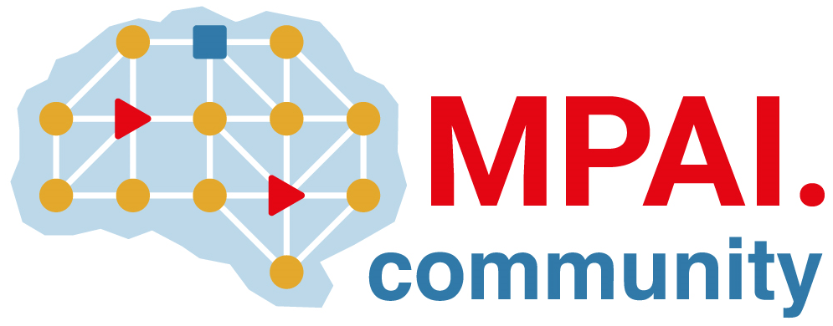 | Moving Picture, Audio and Data Coding by Artificial Intelligence  www.mpai.community

 | 2021/01/08
Source | Communication AC
Title | Proposed MPAI Manifesto
Target | MPAI Members

Use of technologies based on Artificial Intelligence (AI) is extending to more and more applications yielding one of the fastest-growing markets in the data analysis and service sector.
However, industry must overcome hurdles for stakeholders to fully exploit this historical opportunity: the current framework-based development model that makes application redeployment difficult, and monolithic and opaque AI applications that generate mistrust in users.
MPAI – Moving Picture, Audio and Data Coding by Artificial Intelligence – believes that universally accessible standards can have the same positive effects on AI as digital media standards and has identified data coding as the area where standards can foster development of AI technologies, promote use of AI applications and contribute to the solution of existing problems.
MPAI defines data coding as the transformation of data from a given representation to an equivalent one more suited to a specific application. Examples are compression and semantics extraction.
MPAI considers AI module (AIM) and its interfaces as the AI building block. The syntax and semantics of interfaces determine what AIMs should perform, not how. AIMs can be implemented in hardware or software, with AI or Machine Learning legacy Data Processing.
MPAI’s AI framework enabling creation, execution, composition and update of AIM-based workflows (MPAI-AIF) is the cornerstone of MPAI standardisation because it enables building high-complexity AI solutions by interconnecting multi-vendor AIMs trained to specific tasks, operating in the standard AI framework and exchanging data in standard formats.
MPAI standards will address many of the problems mentioned above and benefit various actors:
- Technology providers will be able to offer their conforming AIMs to an open market
- Application developers will find on the open market the AIMs their applications need
- Innovation will be fuelled by the demand for novel and more performing AIMs
- Consumers will be offered a wider choice of better AI applications by a competitive market
- Society will be able to lift the veil of opacity from large, monolithic AI-based applications.
Focusing on AI-based data coding will also allow MPAI to take advantage of the results of emerging and future research in representation learning, transfer learning, edge AI, and reproducibility of performance.
MPAI is mindful of IPR-related problems which have accompanied high-tech standardisation. Unlike standards developed by other bodies, which are based on vague and contention-prone Fair, Reasonable and Non-Discriminatory (FRAND) declarations, MPAI standards are based on Framework Licences where IPR holders set out in advance IPR guidelines.
Finally, although it is a technical body, MPAI is aware of the revolutionary impact AI will have on the future of human society. MPAI pledges to address ethical questions raised by its technical work with the involvement of high-profile external thinkers. The initial significant step is to enable the understanding of the inner working of complex AI systems.

