Moving Picture, Audio and Data Coding by Artificial Intelligence
www.mpai.community

 | 2021/01/12
Source | Valeria Lazzaroli, Guido Perboli, Mariangela Rosano
Title | Proposal for MPAI-CUI Use Cases and Functional Requirements
Target | MPAI Members

Introduction
Moving Picture, Audio and Data Coding by Artificial Intelligence (MPAI) is an international association with the mission to develop AI-enabled data coding standards. Research has shown that data coding with AI-based technologies is more efficient than with existing technologies.
This document is a Call for Technologies for the MPAI Compression and understanding of industrial data (MPAI-CUI) project. The MPAI-CUI standard uses AI substantially to reduce the amount of data with a controlled loss of information and extract the most relevant information from the industrial data, with the aim of assessing company performance and predicting the risk of bankruptcy long before.
The MPAI approach to developing AI data coding standards is based on the definition of standard interfaces of AI Modules (AIM). AIMs operate on input data having a standard format to provide output data having a standard format. AIMs can be combined and executed in an MPAI-specified AI-Framework called MPAI-AIF. A Call for MPAI-AIF Technologies is currently open.
While AIMs must expose standard interfaces to be able operate in an MPAI AI Framework, their performance may differ depending on the technologies used by implementors. MPAI believes that competing developers striving to provide more performing proprietary and interoperable AIMs will promote horizontal markets of AI solutions that tap from and further promote AI innovation.

This document calls for technologies that can specifically be used to develop specifications of input and output interfaces AIMs whose assembly provides a solution to the identified MPAI-CUI Use Case:
- Data Compression and Understanding

It should be noted the Use Case that makes up MPAI-CUI will obviously be non-normative. The internals of the AIMs will also be non-normative. The input and output interfaces of the AIMs whose requirements have been derived to support the Use Cases will be normative.
Therefore, the scope of this Call for Technologies is restricted to the input and output interfaces of the AIMs. However, MPAI invites comments on any element of this Call for Technologies.
The content of this document is

Chapter 2 | briefly introduces the AI Framework Reference Model and its six Components
Chapter 3 | briefly introduces the Use Case.
Chapter 4 | presents the MPAI-CUI Use Case with the following structure  - Reference architecture  - Description of AI Modules and their I/O data  - Technologies and Functional Requirements  - Interfaces of AIM I/O Data
Chapter 5 | identifies the technologies likely to be common across MPAI-CUI and other MPAI use cases
Chapter 6 | gives suggested references. Respondents are advised to become familiar with the references
Chapter 7 | gives a basic list of relevant terms and their definition

The MPAI AI Framework (MPAI-AIF)
Most MPAI applications considered so far can be implemented as a set of AIMs – AI/ML and even traditional data processing-based units with standard interfaces assembled in suitable topologies to achieve the specific goal of an application and executed in an MPAI-defined AI Framework. MPAI is making all efforts to identify processing modules that are re-usable and upgradable without necessarily changing the inside logic.
MPAI plans on completing the development of a 1st generation AI Framework called MPAI-AIF in July 2021.
The MPAI-AIF Architecture is given by
Figure 1.

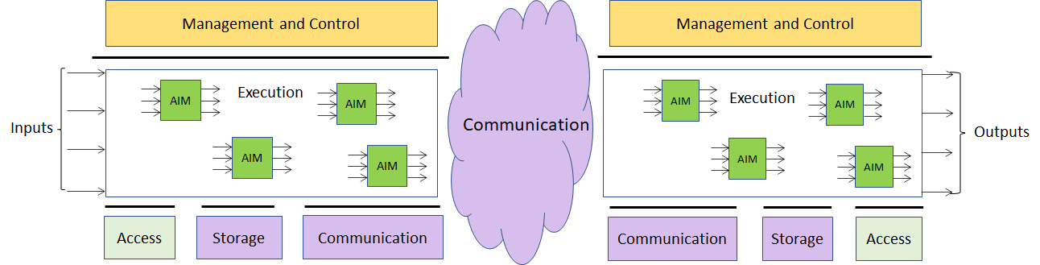

Figure 1 – The MPAI-AIF Architecture
Where
- Management and Control manages and controls the AIMs, so that they execute in the correct order and at the time when they are needed.
- Execution is the environment in which combinations of AIMs operate. It receives external inputs and produces the requested outputs both of which are application specific interfacing with Management and Control and with Communication, Storage and Access.
- AI Modules (AIM) are the basic processing elements receiving processing specific inputs and producing processing specific
- Communication is required in several cases and can be implemented, e.g., by means of a service bus and may be used to connect with remote parts of the framework
- Storage encompasses traditional storage and is used to e.g., store the inputs and outputs of the individual AIMs, data from the AIM’s state and intermediary results, shared data among AIMs.
- Access represents the access to static or slowly changing data that are required by the application such as domain knowledge data, data models, etc.

Use Cases

Data Compression and Understanding

A company may need to access the flow of internal (i.e., financial and governance data) and external data to assess and monitor its financial and organizational performance, as well as the impact of vertical risks (e.g., cyber, seismic, etc.), according to the current regulations (e.g., ISO 31000 on risk assessment and management).

The company generating the data flow may need to perform compression and understanding for its own needs (e.g., to identify core and non-core data). Indeed, the company itself can analyse its financial performance, identifying possible clues to the crisis or risk of bankruptcy years in advance. It may help the board of directors and decision-makers to make the proper decisions to avoid these situations, conduct what-if analysis, and devise efficient strategies.

At the same time, a financial institution that receives a request for financial help from a troubled company, can access its financial and organizational data and make an AI-based assessment of that company, as well as a prediction of future performance. This aids the financial institution to take the right decision in funding or not that company, having a broad vision of its situation.

Functional Requirements

Data Compression and Understanding

Reference architecture
This Use Case can be implemented as in Figure 2.

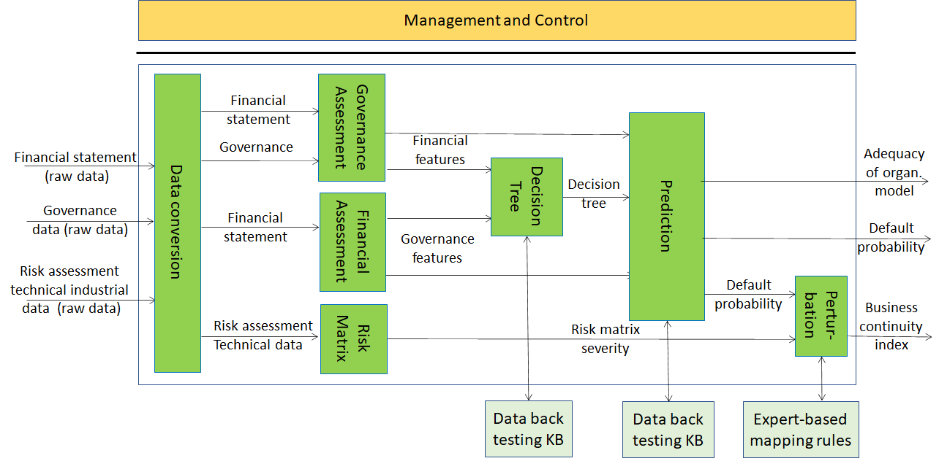

Figure 2 – Compression and understanding of Industrial Data

AI Modules and their I/O data
The AI Modules of Figure 2 perform the functions described in Table 1 – AI Modules .

Table 1 – AI Modules of Industrial Data Compression and Understanding

AIM | Function
Data Conversion (DC) | Gather data needed for the assessment from several sources (internal and external), in different format and covert it in a unique format json.
Financial assessment (FA) | To analyse the data generated by the companies (i.e., financial statements) to assess the preliminary financial performances in the form of indexes. To build and extract the financial features for the machine learner.
Governance assessment (GA) | To build and extract the features related to the adequacy of the governance asset for the machine learner.
Risk matrix (BMR) | To build the risk matrix to assess the impact of vertical risks (i.e., in this use case cyber and seismic).
Decision tree (DT) | To create the decision trees for making decisions according to the Random Forest algorithm.
Prediction (PRF) | To predict values of the likelihood of company default in a time horizon of 36 months and of the adequacy of the organizational model.
Perturbation (PBC) | To perturb the value of the probability of company crisis computed before, considering the impact of vertical risks on company performances

I/O interfaces of AI Modules
The I/O data of Data Compression and Understanding AIMs are given in Table 2 – I/O data of Use Case AIMs.

Table 2 – I/O data of Use Case AIMs

AI Module | Input | Output | External data
Data Conversion (DC) | Financial statement data  Governance data  Risk assessment data | Financial statement data (converted)  Governance data (converted)
Financial assessment (FA) | Financial statement data | Financial features | Standards from knowledgebase
Governance assessment (GA) | Governance data | Governance features
Risk matrix (BMR) | Technical data from BIM, internal assessment on cyber security | Severity | Socio-economic data from data bases  Technical data from KB  Standards from KB
Decision tree (DT) | Financial features, Governance features | Ranking of features importance | Data on active and failed companies from back testing
Prediction (PRF) | Financial features, Governance features | Probability of company crisis  Adequacy of organizational model (indexes) | Data on active and failed companies from back testing
Perturbation (PBC) | Probability of company crisis (index); severity from BMR | Index of business continuity | Expert-based mapping rules

Technologies and Functional Requirements

Financial statement data

The Financial statement (raw data) are produced based on a set of accounting principles driving maintenance and reporting of company accounts, so that financial statements can be consistent, transparent, and comparable across companies.
A first set of principles, identified by International Accounting Standard/International Financial Reporting Standard (IAS/IFRS), can be taken as “universal”, as common recognized across all countries are:
- ...
- ...
- ...
An example of corresponding digital representations is
- ...
- ...
- ...
A second set of principles (Principle B) are typically jurisdiction dependent. In the case of Europe example principles are
- ...
- ...
- ...
Repondents are requested to propose
- A set of Principles A
- The corresponding digital representation
- One or more sets of Principles B where applicable jurisdictions are indentified
- The corresponding digital representation
The Financial statement (raw data) are converted to a standard format by the Data conversion (DC).
Respondent are invited to propose a digital representation of financial statement data that are applicable to a minimum set of financial statements whose semantics of universal and local validity. JSON is a primary example of digital representation. However, other representations are possible.
Proponents are invited to comment on this choice and possibly suggest alternative formats. Preference will be given to formats that have been standardised or are in wide use.

Governance data
By Governance data we mean attributes that indicate the structure of the governance structure of a company and the roles of key personnel.
The most basic roles are shareholder, manager, sole administrator, president/member of the board of directors, auditor, president/member of the statutory board of directors. They can be taken as “universal”, as common recognized across all countries.
Respondent are invited to propose a governance data ontology that captures today’s practice at the global level. How can the data from a specific company be expressed starting from the ontology?

Risk assessment technical data
By Risk assessment technical data, we mean attributes that indicate the internal assessment that the company performs to identify and measure potential or existing vertical risks, and their impact on business continuity.
This data contains values of likelihood, impact, gravity, residual risk and treatments. They should be encoded according to ISO 31000 – “Risk management -- Principles and guidelines”.
Proponents are invited to comment on this choice.
Respondent are invited to propose?

Financial features
Financial features are a set of indexes and ratios computed using financial statement data. Examples of financial features are given by Table 3.

Table 3 – Financial features

Feature | Feature value | Feature type
1 | Absolute value | Revenue/Profit
2 | Index/Percentage (%) | Revenue/Profit
3 | Absolute value | Revenue/Profit
4 | Absolute value | Revenue/Profit
5 | Index/Percentage (%) | Revenue/Profit
6 | Index/Percentage (%) | Cost/Debt
7 | Absolute value | Cost/Debt
8 | Index/Percentage (%) | Cost/Debt
9 | Absolute value | Cost/Debt
10 | Index/Percentage (%) | Cost/Debt
11 | Absolute value | Production
12 | Absolute value | Production
13 | Index/Percentage (%) | Revenue/Profit
14 | Absolute value | Production
15 | Index/Percentage (%) | Cost/Debt

Respondents are requested to propose Financial features suitable for financial assessment, e.g., those reported in Table 3. Financial features shall satisfy the following requirements
- Extracted or computed from the financial statement data
- …
- …

Governance features
Governance features are a set of indexes/ parameters that are used to assess the adequacy of the organizational model. Examples are given by Table 4.

Table 4 – Governance features

Feature | Feature value | Feature type
1 | Absolute value | Decision maker data
2 | Index/Percentage (%) | Shareholder data
3 | Absolute value | Shareholder data
4 | Absolute value | Decision maker data
5 | Absolute value | Decision maker data

Respondents are requested to propose Governance features suitable for assessing the suitability of governance, e.g., those reported in Table 4. Governance features shall satisfy the following requirements
1. Extracted or computed from the Governance data
2. Numerical values
3. …

Severity
A set of values, each of them reflects the level of risk for that specific vertical risk evaluated by the company.
Respondents are requested to propose…

Decision Tree
It is a decision support tool that uses a tree-like model of decision, given the financial and governance features. It is based on the Random forest supervised learning method to predicts the value of the probability of company crisis and bankruptcy.
Respondent are requested to propose other learning methods satisfying the following requirements:
- …
- …

Expert-based mapping rules KB query
Expert-based mapping rules KB contains a set of rules established by experts in the field that express the vertical risk-financial feature assignment, i.e., an expression of the impact of a certain vertical risks on the financial performance of a company.
Respondent are requested to propose:
- According to the new financial features proposed, the list of risks that potentially affect these features.
- A digital representation of these mapping rules.

References
[1] Perboli G., Arabnezhad E., A Machine Learning-based DSS for Mid and Long-Term Company Crisis Prediction. CIRRELT-2020-29. July 2020.

Terminology
Term | Definition
Access
AI Module

