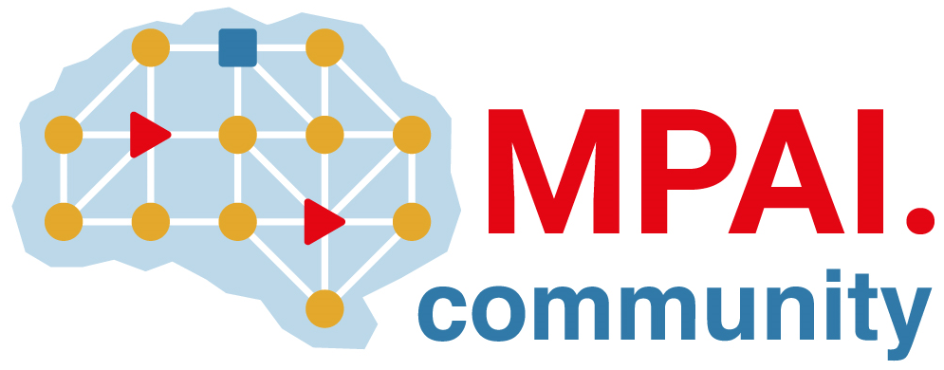 | Moving Picture, Audio and Data Coding  by Artificial Intelligence  www.mpai.community

Draft Public Document
N144 | 2021/02/17
Source | MPAI General Assembly #5 (MPAI-5)
Title | Press Release of MPAI-5
Target | MPAI Members

MPAI receives technologies for its AI framework standard and calls for technologies supporting audio and human-machine conversation

Geneva, Switzerland – 17 february 2021. At its 5th General Assembly, Moving Picture, Audio and Data Coding by Artificial Intelligence (MPAI), an international, unaffiliated standards association
- Has kicked off work on its AI Framework (MPAI-AIF) standard after receiving substantial proposed technologies.
- Is calling for technologies to develop two standards related to audio (MPAI-CAE) and multimodal conversation (MPAI-MMC).
- Will soon be developing the Framework Licence for the next maturing project “Compression and Understanding of Industrial Data” (MPAI-CUI).

MPAI has reviewed responses to the call issued 2 months ago for technologies supporting its AI Framework (MPAI-AIF) standard. The goal is to enable creation and automation of mixed Machine Learning (ML) - Artificial Intelligence (AI) - Data Processing (DP) and inference workflows, implemented as software, hardware or mixed software and hardware. MPAI-AIF will offer extended explainability to applications conforming to MPAI standards. The submissions received are enabling MPAI to develop the intended standard whose publication is planned for July 2021.

MPAI has issued two Calls for Technologies supporting two new standards:

- The Context-based Audio Enhancement (MPAI-CAE) standard will improve the user experience for several audio-related applications in a variety of contexts such as in the home, in the car, on-the-go, in the studio etc. Examples of use are adding a desired emotion to a speech without emotion, preserving old audio tapes, improving the audioconference experience and removing unwanted sounds while keeping the relevant ones to a user walking in the street.

- The Multimodal Conversation (MPAI-MMC) standard will enable a human-machine conversation that emulates human-human conversation in completeness and intensity by using AI. Examples of use are an audio-visual conversation with a machine where the machine is impersonated by a synthesised voice and an animated face, a request for information about an object while displaying it, a human question to a machine translated using a voice preserving the speech features of the human.

The content of the two Calls for Technologies will be introduced at two online conferences. Attendance is open to interested parties.

MPAI has developed the functional requirements for the Compression and Understanding of Industrial Data (MPAI-CUI) and, by decision of the General Assembly, MPAI Active Members may now develop the Framework Licence to facilitate the actual licences – to be developed outside of MPAI. The standard will be used to assess the risks faced by a company by using information from the flow of data produced.

The MPAI web site provides information about other AI-based standards being developed: AI-Enhanced Video Coding (MPAI-EVC) will improve the performance of existing video codecs, Integrative Genomic/Sensor Analysis (MPAI-GSA) will compress and understand the results of combining genomic experiments with those produced by related devices/sensors, and Server-based Predictive Multiplayer Gaming (MPAI-SPG) will improve the user experience of online multiplayer game players.

MPAI develops data coding standards for applications that have AI as the core enabling technology. Any legal entity who supports the MPAI mission may join MPAI if it is able to contribute to the development of standards for the efficient use of data.
Visit the MPAI web site and contact the MPAI secretariat for specific information.

