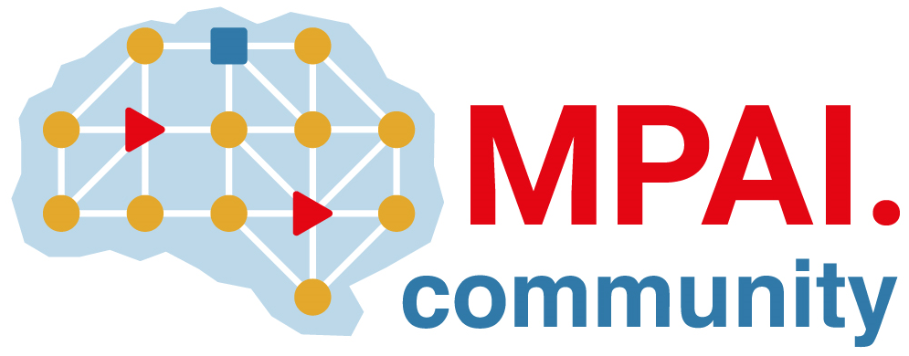 | Moving Picture, Audio and Data Coding by Artificial Intelligence  www.mpai.community

N125 | 2020/12/16
Source | General Assembly (MPAI-4)
Title | MPAI Timeline
Target | MPAI Members

NB1 | Dates in italic indicate estimated dates
NB2 | The UC-FR date refers to the date the GA promotes an area to Functional Requirements stage, etc.
NB3 | .. in a date indicate that only the month is estimated

Acron. | Title | UC-FR | FR-CR | CR-CT | CT-SD | CT-MS
MPAI-AIF | AI Framework | 20/10/21 | 20/11/18 | 20/12/16 | 21/02/17 | 21/07..
MPAI-CAE | Context-based Audio Enhancement | 20/10/21 | 20/12/16 | 21/02/17 | 21/04/14 | 21/09/...
MPAI-MMC | Multi-Modal Conversation | 20/10/21 | 20/12/16 | 21/02/17 | 21/04/14 | 21/09/...
MPAI-CUI | Compression and Understanding of Industrial Data | 20/11/18 | 21/02/17 | 21/03/17 | 21/05/12 | 21/10/...
MPAI-GSA | Integrative AI-based Analysis of Genomic/ Sensor Experiments | 20/10/21 | 21/03/17 | 21/04/14 | 21/06/09
MPAI-SPG | Server-based Predictive Multiplayer Gaming | 20/10/21 | 21/03/17 | 21/04/14 | 21/06/09
MPAI-EVC | AI-Enhanced Video Coding | 20/10/21

