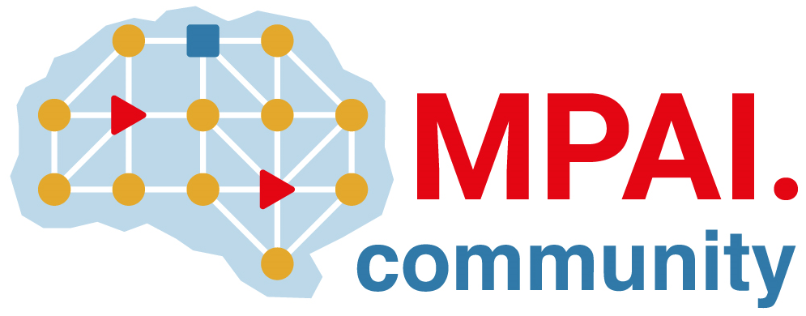 | Moving Picture, Audio and Data Coding by Artificial Intelligence  www.mpai.community

Public document
N173 | 2021/02/15
Source | IPR-SAC
Title | New MPAI-MMC Framework License
Target | MPAI Members

Coverage
The MPAI Multimodal Conversation (MPAI-MMC) standard as will be defined in document Nxyz of Moving Picture, Audio and Data Coding by Artificial Intelligence (MPAI).
MPAI-MMC specifies the input and output interface of AIMs defined for 3 use cases in N153 that satisfy the requirements in N153.

Definitions
Term | Definition
Data | Any digital representation of a real or computer-generated entity, such as moving pictures, audio, point cloud, computer graphics, sensor and actuator. Data includes, but is not restricted to, media, manufacturing, automotive, health and generic data.
Development Rights | License to use MPAI-MMC Essential IPRs to develop Implementations
Enterprise | Any commercial entity that develops or implements the MPAI-MMC standard
Essential IPR | Any Proprietary Rights, (such as patents) without which it is not possible on technical (but not commercial) grounds, to make, sell, lease, otherwise dispose of, repair, use or operate Implementations without infringing those Proprietary Rights
Framework License | A document, developed in compliance with the generally accepted principles of competition law, which contains the conditions of use of the License without the values, e.g., currency, percent, dates etc.
Implementation | A hardware and/or software reification of the MPAI-MMC standard serving the needs of a professional or consumer user directly or through a service
Implementation Rights | License to reify the MPAI-MMC standard
License | This Framework License to which values, e.g., currency, percent, dates etc., related to a specific Intellectual Property will be added. In this Framework License, the word License will be used as singular. However, multiple Licenses from different IPR holders may be issued
Profile | A particular subset of the technologies that are used in MPAI-MMC standard and, where applicable, the classes, subsets, options and parameters relevant to the subset

Conditions of use of the License
- The License will be in compliance with generally accepted principles of competition law and the MPAI Statutes
- The License will cover all of Licensor’s claims to Essential IPR practiced by a Licensee of the MPAI-MMC standard.
- The License will cover Development Rights and Implementation Rights
- The License for Development and Implementation Rights, to the extent it is developed and implemented only for the purpose of evaluation or demo solutions or for technical trials, will be free of charge
- The License will apply to a baseline MPAI-MMC profile and to other profiles containing additional technologies
- Access to Essential IPRs of the MPAI-MMC standard will be granted in a non-discriminatory fashion.
- The scope of the License will be subject to legal, bias, ethical and moral limitations
- Royalties will apply to Implementations that are based on the MPAI-MMC standard
- Royalties will apply on a worldwide basis
- Royalties will apply to any Implementation, with the exclusion of the type of implementations specified in clause 4
- An MPAI-MMC Implementation may use other IPR to extend the MPAI-MMC Implementation or to provide additional functionalities
- The License may be granted free of charge for particular uses if so decided by the licensors
- A license free of charge for limited time and a limited amount of forfeited royalties will be granted on request
- A preference will be expressed on the entity that should administer the patent pool of holders of Patents Essential to the MPAI-MMC standard
- The total cost of the Licenses issued by IPR holders will be in line with the total cost of the Licenses for similar technologies standardised in the context of Standard Development Organisations
- The total cost of the Licenses will take into account the value on the market of the AI Framework technology Standardised by MPAI.

