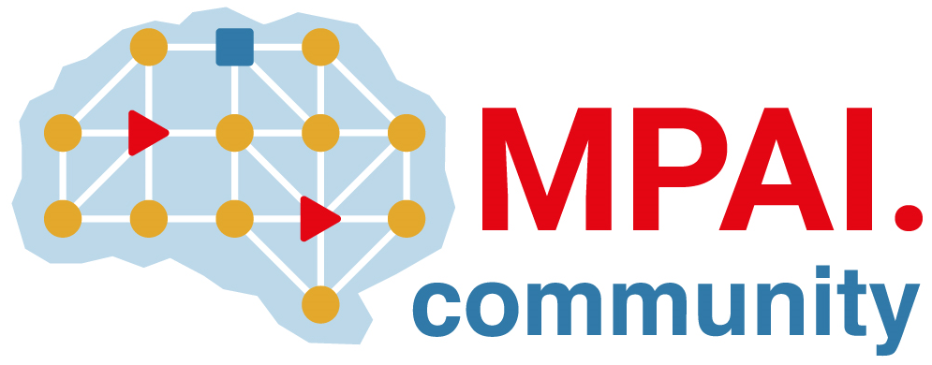 | Moving Picture, Audio and Data Coding  by Artificial Intelligence  www.mpai.community

Public document
N180 | 2021/03/17
Source | MPAI General Assembly #6 (MPAI-6)
Title | Press Release of MPAI-6
Target | MPAI Members

MPAI tackles AI-based risk analysis standard in a new Call for Technologies

Geneva, Switzerland – 17 March 2021. At its 6th General Assembly, the international, unaffiliated Moving Picture, Audio and Data Coding by Artificial Intelligence (MPAI) standards association has promoted its 4th standard project Compression and understanding of industrial data (MPAI-CUI) to the Call for Technologies stage. The standard aims to enable Artificial Intelligence (AI)-based filtering and extraction of information from a company’s governance, financial and risk data enabling prediction of company performance, e.g., organisational adequacy or default probability.

All parties, including non-MPAI members, who believe they have relevant technologies satisfying all or most of the MPAI-CUI Functional Requirements are invited to submit proposals for consideration by MPAI. The MPAI-CUI Call for Technologies requests that technologies proposed, if accepted for inclusion in the standard, be released according to the MPAI-CUI Framework Licence to facilitate eventual definition of the final licence by patent holders.

The content of the Call for Technologies will be introduced at two online conferences. Interested parties are welcome to attend.

MPAI is continuing the development of its AI Framework standard, nicknamed MPAI-AIF. The goal of the standard is to enable creation and automation of mixed Machine Learning (ML) - Artificial Intelligence (AI) - Data Processing (DP) and inference workflows, implemented as software, hardware, or mixed software and hardware. A major MPAI-AIF feature is to offer enhanced explainability to applications conforming to MPAI standards. MPAI retains its intention to release the standard in July 2021.

At its previous General Assembly (MPAI-5), MPAI has issued two Calls for Technologies supporting two new standards:

- Context-based Audio Enhancement (MPAI-CAE) covering four instances: adding a desired emotion to a speech without emotion, preserving old audio tapes, improving the audioconference experience and removing unwanted sounds while keeping the relevant ones to a user walking in the street.

- The Multimodal Conversation (MPAI-MMC) covering three instances: an audio-visual conversation with a machine impersonated by a synthesised voice and an animated face, a request for information about an object while displaying it, a human sentence translated using a synthetic voice that preserves the human speech features.

The MPAI web site provides information about the other AI-based standards being developed: AI-Enhanced Video Coding (MPAI-EVC) will improve the performance of existing video codecs, Integrative Genomic/ Sensor Analysis (MPAI-GSA) will compress and understand the results of combining genomic experiments with those produced by related devices/sensors, and Server-based Predictive Multiplayer Gaming (MPAI-SPG) will improve the user experience of online multiplayer games.

MPAI develops data coding standards for applications that have AI as the core enabling technology. Any legal entity who supports the MPAI mission may join MPAI if it is able to contribute to the development of standards for the efficient use of data.
Visit the MPAI web site and contact the MPAI secretariat for specific information.

