Moving Picture, Audio and Data Coding by Artificial Intelligence
www.mpai.community

N193 | 2021/03/17
Source | Events and Data
Title | MPAI-SPG Use Cases and Functional Requirements
Target | MPAI Members

Introduction
Moving Picture, Audio and Data Coding by Artificial Intelligence (MPAI) is an international association with the mission to develop AI-enabled data coding standards. Research has shown that data coding with AI-based technologies is more efficient than with existing technologies.
The MPAI approach at developing AI data coding standards is based on the definition of AI Modules (AIM) with standard interfaces. AIMs operate on input data and produce output data, both having a standard format. AIMs can be combined and executed in an MPAI-specified AI-Framework. A Call for MPAI-AIF Technologies [2] with associated Use Cases and Functional Requirements [1] was issued on 2020/12/16 and is now closed. The MPAI-AIF standard is currently being developed.
By exposing standard interfaces, AIMs are able to operate in an MPAI AI Framework. However, their performance may differ depending on the technologies used to implement them. Therefore, MPAI believes that competing developers striving to provide more performing proprietary still interoperable AIMs will naturally create horizontal markets of AI solutions that build on and further promote AI innovation.
This document contains a Use Case and the corresponding Functional Requirements for the MPAI Server-based Predictive Multiplayer Gaming (MPAI-SPG) application area. The purpose of this Use Case is to minimise the audio-visual and gameplay discontinuities caused by high latency or packet losses during an online real-time game.
The current Use Case will be the target of Calls for Technologies. In the future MPAI may extend this Use Case of develop new ones falling in the scope of MPAI-SPG.
This document is structured in 7 chapters, including this Introduction.

Chapter 2 | briefly introduces the AI Framework Reference Model and its six Components.
Chapter 3 | introduces the Use Case.
Chapter 4 | presents the Use Case with the following structure:  - Reference architecture  - AI Modules  - I/O data of AI Modules  - Technologies and Functional Requirements
Chapter 5 | gives relevant references
Chapter 6 | gives a basic list of relevant terms and their definition

For the reader’s convenience, Table 1 introduces the meaning of the acronyms used in this document.
Table 1 – MPAI-SPG acronyms

Acronym | Meaning
AI | Artificial Intelligence
AIF | AI Framework
AIM | AI Module
BE | Behaviour engine
CD | Control data
CfT | Call for Technologies
DP | Data Processing
GM | Game message
GS | Game state
GSE | Game state engine
ML | Machine Learning
PE | Physics engine
RE | Rules engine

The MPAI AI Framework (MPAI-AIF)
Most MPAI applications considered so far can be implemented as a set of AIMs – AI, ML and even traditional DP-based units – with standard interfaces assembled in suitable topologies to achieve the specific goal of an application and executed in the MPAI-defined AI Framework. MPAI is making all efforts to identify processing modules that are re-usable and upgradable without necessarily changing the inside logic. MPAI plans on completing the development of a 1st generation MPAI-AIF AI Framework in July 2021.
The MPAI-AIF Architecture is given by Figure 1.

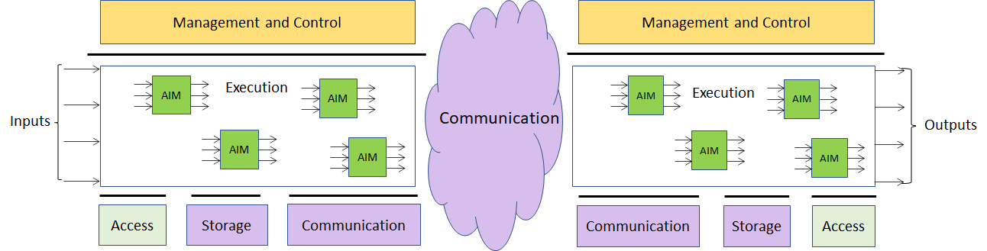

Figure 1 – The MPAI-AIF Architecture

MPAI-AIF is made up of 6 Components:
- Management and Control manages and controls the AIMs, so that they execute in the correct order and at the time when they are needed.
- Execution is the environment in which combinations of AIMs operate. It receives external inputs and produces the requested outputs, both of which are Use Case specific, activates the AIMs, exposes interfaces with Management and Control and interfaces with Communication, Storage and Access.
- AI Modules (AIM) are the basic processing elements receiving processing specific inputs and producing processing specific outputs.
- Communication is the basic infrastructure used to connect possibly remote Components and AIMs. It can be implemented, e.g., by means of a service bus.
- Storage encompasses traditional storage and is used to e.g., store the inputs and outputs of the individual AIMs, intermediary results data from the AIM states and data shared by AIMs.
- Access represents the access to static or slowly changing data that are required by the application such as domain knowledge data, data models, etc.

Use Case
A proper explanation of this Use Case requires an identification of the main components involved. This will be done following the evolution of gaming from offline to online to cloud gaming.

Offline gaming
At high level, an off-line game machine performs three steps:
- Receives inputs from the I/O devices.
- Processes the inputs.
- Produces a sequence of video frames.
A model of an off-line gaming is represented in Figure 2.

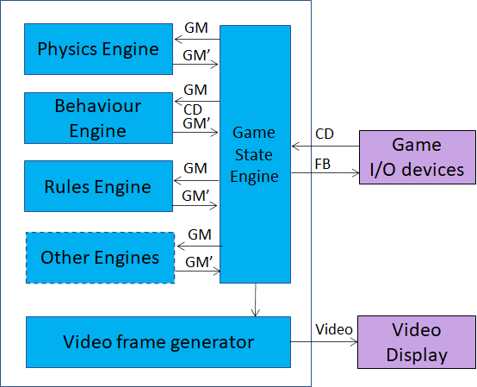
Figure 2 – Architecture of an off-line game machine

The following describes the off-line game machine operation based on Figure 2:
- The game I/O devices send Controller Data (CD) to the Game State Engine (GSE), a process managing the Game State (GS) of the game machine playing a game.
- The Game State Engine
  - Computes the Game Messages (GM) based on the Controller Data received.
  - Sends Controller Data and/or Game Messages (depending on the type of Game Engine) to the Game Engines:
  - The Physics Engine (PE) which computes ...
  - The Behaviour Engine (BE) which computes ...
  - The Rules Engine (RE) which computes ...
  - Other Engine(s), if present.
- The Game Engines send their processed Game Messages (GM’) to the Game State Engine.
- The Game State Engine
  - Creates the Game State, a data structure containing all Game Messages. describe a GM.
  - Sends:
    - Information (what type?) to the Video frame generator.
    - Feedback (FB), e.g. haptic, to game I/O devices.
- The Video frame generator produces and renders a video frame

Online Gaming
In an online gaming, some of the functions carried out by an offline game machine are split between client and server.

Single player online gaming
The game operation becomes (see Figure 3):
- The Client:
  - Receives the Control Data from the game I/O devices.
  - Sends the Control Data to the server.
- The server:
  - Computes the Game Messages?
  - Sends Controller Data and/or Game Messages to the Game Engines.
- The Game Engines:
  - Update the Game Messages (GM’).
  - Send GM’ to the Game State Engine
- The Game State Engine
  - Creates the Game State
  - Sends the Game State to the Client.
- The Client creates and displays a new video frame

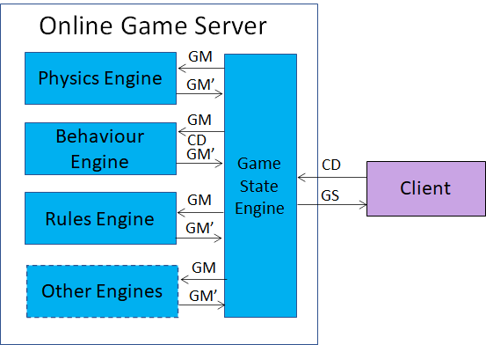
Figure 3 – Online gaming model (single player)

Multiplayer online gaming
The game operation becomes (see Figure 4):
- The Clients send Control Data to Server
- The Game State Engine:
  - Computes the Game Messages using the Control Data (CD) from the Clients.
  - Sends the Control Data and/or the Game Messages to the Game Engines (GM).
- The Game Engines:
  - Compute updated Game Messages (GM’).
  - Send the updated Game Messages to the Game State Engine.
- The Game State Engine:
  - Computes the updated Game State.
  - Sends the new Game State to all clients.
- The Clients produce and display their video frames.

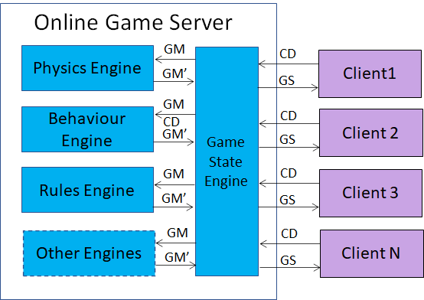
Figure 4 – Multiplayer online gaming model

Cloud gaming
In cloud gaming, the original functions of the offline Client are further split among the Thin Client, the Virtual Client and the Server.
Therefore, the operation of cloud gaming becomes (see Figure 5):
- The Thin Clients send Control Data to their Virtual Clients.
- The Virtual Clients send Control Data to the Server.
- The Game State Engine:
  - Computes the Game Messages
  - Sends Control Data and/or Game Messages to the appropriate Game Engines.
- The Game Engines:
  - Process the Game Messages.
  - Send the updated Game Messages to the Game State Engine.
- The Game State Engine:
  - Creates the Game State.
  - Sends the Game State to the Virtual Clients.
- The Virtual Clients
  - Process the new Game State.
  - Create and compress the video frames
  - Send the video frames to their Thin Clients.
- The Thin Clients display video.

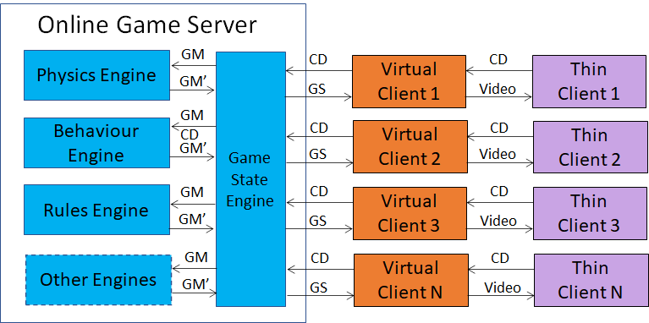
Figure 5 – Cloud gaming

The purposes of MPAI-SPG
MPAI-SPG is designed to serve two purposes:
- Mitigation of the effects of the failed reception by the server of Control Data from some (Thin) Clients caused by network disruption. The is unable to compute and communicate the Game Messages to the (Thing) Clients. This disrupts the user experience, sometimes seriously. AI can provide more effective ways to estimate the missing information.
- Detection of false data sent by some (Thin) Clients (anticheating). AI can also be used to detect attempts by some clients to alter the Control Data of their I/O devices to gain an unfair advantage.

Functional Requirements

Introduction
The Functional Requirements developed here adhere to the following guidelines:
- AIMs are defined to allow implementations by multiple technologies (AI, ML, DP)
- AI-based AIM will typically require a learning process, however, support for this process is not included in this document. MPAI may develop further requirements covering that process in a future extension of the document.
- AIMs can be aggregated in larger AIMs. Some data flows of aggregated AIMs may not necessarily be exposed any longer.

Reference architecture
Figure 7 depicts the MPAI-SPG solution. The figure is applicable to cloud gaming and also to online gaming, if the Thin Clients and the Virtual Clients into Clients. In the following “Client” will be used to indicate both cases.
The first case considered is Anti-cheating.
The Control Data enter the Game State Engine-AI. This has been trained with data that take into account both the values of Control Data at a given time t_{n} and the values at time t_{n-1}. Game State Engine-AI produces GM*. The GM* and the Control Data feed the Game Engines AI’s which have been trained with data that take into account both the values of the Game Messages at a given time t_{n} and the values at time t_{n-1}. The Game State Engine-AI’s produce estimates of the Game Messages (GMp). The green Game State Engine is functionally equivalent to the blue Game State Engine and computes the predicted Game State GSp which is passed to the Game State Engine. If some of the GMp’s are too different than the corresponding GM’, the Game State Engine can take action.
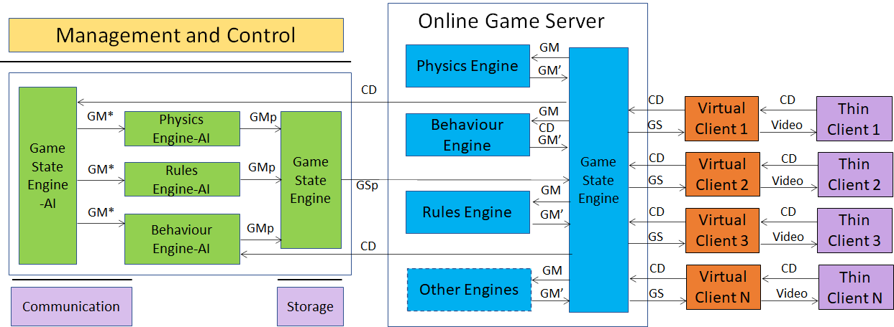
Figure 6 – The MPAI-SPG enhanced cloud gaming setting

Figure 7 is the reference model of MPAI-SPG.

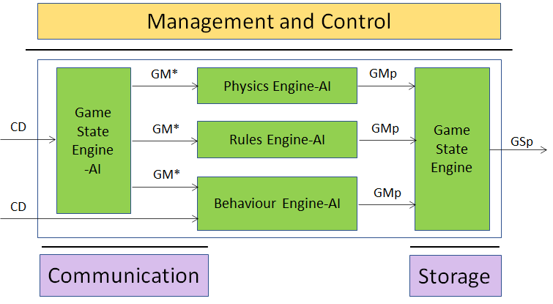
Figure 7 – The MPAI-SPG reference model

AI Modules
The AI Modules perform the functions described in Table 1.

Table 2 – AI Modules

AIM | Function
Game State Engine-AI | Produced preditced GM’
Physics Engine-AI | Produces predicted GMp
Behaviour Engine-AI | Produces predicted GMp
Rules Engine-AI | Produces predicted GMp

I/O interfaces of AI Modules
The I/O data are given in Table 3.

Table 3 – I/O data of Emotion-Enhanced Speech AIMs

AIM | Input Data | Output Data
Game State Engine-AI | CD | GM’
Physics Engine-AI | GM’ | GMp
Behaviour Engine-AI | GM’ | GMp
Rules Engine-AI | CD, GM’ | GMp

Technologies and Functional Requirements

Controller Data (CD)
For each digital input specify | controllerID, inputID, 1/0, clientID, playerID
For each analogue input specify | controllerID, inputID, value, clientID, playerID
For each motion input specify | controllerID, inputID, valuesArray [], clientID, playerID

The game device the has data coming in. However, these are not subject of standardisation.

Game Messages (GM)
There are two types of game messages.
gamemessage (timestamp, methodName, SourceID, DestinationID, typeOfCommunication, param1, param2, ..., paramK)

GameState (GS)
GameState (timestamp, gameMessage1, gameMessage2, ..., gameMessageK)

Terminology
Table 4 identifies and defines the terms used in the MPAI-CAE context.

Table 4 – MPAI-CAE terms

Term | Acron. | Definition
Access |  | Static or slowly changing data that are required by an application such as domain knowledge data, data models, etc.
AI Framework | AIF | The framework where AIM-based workflows are executed
AI Module | AIM | The basic processing element receiving AIM-specific inputs and producing AIM-specific outputs
Application area |  | A collection of homogeneous Use Cases
Controller Data | CD | Data generated by Game I/O devices
Data Processing | DP | A legacy technology that may be used to implement AIMs
Execution |  | The environment in which AIM workflows are executed. It receives external inputs and produces the requested outputs both of which are Use Case specific
Game Message | GM
Game State | GS | A data structure containing all Game Messages at a given instant.
Game State Engine | GSE | A process managing the Game State of the game machine playing a game.
Management and Control |  | Manages and controls the AIMs in the AIF, so that they execute in the correct order and at the time when they are needed
Storage |  | Data repository used to, e.g., store the inputs and outputs of the individual AIMs, data from the AIM’s state and intermediary results, and shared data among AIMs
Use Case | UC | A description of an application that is served by an appropriate combination of AIMs executed in AIF

References
- MPAI-AIF Use Cases and Functional Requirements, N74; https://mpai.community/standards/mpai-aif/#Requirements
- MPAI-AIF Call for Technologies, N100; https://mpai.community/standards/mpai-aif/#Technologies

