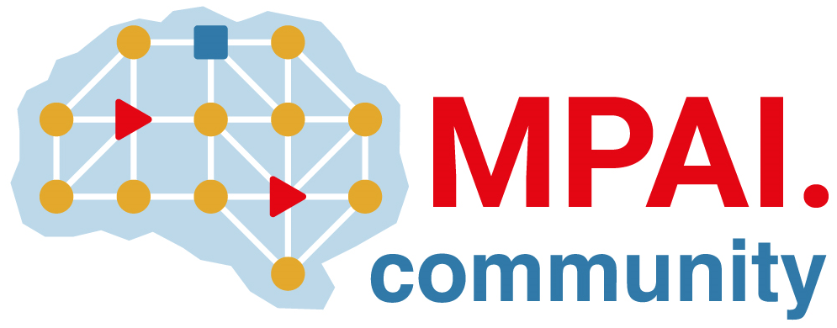 | Moving Picture, Audio and Data Coding by Artificial Intelligence  www.mpai.community

Public Document
N199 | 2021/03/17
Source | MMC-DC
Title | Some issues related to MPAI-MMC Functional Requirements
Target | MPAI Members

MPAI-5 has approved the MPAI-MMC Use Cases and Functional Requirements as attachment to the Call for Technologies N173. However, MMC-DC has identified some issues that are worth a clarification. This is posted on the MPAI web site and will be communicated to those who have informed the Secretariata of their intention to respond.

General issue
MPAI understands that the scope of both N151 and N153 is very broad. Therefore it reiterates the point made in N152 and N154 that:
Completeness of a proposal for a Use Case is a merit because reviewers can assess that the components are integrated. However, submissions will be judged for the merit of what is proposed. A submission on a single technology that is excellent may be considered instead of a submission that is complete but has a less performing technology.

Multimodal Question Answering (Use case #2 in N153)
MPAI welcomes submission that propose a standard set of “type of question intentions” and the means to indicate the language used in the Query Format.
MPAI welcomes proposals that propose a concept format for Reply in addition to or instead of a text format.
The assessment of submissions by Respondents who elect to not consider this point in their submission will not influence the assessment of the rest of their submission

References
- MPAI-MMC Use Cases & Functional Requirements; MPAI N153; https://mpai.community/standards/mpai-mmc/#UCFR
- MPAI-MMC Call for Technologies, MPAI N154; https://mpai.community/standards/mpai-mmc/#Technologies
- MPAI-MMC Framework Licence, N173; https://mpai.community/standards/mpai-mmc/#Licence

