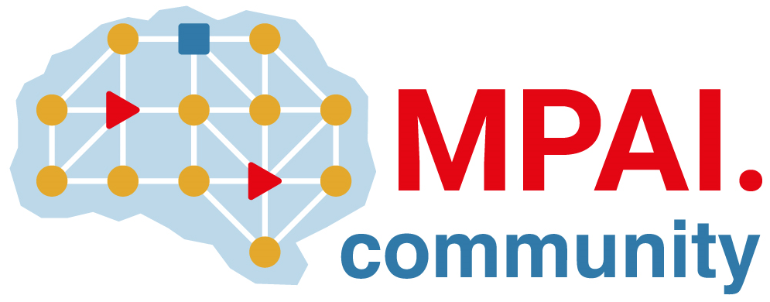 | Moving Picture, Audio and Data Coding  by Artificial Intelligence  www.mpai.community

Public document
N207 | 2021/04/14
Source | MPAI General Assembly #7 (MPAI-7)
Title | Press Release of MPAI-7
Target | MPAI Members

MPAI consolidates the development of three AI-based data coding standards

Geneva, Switzerland – 14 April 2021. At its 7th General Assembly, the international, unaffiliated Moving Picture, Audio and Data Coding by Artificial Intelligence (MPAI) standards association has received substantial proposals in response to its two Calls for Technologies on Enhanced Audio and Multimodal Conversation that closed on the 12th of April. Meanwhile the development of its foundational AI Framework standard is steadily progressing targeting July 2021 for delivery of the standard.

The goal of the the AI Framework standard, nicknamed MPAI-AIF, is to enable creation and automation of mixed Machine Learning (ML) - Artificial Intelligence (AI) - Data Processing (DP) - inference workflows, implemented as software, hardware, or mixed software and hardware. A major MPAI-AIF feature is enhanced explainability to applications conforming to MPAI standards.

Work on the two new Context-based Audio Enhancement (MPAI-CAE) and Multimodal Conversation (MPAI-MMC) standards has started after receiving substantial technologies in response to the Calls for Technologies. MPAI-CAE covers four instances: adding a desired emotion to a speech without emotion, preserving old audio tapes, improving the audioconference experience and removing unwanted sounds while keeping the relevant ones to a user walking in the street. MPAI-MMC covers three instances: audio-visual conversation with a machine impersonated by a synthesised voice and an animated face, request for information about a displayed object, translation of a sentence using a synthetic voice that preserves the speech features of the human.

Work on a fourth standard is scheduled to start at the next General Assembly (12th of May) after receiving responses – both from MPAI and non-MPAI members – to the currently open MPAI-CUI Call for Technologies. The standard will enable prediction of performance, e.g., organisational adequacy or default probability, using Artificial Intelligence (AI)-based filtering and extraction of information from a company’s governance, financial and risk data.

The MPAI web site provides information about other AI-based standards being developed: AI-Enhanced Video Coding (MPAI-EVC) that improves the performance of existing video codecs, Server-based Predictive Multiplayer Gaming (MPAI-SPG) that compensates the loss of data in online multiplayer gaming and Integrative Genomic/Sensor Analysis (MPAI-GSA) that compresses and understands data from combined genomic and other experiments produced by related devices/sensors.

MPAI develops data coding standards for applications that have AI as the core enabling technology. Any legal entity who supports the MPAI mission may join MPAI if it is able to contribute to the development of standards for the efficient use of data.
Visit the MPAI web site and contact the MPAI secretariat for specific information.

