Moving Picture, Audio and Data Coding by Artificial Intelligence
www.mpai.community

N213 | 2021/04/14
Source | General Assembly #7 (MPAI-7)
Title | MPAI-CUI Table of Content
Target | MPAI Members

Contents
1 Introduction 1
2 Scope of standard 1
3 Terms and definitions 1
4 Normative references 2
5 Use Case Architecture 2
5.1 AI-based Performance Prediction 2
6 AI modules 3
6.1 AI-based Performance Prediction 3
6.1.1 Governance data (raw) 4
6.1.2 Financial statement data (raw) 4
6.1.3 Risk assessment technical data (raw) 4
6.1.4 Governance 4
6.1.5 Financial statement 4
6.1.6 Risk assessment technical data 4
6.1.7 Financial features 4
6.1.8 Severity 4
6.1.9 Decision Tree 4
6.1.10 Default probability 5
6.1.11 Business continuity index 5
7 References 5

Introduction

Scope of standard

Terms and definitions
Table 6 – MPAI-CUI terms

Term |  | Definition
Access |  | Static or slowly changing data that are required by an application such as domain knowledge data, data models, etc.
AI Framework | AIF | The environment where AIM-based workflows are executed.
AI Module | AIM | The basic processing elements receiving processing specific inputs and producing processing specific outputs.
Communication |  | The infrastructure that connects the Components of an AIF.
Data Processing | DP | A legacy technology that may be used to implement AIMs.
Decision Tree |  | A decision support tool that uses a tree-like model of decision, given the financial and governance features.
Delivery |  | An AIM that wraps data for transport.
Execution |  | The environment in which AIM workflows are executed. It receives external inputs and produces the requested outputs both of which are application specific.
Financial features |  | A set of indexes and ratios computed using financial statement data.
Financial statement |  | Data produced based on a set of accounting principles driving maintenance and reporting of company accounts, so that financial statements can be consistent, transparent, and comparable across companies.
Governance features |  | A set of indexes/parameters that are used to assess the adequacy of the organizational model.
Knowledge Base |  | Structured and unstructured information made accessible to AIM (especially DP-based).
Management and Control |  | Manages and controls the AIMs in the AIF, so that they execute in the correct order and at the time when they are needed.
Risk assessment |  | Attributes that indicate the internal assessment that the company performs to identify and measure potential or existing vertical risks, and their impact on business continuity.
Severity |  | A set of values, each reflecting the level of risk for that specific vertical risk as evaluated by the company.
Storage |  | Storage used to e.g., store the inputs and outputs of the individual AIMs, data from the AIM’s state and intermediary results, shared data among AIMs.

Normative references

- International Financial Reporting Standard. List of IFRS Standards. Available online: https://www.ifrs.org/issued-standards/list-of-standards/
- International Organization for Standardization. ISO 37000 Guidance for the Governance of Organizations. Available online: https://committee.iso.org/sites/tc309/home/projects/ongoing/ongoing-1.html
- International Organization for Standardization. ISO 31000 Risk Management. Available online: https://www.iso.org/files/live/sites/isoorg/files/store/en/PUB100426.pdf
- International Organization for Standardization. ISO 27005 Information technology -- Security techniques -- Information security risk management

Use Case Architecture

AI-based Performance Prediction
A company may need to access the flow of internal (i.e., financial and governance data) and external data related to the activity of the company to assess and monitor its financial and organizational performance, as well as the impact of vertical risks (e.g., cyber, seismic, etc.), according to the current standards (e.g., ISO 31000 on risk assessment and management). The current version of MPAI-CUI takes into account only cyber and seismic risks that have an impact on financial performance. Other risks will be considered in future versions of the standard.
MPAI-CUI may be used by:
- The company generating the data flow to perform compression and understanding of the data for its own needs (e.g., to identify core and non-core data), to analyse its financial performance, identifying possible clues to a crisis or risk of bankruptcy years in advance. It may help the board of directors and decision-makers to make the proper decisions to avoid these situations, conduct what-if analysis, and devise efficient strategies.
- A financial institution that receives a request for financial help from a troubled company to access its financial and organizational data and make an AI-based assessment of that company, as well as a prediction of future performance. By having a better insight of its situation, a financial institution can make the right decision in funding or not a company.
This Use Case can be implemented as in Figure 2.

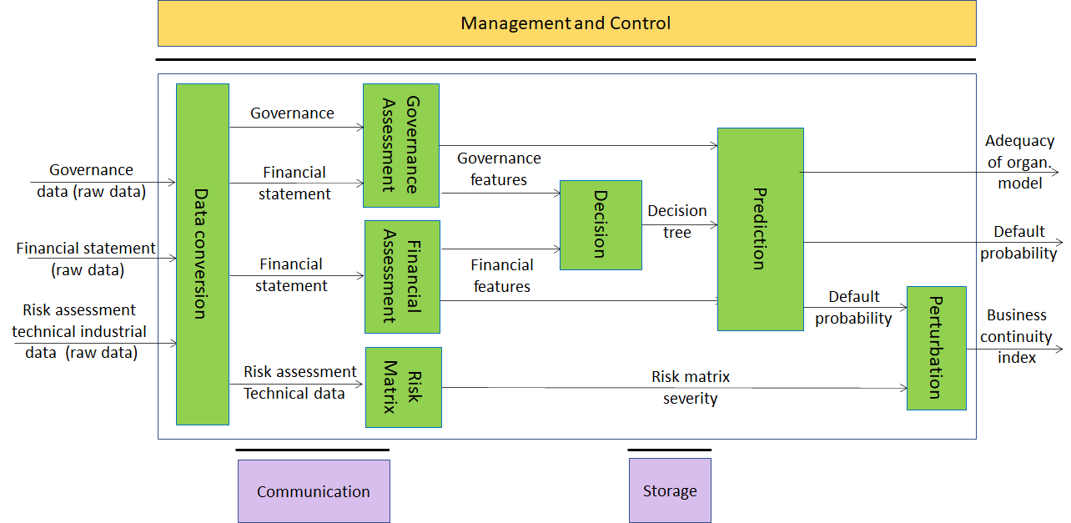

Figure 2 – Compression and understanding of Industrial Data

The AI Modules of Figure 2 perform the functions described in Table 2.

Table 2 – AI Modules of Industrial Data Compression and Understanding

AIM | Function
Data Conversion | Gathers data needed for the assessment from several sources (internal and external), in different formats and coverts it to a unique format (e.g., json).
Financial assessment | Analyses the data generated by a company (i.e., financial statements) to assess the preliminary financial performances in the form of indexes.  Builds and extracts the financial features for the Decision tree and Prediction AIMs.
Governance assessment | Builds and extracts the features related to the adequacy of the governance asset for the Decision tree and Prediction AIMs.
Risk matrix | Builds the risk matrix to assess the impact of vertical risks (i.e., in this Use Case cyber and seismic).
Decision | Creates the decision trees for making decisions.
Prediction | Predicts values of the probability of company default in a time horizon of 36 months and of the adequacy of the organizational model.
Perturbation | Perturbs the probability value of company crisis computed by Prediction, considering the impact of vertical risks on company performance.

AI modules

AI-based Performance Prediction
The I/O data of Data Compression and Understanding AIMs are given in Table 3.

Table 3 – I/O data of Use Case AIMs

AI Module | Input | Output
Data Conversion | Financial statement data  Governance data  Risk assessment data | Financial statement data (converted)  Governance data (converted)
Financial assessment | Financial statement data | Financial features
Governance assessment | Governance data | Governance features
Risk matrix | Technical data from internal risk assessment (i.e., cyber security) | Severity
Decision | Financial features, Governance features | Ranking of features importance
Prediction | Financial features, Governance features | Probability of company crisis  Adequacy of organizational model
Perturbation | Probability of company crisis (index); severity from Risk Matrix | Index of business continuity

Governance data (raw)

Financial statement data (raw)

Risk assessment technical data (raw)

Governance

Financial statement

Risk assessment technical data

Financial features

Severity

Decision Tree

Default probability

Business continuity index

References

