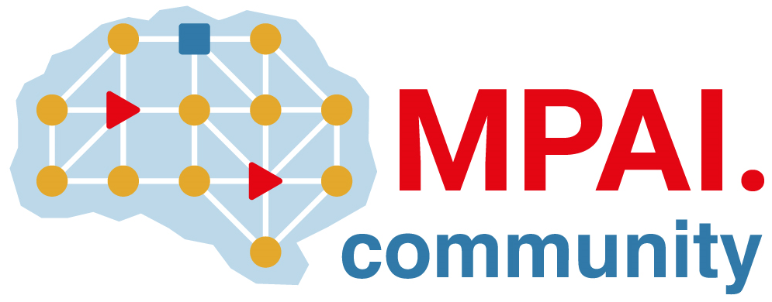 | Moving Picture, Audio and Data Coding  by Artificial Intelligence  www.mpai.community

Public document
N228 | 2021/05/12
Source | MPAI General Assembly #8 (MPAI-8)
Title | Press Release of MPAI-8
Target | MPAI Members

MPAI starts development of
AI-based company performance prediction standard

Geneva, Switzerland – 12 May 2021. At its 8th General Assembly, the international, unaffiliated Moving Picture, Audio and Data Coding by Artificial Intelligence (MPAI) standards association has received substantial proposals in response to its Call for Technologies on AI-based Company Performance Prediction Use Case. Meanwhile the development of its foundational AI Framework standard is steadily progressing and the technical review of responses to the Context-based Audio Enhancement (MPAI-CAE) and Multimodal Conversation (MPAI-MMC) Calls for Technologies has been completed.

The goal of the AI Framework standard, nicknamed MPAI-AIF, is to enable creation and automation of mixed Machine Learning (ML) - Artificial Intelligence (AI) - Data Processing (DP) – inference workflows, implemented as software, hardware, or mixed software and hardware. A major MPAI-AIF feature is enhanced explainability of MPAI standard applications.

Development of two new standards has started after completing the technical review of responses to the Calls for Technologies. Context-based Audio Enhancement (MPAI-CAE) covers four instances: adding a desired emotion to a speech without emotion, preserving old audio tapes, improving the audioconference experience and removing unwanted sounds while keeping the relevant ones to a user walking in the street. and Multimodal Conversation (MPAI-MMC) covers three instances: audio-visual conversation with a machine impersonated by a synthesised voice and an animated face, request for information about a displayed object, translation of a sentence using a synthetic voice that preserves the speech features of the human.

Substantial proposals received in response to the MPAI-CUI Call for Technologies has allowed starting the work on a fourth standard, AI-based Company Performance Prediction, part of the Compression and Understanding of Industrial Data standard. The standard will enable prediction of performance, e.g., organisational adequacy or default probability, by extracting information from governance, financial and risk data of a given company.

The MPAI web site provides information about other AI-based standards being developed: AI-Enhanced Video Coding (MPAI-EVC) will improve the performance of existing video codecs using AI, Server-based Predictive Multiplayer Gaming (MPAI-SPG) will compensates the loss of data and detect false data in online multiplayer gaming and Integrative Genomic/Sensor Analysis (MPAI-GSA) will compress and understand data from combined genomic and other experiments produced by related devices/sensors.

MPAI develops data coding standards for applications that have AI as the core enabling technology. Any legal entity who supports the MPAI mission may join MPAI if it is able to contribute to the development of standards for the efficient use of data.
Visit the MPAI web site and contact the MPAI secretariat for specific information.

