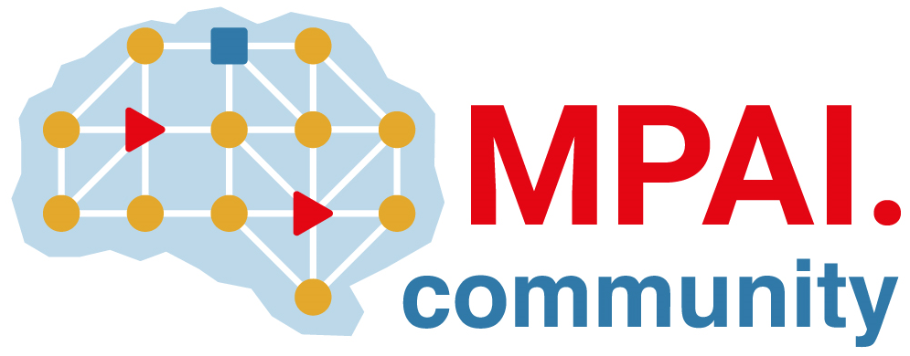 | Moving Picture, Audio and Data Coding by Artificial Intelligence  www.mpai.community

Public Document
N243 | 2021/05/12
Source | MPAI-CAV Group
Title | MPAI Application Note #9 - MPAI-CAV – Connected Autonomous Vehicles
Target | MPAI Members

Proponents: Giorgio Audrito (University of Turin), Leonardo Chiariglione (CEDEO), Gérard Chollet, Miran Choi (ETRI), Ferruccio Damiani (University of Turin), Gianluca Torta (University of Turin)

Description: This use case addresses the Connected Autonomous Vehicle (CAV) domain and the 3 main operating instances of a CAV:
- Autonomous Motion, i.e., the operation of the portion of a CAV that enables its autonomous motion
- Human-to-CAV interaction, i.e., the operation of the portion of a CAV that responds to humans’ commands and queries and senses humans’ activities
- The CAV-to-environment interaction, i.e., the operation of the portion of a CAV that communicates with other CAVs and sources of information.

Comments:
Significant research and experimentation has been carried out in the domain addressed by this Application Note. However,
- While there is a high level of knowledge and result sharing about the algorithms studied and experimented, e.g., in the several challenges, and there is a rough commonality in the Autonomous Motion reference models, no attempt has been done to formalise such a reference model and identify the (classes of) data types in and out of the CAV subsystems.
- There has been no significant effort to identify and classify human commands and queries to CAVs and the level of passenger activity in the CAV passenger compartment.
- While there are significant studies and even a standard addressing CAV-to-CAV interaction, the communication payload considered is not directly connected with the use and relevance of the data that flow inside the CAV.

Examples:
A preliminary study carried out by the MPAI-CAV Requirements group has identified the following subsystems (AIMs, in the MPAI language)
- Vehicle Localiser
- Route Planner
- Occupancy Grid Map Creator
- Environment Mapper
- Moving Objects Tracker
- Traffic Signalisation Detector
- World Representation Creator
- Path Planner
- Behavior Selector
- Motion Planner
- Obstacle Avoider
- Command and Control

A first identification of of input/output data has already been achieved.
A similar work is under way for the Human-to-CAV interaction.
Initial work to identify the CAV-to-environment interaction is under way.

Object of standard:
- Reference models for the 3 CAV components: 1) Autonomous Motion, 2) Human-to-CAV interaction and 3) CAV-to-environment interaction
- Functionalities of AIMs of 1) Autonomous Motion and formats of data between AIMs
- Functionalities of AIMs of 2) Human-to-CAV interaction and formats of data between AIMs, taking into account other MPAI projects
- Messages and data format formats of CAV-to-environment interaction.

Benefits: The standard would help
- development and maturation of technologies required for high performance Autonomous Motion AIMs.
- create synergies between CAV-specific and wider use human-machine interaction.
- develop CAV-to-environment protocols that are focused on the actua needs of CAVs.

Bottlenecks: actual experimentation will require large amounts of data available from market players.

Social aspects: availability of superior technologies, especially in the Autonomous Motion component, will accelerate the development of a much needed application.

Success criteria: the progress of technology triggered by the MPAI Reference Models.

References:
[1] MPAI N242: MPAI-CAV Reference Models
[2] ETSI TR 103 562 V2.1.1 (2019-12), Analysis of the Collective Perception Service (CPS);
Release 2

