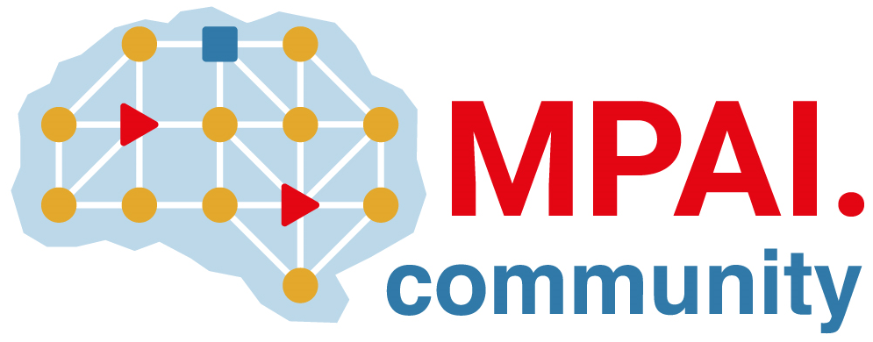 | Moving Picture, Audio and Data Coding  by Artificial Intelligence  www.mpai.community

Public document
N254 | 2021/06/09
Source | MPAI General Assembly #9 (MPAI-9)
Title | Press Release of MPAI-9
Target | MPAI Members

MPAI opens new projects leveraging its unique approach to AI standards

Geneva, Switzerland – 09 June 2021. At its 9th General Assembly, the international, unaffiliated Moving Picture, Audio and Data Coding by Artificial Intelligence (MPAI) standards association has started the development of new projects while continuing the development of four standards.

MPAI application standards use aggregations of components called AI Modules (AIM) executed in an MPAI-specified environment called AI Framework (AIF). MPAI only specifies the interfaces, not the internals of the AIMs, to enable interoperability while promoting the emergence of an open market of components.

MPAI is currently developing functional requirements for a future Connected Autonomous Vehicles standard (MPAI-CAV). Three CAV subsystems are being targeted: Human-CAV interaction, Autonomous Motion and CAV-environment interaction. All data flows between the AIMs in the 3 subsystems are being identified and requirements developed.

The four standards under development are:
- AI Framework standard (MPAI-AIF) enables creation and automation of mixed Machine Learning (ML) - Artificial Intelligence (AI) - Data Processing (DP) – inference workflows, implemented as software, hardware, or mixed software and hardware.
- Context-based Audio Enhancement (MPAI-CAE) covers four instances: adding a desired emotion to a speech without emotion, preserving old audio tapes, improving the audioconference experience and removing unwanted sounds while keeping the relevant ones to a user walking in the street
- Multimodal Conversation (MPAI-MMC) covers three instances: audio-visual conversation with a machine impersonated by a synthesised voice and an animated face, request for information about a displayed object, translation of a sentence using a synthetic voice that preserves the speech features of the human.
- Compression and Understanding of Industrial Data (MPAI-CUI) currently includes one instance: AI-based Company Performance Prediction enabling prediction of performance, e.g., organisational adequacy or default probability, by extracting information from governance, financial and risk data of a given company.

The MPAI web site provides information about other AI-based standards being developed: AI-Enhanced Video Coding (MPAI-EVC) will improve the performance of existing video codecs using AI, Server-based Predictive Multiplayer Gaming (MPAI-SPG) will compensate data loss and detect false data in online multiplayer gaming and Integrative Genomic/Sensor Analysis (MPAI-GSA) will compress and understand data from combined genomic and other experiments produced by related devices/sensors.

MPAI develops data coding standards for applications that have AI as the core enabling technology. Any legal entity who supports the MPAI mission may join MPAI if it is able to contribute to the development of standards for the efficient use of data.
Visit the MPAI web site and contact the MPAI secretariat for specific information.

