Moving Picture, Audio and Data Coding by Artificial Intelligence
www.mpai.community

Public Document
N273 | 2021/06/07
Source | Requirements (CAV)
Title | Initial MPAI-CAV Use Cases and Functional Requirements
Target | MPAI Members

Contents
1 Introduction 1
2 The MPAI approach to standardisation 2
3 Use Cases 3
3.1 Human-to-CAV interaction 3
3.1.1 Reference architecture 3
3.1.2 Input and output data 4
3.1.3 AI Modules 4
3.2 Autonomous Motion 5
3.2.1 Reference architecture 5
3.2.2 Input and output data 6
3.2.3 AI Modules 6
3.3 CAV-to-environment interaction 12
3.3.1 Reference architecture 12
3.3.2 Input and output data 13
3.3.3 AI Modules 14
4 Technologies and Functional Requirements 14
4.1 Introduction 14
4.2 Human-CAV interaction 14
4.3 Autonomous motion 14
4.3.1 Summary of CAV Autonomous Motion data 14
4.4 CAV-environment interaction 15
5 References 15
Annex 1 - Terminology 17
Annex 2 – ETSI Technical Report 19

Introduction
Moving Picture, Audio and Data Coding by Artificial Intelligence (MPAI) is an international association with the mission to develop AI-enabled data coding standards. Research has shown that data coding with AI-based technologies is generally more efficient than with existing technologies. Compression is a notable example of coding as is feature-based description.
The MPAI approach to developing AI data coding standards is based on the definition of standard interfaces of AI Modules (AIM). The Modules operate on input and output data with standard formats. AIMs can be combined and executed in an MPAI-specified AI-Framework according to the emerging MPAI-AIF standard being developed based on the responses to Call for MPAI-AIF Technologies.
By exposing standard interfaces, AIMs are able to operate in an MPAI AI Framework. However, their performance may differ depending on the technologies used to implement them. Therefore, MPAI believes that competing developers striving to provide more performing proprietary still interoperable AIMs will naturally create horizontal markets of AI solutions that build on and further promote AI innovation.
This document, titled Connected Automotive Vehicles (MPAI-CAV), contains use cases for Human-CAV interaction, the “AI-based Performance Prediction” Use Case and associated Functional Requirements. The MPAI-CUI standard uses AI substantially to extract the most relevant information from the industrial data, with the aim of assessing the performance of a company and predicting the risk of bankruptcy long before it may happen.
It should be noted that the AI-based Performance Prediction Use Case will be non-normative. The internals of the AIMs will also be non-normative. However, the input and output interfaces of the AIMs whose requirements have been derived to support the Use Cases will be normative.
This document includes this Introduction and

Chapter 2 | outlines the MPAI approach to standardisation
Chapter 3 | describes the Use Cases giving for each the reference architecture, the input and output data and the AI Modules
Chapter 4 | provides the requirements for all technologies identified

The Terms are defined in Annex 1.

The MPAI approach to standardisation
MPAI standards target components and systems enabled by data coding technologies, especially, but not necessarily, using AI. MPAI subdivides an Implementation of an MPAI-specified Use Case into functional components called AI Modules (AIM). AIMs and AI systems implementing a Use Case are both called Implementations.
MPAI assumes Implementations use Artificial Intelligence (AI) or Machine Learning (ML) or traditional Data Processing (DP) or a combination of these. The implementation technologies can be hardware or software or mixed hardware and software.
An AI system implementing a Use Case is an aggregation of interconnected AIMs executed inside an AI Framework (AIF). MPAI is developing and plans on releasing such an AI Framework (MPAI-AIF) standard in July 2021.
The 2 basic elements of the MPAI standardisation are represented in Figure 1 and Figure 2.

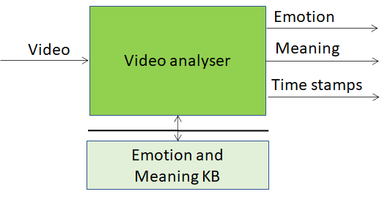 | 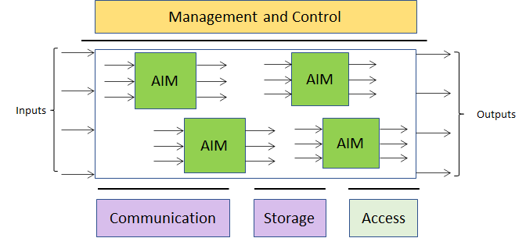
Figure 1 – The MPAI AI Module (AIM) | Figure 2 – The MPAI AI Framework (AIF)

Figure 1 shows a video coming from a camera shooting a human face. The function of this AIM (green block) is to detect the emotion on the face and the meaning of the sentence the human is uttering. The AIM can be implemented with a neural network or with DP technologies. In the latter case, the AIM accesses a knowledge base external to the AIM.
The MPAI approach to developing AI data coding standards is based on the definition of standard interfaces of AI Modules (AIM) combined and executed in an MPAI-specified AI-Framework (MPAI-AIF). AIMs operate on input data with standard formats and produce output data with standard formats. MPAI is silent on how an AIM produces output data from input data, with the constraint that an MPAI-standardised AIM must execute the normatively specified function.
By exposing standard interfaces, AIMs can interoperate in the MPAI AI Framework. However, their performance may differ depending on the technologies used to implement them.
MPAI believes that competing developers striving to provide more performing proprietary while still interoperable AIMs will naturally create horizontal markets of AI solutions that build on and further promote AI innovation.
Each Use Case normatively defines
- Entity 1
  - The input/output data of the AIMs.
- Entity 2
  - The function of each AIM
  - The input/output data of the AIM defined in point 1
- Entity 3
  - The function of the Use Case
  - The input/output data to the AI system implementing the Use Case defined in point 1
  - The topology and the interconnections of the AIMs
A user of the standard can normatively reference one of the following three
- Some data formats of Entity 1 only
- Entity 1 and 2 only
- Entity 1, Entity 2 and Entity 3 for each individual Use Case.

Use Cases
The MPAI-CAV use cases relate to the 3 main subsystem ins a Connected Autonomous Vehicles. It develops and describes three Reference Models:
- Human-to-CAV interaction, i.e., the CAV subsystem that responds to humans’ commands and queries, senses human activities in the CAV passengers compartment and activates other subsystems as required by humans or as deemed necessary by the identified conditions
- Autonomous Motion, i.e., the CAV subsystem that enables its autonomous motion driving the CAV to the intended destination under instructions received through the Human-to-CAV interaction.
- CAV-to-environment interaction, i.e., the CAV subsystem that communicates with sources of external information, including other CAVs, Roadside Units (RSU) etc..

Human-to-CAV interaction

Reference architecture
Humans and CAVs interact in several ways:
- Human-CAV dialogue, e.g.,
  - Commands to Autonomous Motion Subsystem (possibly via radio), e.g.: Go to Pose p, Stop, Park, etc.
  - Other commands, e.g.: Turn off air conditioning, Turn on radio, Make a phone call, Open window or door, Search for information, etc.
  - Information requests, e.g.: How long does it take to destination?, What is the route conditions (e.g., traffic jam), What is the weather at destination?
- Compartment monitoring, e.g.:
  - Physical conditions, e.g.: Temperature, There is no sound, There is anomalous noise, There is high-medium-low noise level, Media is playing, , , etc.
  - Passenger data, e.g.: # of passengers, ID of passengers, Estimated age of passengers, Destination of passengers.
  - Passenger activity, e.g.: Level of activity of passengers (e.g., quiet at first but getting more talkative, or passengers do not talk), Level of passenger-generated sound, Level of passengers movement, Emotion of passengers (e.g. happy face, long face)
  - Passenger-to-passenger dialogue, e.g.: I feel unwell, You look nervous, Two passengers shake hands, passengers hold everyday conversation (e.g., soccer, movies, fashion, weather)
- Passenger-to-web dialogue

The CAV collects data generated by humans inside the vehicle for possible action. In general, such data are anonymised, if meant for later, e.g., statistical use. Any data specific of a human shall be deleted at the end of the travel.
Figure 3 is the reference model of Human-CAV interaction. A combination of Conversation with Emotion and Multimodal QA covers Human-CAV interaction needs.

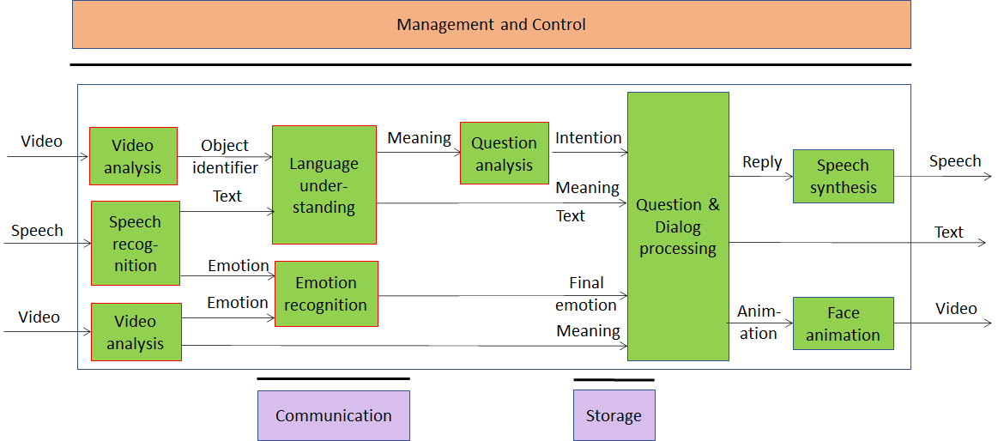
Figure 3 – Human-CAV interaction Reference Model

Depending on the technology used (legacy or AI), the AIMs in Figure 3 may need to access external Knowledge Bases to perform their functions.

Input and output data
Input | Speech
Input | Video
Output | Synthetic speech
Output | Animated video

AI Modules
The AI Modules of Human-CAV interaction are given in Table 1.

Table 1 – AI Modules of Human-CAV interaction

AIM | Function
Speech recognition | Analyse the voice input and generate text output
Video Analysis 1 | Produces the name of the object in focus
Video Analysis 2 | Extracts emotion from human face
Language understanding | Analyses natural language expressed as text using a language model to produce the meaning of the text
Emotion recognition | Fuses Speech and Video emotions
Question analysis | Analyses the meaning of the sentence and determines the Intention
Question & Dialog processing | Analyses user’s neaning and/or question and produces a reply based on user’s Intention
Speech synthesis | Converts input text to speech
Question Answering | Analyses user’s question and produces a reply based on user’s Intention
Intention KB | Responds to queries using a question ontology to provide the features of the question
Image KB | Responds to Image analysis’s queries providing the object name in the image
Online dictionary | Allows Question Answering AIM to find answers to the question

Autonomous Motion

Reference architecture
When properly instructed, the Autonomous Motion subsystem executes the instructions: go to a pose, change target pose and park. It does that by
- using
  - quasi-static online information (offline maps)
  - information transmitted from roadside units
  - information from other CAVs
  - information from other vehicles and persons
  - information captured from
    - electromagnertic sensors (e.g., Lidar, Radar, Camera etc.)
    - acoustic sensors
- complying with traffic rules and regulations
- considering safety and physical comfort of passengers.
The Autonomous Motion subsystem should be designed in such a way that different levels of autonomy, e.g., those indicated by SAE International [1], are possible depending on the amount and level of available functionalities.
The MPAI-CAV reference model is given by Figure 4.

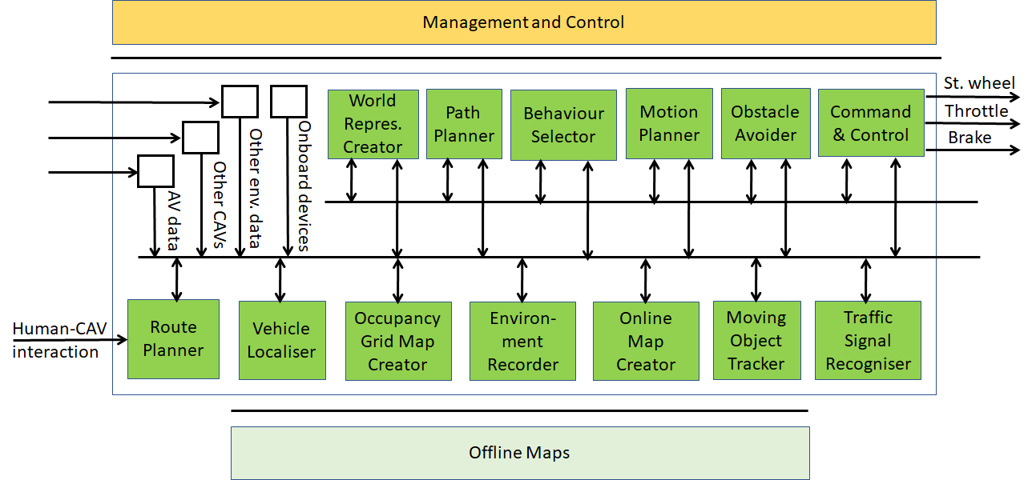
Figure 4 – MPAI-CAV Autonomous Motion Reference Model

With the exception of Route Planner, the AIMs located at the bottom of Figure 4 process typically high-speed data received from the physical environment or from devices inside the CAV (e.g., gyroscope). These signal sources are represented as white boxes. The AIMs at the top typically operate on the basis of processed lower-speed data received from the AIMs at the bottom. The order of the AIMs from left to right roughly corresponds to a sequential order in which AIMs take action after receiving an instruction.

Input and output data
Input | - Captured by sensors, e.g.,  - Global Navigation Satellite System (GNSS)  - Light Detection and Ranging (LIDAR).  - Radio Detection and Ranging (RADAR).  - Cameras (2/D and 3D).  - Ultrasound.  - Microphones.  - Wheel encoder.
- Onboard devices
  - Inertial Measurement Unit (IMU)
  - Odometer, etc.
- Structured
  - Other CAVs
  - Static transmitters
  - Offline maps.
  - Entertainment.

 | - User input
Output | Steering wheel actuation
 | Throttle actuator
 | Brake actuator

- Notes:
  - Road wheel-related sensors:
    - tyre pressure (to be aware of CAV’s reaction to commands).
  - Inertial Measurement Unit (IMU) contains
    - Accelerometer
    - Gyroscope
  - Offline maps are created using satellite or onboard sensors data collected over multiple passes or or crowd-sourced to a fleet of cars, annotated and curated.

AI Modules
The AI Modules of Autonomous Motion are given in Table 2.

Table 2 – AI Modules of Autonomous Motion

AIM | Function
Route Planner | computes a Route 𝑊, through a road network, from the CAV’s Current State to the Final Goal.
Vehicle Localiser | estimates the current CAV State in the Offline Maps
Occupancy Grid Map Creator | represents the environment as a grid structure of binary values
Environment Recorder | processes and records a subset of data
Online Map Creator | creates a map with geometrical and topological properties
Moving Objects Tracker | detects and tracks position and velocity of moving obstacles in the environment comprising the CAV
Traffic Signal Recogniser | detects and recognises signs to enable the CAV to correctly decide in conformance with the traffic rules
World Representation Creator | creates an internal representation of the environment
Path Planner | generates a set of Paths, considering 1) the current Route, 2) the CAV State, 3) the World Representation, and 4) the traffic rules
Behaviour Selector | to set a Goal to be reached with a Driving Behavior, avoiding collisions with static and moving objects within the decision horizon time frame
Motion Planner | define a Trajectory, from the current CAV State to the current Goal following the Behavior Selector’s Path as close as possible, satisfying CAV’s kinematic and dynamic constraints, and passengers’ comfort
Obstacle Avoider | defines a new Trajectory that avoids obstacles
Command and Control | makes the car execute the Trajectory as best as the environment allows

Vehicle Localiser
- Purpose: to estimate the current CAV State in the Offline Maps.
- Input:
  - GNSSs (GPS/Galileo/Glonass/BeiDou)
  - Sensor data
  - Odometry
  - Data from other CAVs.
  - Offline Maps
  - Requests from other AIMs
- Output:
  - State.
- Notes:
  - Offline Maps are static maps of the environment that are:
    - Accessible online
    - Manually annotated, e.g., indicating pedestrian crosswalks or traffic light positions
    - Edited, i.e., without dynamic objects captured by the sensors.
- Technology analysis.
  - GNSSs are the cheapest way to get the CAV pose. However, it not always reliable in cities (e.g., interference by tall trees, buildings, tunnels).
  - Sensor data
    - LIDAR sensors: offer measurement accuracy and processing ease
    - In LIDAR plus camera-based setups, LIDAR data are used to build the map, while camera data estimate the CAV’s position relative to the map
    - Camera-based localisation is cheap, but less precise and/or reliable.
  - Odometry
    - Odometry has precision problems because wheels slip and slide. Over time the distance is increasingly decorrelated from wheel rotation. More so when the CAV operates on non-smooth surfaces.
  - Data from other CAVs
    - by knowing the Pose and Path of another CAV (received from the CAV) and the distance from the CAV (computed), it is possible to know one’s pose
  - Data from offline maps
    - Used to place the CAV on the offline maps.

Route Planner
- Purpose: computes a Route 𝑊, through a road network, from the CAV’s Current State to the Final Goal.
- Input:
  - Current State.
  - Final Goal.
- Output:
  - Route in the Offline Maps.
  - Time estimation.
- Technology analysis.
  - Computing a Route can be reduced to finding the shortest path in a weighted directed graph if the road network is represented by a weighted directed graph where
    - vertices are the way points
    - edges connect pairs of way points
    - edge weights represent the cost of going from a way point to the another.
  - Techniques
    - Goal-directed.
    - Separator-based
    - Hierarchical
    - Bounded-hop
    - Combinations

Occupancy Grid Map Creator
- Purpose: to represent the environment as a grid structure of binary values.
- Input:
  - Sensor data.
  - State.
- Output:
  - Occupancy Grid Map.
- Technology analysis.
  - Regular spacing metric representation
    - An OGM is a space representation into discrete fixed size cells, of the order of cm.
    - An OGM cell contains the probability of occupation of the physical region it represents.
    - The occupancy probability of an OGM cell is assumed to be
      - Independent of the occupancy probability of other cells.
      - Gaussianly distributed around the cell
      - Represented as a Hilbert map
      - Represented as a DCT map
    - Cell occupancy probability is updated based on 3D sensor values.
    - For simplicity, 3D sensor measurements are projected onto the 2D ground plane.
  - Varied spacing metric representation
    - Octree-based Maps stores information with varied 3D resolutions.
    - Hybrid Maps store occupancy and distance measurements with varied resolutions yielding a representation with grid cells of increasing size from the center of the car.

Environment Recorder
- Purpose: to process and record a subset of data
- Input
  - Offline Maps
  - Occupancy Grid Map
  - State
  - Data from other CAVs.
- Output
  - Stored data
- Note
  - Candidate data for processing and storage are: point cloud of the environment, environment data from other CAVs etc.

Online Map Creator
- Purpose: to create a map with geometrical and topological properties.
- Input:
  - Offline Maps
  - Occupancy Grid Map
  - State
  - Data from other CAVs.
- Output:
  - Online Map.
- Note:
  - Online Map should only contain a static representation of the environment (desirable).
  - Pose, class and status of traffic signals
    - Horizontal: lane markings etc.
    - Vertical: speed limits, traffic lights, etc.
  - Traffic rules are typically embedded in road maps.
- Technology analysis.
  - Metric representations
    - Grid maps map the environment into a matrix of fixed size cells
  - Topological representations
    - Topological maps hold more complex information, including multiple lanes, lane crossings, and lane mergers.

Moving Objects Tracker (MOT)
- Purpose: to detect and track position and velocity of moving obstacles in the environment comprising the CAV.
- Input:
  - Offline Maps
  - State
  - Data from other CAVs.
- Output:
  - Pose and velocity of moving obstacles.
- Note: moving obstacles can be
  - other vehicles
  - pedestrians
- Technology analysis of MOT
  - Traditional is divided in: data segmentation, data association, and filtering
    - The positions of moving objects are estimated using ranging sensors, e.g., LIDAR and RADAR, or monocular/stereo cameras.
    - Objects with velocity above a given threshold are considered moving vehicles.
    - The size of the cube bounding box for each cluster is used to call vehicle a cluster.
  - Model-based uses physical models of sensors and geometric models of objects to directly infer from sensor data
  - Stereo vision based detects and tracks moving objects using color and depth information obtained from stereo pairs of images.
  - Grid map based builds an object-based description of the scene by segmentating, associating, and filtering the OGM of the dynamic environment
  - Sensor fusion fuses LIDAR-RADAR-camera data to explore their individual characteristics and improve environment perception. it is divided in two layers
    - The sensor layer extracts features from sensor data for potential description of a moving object hypothesis based on a point or box model, associates features with current hypotheses from the fusion layer
    - The fusion layer selects the best tracking model for each hypothesis and estimates (or updates the estimation of) the hypothesis state based on proposals from the sensor layer.
  - Deep learning uses deep neural networks to detect positions and geometries of moving objects, and to track their future states based on current camera data

Traffic Signal Recogniser
- Purpose: to detect and recognise signs included in the traffic rules to enable the CAV to correctly decide in conformance with the traffic rules.
- Input:
  - Sensor data
  - State
  - Offline Maps
  - Online Maps
  - Data from other CAVs.
- Output:
  - Traffic signals’ pose, class and status
  - Traffic rules.
- Technology analysis
  - Traffic light detection and recognition
    - Detects the position of one or more traffic lights around the CAV and recognises their states (RGY).
    - Methods used are model-based and learning-based
  - Traffic sign detection and recognition
    - Detects the locations of traffic signs and recognises their categories (e.g., speed limit, stop, and yield sign.)
    - Model-based using simple features (e.g., colors, shapes, and edges)
    - Learning-based leveraging simple features, but evolving into more complex features (e.g., patterns, appearance, and templates)
  - Pavement marking detection and recognition
    - detects the positions of pavement marking and recognizing their types (e.g., lane markings, road markings, messages, and crosswalks)
  - CNNs are used to detect single or multiple traffic signs [10]

World Representation Creator
- Purpose: to create an internal representation of the environment.
- Input:
  - State
  - Pose, class and status of traffic signalisations
  - Pose of static obstacles
  - Pose and velocity of moving obstacles
- Output:
  - Representation of the environment.

Path Planner
- Purpose: to generate a set of Paths, = {𝑃₁, 𝑃₂, …,𝑃_{|𝑃 |}}, considering 1) the current Route, 2) the CAV State, 3) the World Representation, and 4) the traffic rules. Paths extend some tens/hundreds of metres.
- Input:
  - Route
  - State
  - Traffic Rules.
- Output:
  - A set of Paths.
- Technology analysis
  - Graph search based
  - Interpolating curves
- Technology analysis

Behaviour Selector
- Purpose: to set a Goal to be reached with a Driving Behavior, avoiding collisions with static and moving objects within the decision horizon time frame (ca. 5 s).
- Input:
  - Pose.
- Output:
  - Path.
  - Pose and velocity of moving obstacles.
- Technology analysis
  - Finite State Machines
    - The Behavior is represented by states and transitions are based on discrete rules stemming from perception information. The states are drawn from several urban traffic scenarios.
  - Ontology
    - An ontology-based Knowledge Base is used to model traffic regulations and sensor data in order to help CAVs understand the world.
  - Markov decision processes

Motion Planner
- Purpose: to define a Trajectory 𝑇, from the current CAV State to the current Goal following the Behavior Selector’s Path 𝑃_{𝑗} as close as possible, satisfying CAV’s kinematic and dynamic constraints, and passengers’ comfort.
- Input:
  - Path.
- Output:
  - Trajectory.
- Technology analysis
  - A Trajectory may be defined as a sequence of
    - Commands, i.e. 𝑇^{𝑐} = {𝑐₁, 𝑐₂, …, 𝑐_{|𝑇 |}}, where each command 𝑐_{𝑘} = (𝑣_{𝑘}, 𝜑_{𝑘}, 𝛥𝑡_{𝑘}) and 𝑣_{𝑘} is the desired velocity at time 𝑘, 𝜑_{𝑘} is the desired steering angle at time 𝑘, and 𝛥𝑡_{𝑘} is the duration of 𝑐_{𝑘};
    - States 𝑇^{𝑠} = {𝑠₁ , 𝑠2 , …, 𝑠_{|𝑇 |}), where each state 𝑠_{𝑘} = (𝑝_{𝑘}, 𝑡_{𝑘}) and 𝑝_{𝑘} is a pose, and 𝑡_{𝑘} is the time in seconds after which 𝑝_{𝑘} is expected to be achieved.
  - Motion planning methods can be categorised into 4 classes: graph search, sampling, interpolating curve, and numerical optimization.

Obstacle Avoider
- Purpose: define a new Trajectory that avoids obstacles.
- Input:
  - Trajectory from Motion Planner.
  - Pose and velocity of moving obstacles.
- Output:
  - Trajectory.

Command and Control
- Purpose: to make the car execute the Trajectory as best as the environment allows.
- Input:
  - Trajectory from Obstacle Avoider.
- Output:
  - Effort commands to steering wheel actuator
  - Effort commands to throttle actuator
  - Effort commands to brakes actuator.

CAV-to-environment interaction

Reference architecture
Figure 5 depicts the environment applicable to MPAI-CAV.

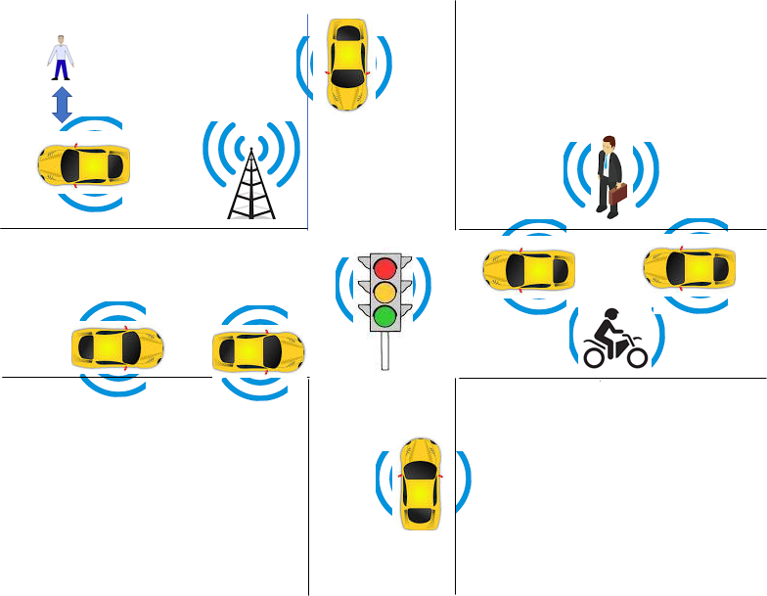
Figure 5 – The MPAI-CAV Environment

CAVs can communicate via radio with other CAVs and other information sources.

CAVs can improve their perception capabilities by exchanging information about what they sense with other entities:
- Neighbouring CAVs transmitting data in broadcast or unicast mode.
- Other vehicles, such as electric scooters, bicycles.
- Pedestrians.
- Fixed equipment (e.g., traffic light, bus stop)

The following categories of vehicular communication are part of the literature or industry effort:

V2V | Vehicle-to-Vehicle | communication between vehicles to exchange information about the speed and position of surrounding vehicles
V2I | Vehicle-to-Infrastructure | communication between vehicles and road infrastructure.
V2X | Vehicle-to-Everything | communication between a vehicle and any entity that may affect, or may be affected by, the vehicle
V2R | Vehicle-to-Roadside | communication between a vehicle and Road Side Units (RSUs).
V2P | Vehicle-to-Pedestrian | communications between a vehicle and (multiple) pedestrian device(s) and to other vulnerable road users, e.g., cyclists, in close proximity
V2S | Vehicle-to-Sensors | communication between a vehicle and its sesnors on board
V2D | Vehicle-to-Device | communication between a vehicle and any electronic device that may be connected to the vehicle itself
V2G | Vehicle-to-Grid | communication with the power grid to sell demand response services by either returning electricity to the grid or by throttling their charging rate
V2N | Vehicle-to-Network | broadcast and unicast communications between vehicles and the V2X management system and also the V2X AS (Application Server)
V2C | Vehicle-to-Cloud | communication with data centers and other devices connected to the internet
Technologies exist that support at least some aspects of the communivation types of the table:
- Radio access, e.g., visible light communication, mmWave, Cellular-V2X, and 5G
- Radio resource management (RRM) for vehicular communication using cellular technology
- 3GPP Release 14: air interfaces and core network technologies to support V2X communication.
- Vehicular ad hoc network (VANET)
- Dedicated Short-Range Communication (DSRC): 5.9 GHz band with a range of ~300 metres.
- Software defined vehicular networks (SDVN)
- Internet of vehicles (IoV)
- Protocol stack of the intelligent transportation system (ITS)
- Cooperative Awareness Messages (CAMs) messages related to the status of CAV’s sent via wireless broadcast in VANETs.
- Cooperative or collective perception improve CAV’s perception beyond the sensors’ detection range
- Traffic situation can be extracted from Local dynamic map (LDM) that aggregates CAMs.

Input and output data

CAVs within range
MPAI is developing a different payload as indicated in Table 3. This relies on a common world volumetric model. CAVs communicate in broadcast mode with other CAVs.

Table 3 – MPAI-CAV Interaction with Environment data

 | Data type | Description
V | CAV identity | Digital equivalent of plate number, including CAV model
V | Attitude-Path-Trajectory | See definitions
O | Spatial attributes | Position, velocity, acceleration, bounding box and semantics of objects in the environment
V | World representation | CAV’s world representation. (original or after fusion?)
V | Distance | Estimated distance between the CAV and all other CAVs.
E | Events | E.g., Works, Traffic jams, Number of cars at a traffic light etc.

What is the size (MByte/GByte) of a lidar scan? say 17 Mpoint ~550 MB
difference maps

Other vehicles (not CAVs)
Other vehicles can be scooters, motorcycles, bicycles, other non-CAV vehicles.
They transmit their position as derived from GPS?

Pedestrians
Their smartphones can transmit their coordinates as available from GPS

Fixed equipment
Fixed equipment are traffic lights, bus stops, road side units.

Traffic lights can transmit
- geographic coordinates
- state (Green-Yellow-Red), time to change state
- lane marking
- speed limits
- pedestrian crosswalks

Road side transmitters can transmit
- Geographic coordinates
- 3D representation of environment

AI Modules

Technologies and Functional Requirements

Introduction
The Functional Requirements refer to the individual technologies identified as necessary to implement Use Cases belonging to given MPAI-CAV application area using AIMs operating in an MPAI-AIF AI Framework. The Functional Requirements developed adhere to the following guidelines:
- AIMs are defined to allow implementations by multiple technologies (AI, ML, DP)
- DP-based AIMs need interfaces such as to a Knowledge Base. AI-based AIM will typically require a learning process, however, support for this process is not included in the document. MPAI may develop further requirements covering that process in a future document.
- AIMs can be aggregated in larger AIMs. As a consequence, some data flows of aggregated AIMs may not necessarily be exposed any longer.

Human-Cav Interaction

Autonomous Motion

Summary of CAV Autonomous Motion data
The table gives, for each AIM (1st column), the input dats (2nd column) from the AIM (3rd column) and the output data (4th column).

Table 4 – MPAI-CAV Autonomous Motion data

CAV AIM | Input | From | Output
Route Planner | State | Vehicle Localiser | Route  Estimated time
Vehicle Localiser | Sensor data | Input Data | State
 | Odometry | Onboard devices
 | Offline Maps | Input Data
 | Sensor Data | Other CAVs
 | Final Goal | User
OGM Creator | Various Data | Input Data | Occupancy Grid Map
Environment Recorder | State | Vehicle Localiser | --
 | OGM | OGM Creator
 | Data (TBD) | Other CAVs
Online Map Creator | State | Vehicle Localiser | Online Map
 | Offline Maps | Input Data
 | Occupancy Grid Map | OGM Creator
 | Various Data | Other CAVs
Traffic Signal. Detector | State | Vehicle Localiser | Traffic signals  Traffic rules
 | Sensor data | Input Data
 | Offline Maps | Input Data
 | Online map | Mapper
 | Various Data | Other CAVs
Moving Objects Tracker | State | Vehicle Localiser | Moving objects’ poses and velocities
 | Online Map | Mapper
 | Various Data | Other CAVs
World Representation Creator | State | Vehicle Localis. | World Representation
 | Array of traffic signals | Traffic Signalis. Detector
 | Static object poses | OGM Creator
 | Moving object’s poses and velocities | Moving Objects Tracker
Path Planner | Route | Route Planner | Set of Paths
 | State | Input Data
 | Traffic Rules | Traffic Signalis. Detector
Behaviour Selector | Pose | Vehicle Localis. | Path
 |  |  | Pose & velocity of moving objects
Motion planner | Path | Behaviour Selector | Trajectory
Obstacle Avoider | Trajectory | Motion Planner | Trajectory
Command and Control | Trajectory | Obstacle Avoider | Actuation of steering weel  Actuation of throttle  Actuation of brakes

Environment sensor data

Global Navigation Satellite System (GNSS)

Light Detection and Ranging (LIDAR)

Radio Detection and Ranging (RADAR)

Cameras (2/D and 3D)

Ultrasound

Microphones

Wheel encoder

Onboard device data

Odometer

Accelerometer

Road wheel sensor

User input data

Offline map

State

Goal

Route

Occupancy Grid Map

Online map

Traffic signals

Traffic rules

Pose

Velocity

World representation

Path

Trajectory

Output data

Steering wheel actuation

Throttle actuation

Brake actuation

CAV-environment interaction

CAV identity

Attitude-Path-Trajectory

Spatial attributes

World representation

Distance

Events

References
- SAE International Releases Updated Visual Chart for Its “Levels of Driving Automation” Standard for Self-Driving Vehicles, https://www.sae.org/news/press-room/2018/12/sae-international-releases-updated-visual-chart-for-its-%E2%80%9Clevels-of-driving-automation%E2%80%9D-standard-for-self-driving-vehicles
- ISO 8855: "Road vehicles -- Vehicle dynamics and road-holding ability -- Vocabulary"
- Rodolfo W. L. Coutinho and Azzedine Boukerche, Guidelines for the Design of Vehicular Cloud Infrastructures for Connected Autonomous Vehicles, IEEE Wireless Communications - August 2019
- Claudine Badue, Rânik Guidolini, Raphael Vivacqua Carneiro, Pedro Azevedo, Vinicius B. Cardoso, Avelino Forechi, Luan Jesus, Rodrigo Berriel, Thiago M. Paixão, Filipe Mutz, Lucas de Paula Veronese, Thiago Oliveira-Santos, Alberto F. De Souza; Self-driving cars: A survey; Expert Systems With Applications 165 (2021) 113816
- D. Cireşan, U. Meier, J. Masci, and J. Schmidhuber, “Multi-column deep neural network for traffic sign classification,” Neural Netw., vol.32, pp.333–338, Aug. 2012
- ETSI TR 103 562 V2.1.1 (2019-12), Analysis of the Collective Perception Service (CPS); Release 2.
- CAR 2 CAR Communication Consortium, https://www.car-2-car.org/
- Usman Ali Khan and Sang Sun Lee; Distance-Based Resource Allocation for Vehicle-to-Pedestrian Safety Communication; https://www.mdpi.com/2079-9292/9/10/1640/pdf
- Gokulnath Thandavarayan, Miguel Sepulcre, and Javier Gozalvez; Generation of Cooperative Perception Messages for Connected and Automated Vehicles; IEEE Transactions on Vehicular Technology, Vol. 69, No. 12, December 2020
- Pranav Kumar Singhab, Sunit Kumar Nandiac, Sukumar Nandi; A tutorial survey on vehicular communication state of the art, and future research directions; Vehicular Communications Volume 18, August 2019, 100164
- https://phantom.ai/assets/uploads/PAI%20Renesas%20Partnership%20Announcement%20(1).pdf

Annex 1 - Terminology

Term | Acron. | Definition
Advanced Driver Assistance System | ADAS | Electronic systems that assist drivers in driving and parking functions
Aggregate Programming | AP | (Paradigm) prescribes that each AIM M periodically and asynchronously evaluates a program P (the same for all devices) by performing the following steps  - collects the non-expired message received from the neighbour AIMs and (possibly) other local data from M;  - evaluates the program P;  - sends messages to the neighbour AIMs and (possibly) perform other action local to M.
AI Framework | AIF
AI Module | AIM | A computational entity with a defined (and fair and ethical) purpose (local or networked, single or multi processor) that exposes a set of MPAI interfaces that can be implemented as HW signals, SW APIs, protocols). Whatever is inside an AIM is not relevant. It can be connectionless or connection oriented.
Collective Awareness | CA | Periodic exchange of status information between ITS-Ss (ETSI)
Collective Perception | CP | Sharing the perceived environment of an ITS-S based on perception sensors (ETSI)
Collective Perception Message | CPM | Enables a CAV to share information about detected objects with other CAVs (ETSI)
Collective Perception Service | CPS | Enables CAVs to share information about other road users and obstacles that were detected by its perception sensors (ETSI).
Cooperative Awareness Message | CAM | Messages exchanged in the ITS network between ITS-Ss to create and maintain awareness of each other and to support cooperative performance of vehicles using the road network (ETSI)
Command and Control | CAC | The AIM converting AOD’s decisions into actual commands and controls.
Communication |  | The infrastructure that connects the Components of an AIF and distributed AIMs
Component |  | An element of the AIF Reference Model
Connected and Autonomous Vehicle | CAV | A vehicle capable to reach an assigned target by planning a route and acting on the CAV after sensing and interpreting the environment and possibly exchanging information with other CAVs.
Computational Field | CF | A distributed data structure that associates a value to each AIM. Each value is stored in the corresponding AIM, which can therefore read it
Decision horizon |  | The estimated time between the current state and the 𝐺𝑜𝑎𝑙_{𝑔}
Driving behaviour |  | A collection of behaviours, such as lane keeping, intersection handling, traffic light handling, etc.
Execution |  | Component where AIM workflows are executed. It receives external inputs and produces the requested outputs both of which are application specific
Goal |  | 𝐺𝑜𝑎𝑙_{𝑔}=(𝑝_{𝑔},𝑣_{𝑔}) is the pair 𝑝_{𝑔} and associated velocity.
Inertial Measurement Unit | IMU | Inertial positioning devices such as accelerometer, gyroscope, odometer
Machine Learning | ML
Management and Control | MAC | Components that manages and controls the AIMs in the AIF, so that they execute in the correct order and at the time when they are needed
Occupancy Grid Map | OGM | A representation of the environment as evenly spaced grids of 1/0 (presence/absence) representing an obstacle at that location computed using sensor data and CAV’s State.
Offline Map |  | An offline-created map of a location with annotation
Online map |  | An online-created map Merging Offline Maps and the Occupancy Grid Map computed online using sensors’ data  and the current car’s State.
Path |  | 𝑃𝑗 = {𝑝₁ , 𝑝₂ , …, 𝑝_{|𝑃|}} is a sequence of CAV Poses 𝑝_{𝑖} = (𝑥_{𝑖},𝑦_{𝑖},𝜃𝑖) in the Offline Maps.
Pose |  | 2D coordinates of the CAV in the Offline Maps with its orientation p = (𝑥,𝑦,𝜃)
Remission Grid Map |  | A grid map of reflectance intensity distribution of the environment measured by a LIDAR scanner
Route |  | A sequence of Way Points
State |  | The set of: pose, linear and angular velocity, acceleration etc. characterising the CAV at a given time
Storage |  | A Component used, e.g., to store inputs and outputs of the individual AIMs, data from the AIM’s state and intermediary results, shared data among AIMs etc.
Trajectory |  | A sequence of commands 𝑐_{𝑘} = (𝑣_{𝑘}, 𝜑_{𝑘}, 𝛥𝑡_{𝑘}), where 𝑣_{𝑘} is the desired velocity at time t_{𝑘}, 𝜑_{𝑘} is the desired steering angle at t_{𝑘}, and 𝛥𝑡_{𝑘} is the duration of 𝑐_{𝑘}. Other definitions of Trajectory exist.
Way Point | WP | A point 𝑤_{𝑖} given as a coordinate pair (𝑥_{𝑖}, 𝑦_{𝑖}), in an Offline Map

Annex 2 – ETSI Technical Report
ETSI specifies the Collective Perception Service (CPS) in its Technical Report [6]. The CPS includes the format and generation rules of the Collective Perception Message (CPM).
The CPM message format is (H=header, C=container, M=mandatory, O=optional).

Table 5 – ETSI Collective Perception Message format

PDU header | H | M | protocol version, message ID and Station ID.
Management | C | M | transmitter type (e.g., vehicle or RSU) and position.
Station Data | C | O | transmitter heading, velocity, or acceleration etc.
Sensor Information | C | O | - transmitter (e.g., speed, heading, or acceleration)  - capabilities of the vehicle’s sensors.
Perceived Object | C | O | - detected objects (e.g., distance, speed and dimensions)  - time at which the measurements were done.  A CPM can report up to 128 detected objects
Free Space Addendum | C | O | free space areas/volume within the sensor detection areas

Every 0.1s a CPM is generated if one of the 3 conditions is satified
- no CPM has been generated in the last 1s
- a new object has been detected
- since last CPM sending info about a previously detected object (it must have an ID)
  - the following attributes have changed:
    - Absolute position ΔP > 4 m
    - Absolute speed ΔV > 0.5 m/s
  - more than 1s has passed (ΔT > 1 s).
ETSI makes use of a common coordinate system. A vehicle can communicate its absolute coordinates roll, pitch and yaw (Attitude).
Different CPM generation rules have been investigated [9].

