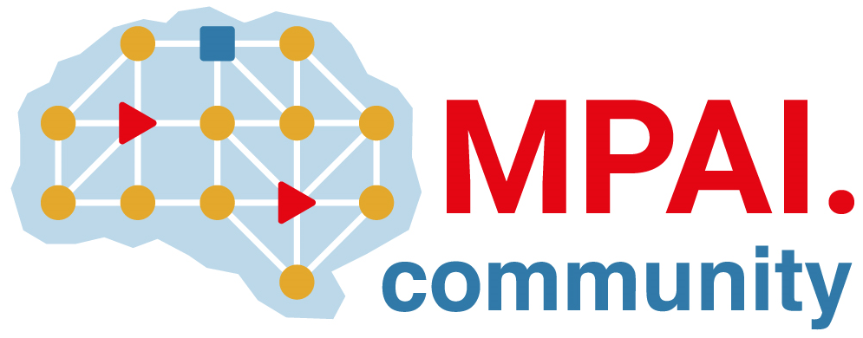 | Moving Picture, Audio and Data Coding  by Artificial Intelligence  www.mpai.community

Public document
N318 | 2021/08/25
Source | MPAI General Assembly #11 (MPAI-11)
Title | Press Release of MPAI-11
Target | MPAI Members

MPAI publishes 2 draft standards and 1 document for comments

Geneva, Switzerland – 25 August 2021. At its 11th General Assembly, the international, unaffiliated Moving Picture, Audio and Data Coding by Artificial Intelligence (MPAI) standards developing organisation has published 2 draft standards and 1 foundational document for comment.

Comments are requested, by 20 September, prior to final approval at MPAI’s next General Assembly (MPAI-12) on:
- Compression and Understanding of Industrial Data (MPAI-CUI). AI-based Company Performance Prediction enables a user to assess a company’s default probability, organisational adequacy and business discontinuity probability in a given prediction horizon.
- Multimodal Conversation (MPAI-MMC). Conversation with Emotion supports audio-visual conversation with a machine impersonated by a synthetic voice and an animated face; Multimodal Question Answering supports request for information about a displayed object; Unidirectional, Bidirectional and One-to-Many Speech Translation support conversational translation using a synthetic voice that preserves the speech features of the human.
- Governance of the MPAI Ecosystem lays down the rules governing an ecosystem of implementers and users of secure and performance-guaranteed MPAI standard implementations accessible through the not-for-profit MPAI Store.

MPAI is currently also working on other standards, e.g.:
- Context-based Audio Enhancement (MPAI-CAE): adding a desired emotion to an emotion-less speech segment, preserving old audio tapes, restoring audio segments, improving the audio conference experience and removing unwanted sounds to a user on the go.
- AI Framework (MPAI-AIF) enables creation and automation of mixed Machine Learning, Artificial Intelligence, Data Processing and inference workflows, implemented as software, hardware, or hybrid software and hardware.
- Server-based Predictive Multiplayer Gaming (MPAI-SPG) uses AI to train a network that compensates data losses and detects false data in online multiplayer gaming.
- AI-Enhanced Video Coding (MPAI-EVC) uses AI to improve the performance of existing video coding tools.
- Connected Autonomous Vehicles (MPAI-CAV) uses AI in key features: Human-CAV Interaction, Environment Sensing, Autonomous Motion, CAV to Everything and Motion Actuation.
- Mixed Reality Collaborative Spaces (MPAI-MCS) applies Artificial Intelligence to create mixed-reality spaces populated by streamed objects such as avatars representing individuals, other objects and sensor data, and their descriptions for meetings, education, biomedicine, science, gaming and manufacturing.
MPAI develops data coding standards for applications that have AI as the core enabling technology. Any legal entity who supports the MPAI mission may join MPAI if it is able to contribute to the development of standards for the efficient use of data.
Visit the MPAI web site and contact the MPAI secretariat for specific information.

