Moving Picture, Audio and Data Coding by Artificial Intelligence
www.mpai.community

Public document
N319 | 2021/08/25
Source | General Assembly #11 (MPAI-11)
Title | MPAI workplan
Target | Public document

Introduction
MPAI’s standards development is based on projects evolving through a workflow extending on 6 + 1 stages.

# | Acr | Name | Description
0 | IC | Interest Collection | Collection and harmonisation of use cases proposed
1 | UC | Use cases | Proposals of use cases, their description and merger of compatible use cases
2 | FR | Functional Reqs | Identification of the functional requirements that the standard including the Use Case should satisfy
3 | CR | Commercial Reqs | Development and approval of the framework licence of the standard
4 | CfT | Call for Technologies | Preparation and publication of a document calling for technologies supporting the functional and commercial requirements
5 | SD | Standard development | Development of the standard in a specific Development Committee (DC)
6 | MS | MPAI standard | The standard is approved by the General Assembly after its has been successfully completed and approved by the DC and all Members have made the appropriate declarations

A project progresses from one stage to the next by resolution of the General Assembly.
The stages of currently (MPAI-10) active MPAI projects are graphically represented by Figure 1.

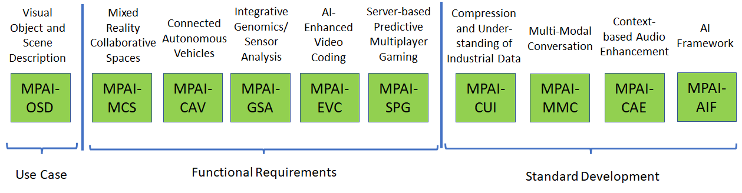
Figure 1 – Snapshot of the MPAI work plan

Areas at stage 5 (SD)

MPAI-AIF
Artificial Intelligence Framework (MPAI-AIF) enables creation and automation of mixed ML-AI-DP processing and inference workflows for the application areas work currently considered at stages 1, 2 and 3 of the MPAI work plan. MPAI-AIF will be extended to support new applications areas, if the need will arise.
The said areas of work share the notion of an environment (the Framework) that includes 6 components – Management and Control, Execution, AI Modules (AIM), Communication, Storage and Access. AIMs are connected in a variety of topologies and executed under the supervision of Management and Control. AIMs expose standard interfaces that make them potentially re-usable in different applications. Figure 2 shows the general MPAI-AIF Reference Model.

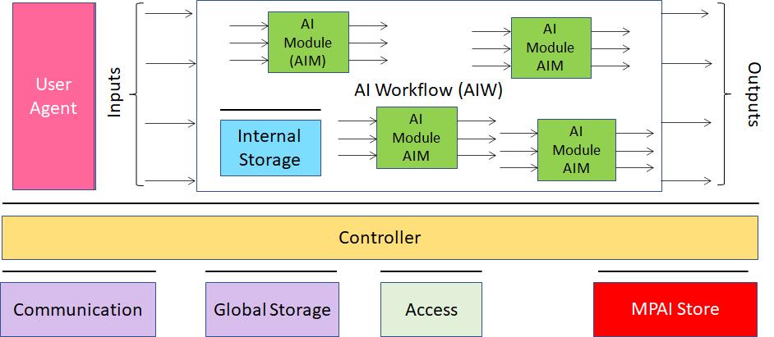

Figure 2 – Reference model of the MPAI AI Framework

Public MPAI documents supporting the MPAI-AIF project at the current stage are:
- MPAI-AIF Use Cases & Functional Requirements, N74 [1]
- MPAI-AIF Call for Technologies, N100 [2]
- MPAI-AIF Framework Licence, N101 [3]
Stage 6 is expected to be reached in October 2021.

Areas at stage 4 (CT)

MPAI-CAE
Context-based Audio Enhancement (MPAI-CAE) improves the user experience for several audio-related applications including entertainment, communication, teleconferencing, gaming, post-production, restoration etc. in a variety of contexts such as in the home, in the car, on-the-go, in the studio etc. using context information to act on the input audio content using AI, processing such content via AIMs, and potentially deliver the processed output via the most appropriate protocol.
So far, MPAI-CAE has been found applicable to 11 usage examples, for 4 of which the definition of AIM interfaces is at an advanced stage: Emotion enhanced speech, Audio Recording Preservation, Enhanced Audioconference Experience and Audio-on-the-go. Figure 3 addresses the Emotion enhanced speech Use Case.
MPAI documents supporting the MPAI-CAE project at the current stage are:
- MPAI-CAE Use Case and Functional Requirements, N151 [4]
- MPAI-CAE Call for Technologies, N152 [5]
- MPAI-CAE Framework Licence, N171 [6]
Stage 6 is expected to be reached in September 2021.
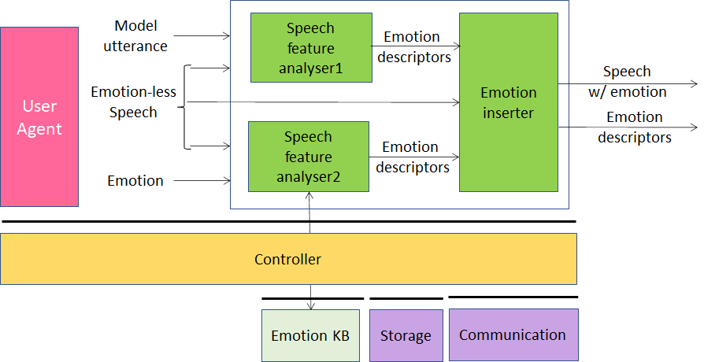
Figure 3 – An MPAI-CAE Use Case: Emotion-enhanced speech

MPAI-MMC
Multi-modal conversation (MPAI-MMC) aims to enable human-machine conversation that emulates human-human conversation in completeness and intensity by using AI.
So far, 3 Use Cases have been identified for MPAI-MMC: Conversation with emotion, Multimodal Question Answering (QA) and Personalized Automatic Speech Translation.
Figure 4 addresses the Conversation with emotion Use Case.

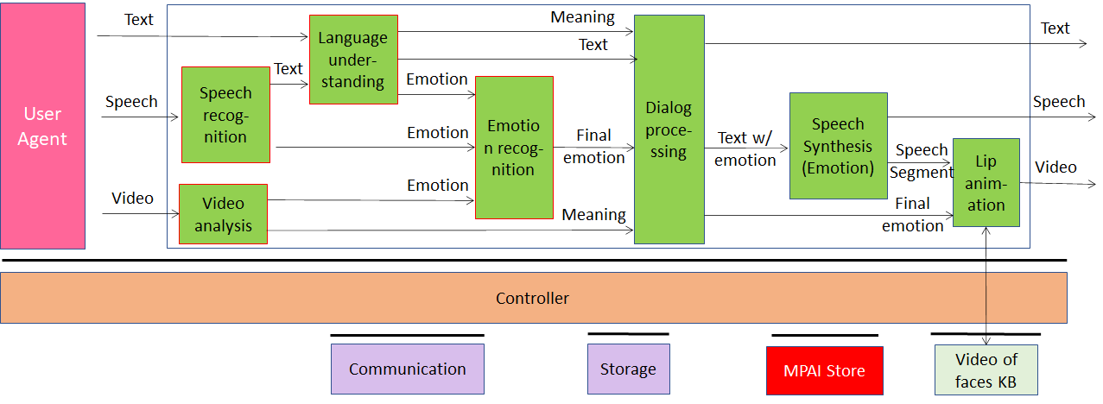
Figure 4 – An MPAI-MMC Use Case: Conversation with emotion

MPAI documents supporting the MPAI-MMC project at the current stage are:
- MPAI-MMC Use Case and Functional Requirements, N153 [7]
- MPAI-MMC Call for Technologies, N154 [8]
- MPAI-MMC Framework Licence, N173 [9]
- MPAI-MMC WD0.4 [10]
Stage 6 is expected to be reached in September 2021.

MPAI-CUI
Compression and understanding of industrial data (MPAI-CUI) aims to enable AI-based filtering and extraction of key information to predict company performance by applying Artificial Intelligence to governance, financial and risk data.
MPAI-CUI requires standardisation of all data formats to be fed into an AI machine to extract information that is relevant to the intended use. Converted data undergo a further conversion and are then fed to specific neural networks. This is depicted in Figure 5.

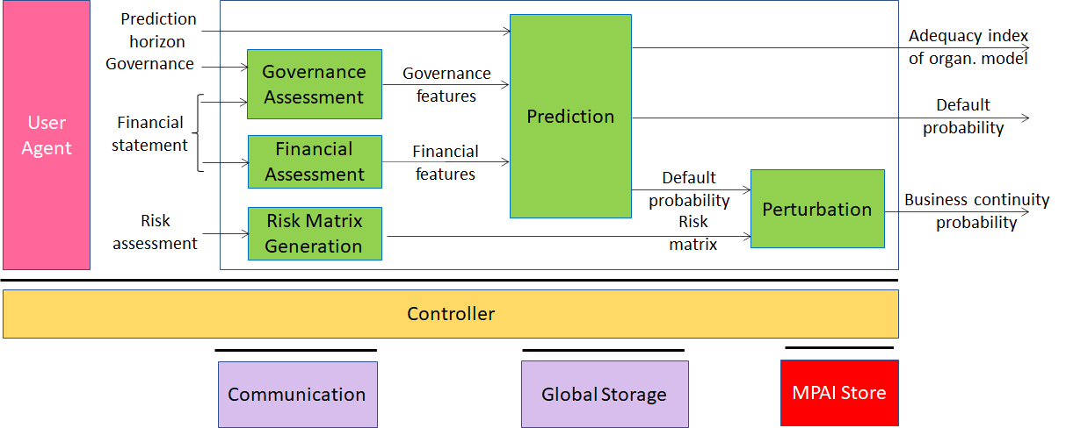
Figure 5 – The MPAI-CUI Use Case

MPAI documents supporting the MPAI-CUI project at the current stage are:
- MPAI-CUI Use Cases and Functional Requirement, N200 [10]
- MPAI-CUI Call for Technologies, N201 [12]
- MPAI-CUI Framework Licence, N202 [13]
- MPAI-CUI WD0.4, N330 []
Stage 6 is expected to be reached in July 2021.

Areas at stage 2 (FR)

MPAI-SPG
Server-based Predictive Multiplayer Gaming (MPAI-SPG) aims to minimise the audio-visual and gameplay discontinuities caused by high latency or packet losses during an online real-time game. In case information from a client is missing, the data collected from the clients involved in a particular game are fed to an AI-based system that predicts the moves of the client whose data are missing. The same technologies provide a response to the need to detect who amongst the players is cheating.
Figure 6 depicts the MPAI-SPG reference model including the cloud gaming model.
Public MPAI document supporting the MPAI-SPG work area is:
- MPAI-SPG Use Cases and Functional Requirement, N214 [16]
MPAI is currently engaged in the MPAI-SPG Design Verification Project.

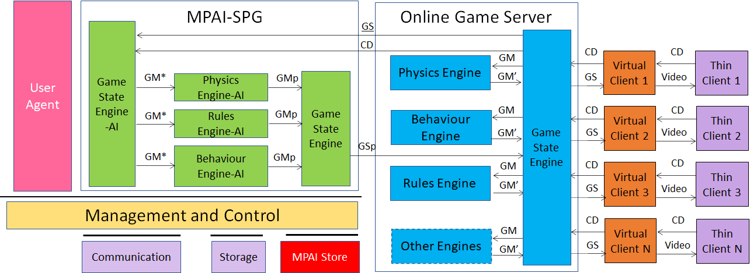
Figure 6 – The MPAI-CUI Use Case

MPAI-GSA
Integrative Genomic/Sensor Analysis (MPAI-GSA) uses AI to understand and compress the result of high-throughput experiments combining genomic/proteomic and other data, e.g., from video, motion, location, weather, medical sensors.
So far, MPAI-GSA has been found applicable to 4 Use Areas (collections of compatible Use Cases):
- Integrative analysis of ‘omics datasets
- Smart Farming
- Genomics and phenotypic/spatial data
- Genomics and behaviour
MPAI documents supporting the MPAI-GSA project at the current stage are:
- Draft MPAI-GSA Use Cases and Functional Requirement, N194 [14].
Figure 7 addresses the Smart Farming Use Case.

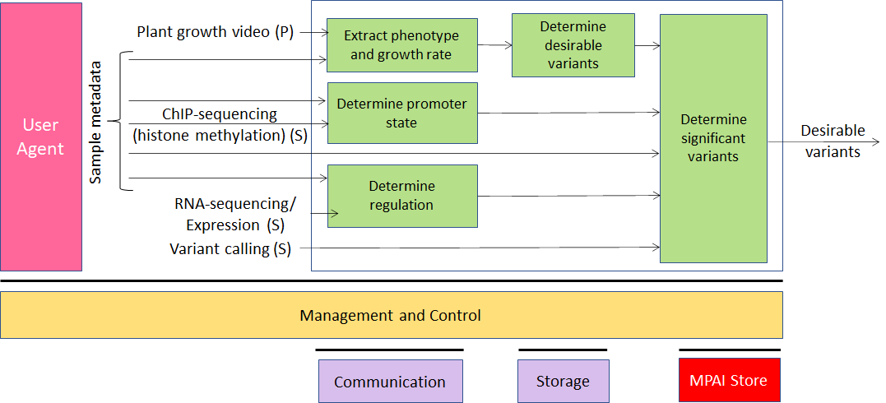
Figure 7 – An MPAI-GSA Use Case: Smart Framing

MPAI-EVC
AI-Enhanced Video Coding (MPAI-EVC) is a video compression standard that substantially enhances the performance of a traditional video codec by improving or replacing traditional tools with AI-based tools. Two approaches – Horizontal Hybrid and Vertical Hybrid – are envisaged. The Horizontal Hybrid approach introduces AI based algorithms combined with traditional image/video codec, trying to replace one block of the traditional schema with a machine learning-based one. This case can be described by Figure 8 where green circles represent tools that can be replaced or enhanced with their AI-based equivalent.
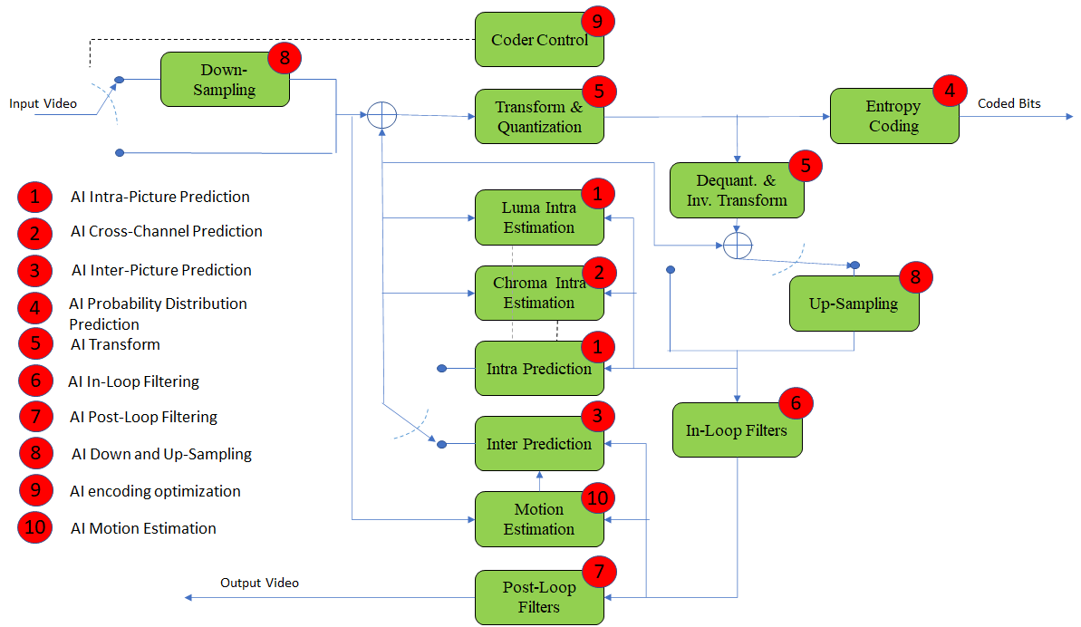
Figure 8 – A reference diagram for the Horizontal Hybrid approach

The Vertical Hybrid approach envigaes an AVC/HEVC/EVC/VVC base layer plus an enhanced machine learning-based layer. This case can be represented by Figure 9.

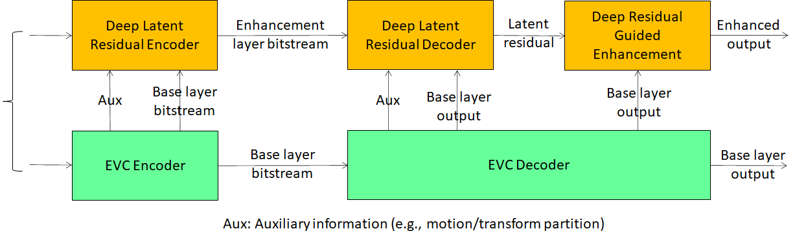
Figure 9 – A reference diagram for the Vertical Hybrid approach

MPAI is engaged in the MPAI-EVC Evidence Project seeking to find evidence that AI-based technologies provide sufficient improvement to the Horizontal Hybrid approach. A second project on the Vertical Hybrid approach is being considered.
Approved MPAI documents supporting the MPAI-EVC work area are:
- MPAI Application Note #3 R1 - MPAI-EVC, N61 [17]
- MPAI-EVC Use Cases and Requirements, N92 [18]
- Collaborative Evidence Conditions for MPAI-EVC Evidence Project Rev.1, N69 [19]
- Operational Guidelines for MPAI-EVC Evidence Project, N70 [20]
- Status report of MPAI-EVC Evidence Project, N271 [21].

MPAI-CAV
Connected Autonomous Vehicles (CAV) is a Use Case addressing the Connected Autonomous Vehicle (CAV) domain and the 5 main operating instances of a CAV:
- Human-CAV interaction (HCI), i.e., the CAV subsystem that responds to humans’ commands and queries, senses human activities in the CAV passenger compartment and activates other subsystems as required by humans or as deemed necessary by the identified conditions.
- CAV-Environment interaction, i.e., the subsystem that acquires information from the physical environment via a variety of sensors.
- Autonomous Motion Subsystem (AMS), i.e., the CAV subsystem that uses different sources of information to instructs the CAV to reach the intended destination.
- CAV-Device Interaction (CDI), i.e., the subsystem that communicates with sources of external information, including other CAVs, Roadside Units (RSU), other vehicles etc.
- Motion Actuation Subsystem (MAS), i.e., the subsystem that operates and actuates the motion instructions in the physical world.
The interaction of the 5 subsystems in depicted in Figure 10
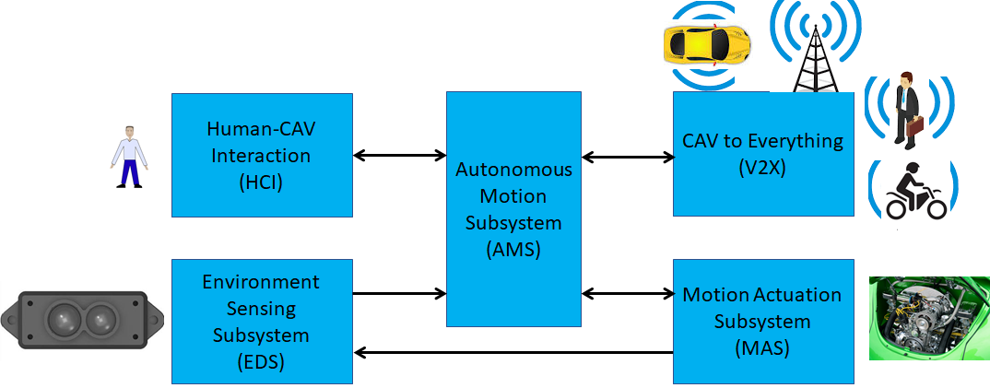
Figure 10 – The CAV subsystems

Approved public MPAI document supporting the MPAI-CAV work area is:
- MPAI Application Note #9 - MPAI-CAV, N243 [22]
- MPAI-CAV Use Cases and Functional Requirements, N304 [23]

Mixed-Reality Collaborative Spaces
New technologies are emerging which equip developers to deliver mixed-reality collaborative space (MCS) scenarios where biomedical, scientific, and industrial sensor streams and recordings are to be viewed.
Artificial intelligence can be utilized throughout MCS systems for immersive presence, spatial maps (e.g. Lidar scans, inside-out tracking) rendering, and multiuser synchronization etc.
A Use Case being considered is “Avatar videoconference in a local 3D audio-visual space”

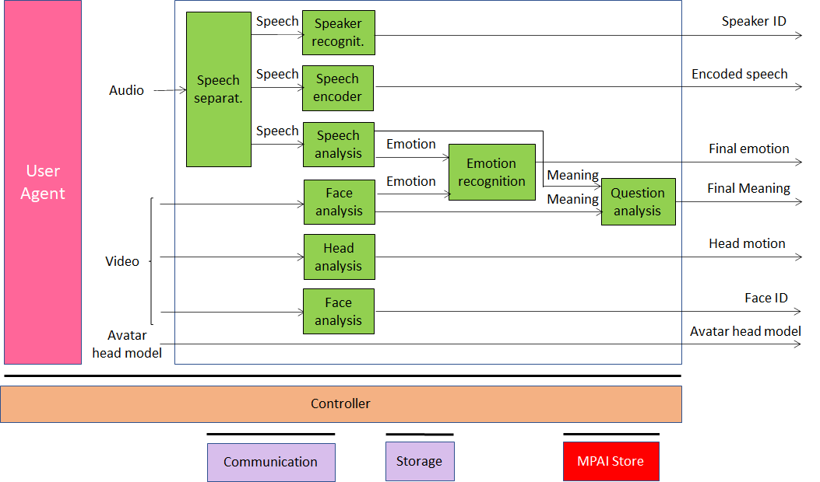

Figure 11 – An avatar-based videoconference model (participant)

Approved MPAI document supporting the MPAI-MCS work area is:
- Revised MPAI Application Note #10 - MPAI-MCS, N305 [24]
- MPAI-MCS Use Cases, Components and Data formats, N338 [25]

Areas at stage 1 (UC)

MPAI-OSD
Visual object and scene description is a collection of Use Cases sharing the goal of describe visual object and locate them in the space. Scene description includes the usual description of objects and their attributes in a scene and the semantic description of the objects.
Unlike proprietary solutions that address the needs of the use cases but lack interoperability or force all users to adopt a single technology or application, a standard representation of the objects in a scene allows for better satifaction of the requirements.
Approved MPAI document supporting the MPAI-OSD work area is:
- MPAI Application Note #8 - MPAI-OSD, N93 [24]

Other possible areas
Several potential areas for standardisation are likely to emerge from [27].

Vision-to-Sound Transformation
It is possible to give a spatial representation of an image that visually impaired people can hear with two headphones as a localization and description medium. It is a conversion (compression) technique from one space to a different interpretation space.

Anomalous service access
A machine that has learnt "typical" service access values for a particular service provider can detect attempts beyond "typical" values.

Anomalous vibrations
A machine learns from the data generated by inertial sensors (accelerometer with gyroscope) to distinguish between regular and anomalous vibrations.

References
- MPAI-AIF Use Cases & Functional Requirements, N74; https://mpai.community/standards/mpai-aif/#UCFR
- MPAI-AIF Call for Technologies, N100; https://mpai.community/standards/mpai-aif/#CfT
- MPAI-AIF Framework Licence, MPAI N171; https://mpai.community/standards/mpai-aif/#FWL
- MPAI-CAE Use Cases & Functional Requirements; MPAI N151; https://mpai.community/standards/mpai-cae/#UCFR
- MPAI-CAE Call for Technologies, MPAI N152; https://mpai.community/standards/mpai-cae/#CfT
- MPAI-CAE Framework Licence, MPAI N171; https://mpai.community/standards/mpai-cae/#FWL
- MPAI-MMC Use Cases & Functional Requirements; MPAI N153; https://mpai.community/standards/mpai-mmc/#UCFR
- MPAI-MMC Call for Technologies, MPAI N154; https://mpai.community/standards/mpai-mmc/#CfT
- MPAI-MMC Framework Licence, N173; https://mpai.community/standards/mpai-mmc/#FWL
- MPAI-MMC WD 0.4, N328
- MPAI-CUI Use Cases and Functional Requirement, N200; https://mpai.community/standards/mpai-cui/#UCFR
- MPAI-CUI Call for Technologies, N201; https://mpai.community/standards/mpai-mmc/#CfT
- MPAI-CUI Framework Licence, N202; https://mpai.community/standards/mpai-cae/#FWL
- MPAI-CUI WD 0.4
- Draft MPAI-GSA Use Cases and Functional Requirements, N194; https://mpai.community/standards/mpai-gsa/#UCFR
- Draft MPAI-SPG Use Cases and Functional Requirements, N218; https://mpai.community/standards/mpai-spg/#UCFR
- MPAI Application Note #3 R1 - MPAI-EVC, N61; https://mpai.community/standards/mpai-evc/#Note
- MPAI-EVC Use Cases and Requirements, N92; https://mpai.community/standards/mpai-evc/#UCFR
- Collaborative Evidence Conditions for MPAI-EVC Evidence Project Rev.1, N69; https://mpai.community/wp-content/uploads/2020/11/Collaborative-Evidence-Conditions-for-MPAI-EVC-Evidence-Project-R1.docx
- Operational Guidelines for MPAI-EVC Evidence Project, N70; https://mpai.community/wp-content/uploads/2020/11/N70-Operational-Guidelines-for-MPAI-EVC-Evidence-Project.docx
- Status report of MPAI-EVC Evidence Project, N271; https://mpai.community/standards/mpai-evc/#Status
- MPAI Application Note #9 - MPAI-CAV, N243; https://mpai.community/standards/mpai-cav/#Note
- MPAI-CAV Use Cases and Functional Requirements, N304; https://mpai.community/standards/mpai-cav/#UCFR
- MPAI Application Note #10 - MPAI-MCS – Mixed Reality Collaborative Spaces, N305; https://mpai.community/standards/mpai-mcs/#Note
- MPAI-MCS Use Cases, Components and Data formats, N338
- MPAI Application Note #8 - MPAI-OSD, N93; https://mpai.community/standards/mpai-osd/#Note
- MPAI Use Cases Rev2.0, N46; https://mpai.community/wp-content/uploads/2020/11/N46-MPAI-Use-Case-Rev2.0.docx

