Moving Picture, Audio and Data Coding
by Artificial Intelligence www.mpai.community

N341 | 2021/08/25
Source | Communication
Title | Governance of the MPAI Ecosystem WD0.4
Target | MPAI-11

Moving Picture, Audio and Data Coding
by Artificial Intelligence
www.mpai.community

MPAI Document

Governance of the MPAI Ecosystem
Version 1

Proposed WD 0.4

WARNING

Use of the technologies described in this Document may infringe patents, copyrights or intellectual property rights of MPAI Members or non-members.

MPAI or any of its Members accept no responsibility whatsoever for damages or liability, direct or consequential, which may result from use of this Technical Specification.

Readers are invited to review Annex 1 – Notices and Disclaimers.

© Copyright MPAI 2021. All rights reserved
Governance of the MPAI Ecosystem

1 Introduction 3
1.1 The first level of MPAI standardisation 3
1.2 The second level of MPAI standardisation 4
1.3 The third level of MPAI standardisation 6
1.4 The MPAI ecosystem 6
2 Scope of standard 7
3 Terms and definitions 7
4 Normative references 9
5 MPAI standards 9
6 Definition of Performance 10
7 Governance of the ecosystem 10
8 The operation of the MPAI ecosystem 11
9 The actors of the MPAI ecosystem 12
10 Data types 13
Annex 1 - Initial ideas for the Identifier structure 15

Introduction
Moving Picture, Audio and Data Coding by Artificial Intelligence (MPAI) is an international Standards Developing Organisation with the mission to develop AI-enabled data coding standards. Research has shown that data coding with AI-based technologies is generally more efficient than with existing technologies. Compression and feature-based description are notable examples of coding.
This document sets the rules enabling the creation of an ecosystem – the MPAI Ecosystem – where Users can develop or access Implementations of AI applications and services that rely on the MPAO AI Framework (AIF) architecture of Figure 1.

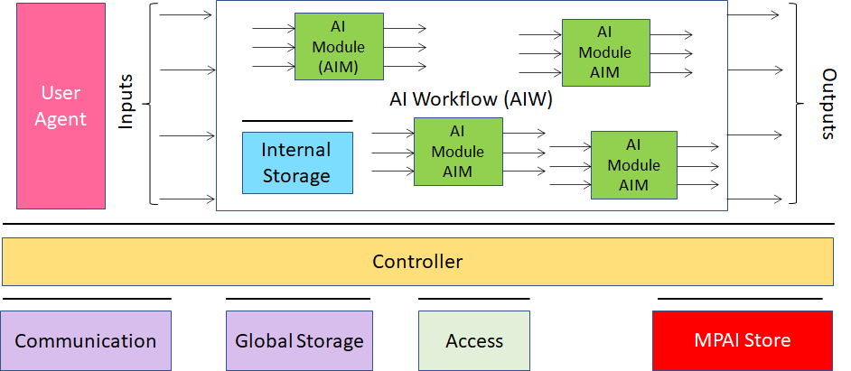
Figure 1 – The AI Framework (AIF) and its Components

The said Implementations can claim one of three different levels of Interoperability, i.e., ability of an AIM to be functionally replaced by another AIM having the same Interoperability Level.:

Level 1 | Implementations running wirkflowss – called AI Workflows (AIW) of data processing elements – called AI Modules (AIM) – with any function and any interfaces making them executable in an MPAI standard environment – called AI Framework (AIF).
Level 2 | Implementations with the additional feature of AIWs and AIMs having functions and interfaces normatively specified by an MPAI Technical Specification and executed in an AIF.
Level 3 | Implementations with the additional feature of having Level 2 AIWs and AIMs certified to have the attributes of Reliability, Robustness, Replicability and Fairness, collectively called Performance.

MPAI Standards includes four documents:
- Technical Specification specifies the elements and operation of the standard and is the main source of information to Implementers.
- Reference Software is a technically correct implementation of the Technical Specification and can be used as a supplement to the Technical Specification to guide Implementations.
- Conformance Testing specifies the process, the tools and the data to test the Conformance of Implementation.
- The Performance Assessment specifies the process, the tools and the data or data specification to test the Performance of the Implementation.

The MPAI ecosystem offers users access to the promised benefits of AI with a guarantee of increased transparency, trust and reliability as the Level of Interoperability moves from 1 to 3.

Level 1 of MPAI standardisation
MPAI issues and maintains a standard – called MPAI-AIF – composed of the following (see Figure 1):
- An environment (AIF) where AIWs (AIW) are executed
- AIMs exposing standard interfaces (e.g., access to Controller API) operating as part of an AIW.
- A distribution system of AIF, AIW and AIM Implementations called MPAI Store that an AIF can access.

Implementers’ benefits | Upload to the MPAI Store and have globally distributed Implementations of  - AIFs conforming to MPAI-AIF.  - AIWs and AIMs performing proprietary functions executable in AIF.
Users’ benefits | Rely on implementations that have been tested for security.
MPAI Store | - Tests Implementations for conformance to MPAI-AIF.  - Verifies Implementations’ security, e.g., absence of malware.  - Indicates unambiguously that Implementations are Level 2.

Level 2 of MPAI standardisation
MPAI Application Standards normatively specify AIWs supporting MPAI-identified Use Cases. The rectangle including green boxes in Figure 2 depicts an AIW Implementation supporting the function of an MPAI-specified Use Case.

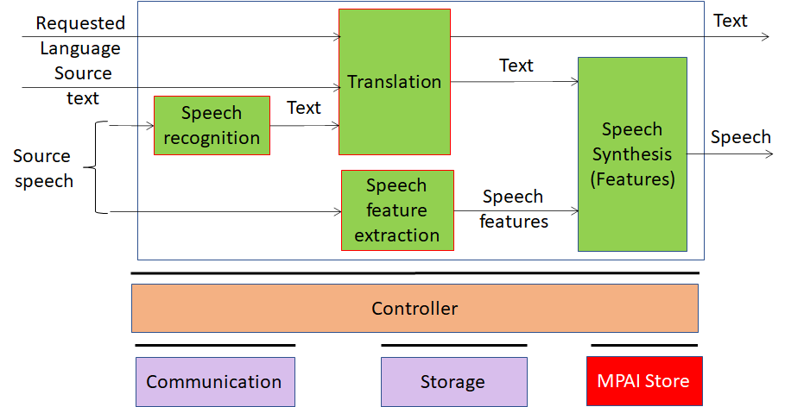
Figure 2 – An AIW example

With reference to Figure 2, an MPAI Application Standard normatively specifies the following aspects of an AIW:
- The format of the input data, e.g., “source speech”, “source text” and “input and output languages”.
- The function, e.g., “interpreting a sentence from a language to another preserving the characteristics of the original sentence”.
- The format of the output data, e.g., “speech” and “text”.
- The connections between AIMs.

As depicted by the green boxes of Figure 2, an AIW is composed of AIMs. Figure 3 and Figure 4 depict two examples of AIMs. The former includes the specific knowledge (e.g. a neural network) while the latter accesses that knowledge from an external knowledge base.

Figure 3 – An AIM with embedded knowledge | Figure 4 – An AIM with access to an external knowledge base

With reference to Figure 3 and Figure 4, an MPAI application standard specifies the following elements of an AIM:
- The format and semantics of the input data, e.g., “Text and Speech Features”.
- The function, e.g., “produce a synthetic speech from text and emotion descriptors”.
- The format of the output data, e.g., “speech”.

An AIM is defined by its function and interfaces, but not by its internal architecture, which may be be based on AI (e.g., Figure 3) or data processing (e.g., Figure 4), and implemented in software, hardware or hybrid software and hardware technologies.

In a Level 1 implementation of the Figure 2 AIW, an implementer can use proprietary AIMs within the constraints of the MPAI-AIF Standard. In a Level 2 implementation, however, the AIW must be implemented with AIMs that conform with an MPAI Application Standard.

Implementers’ benefits | Upload to the MPAI Store and have globally distributed Implementations of  - AIFs conforming to MPAI-AIF.  - AIWs and AIMs conforming to MPAI Application Standards.
Users’ benefits | - Rely on Implementations of AIWs and AIMs with functions and interfaces reviewed during standardisation.  - Achieve a level of explainability of the AIW operation because the AIM functions and interfaces are known.
Market’s benefits | - Open AIW and AIM markets foster competition leading to better products.  - Competition of AIW and AIM Implementations fosters AI innovation.
MPAI Store’s role | - Tests Conformance of Implementations with the relevant MPAI Application Standard.  - Verifies Implementations’ security.  - Indicates unambiguously that Implementations are Level 2.

Level 3 of MPAI standardisation
MPAI does not generally set standards on how and with what data an AIM should be trained because data sets are important differentiators promotong competition leading to better AI systems. However, the performance of an AIM is typically higher if the data used for training are in greater quantity and more in tune with the scope of use. Training data that have large variety and cover the spectrum of all cases of interest in breadth and depth typically lead to implementations of higher “quality”.
A Level 3 Implementation, the Grade of Performance – the set of Performance are Reliability, Robustness, Replicability and Fairness attributes – assessed according to process and data provided or normatively specified by MPAI shall be above a given value. Attributes are meant to apply to data outside of the training set. The Performance Assessment of an MPAI standard specifies which of the 4 attributes should be assessed.

Implementers’ benefits | May claim Implementations have passed Performance Assessment.
Users’ benefits | Get assurance the Implementation being used performs correctly, e.g., it has been properly trained.
Market’s benefits | Implementations’ Performance Grades stimulate the development of more Performing AIM and AIW Implementations.
MPAI Store’s role | - Verifies the Implementations’ security  - Indicates unambiguously that Implementations are Level 3.

The MPAI ecosystem
Figure 5 is a high-level description of the MPAI ecosystem operation applicable to fully conforming MPAI implementations:

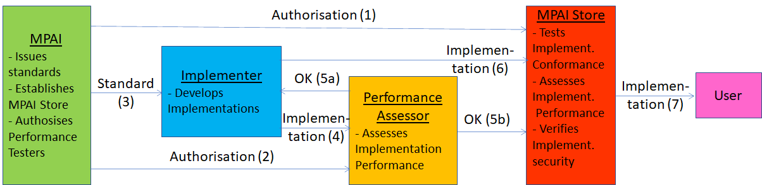
Figure 5 – The MPAI ecosystem operation

- MPAI establishes and controls the not-for-profit MPAI Store (step 1).
- MPAI appoints Performance Assessors (step 2).
- MPAI publishes standards (step 3).
- Implementer submits an Implementation to a Performance Assessor (step 4).
- If the Performance of the Implementation is acceptable, Performance Assessor informs the Implementer (step 5a) and the MPAI Store (step 5b).
- Implementer submits Implementation to the MPAI Store (step 6). Then the Store internally Tests the Conformance and security of the Implementation.
- User downloads Implementation (step 7).
The MPAI ecosystem allows an Implementer of an AIM with outstanding features to access the global market because users will download the AIM for use in their AIWs.

Scope of Document
This Document specifies the rules governing the MPAI Ecosystem established to achieve the practical implementation of the three Interoperability Levels described in the Introduction through
development and maintenance of:
- AI Framework Technical Specification.
- Application-oriented Technical Specifications of:
  - The function performed by a Use Case.
  - The input and output data (e.g., given to and received by the user interface).
  - The AIMs and their input and output data.
  - The AIM topology, interconnections and timing.
- Reference Software, with equal normative value as the corresponding Technical Specification, as a source code implementation of the AIF and of the AIW exposing all AIM interfaces and technically conforming implementations of the AIMs as source code or compiled.
- Conformance Testing standards that allow implementers to ascertain whether their implementation is technically correct and include:
  - The definition of Conformance Testing.
  - The Conformance Testing procedure to be followed for testing.
  - The data sets used for testing.
- Performance Assessment specifications of application-oriented Technical Specifications that allow independent, MPAI-appointed Conformance Testers to assess the grade of Performance of an implementation under test, that contain:
  - The definition of Performance.
  - The Performance Assessment process.
  - The Means – tools, data sets, etc. – used to carry out Performance Assessment.
  - The information that a Performance Assessor shall provide to an Implementer in support of their Assessment results.

Terms and definitions
The terms whose first letter is a capital letter used in this document are defined by Table 1.

Table 1 –Terms used in this document

Term | Definition
AI Framework (AIF) | The environment where AIWs are executed.
AI Module (AIM) | A processing element receiving AIM-specific Inputs and producing AIM-specific Outputs according to according to its Function.
AI Workflow (AIW) | An organised aggregation of AIMs implementing a Use Case receiving AIM-specific Inputs and producing AIM-specific Outputs according to its Function.
Application Standard | An MPAI Standard designed to enable a particular application domain.
Conformance | The attribute of an Implementation of being a correct technical Implementation of a Technical Specification.
Conformance Tester | An entity authorised by MPAI to Test the Conformance of an Implementation.
Conformance Testing | The normative document specifying the procedures, the tools, the data sets and/or the data set characteristics to Test the Conformance of an Implementation.
Conformance Testing Means | Procedures, tools, data sets and/or data set characteristics to Test the Conformance of an Implementation.
Connection | The channel between an output port of an AIM and an input port of an AIM.
Data format | The standard digital representation of data and their semantics.
Ecosystem | The ensemble of MPAI, MPAI Store, Implementers, Conformance Testers, Performance Testers and Users of required to enable a market of Implementations if certified Interoperability Levels.
Explainability | The ability to trace the output of an implementation back to the inputs that have produced it.
Fairness | The attribute of an implementation whose extent of applicability can be assessed by making the training set and/or network open to testing for bias and unanticipated results.
Function | The expected operation of an AIW of an AIM on input data.
Identifier | A name that uniquely identifies an Implementation.
Implementation | - An embodiment of the MPAI-AIF Technical Specification.  - An AIW or AIM of a particular Level (1-2-3) conforming with a Use Case of an Application Standard.
Interoperability | The possibility for an AIM to be functionally replaced by another AIM having the same Interoperability Level.
Interoperability Level | One of the following:  Level 1 AIM Implementations are proprietary but their AIWs can be executed in an AIF Implementations.  Level 2 AIM Implementations Conform to the Conformance Testing specification of an Application Technical Specification.  Level 3 AIM Implementations Perform according to the Performance Testing specification of an Application Technical Specification.
Normativity | The set of attributes of a technology or a set of technologies specified by the applicable parts of an MPAI standard.
Performance | The attribute of an Implementation of being Reliable, Robust, Fair and Replicable.
Performance Assessment | The normative document specifying the procedures, the tools, the data sets and/or the data set characteristics to Assess the Grade of Performance of an Implementation.
Performance Assessment Means | Procedures, tools, data sets and/or data set characteristics to Assess the Performance of an Implementation.
Performance Assessor | An entity authorised by MPAI to Assess the Performance of an Implementation in a given application domain
Profile | A particular subset of the technologies that are used in AIF, AIW or AIM and, where applicable, the classes, other subsets, options and parameters relevant to that subset.
Reference Software | A technically correct software implementation of a Technical Specification containing source code, or source and compiled code.
Reliability | The attribute of an Implementation that performs as specified by the standard, profile and version the Implementation refers to, e.g., within the application scope, stated limitations, and for the period of time specified by the Implementer.
Replicability | The attribute of an Implementation whose Performance, as Assessed by a Performer, can be replicated, within an agreed level, by another Performer.
Robustness | The attribute of an Implementation that copes with data outside of the stated application scope with an estimated degree of confidence.
Service Provider | An entrepreneur who offers an Implementation as a service (e.g., a recommendation service) to Users.
Standard | The ensemble of Technical Specification, Reference Software, Conformance Testing and Performance Assessment of an MPAI Standard.
Technical Specification | (Framework) the normative specification of the AIF.  (Application) the normative specification of the set of AIWs belonging to an Application domain along with the AIMs required to Implement the AIWs that includes:  - The formats of the Input/Output data of the AIWs implementing the AIWs.  - The Connections of the AIMs of the AIW.  - The formats of the Input/Output data of the AIMs belonging to the AIW.
Use Case | A particular instance of the Application domain target of an Application Standard.
Version | A revision or extension of a Standard or of one of its elements.

Normative references
The Governance of the MPAI Ecosystem normatively references the following Technical Specifications:
- MPAI Technical Specification: AI Framework (MPAI-AIF)
- MPAI Technical Specification: Context-based Audio Enhancement (MPAI-CAE)
- MPAI Technical Specification: Multimodal Conversation (MPAI-MMC)
- MPAI Technical Specification: Compression and Understanding of Industrial Data (MPAI-CUI)

MPAI standards
The MPAI-AIF Standard specifies the environment in which AIWs composed of AIMs can be executed.
MPAI Application Standards normatively specify:
- AIWs: implement MPAI-specified Use Cases. AOWs are characterised by:
  - The function it performs.
  - The format of the data entering and leaving it.
  - The Connections of the AIMs composing it.
- AIM: data processing components that are characterised by:
  - The function performed.
  - The formats of the data entering and leaving it.
- Data Formats: any type of time-independent or time-dependent data used within an AIF.

It is up to the Implementer to claim Conformance of an Implementation to:
- A specific AIW, its AIMs or their Data Formats.
- Selected AIMs and their Data Formats.
- Selected Data Formats.
- None of the above.
A claim of Conformance to
- An AIW implies a claim of Conformance to all its AIMs
- An AIM implies a claim of Conformance to all its Data Formats.

MPAI defines two types of compliance of an Implementation with an MPAI standard:
- Conformance, i.e., when the Conformance of an Implementation has been tested and found to be technically correct. Conformance may be claimed for:
  - An AIW.
  - An AIM.
  - A Data Format.
- Performance, i.e., when the Per formance of the Implementation has been Assessed and found to satisfy the requirements given in the Performance Assessment specification. Grades of Performance may be claimed for:
  - An AIW.
  - An AIM.

Definition of Performance
The Performance of an Implementation is measured against the following attributes:
- Reliability: Implementation performs as specified by the standard, profile and version the Implementation refers to, e.g., within the application scope, stated limitations, and for the period of time specified by the Implementer.
- Robustness: the ability of the Implementation to cope with data outside of the stated application scope with an estimated degree of confidence.
- Replicability: Performance of an Implementation as Tested by an entity can be replicated, within an agreed level, by another entity.
- Fairness: the training set and/or network is open to testing for bias and unanticipated results so that the extent of applicability of the system can be assessed.

The foundations of the MPAI Ecosystem Governance
The Governance of the MPAI Ecosystem is ensured by:
- MPAI
  - Acts as the root of trust.
  - Defines the rules of Governance.
  - Establishes and controls the MPAI Store.
  - Appoints Performance Assessors.
  - Develops the 4 components of an MPAI Standard.
- MPAI Store
  - Tests implementations submitted by implementers for Conformance and Security.
  - Posts software implementations for download.
- Performance Assessors assesses the Performance of Implementations.
- Identification System identifies Implementations.

These steps of the Performance Assessment process are:
- The Performance Assessment specification of an Implementation of an MPAI Use Case shall contain the following Use Case-specific elements:
  - Definition of Performance.
  - Means – process, tools, data sets, etc. – used to carry out Performance Assessment.
  - Information that a Performance Assessor shall provide in support of their results, e.g.,
    - The 4 attributes of Performance.
    - The nature and amount of the information that a Performance Assessor shall disclose to an Implementer in case an assessment has failed.
  - Pointers to the Performance Assessment Means.
- The Performance Assessor
  - May be an Implementer or a Testing Laboratory appointed by MPAI.
  - Is the sole holders of the MPAI-granted name spaces used to assign Identifiers to successfully assessed Implementations.
  - May not test the Performance of their implementations.
  - May not be MPAI.
  - Is appointed for a particular domain for an indefinite duration but the appointment may be revoked.
- The MPAI Store
  - Manages a reputation system where Users may post a numerical score of their user experience of an Implementation
  - Will make the average score public and post the individual textual comments, possibly after moderation, if this becomes necessary.
- The Identifiers are mandatorily attached to Implementations.

The operation of the MPAI ecosystem
The operation of the MPAI ecosystem is depicted in Figure 6.

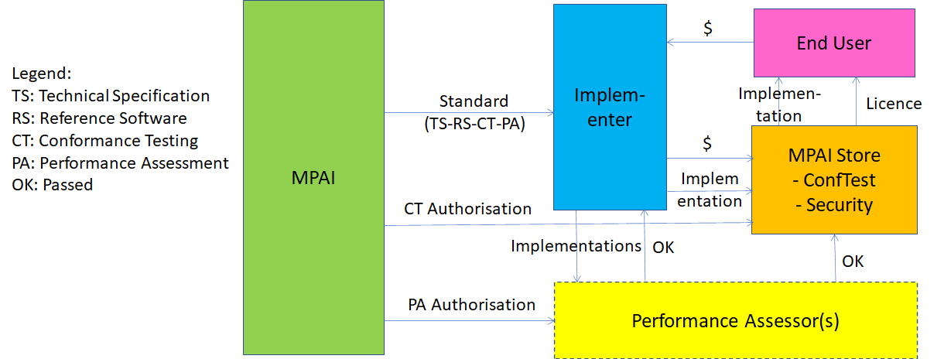
Figure 6 – The operation of the MPAI ecosystem

The roles of the entities in Figure 6 are:
- MPAI
  - Develops the 4 types of standards.
  - Appoints Performance Assessors.
- An Implementer developing an Implementation may upload to the MPAI Store:
  - AIFs and its proprietary AIWs and AIMs (Level 1).
  - AIWs or AIMs conforming to MPAI Application Standards straight away (Level 2) or after a Performance Assessor has assessed their Performance (Level 3).
- The MPAI Store:
  - Validates the security of the Implementation.
  - Tests the Conformance of the Implementation if the Implementer claims Conformance to an MPAI standard.
  - Verifies if a Performance Assessor as assessed the Performance of the Implementation.
  - Assigns Interoperability Levels accordingly.
- A User wishing to download an Implementation from the MPAI Store:
  - Is sent to the Implementer.
  - Gets a licence from the implementer.
  - Downloads the Implementation from the MPAI Store.

The MPAI Store is a not-for-profit commercial organisation. However, the MPAI Store may recover the costs (e.g., ICT infrastructure, personnel, consultants) deriving from the operation of the MPAI Store from Implementers, Users and Service Providers. Examples of ways to recover costs are:
- From Omplementers:
  - Conformance and Security Testing cost: at a fixed or variable price.
  - ICT costs: use of space of storage and amount of data streamed at an assigned price per 1 MByte of storage per month and 1 Mbyte of streaming.
- From Users: a percentage of the amount paid to Implementers.
- From Service Providers: e.g., pay like an Implementer.
A price can also be applied to Conformance Testing and Performance Assessment data stored in the MPAI Store.

The actors of the MPAI ecosystem
The actors enabling the MPAI ecosystem to operate are given by Table 2.

Table 2 – The actors of the MPAI ecosystem

Actor | Role
MPAI | Is the non-profit, international, non-affiliated standardisation body who:  - Standardises  - AIF  - AIWs  - AIMs  - Conformance Testing of AIWs and AIMs  - Performance Assessment of AIWs and AIMs  - Defines the rules governing the MPAI ecosystem:  - Certifies Performance Assessors.  - Assigns Identifier name spaces to Performance Assessors.  - Establishes and controls the operation of the MPAI Store.
MPAI Store | - Independent commercial not-for-profit entity established and controlled by MPAI  - Charges MPAI Store users (implementers, service providers and end users) on a cost recovery basis  - Receives implementations from implementers  - Tests submitted implementations for Conformance and security.  - Stores Conformance Testing data as guarantor of the Ecosystem. This data will only be offered for download. Availability will be best effort. The MPAI Store may allow publicly available data to be mirrored.  - Receives results of Performance Assessment of implementations claimed to be in accordance with an MPAI standard  - Stores Performance Assessment data as guarantor of the Ecosystem. Alternatively receives a guarantee from the Performance Assessor that the data used to Assess the Performance are stored in a way that does not allow changes to the data.  - AIWS and AIMs may be implementations of MPAI standards or independently developed but suitable to be executed in AIFs.  - Assigns AIWs and AIMs to security experts for testing (either employees or consultants).  - Submitted non MPAI-specified AIWs and AIMs that are approved by security experts will be given a special identifier and made available for distribution.  - Interacts with Implementers of AIF, AIWs and AIMs in order to enforce commercial licenses whenever needed.  - Distributes Implementations that are approved by security experts to service providers and users.  - Undertakes to make Implementations available through high availability ICT infrastructure.
Standard developer | An expert contributing to the development of the 4 types of MPAI standard.
Implementer | A possibly commercial entity providing Implementations of AIF, AIWs and AIMs.
Performance Assessor | An entity certified by MPAI to determine whether an AIW or AIM:  - Conforms with one or more MPAI standards.  - Offers sufficient Performance.
Security expert | An entity authorised by MPAI to develop tests establishing whether an AIW or AIM presents outstanding security issues.
Mirror | A site external to the MPAI Store providing access to data approved by rhe MPAI Store for redistribution, e.g., data generated during the standard approval process.
Service provider | An entity running AIWs on their infrastructure (e.g., a private or public cloud). Users can request such entity to run AIWs on their behalf, for free or for a fee.
End User | The ultimate beneficiary of the execution of AIWs. They may execute AIWs and AIMs in a local environment.

Data types
The data types proper of the MPAI ecosystem are

Table 3 – The data types of the MPAI ecosystem
Data type | Definition
Conformance data | Data developed by MPAI to test the Conformance of an Implementation. It is defined and version controlled by MPAI and freely accessible from the MPAI Store.
Performance data | Data developed or specified by MPAI to assess the Performance of an Implementation. It is version controlled by MPAI and accessible either from the MPAI Store or from a qualified third party.
Implementations | of AIF and AIWs and AIMs. Implementations intended to be MPAI-conforming are:  - submitted by providers.  - validated by MPAI validators.  - Performance-certified by Performance Assessors.  - tested against security issues by MPAI security experts.  - assigned a unique ID.  Implementations not intended to be MPAI-conforming are:  - submitted by providers.  - tested against security issues by MPAI security experts.  - assigned a unique ID in a different name space.  Calls exist in the MPAI-AIF API to test the Level of a running AIW.  Implementations available on the MPAI Store can be commercial or non-commercial.
Authorisation-authentication | AIWs and AIMs have an associated free or commercial Licence. MPAI-AIF defines an API that checks that a User has all the needed privileges to use an Implementation, typically through a local licence cache or remote licence store that interacts with the user device and the MPAI Store.
Licence | A token describing the rights of a User.

Annex 1 - Notices and Disclaimers Concerning MPAI Standards (Informative)

The notices and legal disclaimers given below shall be borne in mind when downloading and using approved MPAI Standards downloaded from https://www.mpai.community/resources/.

In the following, “Standard” means the collection of four documents: “Technical Specification”, “Reference Software” and “Conformance Testing” and, where applicable, “Performance Testing” approved and published by MPAI at https://www.mpai.community/resources/.

Life cycle of MPAI Standards
MPAI Standards are developed in accordance with the MPAI Statutes (https://mpai.community/statutes/). An MPAI Standard may only be developed when a Framework Licence has been adopted. MPAI Standards are developed by especially established MPAI Development Committees who operate on the basis of consensus, as specified in Annex 1 of the MPAI Statutes (https://mpai.community/statutes/). While the MPAI General Assembly and the Board of Directors administer the process of the said Annex 1, MPAI does not independently evaluate, test, or verify the accuracy of any of the information or the suitability of any of the technology choices made in its Standards.

MPAI Standards may be modified at any time by corrigenda or new editions. A new edition, however, may not necessarily replace an existing MPAI standard. In order to determine the status of any given MPAI Standard, a user should visit https://mpai.community/resources/ web page.

Comments on MPAI Standards are welcome from any interested parties, whether MPAI members or not. Comments shall mandatorily include the name and the version of the MPAI Standard and, if applicable, the specific page or line the comment applies to. Comments should be sent to the MPAI Secretariat secretariat@mpai.community. Comments will be reviewed by the appropriate committee for their technical relevance. However, MPAI does not provide interpretation, consulting information, or advice on MPAI Standards. Interested parties are invited to join MPAI so that they can attend the relevant Development Committees.

Coverage and Applicability of MPAI Standards
MPAI makes no warranties or representations concerning its Standards, and expressly disclaims all warranties, expressed or implied, concerning any of its Standards, including but not limited to the warranties of merchantability, fitness for a particular purpose, non-infringement etc. MPAI Standards are supplied “AS IS”.

The existence of an MPAI Standard does not imply that there are no other ways to produce and distribute products and services in the scope of the Standard. Technical progress may render the technologies included in the MPAI Standard obsolete by the time the Standard is used, especially in a field as dynamic as AI. Therefore, those looking for standards in the Data Compression by Artificial Intelligence area should carefully assess the suitability of MPAI Standards for their needs.

IN NO EVENT SHALL MPAI BE LIABLE FOR ANY DIRECT, INDIRECT, INCIDENTAL, SPECIAL, EXEMPLARY, OR CONSEQUENTIAL DAMAGES (INCLUDING, BUT NOT LIMITED TO: THE NEED TO PROCURE SUBSTITUTE GOODS OR SERVICES; LOSS OF USE, DATA, OR PROFITS; OR BUSINESS INTERRUPTION) HOWEVER CAUSED AND ON ANY THEORY OF LIABILITY, WHETHER IN CONTRACT, STRICT LIABILITY, OR TORT (INCLUDING NEGLIGENCE OR OTHERWISE) ARISING IN ANY WAY OUT OF THE PUBLICATION, USE OF, OR RELIANCE UPON ANY STANDARD, EVEN IF ADVISED OF THE POSSIBILITY OF SUCH DAMAGE AND REGARDLESS OF WHETHER SUCH DAMAGE WAS FORESEEABLE.

MPAI alerts users that practicing its Standards may infringe patents and other rights of third parties.

Users of MPAI Standards should consider all applicable laws and regulations when using an MPAI Standard. The validity of Conformance Testing is strictly technical and refers to the correct implementation of the MPAI Standard. Moreover, positive Performance Assessment of an implementation applies exclusively in the context of the MPAI Governance (https://mpai.community/governance/) and does not imply compliance with any regulatory requirements in the context of any jurisdiction. Therefore, it is the responsibility of the MPAI Standard Implementer to observe or refer to the applicable regulatory requirements. By publishing an MPAI Standard, MPAI does not intend to promote actions that are not in compliance with applicable laws, and the Standard shall not be construed as doing so. In particular, users should evaluate MPAI Standards from the viewpoint of data privacy and data ownership in the context of their jurisdictions.

Implementers and Users of MPAI Standards documents are responsible for determining and complying with all appropriate safety, security, environmental and health and all applicable laws and regulations.

Copyright
MPAI draft and approved standards, whether they are in the form of documents or as web pages or otherwise, are copyrighted by MPAI under Swiss and international copyright laws. MPAI Standards are made available and may be used for a wide variety of public and private uses, e.g., Implementation, use and reference, in laws and regulations and standardisation. By making these documents available for these and other uses, however, MPAI does not waive any rights in copyright to its Standards. For inquiries regarding the copyright of MPAI standards, please contact the MPAI Secretariat secretariat@mpai.community.

The Reference Software of an MPAI Standard is released with the MPAI Modified Berkeley Software Distribution licence (https://mpai.community/resources/licence/).

