Moving Picture, Audio and Data Coding
by Artificial Intelligence
www.mpai.community

N377 | 2021/09/30
Source | Leonardo Chiariglione
Title | MPAI-CAV Use Cases and Functional Requirements WD0.4
Target | MPAI Community

1 Introduction 3
2 Scope of the Use Cases 4
3 Terms and definitions 5
4 References 6
4.1 Normative References 6
4.2 Informative References 6
5 Use Cases 7
5.1 Human-CAV interaction (HCI) 9
5.1.1 Use Case description 9
5.1.2 Reference architecture 10
5.1.3 Input and output data 10
5.1.4 AI Modules 11
5.2 Environment Sensing Subsystem (ESS) 12
5.2.1 Use Case description 12
5.2.2 Reference architecture 12
5.2.3 Input and output data 13
5.2.4 AI Modules 13
5.3 Autonomous Motion Subsystem (AMS) 14
5.3.1 Use Case description 14
5.3.2 Reference architecture 14
5.3.3 Input and output data 14
5.3.4 AI Modules 15
5.4 CAV-to-Everything (V2X) 15
5.4.1 Use Case description 15
5.4.2 Reference architecture 16
5.4.3 Input and output data 16
5.4.4 AI Modules 17
5.5 Motion Actuation Subsystem (MAS) 18
5.5.1 Use Case description 18
5.5.2 Reference architecture 18
5.5.3 Input and output data 18
5.5.4 AI Modules 19
6 Functional Requirements 19
6.1 Human-CAV Interaction 19
6.1.1 I/O Data summary 19
6.1.2 Audio 20
6.1.3 Autonomous Motion Subsystem Response 20
6.1.4 Concept (Face) 21
6.1.5 Concept (Speech) 21
6.1.6 Emotion 21
6.1.7 Face identity 21
6.1.8 Face Objects 21
6.1.9 Full World Representation 22
6.1.10 Full World Representation commands 22
6.1.11 Human Commands 22
6.1.12 Intention 22
6.1.13 Meaning 22
6.1.14 Object Identifier 22
6.1.15 Speaker Identity 22
6.1.16 Text 23
6.1.17 Video 23
6.2 Environment Sensing Subsystem 23
6.2.1 I/O Data summary 23
6.2.2 Audio Array 24
6.2.3 Audio Objects 24
6.2.4 Basic World Representation 24
6.2.5 GNSS Coordinates 25
6.2.6 GNSS Data 25
6.2.7 Lidar Data 25
6.2.8 Moving Object Tracker Data 26
6.2.9 Offline maps 26
6.2.10 Radar 26
6.2.11 State 27
6.2.12 Traffic Signalisation 27
6.2.13 Ultrasound Data 27
6.2.14 Video Camera data 27
6.2.15 Visual Objects and Scene (Camera) 27
6.2.16 Visual Objects and Scene (Lidar) 28
6.2.17 Visual Objects and Scene (Radar) 28
6.2.18 Ultrasound Objects and Scene (Ultrasound) 28
6.3 Autonomous Motion Subsystem 28
6.3.1 Summary of Autonomous Motion Subsystem data 28
6.3.2 Basic World Representation 28
6.3.3 Full World Representation 29
6.3.4 Goal 29
6.3.5 Offline map 29
6.3.6 Path 29
6.3.7 Pose 29
6.3.8 Route 29
6.3.9 State 29
6.3.10 Traffic rules 30
6.3.11 Traffic Signals 30
6.3.12 Trajectory 30
6.3.13 User input data 30
6.3.14 Velocity 30
6.4 CAV to Everything 30
6.4.1 Summary of CAV to Everything data 30
6.4.2 Basic World Representation 31
6.4.3 CAV Identifier 31
6.4.4 Events 31
6.4.5 Full World Representation 31
6.4.6 Path 31
6.4.7 State 31
6.4.8 Trajectory 31
6.5 Motion Actuation Subsystem 32
6.5.1 Summary of Motion Actuation Subsystem data 32
6.5.2 Accelerometer data 32
6.5.3 Brakes Command 32
6.5.4 Brakes Feedback 32
6.5.5 Command from AMS 32
6.5.6 Feedback to AMS 33
6.5.7 Motion Data 33
6.5.8 Odometer Data 33
6.5.9 Other Environment Data 33
6.5.10 Road Wheel Direction Command 33
6.5.11 Road Wheel Direction Feedback 33
6.5.12 Road Wheel Motor Command 33
6.5.13 Road Wheel Motor Feedback 33
6.5.14 Speedometer 33
7 Data privacy 33
7.1 Human-CAV Interaction (HCI) 34
7.2 Environment Sensing Subsystem (ESS) 34
7.3 Autonomous motion subsystem (AMS) 34
7.4 CAV to Everything (V2X) 34
7.5 Motion Actuation Subsystem (MAS) 34
Annex 1 – General MPAI Terminology (Normative) 35
Annex 2 - Notices and Disclaimers Concerning MPAI Standards (Informative) 38
Annex 3 – The Governance of the MPAI Ecosystem (Informative) 40
Annex 2 – Datasets for CAV research 42
Annex 4 – ETSI Technical Report 43
Annex 5 – Some CAV Communication Technologies 44

Introduction
Moving Picture, Audio and Data Coding by Artificial Intelligence (MPAI) is an international Standards Developing Organisation with the mission to develop AI-enabled data coding standards. Research has shown that data coding with AI-based technologies is generally more efficient than with existing technologies. Compression and feature-based description are notable examples of coding.
In the following, Terms beginning with a capital letter are defined in Table 3 if they are specific to MPAI-MCS Standard and to Table 17 if they are common to all MPAI Standards.
MPAI Application Standards enable the development of AI-based products, applications and services. The MPAI AI Framework (AIF) Standard (MPA-AIF) [2] provides the foundation on which the technologies defined by MPAI Application Standards operate.
Figure 1 depicts the MPAI-AIF Reference Model. Annex 3 gives an introductory analysis of all its Components. In this Introduction only the basic processing elements called AI Modules (AIM) making up the AI Workflows (AIW) are introduced.

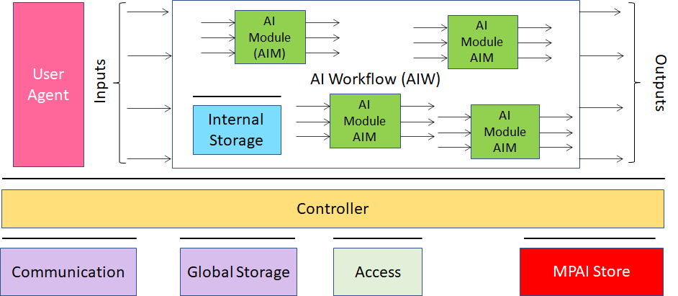
Figure 1 – The AI Framework (AIF) Reference Model and its Components

MPAI Application Standards normatively specify the following aspects of:
- An AIW:
  - The Semantics and Format of input data.
  - The Function.
  - The Semantics and Format of output data.
- An AIM:
  - The Semantics and Format of the input data.
  - The Function.
  - The Semantics and Format of the output data.
  - The Connections between and among the AIMs of an AIW.
In particular, an AIM is defined by its Function and Data, but not by its internal architecture, which may be based on AI or data processing, and implemented in software, hardware or hybrid software and hardware technologies.
MPAI defines Interoperability as the ability to replace an AIF, an AIW or an AIM Implementation with a functionally equivalent Implementation and MPAI defines 3 Interoperability Levels of an AIF that runs an AIW composed of AIMs:
- Executing any proprietary AIW and AIM function and using any proprietary data Format (Level 1).
- Executing an AIW composed of AIMs having all their Functions, Formats and Connections specified by an MPAI Application Standard (Level 2).
- Certified by an MPAI-appointed Assessor to possess the attributes of Reliability, Robustness, Replicability and Fairness – collectively called Performance (Level 3).
MPAI is the basic element of the MPAI Ecosystem [1] offering Users access to the promised benefits of AI with a guarantee of increased transparency, trust and reliability as the Interoperability Level of an Implementation moves from 1 to 3.

Scope of the Use Cases
Connected Autonomous Vehicles (MPAI-CAV) is an MPAI standard project, comprising several identified candidate use cases.
The purpose of this document is:
- To collect and describe the identified use cases.
- To define the functions of the AIWs that implement the use cases.
- To identify the input and output data of the AIWs.
- To identify the AIMs required to realise the AIWs.
- To define the functions of the AIMs.
- To identify the input and output data of the AIMs.
Chapter 6 specifies the requirements that the data formats identified in points 3. and 6. above should satisfy.

Terms and definitions
Table 1 defines the terms used in this document. Terms are organised by the CAV Subsystems identified in Figure 3. The general MPAI Terms are defined in Table 17.

Table 1 – Definition of Terms used in this document organised by subsystems

SubS | Term | Definition
AMS | Command | High-level instructions whose execution allows a CAV to reach a Goal.
AMS | Decision Horizon | The estimated time between the current State and the Goal.
AMS | Full World Representation | A digital representation of the Environment created by fusing all available Basic World Representations.
AMS | Goal | The planned State at the end of the Decision Horizon.
AMS | Path | A sequence of Poses 𝑝_{𝑖} = (𝑥_{𝑖},𝑦_{𝑖},z_{i},𝜃_{𝑖}) in the Offline Map.
AMS | Pose | Coordinates and orientation of the CAV in the Offline Map p = (𝑥,𝑦,z,𝜃)
AMS | Route | A sequence of Way Points
AMS | State | CAV’s Pose, Velocity and Acceleration at a given time.
AMS | Traffic Rules | The digital representation of the traffic rules applying to a Pose.
AMS | Way Point | A point 𝑤_{𝑖} given as a coordinate pair (𝑥_{𝑖}, 𝑦_{𝑖}), in an Offline Map
CAV | Connected Autonomous Vehicle | A vehicle capable to autonomously reach an assigned target by understanding human utterances, planning a route, sensing and interpreting the environment, exchanging information with other CAVs and acting on the CAV’s motion subsystem.
CAV | Health | The condition, e.g., mechanical, of a Subsystem or an AIM of a CAV.
CAV | Reference Model | The graphical representation of the AIW implementing a CAV Subsystem comprising:  - AIW input and output data.  - AIMs’ input and output data.  - AIMs’ connections.
CAV | Subsystem | One of the 5 components making up the CAV.
ESS | Basic World Representation | A digital representation of the Environment created with information available from the CAV’s ESS and an Offline Map.
ESS | Environment | The portion of the world of interest to the CAV.
ESS | Global Navigation Satellite System | (GNSS) includes GPS, Galileo, Glonass. BeiDou, Quasi Zenith Satellite System (QZSS) and Indian Regional Navigation Satellite System (IRNSS).
ESS | Inertial Measurement Unit | An inertial positioning device, e.g., accelerometer, speedometer, gyroscope, odometer etc.
ESS | Offline Map | An offline-created map of a location and associated metadata.
HCI | Command | High-level instructions whose execution allows a CAV to reach a Goal.
HCI | Full World Representation | A description of Environment using the CAV’s and other CAVs’ Basic World Representation.
V2X | RSU | Roadside Unit.

References

Normative References
This document references the following normative documents:
- The Governance of the MPAI Ecosystem, MPAI document N341.
- Technical Specification: AI Framework (MPAI-AIF), MPAI document N324.
- Technical Specification: Context-based Audio Enhancement (MPAI-MMC), MPAI document N326.
- Technical Specification: Multimodal Conversation (MPAI-MMC), MPAI document N328

Informative References
This document references the following informative documents:
- SAE International Releases Updated Visual Chart for Its “Levels of Driving Automation” Standard for Self-Driving Vehicles, https://www.sae.org/news/press-room/2018/12/sae-international-releases-updated-visual-chart-for-its-%E2%80%9Clevels-of-driving-automation%E2%80%9D-standard-for-self-driving-vehicles
- ISO 8855: "Road vehicles -- Vehicle dynamics and road-holding ability -- Vocabulary"
- Rodolfo W. L. Coutinho and Azzedine Boukerche, Guidelines for the Design of Vehicular Cloud Infrastructures for Connected Autonomous Vehicles, IEEE Wireless Communications - August 2019
- Claudine Badue, Rânik Guidolini, Raphael Vivacqua Carneiro, Pedro Azevedo, Vinicius B. Cardoso, Avelino Forechi, Luan Jesus, Rodrigo Berriel, Thiago M. Paixão, Filipe Mutz, Lucas de Paula Veronese, Thiago Oliveira-Santos, Alberto F. De Souza; Self-driving cars: A survey; Expert Systems With Applications 165 (2021) 113816
- D. Cireşan, U. Meier, J. Masci, and J. Schmidhuber, “Multi-column deep neural network for traffic sign classification,” Neural Netw., vol.32, pp.333–338, Aug. 2012
- ETSI TR 103 562 V2.1.1 (2019-12), Analysis of the Collective Perception Service (CPS); Release 2.
- CAR 2 CAR Communication Consortium, https://www.car-2-car.org/
- Usman Ali Khan and Sang Sun Lee; Distance-Based Resource Allocation for Vehicle-to-Pedestrian Safety Communication; https://www.mdpi.com/2079-9292/9/10/1640/pdf
- Gokulnath Thandavarayan, Miguel Sepulcre, and Javier Gozalvez; Generation of Cooperative Perception Messages for Connected and Automated Vehicles; IEEE Transactions on Vehicular Technology, Vol. 69, No. 12, December 2020
- Pranav Kumar Singhab, Sunit Kumar Nandiac, Sukumar Nandi; A tutorial survey on vehicular communication state of the art, and future research directions; Vehicular Communications Volume 18, August 2019, 100164
- https://phantom.ai/assets/uploads/PAI%20Renesas%20Partnership%20Announcement%20(1).pdf
- Charles R., Qi Li, Yi Hao Su, Leonidas J. Guibas; PointNet++: Deep Hierarchical Feature Learning on Point Sets in a Metric Space; https://arxiv.org/pdf/1706.02413.pdf
- MPAI-MMC Call for Technologies, N154, https://mpai.community/standards/mpai-mmc/#CfT
- Bernard, Olivier; Bradway, David; Hansen, Hendrik H.G.; Kruizinga, Pieter; Nair, Arun; Perdios, Dimitris; Ricci, Stefano; Rindal, Ole Marius Hoel; Rodriguez-Molares, Alfonso; Stuart, Matthias Bo; The Ultrasound File Format (UFF) - First draft, Proceedings of 2018 IEEE International Ultrasonics Symposium
- LAS (LASer) File Format, Version 1.4 , https://www.loc.gov/preservation/digital/formats/fdd/fdd000418.shtml
- https://www.lesliesikos.com/pcap/
- https://pointclouds.org/documentation/tutorials/hdl_grabber.html
- https://www.mathworks.com/help/vision/ref/velodynefilereader.html
- M. Heistermann, S. Jacobi and T. Pfaff,Technical Note: An open source library for processing weather radar data (wradlib), https://hess.copernicus.org/articles/17/863/2013/hess-17-863-2013.pdf
- https://pro.arcgis.com/en/pro-app/latest/help/data/data-interoperability/supported-formats-with-the-data-interoperability-extension.htm
- CDOT and Panasonic Take First Steps to Turn I-70 into Connected Roadway, https://www.codot.gov/news/2018/july/cdot-and-panasonic-take-first-steps-to-turn-i-70-into-connected-roadway
- Navigation Data Standards, https://nds-association.org/
- Matthias Schreier; Environment Representations for Automated On-Road Vehicles; https://www.researchgate.net/publication/323105152_Environment_Representations_for_Automated_On-Road_Vehicles
- Toh Chai Keong, Juan Carlos Cano, Carlos-Javier Fernandez-Laguia, Pietro Manzoni; Wireless Digital Traffic Signs of the Future; IET Networks, September 2018
- Vladimir Hahanov, Wajeb Gharibi, Eugenia Litvinova, Svitlana Chumachenko, Arthur Ziarmand, Irina Englesi, Igor Gritsuk, Vladimir Volkov, Anastasiia Khakhanova; Cloud-Driven Traffic Monitoring and Control Based on Smart Virtual Infrastructure; 2017-03-28
- SharedStreets; https://sharedstreets.io/
- Serban, Alexandru Constantin, Erik Poll, and Joost Visser. “A Standard Driven Software Architecture for Fully Autonomous Vehicles.” 2018 IEEE International Conference on Software Architecture Companion (ICSA-C). IEEE, 2018.
- Bojarski, Mariusz, et al. “End to end learning for self-driving cars.” arXiv preprint arXiv:1604.07316 (2016).
- James S. Albus; The NIST Real-time Control System (RCS) An Approach to Intelligent Systems Research; https://tsapps.nist.gov/publication/get_pdf.cfm?pub_id=820528
- Integrated Public Alert & Warning System; https://www.fema.gov/gu/emergency-managers/practitioners/integrated-public-alert-warning-system/public
- OASIS Standard; Common Alerting Protocol Version 1.2; https://docs.oasis-open.org/emergency/cap/v1.2/CAP-v1.2-os.pdf
- Dorais G., Kortenkamp D. (2001) Designing Human-Centered Autonomous Agents. Lecture Notes in Computer Science, vol 2112. Springer, Berlin, Heidelberg. https://doi.org/10.1007/3-540-45408-X_32
- https://youtu.be/nCaomvjPIok

Use Cases
MPAI-CAV seeks to standardise all components that enable the implementation of a Connected Autonomous Vehicle (CAV), i.e., a mechanical system capable of executing the command to move its body autonomously – save for the exceptional intervention of a human – based on the analysis of the data produced by a range of sensors exploring the environment and the information transmitted by other sources in range, e.g., CAVs and roadside units (RSU). Figure 2 depicts the context where a CAV operates.
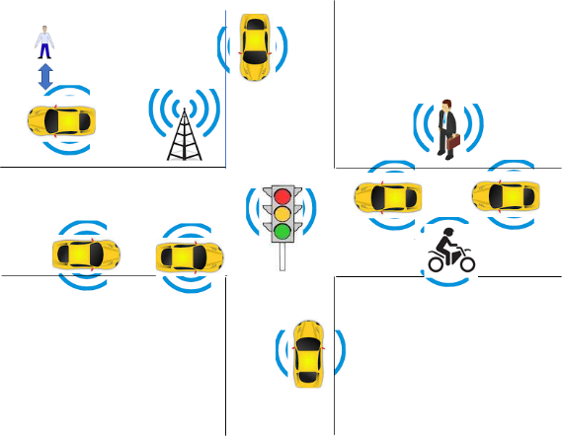
Figure 2 – The environment where a CAV operates
MPAI-CAV includes 5 Use Cases that correspond to the 5 main subsystems of a Connected Autonomous Vehicle:
- Human-CAV interaction (HCI) recognises the human CAV rights holder, responds to humans’ commands and queries, provides extended environment representation (Full World Representation) for humans to enjoy, senses human activities during the travel and may activate other subsystems as required by humans or as deemed necessary by the identified conditions.
- Environment Sensing Subsystem (EDS) acquires information from the physical environment via a variety of sensors and develops the best representation of the environment (Basic World Representation).
- Autonomous Motion Subsystem (AMS) computes the Route to destination, uses different sources of information –CAV sensors, other CAVs and transmitting units – to produce a Full World Representation and gives command that drive the CAV to the intended destination.
- CAV to Everything Subsystem (V2X) receives information from external sources, including other CAVs, other vehicles, Roadside Units (RSU) and sends information to other CAVs.
- Motion Actuation Subsystem (MAS) provides environment information¸ receives and actuates motion commands in the physical world.
The interaction of the 5 subsystems in depicted in Figure 3:

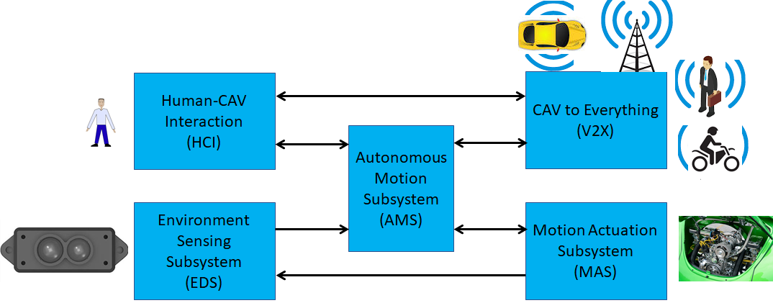
Figure 3 – The CAV subsystems

The following high-level workflow illustrates the operation of the CAV envisaged by this document.
- A human with appropriate credentials requests the CAV, via Human-CAV Interaction, to take the human to a given place.
- Human-CAV Interaction authenticates the human, interprets the request and passes a command to the Autonomous Motion Subsystem.
- Autonomous Motion Subsystem:
  - Requests Environment Sensing Subsystem to provide the current Pose.
  - Computes the Route.
  - Issues the start command.
- Environment Sensing Subsystem computes and sends Basic World Representations to the Autonomous Motion Subsystem.
- CAV to Everything
  - Becomes aware of other CAVs and external sources (CAVs, RSU etc.).
  - Shares the CAV’s Basic World Representation with CAVs in range.
- Autonomous Motion Subsystem:
  - Receives and processes data broadcasted by external sources (CAVs, RSU etc.).
  - Computes the Full World Representation.
  - Shares the CAV’s Full World Representation with CAVs in range.
  - Computes a Path.
  - Issues commands to the Motion Actuation Subsystem to move the CAV accordingly.
- While the CAV moves, humans
  - Interact and hold conversation with the Human-CAV Interaction and possibly other humans on board.
  - Issue commands.
  - Request views of the environment (Full World Representation) etc.
  - Interact with other CAVs.

Human-CAV interaction (HCI)

Use Case description
The human-CAV interaction is based on the principle that the CAV is impersonated by an avatar, selected by the CAV right-holder, who has the capability to animate head and face and emit speech that include features that display as much as possible the features, e.g., emotion, that would be displayed by a human driver.
Examples are:
- The CAV’s avatar is reactive to the Environment shows, e.g., it shows an angry face because a driver has made an improper motion.
- The CAV’s avatar is reactive to a Human, e.g., it shows an appropriate face to a human who has made a joke.
Other forms of interaction are:
- CAV authenticates human.
- A human issues commands to a CAV, e.g.,
  - Commands to Autonomous Motion Subsystem, e.g.: go to a Way point, display Full World Representation (see 5.3), etc.
  - Other commands, e.g.: turn off air conditioning, turn on radio, call a person, open window or door, search for information etc.
- A human entertains a dialogue with a CAV, e.g.,
  - Information requests, e.g.: time to destination, route conditions, weather at destination etc.
  - Casual conversation.
- A CAV monitors the passenger compartment, e.g.,
  - Physical conditions, e.g.: temperature level, media being played, sound level, noise level, anomalous noise, etc.
  - Passenger data, e.g.: number of passengers, ID, estimated age, destination of passengers.
  - Passenger activity, e.g.: level of passenger activity, level of passenger-generated sound, level of passenger movement, emotion on face of passengers.
  - Passenger-to-passenger dialogue, two passengers shake hands, or passengers hold everyday conversation.
The Human-CAV Interaction collects a variety of data generated by humans inside the vehicle for possible action. This issue if part of the more general problem of data privacy in a CAV that is handled in a dedicated chapter
It is important to point out that, regardless of the fact that vehicles can exhibit different levels of autonomy, the exhibited autonomy should always be adjustable [1]. The system should recognise people as intelligent agents it should inform and be informed by. A CAV should be able to change its level of autonomy to one of many levels while it operates. Such an adjustment may be initiated by a human, another system, or the CAV itself. One of the most important benefits achieved with adjustable, user-centered autonomy is increased user acceptance of the system [32].

Reference architecture
Figure 4 is the Human-CAV Interaction (HCI) reference model. The following is noted:
- A combination of Conversation with Emotion and Multimodal Question Answering AIMs with gesture recognition capabilities covers most Human-CAV Interaction needs.
- Additional AIMs can be added should new HCI interactions be required.

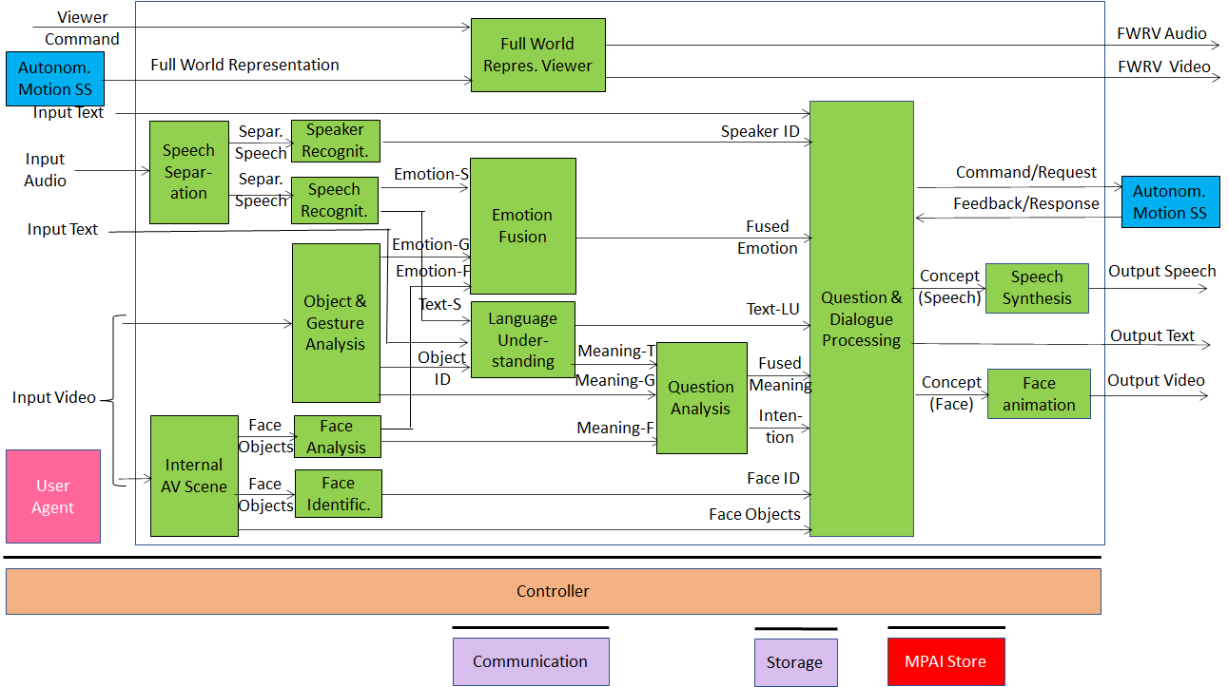
Figure 4 – Human-CAV Interaction Reference Model

Depending on the technology used (data processing or AI), the AIMs in Figure 4 may need to access external information, such as Knowledge Bases, to perform their functions. While not represented in Figure 4, they will be identified, if required, in the AI Modules subsection.

Input and output data
Table 2 – I/O data of Human-CAV Interaction
Input data | From | Comment
Audio | User Outdoor | User authentication  User command
Text | User Outdoor | User authentication  User command
Text | Passenger Compartment | Social life of user  Commands or interaction with CAV
Audio | Passenger Compartment | Social life of user  Commands or interaction with CAV
Video | Passenger Compartment | Social life of user  Commands or interaction with CAV
Full World Representation | Autonomous Motion SS | For processing by FWR Viewer
Output data | To | Comments
Text | Autonomous Motion Subsystem | Commands to be executed
Synthetic Speech | Passenger Compartment | CAV’s response to passengers
Synthetic Face | Passenger Compartment | CAV’s response to passengers
Full World Representation | Passenger Compartment | For passengers to view external world

AI Modules
The AI Modules of the Human-CAV Interaction depicted in Figure 4 are given in Table 3.

Table 3 – AI Modules of Human-CAV interaction

AIM | Function
Speech detection and separation | - Separates relevant speech vs non-speech signals  - Detects request for dialogue.
Speaker identification | Recognises speaker.
Speech recognition | - Analyses the speech input  - Generates text and emotion output.
Object and gesture analysis | - Analyses video to identify object  - Produces the ID of the object in focus  - Analyses video  - Produces motion and meaning of gesture.
Face recognition | - Analyses the video of the face of a human  - Recognise the human’s identity.
Face analysis | - Analyses the video of the face of a human  - Extracts emotion and meaning.
Language understanding | - Uses a language model (embedded in AIM)  - Analyses natural language expressed as text  - Produces the meaning of the text.  - Produces text related to Object ID
Emotion recognition | - Fuses Emotions from Speech, Face and Gesture.  - Produces Final Emotion.
Question analysis | - Fuses Meanings of Speech, Face and Gesture  - Analyses the meaning of the sentence  - Determines the Intention.  - Outputs Final Meaning
Question & dialog processing | - Receives Speaker ID and Face ID  - If speaker ID and face ID match, then  - Produces a command to Autonomous Motion SS  - Analyses user’s emotion, intention, meaning and/ or question, text  - Produces Reply (speech) and Reply (face).  - Else, responds appropriately.
Speech synthesis | Converts Concept (Speech) to Output Speech.
Face animation | Converts Concept (Face) to Output Video.
Full World Representation Viewer | - Receives Full World Representation (FWR)  - Presents a FWR view as instructed by human via FWR Commands.

Environment Sensing Subsystem (ESS)

Use Case description
The typical series of operations carried out by the Environment Sensing Subsystem (ESS) is given below. The sequential description of steps does not imply that an action is only carried out after the preceding one has been completed.
- The CAV gets its Pose and other environment data from
  - Global Navigation Satellite System (GNSS).
  - Vehicle Localiser in Environment Sensing Subsystem (ESS).
  - Other sensor data converter (e.g., weather, air pressure etc.)
- The CAV creates a Basic World Representation (BWR) by:
  - Acquiring available Offline maps of its current Pose.
  - Updating the Offline maps with
    - Other static objects.
    - All moving objects.
    - All traffic signals.
- The CAV compresses a subset of the sensor data and stores them on board.

Reference architecture
Figure 5 gives the Reference Model.

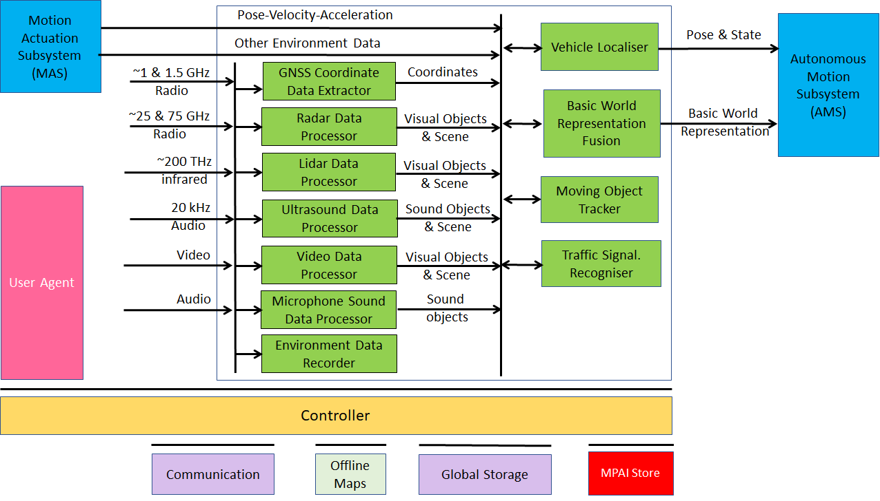
Figure 5 – Environment Sensing Subsystem Reference Model

Input and output data
Table 4 – I/O data of Environment Subsystem

Input data | From | Comment
Pose-Velocity-Acceleration | Motion Actuation Subsystem | To be fused with GNSS data
Other Environment Data | Motion Actuation Subsystem | Temperature etc. to be added to Basic World Representation
Global Navigation Satellite System (GNSS) | ~1 & 1.5 GHz Radio | Get Pose from GNSS
Radio Detection and Ranging (RADAR) | ~25 & 75 GHz Radio | Get RADAR view of Environment
Light Detection and Ranging (LIDAR) | ~200 THz infrared | Get LiDAR view of Environment
Ultrasound | 20 kHz Audio | Get 20 kHz view of Environment
Cameras (2/D and 3D) | Video (400-800 THz) | Get visible view of Environment
Microphones | 16 Hz-16 kHz sound | Get Audible view of Environment
Output data | To | Comment
State | Autonomous Motion Subsystem | For Route, Path and Trajectory
Basic World Representation | Autonomous Motion Subsystem | Locate CAV in Environment

AI Modules
The AI Modules of Environment Sensing Subsystem are given in Table 5.

Table 5 – AI Modules of CAV-Environment Interaction

AIM | Function
GNSS Data Coordinate Extractor | Computes global coordinates of CAV.
Radar Data Processor | Extracts electromagnetic scene and objects.
Lidar Data Processor | Extracts electromagnetic scene and objects.
Ultrasound Data Processor | Extracts ultrasound scene and objects.
Camera Data Processor | Extracts visual scene and objects.
Environment Sound Data Processor | Extracts audible audio scene and objects.
Environment Data Recorder | Compresses/records a subset of data produced by CAV sensors at a given time.
Vehicle Localiser | Estimates the current CAV State in the Offline Maps.
Moving Objects Tracker | Detects, tracks and represents position and velocity of Environment moving objects.
Traffic Signalisation Recogniser | Detects and recognises traffic signs to enable the CAV to correctly move in conformance with traffic rules.
Basic World Representation Fusion | Creates Basic World-Representation by fusing Offline Map, moving and traffic objects, and other sensor data

Autonomous Motion Subsystem (AMS)

Use Case description
The typical series of operations carried out by the Autonomous Motion Subsystem (AMS) is described below. Note that the sequential description does not imply that an operations can only be carried out after the preceding one has been completed.
- Human-CAV Interaction requests Autonomous Motion Subsystem to plan and move the CAV to the Pose indicated by the human.
- CAV requests Environment Sensor Subsystem to provide the current Basic World Representation
- While moving. CAV
  - Transmits the Basic World Representation and other data to CAVs in range.
  - Receives Basic World Representations and other data from CAVs.
  - Produces the Full World Representation by fusing its own Basic World Representation with those from other CAVs in range.
  - Plans a Path connecting Poses.
  - Selects behaviour to reach intermediate Goals taking into account information about the Goals other CAVs in range intend to reach.
  - Defines a Trajectory that
    - Complies with general traffic rules and local traffic regulations
    - Preserves passengers’ comfort.
  - Refines Trajectory to avoid obstacles.
  - Sends the Motion Actuation Subsystem the commands to take the CAV to the next Goal.
The AMS should be designed in such a way that different levels of autonomy, e.g., those indicated by SAE International [1], are possible depending on the amount and level of available functionalities.

Reference architecture
The Autonomous Motion Subsystem Reference Model is given by Figure 6.

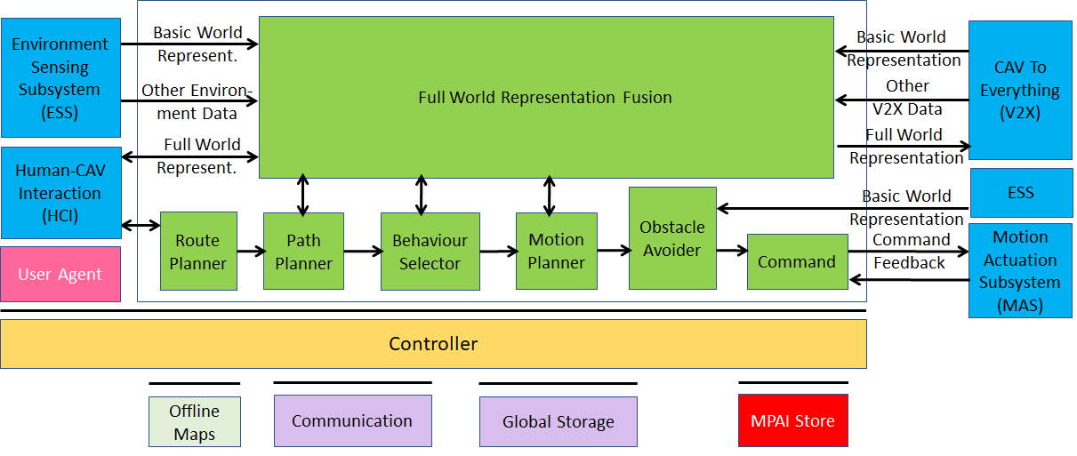
Figure 6 – Autonomous Motion Subsystem Reference Model

Input and output data
Table 6 – I/O data of Autonomous Motion Subsystem

Input data | From | Comment
Human Command | Human-CAV Interaction | Human commands, e.g., “take me home”
Basic World Representation | Environment Sensing Subsystem | Internal Environment representation
Other Environment Data | Environment Sensing Subsystem | E.g., temperature, air pressure
Other V2X Data | CAV To Everything | Roadside units, other vehicles
Command Feedback | Motion Actuation Subsystem | CAV’s response to command
Output data | To | Comment
AMS Response | Human-CAV Interaction | CAV’s response to AMS command
AMS Command | Motion Actuation Subsystem | Macro-instructions, e.g., “in 5s assume a given State”.
Full World Representation | CAV To Everything | For information to other CAVs

AI Modules
The AI Modules of the Autonomous Motion Subsystem are given in Table 7.

Table 7 – AI Modules of Autonomous Motion Subsystem

AIM | Function
Route Planner | Computes a Route, through a road network, from the current to the target Pose.
Path Planner | Generates a set of Paths, considering  - Current Route.  - State.  - Full World-Representation.  - Traffic Rules.
Behaviour Selector | Sets a Goal with a Driving Behaviour, to be reached within the Decision Horizon time frame.
Motion Planner | Defines a Trajectory, from the current State to the current Goal following the Behaviour Selector’s Path to the extent possible, satisfying the CAV’s kinematic and dynamic constraints, and considering passengers’ comfort.
Obstacle Avoider | Defines a new Trajectory to avoid obstacles.
Command | Instructs the CAV to execute the Trajectory considering the Environment conditions.
Full World-Representation Fusion | Creates an internal representation of the Environment by fusing information from itself, CAVs in range and other transmitting units..

CAV-to-Everything (V2X)

Use Case description
A CAV exchanges information via radio with other entities, e.g., CAVs in range and other information sources such as Roadside Units and Traffic Lights, thereby improving its perception capabilities:
- In two-way mode:
  - Other CAVs in range.
  - Fixed equipment (e.g., traffic light, roadside units).
- In one-way mode
  - Static objects (e.g., bus stop).
  - Other vehicles (not CAVs), such as electric scooters, bicycles.
  - Pedestrians whose personal devices transmits their Pose.

Reference architecture
CAVs in range are important not just as sources of valuable information, but also because, by communicating with them, each CAV can minimise interfence with other CAVs while pursuing its own goals.
The selected way to achieve this is by having a “CAV Proxy AIM” running in the CAV-to-Everything AIW next to a “General Data Communication” Subsystem which is in charge or communication with all other non-CAV communication entities.
The CAV-to-Everything Subsystem Reference Model is given by Figure 7.

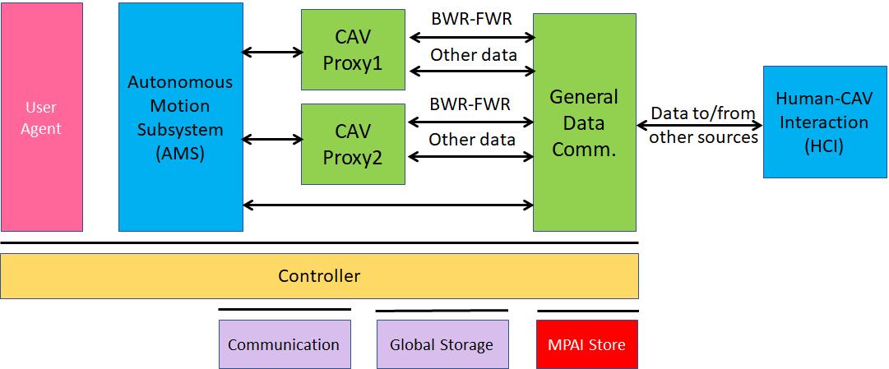
Figure 7 – The CAV-to-Everything Subsystem Reference Model

Input and output data

CAVs within range
Table 8 gives the data types a CAV broadcasts to CAVs in range. The Simple and Full World Representation data are exchanged to enable all relevant CAVs to share a common volumetric model of the Environment.

Table 8 – I/O data of CAV-to-Everything

Input Data | From | Comments
Basic World Representation | Other CAVs | A digital representation of the Environment created with information available from the CAV’s ESS and an Offline Map.
BWR Misalignments | Other CAVs | IDs and coordinates of objects having serious misalignments.
CAV Identity | Other CAVs | Digital equivalent of today’s plate number with Manufacturer, Model information.
CAV Intention | Other CAVs | The Path and other motion data relevant to other CAVs
Full World Representation | Other CAVs | A digital representation of the Environment created by fusing all available Basic World Representations.
Information Messages | Other CAVs | These are some of the messages a CAV can broadcast. Sources of messages potentially important for CAVs are given by [30, 31]  - CAV is an ambulance  - CAV carries an authority  - CAV carries a passenger with health problem  - CAV has a mechanical problem up to a certain level  - works and traffic jams ahead  - environment must be evacuated  - ....
Output Data | To | Comments
Basic World Representation | Other CAVs | Same as input for all other input data.

Other vehicles (not CAVs)
Other vehicles can be scooters, motorcycles, bicycles, other non-CAV vehicles.
They transmit their position as derived from GNSS.

Pedestrians
Their smartphones can transmit their coordinates as available from GNSS.

CAV-aware fixed equipment
Fixed equipment are traffic lights, roadside units. They can broadcast Basic and/or Full World Representations.
They can either issue orders to CAVs in range of be just one CAV-aware entity like any other CAV in range.

Traffic lights can broadcast:
- Geographic coordinates.
- State (Green-Yellow-Red), time to change state.
- Lane markings.
- Speed limits.
- Pedestrian crosswalks
- General traffic information.

Roadside units can broadcast:
- Identity and coordinates (exact coordinate reference)
- Full World Description (without moving objects) recorded in a roadside unit and regularly updated via download (this could be part of the offline map).

AI Modules
The AI Modules of Autonomous Motion Subsystem are given in Table 11.

Table 9 – AI Modules of CAV-To-Everything Subsystem

AIM | Function
General Data Communication | Communicates with non-CAV sources
CAV Proxy | Communicates data received from localCAV AIMs to the remote CAV it represents.  Communicates data received from remote CAV to appropriate local AIMs.

Motion Actuation Subsystem (MAS)

Use Case description
The Motion Actuation Subsystem is in charge to
- Receive instructions from Autonomous Motion Subsystem.
- Translate instructions into specific commands to its own mechanical subsystems, e.g., road wheels, accelerator, brakes.
- Receive feedbacks from its mechanical subsystems.
- Package feedbacks into high-level information.
- Send packaged information to Autonomous Motion Subsystem.
- Transmit information gathered from its subsystems to Environment Sensing Subsystem.

Reference architecture
The Motion Actuation Subsystem reference model is given by Figure 8.

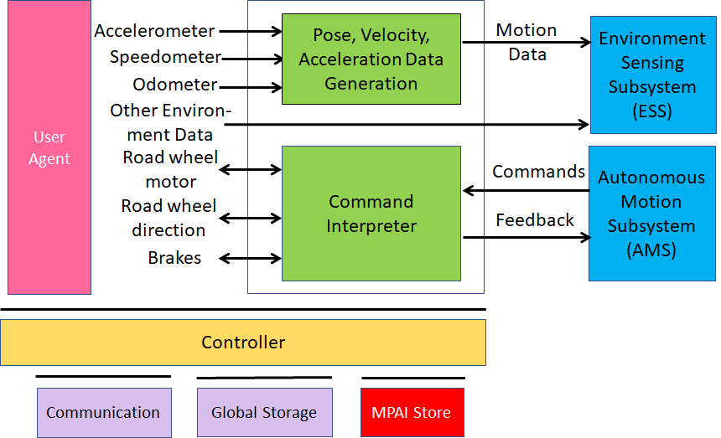
Figure 8 – The Motion Actuation Subsystem Reference Model

Figure 8 includes data from other sensors that are relevant to the motion of the CAV in the environment, e.g., air humidity, temperature, pressure etc.

Input and output data
Table 10 – I/O data of Motion Actuation Subsystem

Input | Comments
Odometer | Provides distance data.
Speedometer | Provides instantaneous velocity.
Accelerometer | Provides instantaneous acceleration.
Other Sensors | Provide other environment data, e.g., humidity, pressure, temperature.
Road Wheel Motor | Forces rotation of the road wheels.
Road Wheel Direction | Moves road wheels by an angle.
Brakes | Acts on brakes.
Commands from AMS | High-level motion command.
Output | Comments
Motion data | Position, velocity, acceleration.
Other data | Other environment data.
Feedback to AMS | Feedback from Command Converter during and after Command execution

AI Modules
The AI Modules of Autonomous Motion Subsystem are given in Table 11.

Table 11 – AI Modules of Motion Actuation Subsystem

AIM | Function
Pose-Velocity-Acceleration Data Generation | Transforms odometer, speedometer, accelerometer data to standard data format.
AMS Command Interpreter | Converts commands into specific actuation commands to Road wheel motor, Road wheel direction and Brakes.

Functional Requirements
Functional Requirements developed in this document refer to the individual technologies identified as necessary to implement MPAI-CAV Use Cases using AIMs operating in an MPAI AI Framework (AIF) and adhere to the following guidelines:
- AIMs are defined to allow implementations by multiple technologies (AI, ML, DP).
- DP-based AIMs may need interfaces, e.g., to a Knowledge Base. AI-based AIM will typically require a learning process, however, support for this process is not included in the document. MPAI may develop further requirements covering that process in a future document.
- AIMs can be aggregated in larger AIMs. Consequently, some data flows of aggregated AIMs may no longer be accessible.

Human-CAV Interaction

I/O Data summary
For each AIM (1st column), Table 12 gives the input (2nd column) and the output data (3rd column).

Table 12 – I/O data of Human-CAV Interaction AIMs

AIM | Input Data | Output Data
Speech Separation | Input Audio | Separated Speech
Internal AV Scene | Input Video | Face Objects
Speaker Recognition | Separated Speech | Speaker ID
Speech recognition | Separated Speech | Emotion (Speech)  Text (Speech)
Object and Gesture Analysis | Input Video | Object ID  Emotion (Gesture)  Meaning (Gesture)
Face Analysis | Face Objects | Emotion (Face)  Meaning (Face)
Face Identification | Face Objects | Face ID
Full World Representation Viewer | Viewer Command  Full World Representation | FWRV Audio  FWRV Video
Emotion Fusion | Emotion (Speech)  Emotion (Face)  Emotion (Gesture) | Fused Emotion
Language Understanding | Text (Speech)  Input Text  Object ID | Text (Language Understanding)  Meaning (Text)
Question analysis | Meaning (Text)  Meaning (Gesture)  Meaning (Face) | Fused Meaning  Intention
Question and dialogue processing | Input Text  Speaker ID  Fused emotion  Text (Speech)  Fused Meaning  Intention  Face ID  Face Objects | Command/Request  Feedback/Response  Concept (Speech)  Output Text  Concept (Face)
Speech synthesis | Concept (Speech) | Output Speech
Face animation | Concept (face) | Output Video

MPAI has issued a Call for Technologies for the MPAI-MMC standard [13] and acquired a set of first-generation technologies related to the data types listed below. MPAI is ready, however, to consider new technologies related to the data Formats requested in this Section if 1) they support new requirements and/or to enhance capabilities, and 2) the needs to support such new enhanced capability requirements are documented.

Audio
Audio is sampled from an analogue source (passenger compartment) at a frequency in the 44.1-96 kHz range with at least 16 and at most 24 bits/sample.

To respondents
Respondents are invited to comment on this choice.

Autonomous Motion Subsystem Response
The responses of the Autonomous Motion Subsystem are:
- Enumeration of possible routes with major features of each route.
- Enumeration of possible parking places with major features of each place.
- Announcement of obstacles preventing the expeditious accomplishment of the Command.
- Announcement that the desired Waypoint has been reached.

To respondents
Respondents are requested to propose a coded representation of the above commands. Proposals of coded representation of additional responses are welcome.

Concept (Face)
MPAI-MMC has adopted a Lips Animation format [4] for its MPAI-MMC Standard.

To Respondents
MPAI is now looking for a technology that can animate head and face of the avatar with the purpose to represent:
- Motion of head when speaking.
- Motion of face muscles and eyeballs.
- Turning of gaze to a particular person.
- Emotion of the associated spoken sentence.
- Meaning of the associated spoken sentence.

Concept (Speech)
MPAI-MMC has adopted Text With Emotion as Reply (speech) format [4] in its MPAO-MMC Standard.

To Respondents
Respondents are requested to propose a “Concept to Speech” format with the following requirements:
- Capability to represent varying Emotions in the synthetic Speech.
- Capability to represent varying Meanings of the CAV reply.

Emotion
MPAI has defined an extensible 3-level set of Emotions [4].

To respondents
Respondents are requested to comment on the suitability of the technology standardised in [4] for CAV purposes.

Face identity
The Face Identity AIM shall be able to represent the identity of a limited number of faces.

To respondents
Respondents are requested to propose a face identification system suitable for a limited number of faces.
Proposals of a face identification usable in the context of a company renting CAVs to customers are welcome.

Face Objects
In order for the HCI Subsystem to have a full understanding of what is happening in the passenger compartment (e.g., to have a more natural audio-visual interaction with the passengers, recording of what happened in the compartment etc.), the HCI Subsystem needs to represent the data acquired from the compartment. The current use is
- To extract the face of a passenger for the purpose of extracting Emotion and Identity.
- To determine the exact location of a passenger in the compartment in order to animate the CAV’s Avatar Face in such a way that the Avatar gazes into the eyes of the passenger it is talking to.

To respondents
Respondents are invited to propose a format for Face Objects to be used as input to Face Analysis, Face Identification and Question and Dialogue Processing satisfying the above requirements.

Full World Representation
The requirements of the FWR AIM are developed in the context of CAV Autonomous Motion Subsystem requirements.

Full World Representation commands
The requirements of FWR interaction will be developed once the FWR requirements are defined.

Human Commands
The basic commands given to the Autonomous Motion Subsystem are:
- Go to a Waypoint.
- Park close to a Waypoint.
- Drive faster.
- Drive slowly.
- Display Full World Representation.

To respondents
Respondents are requested to propose a coded representation of the above commands. Proposals of coded representation of additional commands are welcome.

Intention
MPAI has defined a digital representation format for Intention [4].

To respondents
Respondents are requested to comment on the suitability of the technology standardised in [4] for CAV purposes.

Meaning
MPAI has defined a digital representation format for Meaning [4].

To respondents
Respondents are requested to comment on the suitability of the technology standardised in [4] for CAV purposes.

Object Identifier
MPAI has defined a digital representation format for Object Identifier [4].

To respondents
Respondents are requested to comment on the suitability of the technology standardised in [4] for CAV purposes.

Speaker Identity
The current Speaker Identity requirements demand the ability to identify a limited number of Speakers.

To respondents
Respondents are requested to propose a Speaker Identification methods suitable for a limited number of speakers.
Proposals of a Speaker Identification method usable in a content of a company renting CAVs to customers are welcome.

Text
As there is a need to support most languages in use, Text representation conforms to ISO/IEC 10646, Information technology – Universal Coded Character Set (UCS).

To respondents
Respondents are invited to comment on this choice.

Video
Video is intended for use in the passenger compartment.
The following characteristics of 2D Video have been adopted.
- Pixel shape: square
- Bit depth: 8-10 bits/pixel
- Aspect ratio: 4/3 and 16/9
- 640 < # of horizontal pixels < 1920
- 480 < # of vertical pixels < 1080
- Frame frequency 50-120 Hz
- Scanning: progressive
- Colorimetry: ITU-R BT709 and BT2020
- Colour format: RGB and YUV
- Compression: uncompressed, if compressed AVC, HEVC

To respondents
Respondents are invited to comment on MPAI’s choice for 2D Video.
Respondents are also requested to propose a data format for 3D Video having video+depth as the baseline format or other 3D Video data formats.

Environment Sensing Subsystem

I/O Data summary
For each AIM (1st column), Table 13 gives the input (2nd column) and the output data (3rd column). The following 3-digit subsections give the requirements of the data formats in columns 2 and 3.

Table 13 – Environment Sensing Subsystem data

AIM or Subsystem | Input | Output
Vehicle Localiser | GNSS Coordinates | State
 | Pose-Velocity-Acceleration
 | Offline Maps
Environment Recorder | State | --
 | Volumetric data (TBD)
 | Environment conditions (TBD)
GNSS Coordinate Data Extractor | GNSS data | Global coordinates
Radar Data Processor | Radar data | Visual Objects and Scene
Lidar Data Processor | Lidar data | Visual Objects and Scene
Ultrasound Data Processor | Ultrasound data | Visual Objects and Scene
Camera Data Processor | Camera data | Visual Objects and Scene
Microphone Sound Data Processor | Microphone data | Sound Objects and Scene
Traffic Signalisation Detector | Visual Objects and Scene | Traffic signals  Traffic rules
Moving Objects Tracker | Visual Objects and Scene | Moving objects’ states
Basic World Representation Fusion | State | Basic World Representation
 | Offline maps
 | Visual Objects and Scenes
 | Static and moving objects
 | Traffic signals

Audio Array
Microphones are used to capture the external sound, (e.g., for noise suppression inside the passenger compartment, but also to add the sound dimension to the Full World Representation.
Audio from the Environment is captured by an array of microphones.

To Respondents
Respondents are requested to propose an Audio Array Format suitable to create a 3D sound field representation of the Environment to be added to the Basic World Representation and used inside the passenger compartment, e.g., to cancel Environment noise.

Audio Objects
To Respondents
Respondents are requested to propose an Audio Objects Format that provides information about audio objects identified in the Environment with semantics and accuracy.

Basic World Representation
Data from different information sources, e.g., CAV’s Environment sensors, CAVs in range and Offline maps are combined to one comprehensive Basic World Representation (BWR) [23]. The BWR ensures that all CAV functions base their decisions on the same knowledge base, thus ensuring consistency of system operation.
The requirements of the BWR are:
- All perceived objects that impact the path decision process in the Decision Horizon Time shall be represented in the BWR
- Each object in the BWR shall be described by
  - Its ID.
  - Its State.
  - Its physical characteristics, e.g., static or dynamic.
  - Its bounding box (as a minimum) and its full shape if known.
  - Its semantics (e.g., other CAVs or other objects).
  - An accuracy estimate.
- The ground (roads etc.) shall be described with all traffic signalisations, including roads and lane geometry, topology, and lane-specific traffic rules.
- The BWR shall have the ability to scale as to the level of structuredness of the Environment increases.
- The BWR shall have a scalable representation that allows fast access to critical data.

To Respondents
Respondents are requested to propose a Basic World Representation data format satisfying the requirements.

GNSS Coordinates
To Respondents
Respondents are requested to provide a format for the coordinates and the accuracy of the data.

GNSS Data
Global Navigation Satellite Systems (GNSS) provide spatial information with different accuracies. GNSS can only be relied on when reception conditions are above a certain level. This excludes GNSS in tunnels or urban canyons.
Some data formats are:
- GPS Exchange Format (GPX) provides an XML schema providing a common GPS data format that can be used to describe waypoints, tracks, and routes.
- World Geodetic System (WGS) includes the definition of the coordinate system's fundamental and derived constants, the ellipsoidal (normal) Earth Gravitational Model (EGM), a description of the associated World Magnetic Model (WMM), and a current list of local datum transformations.
- International GNSS Service (IGS) SSR is a format used to disseminate real-time products to support the IGS (igs.org) Real-Time Service. The messages support multi-GNSS and include corrections for orbits, clocks, DCBs, phase-biases and ionospheric delays. Extensions are planned to also cover satellite attitude, phase centre offsets and variations and group delay variations.

To Respondents
Respondents are requested to propose a single GNSS data format that is capable to represent the features of all GNSS types.

Lidar Data
Like Radar, Light Detection and Ranging (LiDAR) is an active sensor. Unlike Radar, however, it operates in the µm range. It sends an electromagnetic signal and receives the reflected signal back. A typical eye-safe LiDAR:
- Has a frequency of ~200 THz and a wavelength ~1.5 µm (the visible range is 0.4 to 0.75 µm).
- Measures the range in each pixel (called also voxels).
- Pixel grayscale is measured by the intensity variation of the reflected light.
- The colour of an object can be measured by using more than one wavelength.
- Velocity can be measured using the Doppler shift in frequency due to motion, or by measuring the position at different times.
- Micro-motion can be measured using the Doppler shift measured with a coherent LiDAR.
- Produces 100 kpoints/frame or 1.35 Mbytes: 32*3 bits (coordinates) +16 bits (reflectance). Today 200 kpoints/frame are reasonable.
- Angular resolution is 0.1º and the vertical field is 40º.
- A Lidar scan captured at 25 fps is 270 Mbit/s or 33.75 Mbytes/s.

To Respondents
The LAS (LASer) format is a binary file format for LiDAR point cloud data specified by the American Society for Photogrammetry and Remote Sensing (ASPRS) [15].
Pcap are a well-established data format for Lidar scans [16, 17, 18]. Other formats are listed in [20]. E57 is one of them.
Respondents are invited to provide a LiDAR data format that facilitates identification, tracking and digital representation of objects.

Moving Object Tracker Data
Moving Object Tracker receives the Visual Objects and Scene data from the different sources – Lidar, Radar, Cameras, Ultrasound, Environment Sound – and provides a list of Visual Objects where each Object has the following associated data
- Spatial coordinates
- Bounding Boxes
- Coordinated of vertices of Bounding Boxes
- Velocity and Acceleration
- Accuracy of the data.

To Respondents
Respondents are requested to propose a format for the list and the Objects.

Offline maps
Offline maps or HD maps or 3D maps are roadmaps with cm-level accuracy and a high environmental fidelity. They report the exact positions of pedestrian crossings, traffic lights/signs, barriers and more.
Navigation Data Standards [22] calls itself “The worldwide standard for map data in automotive eco-systems”. The NDS specification covers data model, storage format, interfaces, and protocols.
SharedStreets [26] Referencing System is a global non-proprietary system for describing streets.

To Respondents
Respondents are requested to propose an Offline Map Format. The Format should support different levels of conformance.

Radar
Radio Detection and Ranging (RADAR), LiDAR and ultrasound are based on “time-of-flight”, i.e., they measure distance and speed based on the time it takes for a signal to hit an object and be reflected back.
Radar operates in the mm range. Radar can detect vehicles (CAVs and trucks) because they typically reflect Radar signals while objects that are smaller and have less reflectance, e.g., pedestrians and motorcycles have a poor reflectance. In a busy environment, vehicles’ reflections can swamp that from a motorcycle; a child next to a vehicle can go undetected, while a can may produce an image out of proportion to its size.
Main features of Radar
- Measure distance.
- Independent of environment.
- Low resolution (objects detected, not classified).
- Short range radar in the 25 GHz band, distance is computed.
- Long range radar in the 76-77 GHz, detects objects and measures speed @ ≤ 250 m. Typical ranges of long-range radar (LRR) systems are 80-200 m. The antenna is small because the wavelength is ~3.5-4 mm. Atmospheric absorption limits interference with other systems. A multitask 94-GHz pulse Doppler radar has 25-cm radial and 1.5 degrees angular resolution
Frequency Modulated Continuous Wave (FMCW) is the dominant radar technology. A radar TX sends a sinusoidal carrier with a frequency that increases then decreases periodically over time (chirp). The difference in frequency between the RX signal (representing an object) and the TX signal is proportional to travel time and a measure of the distance. The relative velocity of an object is obtained by comparing the Doppler frequency shifts of the chirp’s increasing and decreasing frequency portions.
Radar sensors build a representation of the environment based on the observation of complex, scattered radio waves, from which information of an object’s distance and velocity can be derived.
Known Radar data formats include [19]:
- OPERA BUFR format (Paulitsch et al., 2010).
- hdf5 formats (Michelson et al., 2011).
- NetCDF files generated by the commercial EDGE software.
- hdf5 files generated by the commercial GAMIC software.
- German Weather Services quantitative local scan format (DX).
- Quantitative composite format (RADOLAN, see German Weather Service, 2004).

To Respondents
Respondents are invited to propose a format of Radar images that facilitates identification, tracking and representation of objects.

State
State is the set of the following CAV attributes at a given time:
- Pose, Velocity and Acceleration
- Orientation, Angular Velocity and Angular Acceleration.

To Respondents
Respondents are requested to propose a State Format suitable for use in CAVs.

Traffic Signalisation
Traffic Signalisation types are:
- Traffic signs
- Road signs
- Placement signs
- Acoustic signs
- Traffic lights

To Respondents
Respondents are requested to propose a set of Traffic Signalisation Descriptors.

Ultrasound Data
- Operates at 20 kHz
- Independent of environment
- Low resolution
- Limited range (≤ 10 m)

To Respondents
The Ultrasound File Format initiative has defined the Ultrasound File Format (UFF) format [14].
Respondents are invited to propose an ultrasound format that facilitates identification, tracking and representation of sound objects.

Video Camera data
To Respondents
Respondents are invited to provide a data Format for RGB-D cameras.

Visual Objects and Scene (Camera)
To Respondents
Respondents are invited to provide a Format for scenes captured by cameras. The format should be sufficiently generic to be capable to be used for scenes captured by Radar, Lidar and Ultrasound devices.

Visual Objects and Scene (Lidar)
To Respondents
Respondents are invited to provide a Format for scenes captured by Lidars. The format should be sufficiently generic to be capable to be used for scenes captured by Radar, Video and Ultrasound devices.

Visual Objects and Scene (Radar)
To Respondents
Respondents are invited to provide a Format for scenes captured by Radars. The format should be sufficiently generic to be capable to be used for scenes captured by Lidar, Video and Ultrasound devices.

Ultrasound Objects and Scene (Ultrasound)
To Respondents
Respondents are invited to provide a Format for scenes captured by Ultrasound. The format should be sufficiently generic to be capable to be used for scenes captured by Lidar, Radar and Video devices.

Autonomous Motion Subsystem

Summary of Autonomous Motion Subsystem data
Table 14 gives, for each AIM (1st column), the input (2nd column) and the output data (4th column).

Table 14 – CAV Autonomous Motion Subsystem data

CAV/AIM | Input | Output
Route Planner | State  Destination | Route  Estimated time
Full World Representation Fusion | State | Full World Representation
 | Offline Maps
 | Basic World Representations
 | Other Environment Data
Path Planner | State | Set of Paths
 | Route
 | Traffic Rules
Behaviour Selector | State | Path
 | Route
 | Full World Representation
Motion planner | Path | Trajectory
Obstacle Avoider | Full World Representation Trajectory | Trajectory
Command | Trajectory | Actuations

Basic World Representation
Defined in Environment Sensing Subsystem.

To Respondents
No response requested here. Comments welcome.

Full World Representation
The elements of the FWD are:
- Appropriate portion of the offline map.
- Physics of the environment: weather, temperature, air pressure, ice and water on the road).
- For each object: ID, position, velocity, acceleration bounding box (more than a box, if available), semantics, flags (e.g., warning).
- For CAVs, the Path and bounding box or the shape of the body, if available.
- Road structure.
- Local traffic signalisation.
- Scalable representation that
  - Allows fast access to different data depending on the AIM who needs to access it.
  - Supports deliberative and reactive actions.
- The estimated accuracy of each data element.

Goal
Is a particular Pose, which is an element of the State.

To Respondents
No response requested. Comments welcome.

Offline map
Defined in Environment Sensing Subsystem.

To Respondents
No response requested here. Comments welcome.

Path
A sequence of Poses in the Offline Map

To Respondents
No response requested here. Comments welcome.

Pose
See above

Route
A route is a sequence of Waypoints.

To Respondents
A Route Format compatible with a proposed Offline Map Format is requested

State
Defined in Environment Sensing Subsystem.

To Respondents
No response requested here. Comments welcome.

Traffic rules
The traffic rules should be digitally represented to realise a route [25]. Traffic Ontology.

To Respondents
MPAI requests a digital representation of traffic rules satisfying the following requirements:
- Produce the traffic rules from a given set of traffic signals
- Produce the traffic signals from the traffic rules.

Traffic Signals
Format to represent traffic signals on a road and around it.

To Respondents
MPAI requests a Traffic Signals Format capable to represent
- All traffic signalisations required
- The specific local version of traffic signalisation
- The coordinates of the traffic signals

Trajectory
A Trajectory is defines as the Path that allows a CAV to start from a State and reach another State in a given amount of time.

To Respondents
No response requested here. Comments welcome.

User input data
Text. To be further discussed.

Velocity
Defined in Environment Sensing Subsystem.

To Respondents
No response requested here. Comments welcome.

CAV to Everything

Summary of CAV to Everything data
Table 14 gives, for each AIM (1st column), the input data (2nd column) from which AIM (3rd column) and the output data (4th column).

Table 15 –CAV to Everything data

CAV AIM | Input | Output
General Data Communication | Transmission request | CAV identity and model
General Data Communication | Transmission request | State-Path-Trajectory
General Data Communication | Transmission request | Basic World Representation
General Data Communication | Transmission request | Full World Representation
General Data Communication | Transmission request | Messages
General Data Communication | Remote CAV #1 | Basic World Representation
AMS | Basic World Representation | Remote CAV #1

Basic World Representation
As in Environment Sensing Subsystem.

To Respondents
No response requested here. Comments welcome.

CAV Identifier
The CAV identification system should carry the following information
- Country where the CAV has been registered
- Registration number in the country
- CAV manufacturer identifier
- CAV model identifier

To Respondents
MPAI requests proposals for universal CAV identification system. Justified proposals for inclusion of additional data in the CAV Identifier are welcome

Events
Events is used to give CAV information that is useful for its travel.
Examples are:
- Road is blocked at waypoint x,y,z
- Traffic jam at waypoint x,y,z
- ...

To Respondents
MPAI requests proposals for events, their semantics and coded representation.

Full World Representation
Defined in Autonomous Motion Subsystem.

To Respondents
No response requested here. Comments welcome.

Path
Defined in Autonomous Motion Subsystem.

To Respondents
No response requested here. Comments welcome.

State
Defined in Autonomous Motion Subsystem.

To Respondents
No response requested here. Comments welcome.

Trajectory
Defined in Autonomous Motion Subsystem.

To Respondents
No response requested here. Comments welcome.

Motion Actuation Subsystem

Summary of Motion Actuation Subsystem data
Table 14 gives, for each AIM (1st column), the input data (2nd column) from which AIM (3rd column) and the output data (4th column).

Table 16 –Motion Actuation Subsystem data

CAV/AIM | Input | Output
Command converter | Command from AMS | Road Wheel Motor Command  Road Wheel Direction Command  Brakes Command
Command Interpreter | Road Wheel Motor Feedback  Road Wheel Direction Feedback  Brakes Feedback | Feedback to AMS
Pose, Velocity, Acceleration Data Generation | Accelerometer  Speedometer  Odometer | Motion Data
Other Data Converter | Other Environment | Other Environment Data

Accelerometer data
An accelerometer is an electronic sensor that measures the acceleration forces acting on a CAV. An accelerometer measures proper acceleration, i.e., the acceleration of a body in its own instantaneous rest frame, not to be confused with coordinate acceleration, i.e., acceleration in a fixed coordinate system. Therefore, an accelerometer at rest on the surface of the Earth measures an acceleration straight upwards of g ≈ 9.81 m/s2. In free fall (falling toward the centre of the Earth at ≈ 9.81 m/s2) measures zero.

To Respondents
Respondents are requested to propose a single Accelerometer data format.

Brakes Command
To Respondents
Respondents are requested to propose a set of command messages.

Brakes Feedback
To Respondents
Respondents are requested to propose a set of feedback messages.

Command from AMS
To Respondents
Respondents are requested to propose a set of high-level command messages.

Feedback to AMS
To Respondents
Respondents are requested to propose a set of high-level feedback messages

Motion Data
To Respondents
Respondents are requested to propose a Motion Data Format bearing in mind that Motion Data will be used to create the CAV State by adding GNSS information.

Odometer Data
An odometer converts as the distance travelled the number of wheel rotations times the tire circumference (π x tire diameter) from the start up to the point being considered.

To Respondents
Respondents are requested to propose a single Odometer Data Format.

Other Environment Data
To Respondents
Respondents are requested to propose a set Environment Data Formats.

Road Wheel Direction Command
To Respondents
Respondents are requested to propose a set of Road Wheel Direction Commands

Road Wheel Direction Feedback
To Respondents
Respondents are requested to propose a set of Road Wheel Direction Feedbacks

Road Wheel Motor Command
To Respondents
Respondents are requested to propose a set of Road Wheel Motor Commands

Road Wheel Motor Feedback
To Respondents
Respondents are requested to propose a set of Road Wheel Motor Feedbacks

Speedometer
A speedometer is an electronic sensor that measures the instantaneous speed of a CAV.

To Respondents
Respondents are requested to propose a single Speedometer data format.

Data privacy
A CAV can generate or acquire data for which privacy is an important characteristic. here are some of the functions potentially affected by data privacy or that are liable to become accessible to authorities. e.g., police, judiciary.

Human-CAV Interaction (HCI)
By having interactions with humans, HCI becomes aware of potentially sensitive information, e.g.:
- Result of monitoring the passenger compartment.
- Minute requests from humans, e.g., go to a way point, display Full World Representation, turn off air conditioning, etc.
- Dialogue with human

Environment Sensing Subsystem (ESS)
ESS collects large among of environment data for the purpose of creating instantaneous Basic World Representations, e.g.:
- GNSS gives the position of the CAV and of whatever is perceived by the CAV that is approximate, but sufficiently precise for my uses.
- Radar, Lidar, Ultrasound give variously defined information about what is in the environment surrounding the CAV.
- Cameras give a 360° panoramic view of the environment where all objects, save those occluded, are visible.
- External microphones give a complete representation of the external sound field.
A user could create a permanent and certified recording of important data acquired by ESS.
The environment recorder could compress and record all data acquired for a limited amount of time. Some data could be recorded for a longer time.

Autonomous motion subsystem (AMS)
AMS knows the exact waypoints the CAV has passed through and all the commands given to the Motion Actuation Subsystem.
By integrating the Basic World Representations of all CAVs in range and its own, a CAV can create a pretty detailed and extended map of the environment.

CAV to Everything (V2X)
V2X acquires the identity of the CAVs in range and communicates appropriate subsets of the Basic and Full Worlds Representations.

Motion Actuation Subsystem (MAS)
MAS acquires position information through its Inertial Measurements Unit.

Annex 1 – General MPAI Terminology (Normative)
The Terms used in this standard whose first letter is capital and are not already included in Table 1 are defined in Table 17.

Table 17 – MPAI-wide Terms

Term | Definition
Access | Static or slowly changing data that are required by an application such as domain knowledge data, data models, etc.
AI Framework (AIF) | The environment where AIWs are executed.
AI Workflow (AIW) | An organised aggregation of AIMs implementing a Use Case receiving AIM-specific Inputs and producing AIM-specific Outputs according to its Function.
AI Module (AIM) | A processing element receiving AIM-specific Inputs and producing AIM-specific Outputs according to according to its Function.
Application Standard | An MPAI Standard designed to enable a particular application domain.
Channel | A connection between an output port of an AIM and an input port of an AIM. The term “connection” is also used as synonymous.
Communication | The infrastructure that implements message passing between AIMs
Component | One of the 7 AIF elements: Access, Communication, Controller, Internal Storage, Global Storage, MPAI Store, and User Agent
Conformance | The attribute of an Implementation of being a correct technical Implementation of a Technical Specification.
Conformance Tester | An entity authorised by MPAI to Test the Conformance of an Implementation.
Conformance Testing | The normative document specifying the Means to Test the Conformance of an Implementation.
Conformance Testing Means | Procedures, tools, data sets and/or data set characteristics to Test the Conformance of an Implementation.
Connection | A channel connecting an output port of an AIM and an input port of an AIM.
Controller | A Component that manages and controls the AIMs in the AIF, so that they execute in the correct order and at the time when they are needed
Data Format | The standard digital representation of data.
Data Semantics | The meaning of data.
Ecosystem | The ensemble of the following actors: MPAI, MPAI Store, Implementers, Conformance Testers, Performance Testers and Users of MPAI-AIF Implementations as needed to enable an Interoperability Level.
Explainability | The ability to trace the output of an Implementation back to the inputs that have produced it.
Fairness | The attribute of an Implementation whose extent of applicability can be assessed by making the training set and/or network open to testing for bias and unanticipated results.
Function | The operations effected by an AIW or an AIM on input data.
Global Storage | A Component to store data shared by AIMs.
Internal Storage | A Component to store data of the individual AIMs.
Identifier | A name that uniquely identifies an Implementation.
Implementation | - An embodiment of the MPAI-AIF Technical Specification, or  - An AIW or AIM of a particular Level (1-2-3) conforming with a Use Case of an MPAI Application Standard.
Interoperability | The ability to functionally replace an AIM with another AIM having the same Interoperability Level
Interoperability Level | The attribute of an AIW and its AIMs to be executable in an AIF Implementation and to:  - Be proprietary (Level 1)  - Pass the Conformance Testing (Level 2) of an Application Standard  - `Pass the Performance Testing (Level 3) of an Application Standard.
Knowledge Base | Structured and/or unstructured information made accessible to AIMs via MPAI-specified interfaces
Message | A sequence of Records transported by Communication through Channels.
Normativity | The set of attributes of a technology or a set of technologies specified by the applicable parts of an MPAI standard.
Performance | The attribute of an Implementation of being Reliable, Robust, Fair and Replicable.
Performance Assessment | The normative document specifying the procedures, the tools, the data sets and/or the data set characteristics to Assess the Grade of Performance of an Implementation.
Performance Assessment Means | Procedures, tools, data sets and/or data set characteristics to Assess the Performance of an Implementation.
Performance Assessor | An entity authorised by MPAI to Assess the Performance of an Implementation in a given Application domain
Profile | A particular subset of the technologies used in MPAI-AIF or an AIW of an Application Standard and, where applicable, the classes, other subsets, options and parameters relevant to that subset.
Record | A data structure with a specified structure
Reference Model | The AIMs and theirs Connections in an AIW.
Reference Software | A technically correct software implementation of a Technical Specification containing source code, or source and compiled code.
Reliability | The attribute of an Implementation that performs as specified by the Application Standard, profile and version the Implementation refers to, e.g., within the application scope, stated limitations, and for the period of time specified by the Implementer.
Replicability | The attribute of an Implementation whose Performance, as Assessed by a Performance Assessor, can be replicated, within an agreed level, by another Performance Assessor.
Robustness | The attribute of an Implementation that copes with data outside of the stated application scope with an estimated degree of confidence.
Service Provider | An entrepreneur who offers an Implementation as a service (e.g., a recommendation service) to Users.
Standard | The ensemble of Technical Specification, Reference Software, Conformance Testing and Performance Assessment of an MPAI application Standard.
Technical Specification | (Framework) the normative specification of the AIF.  (Application) the normative specification of the set of AIWs belonging to an application domain along with the AIMs required to Implement the AIWs that includes:  - The formats of the Input/Output data of the AIWs implementing the AIWs.  - The Connections of the AIMs of the AIW.  - The formats of the Input/Output data of the AIMs belonging to the AIW.
Testing Laboratory | A laboratory accredited by MPAI to Assess the Grade of Performance of Implementations.
Time Base | The protocol specifying how Components can access timing information
Topology | The set of AIM Connections of an AIW.
Use Case | A particular instance of the Application domain target of an Application Standard.
User | A user of an Implementation.
User Agent | The Component interfacing the user with an AIF through the Controller
Version | A revision or extension of a Standard or of one of its elements.
Zero Trust

Annex 2 - Notices and Disclaimers Concerning MPAI Standards (Informative)

The notices and legal disclaimers given below shall be borne in mind when downloading and using approved MPAI Standards.

In the following, “Standard” means the collection of four MPAI-approved and published documents: “Technical Specification”, “Reference Software” and “Conformance Testing” and, where applicable, “Performance Testing”.

Life cycle of MPAI Standards
MPAI Standards are developed in accordance with the MPAI Statutes. An MPAI Standard may only be developed when a Framework Licence has been adopted. MPAI Standards are developed by especially established MPAI Development Committees who operate on the basis of consensus, as specified in Annex 1 of the MPAI Statutes. While the MPAI General Assembly and the Board of Directors administer the process of the said Annex 1, MPAI does not independently evaluate, test, or verify the accuracy of any of the information or the suitability of any of the technology choices made in its Standards.

MPAI Standards may be modified at any time by corrigenda or new editions. A new edition, however, may not necessarily replace an existing MPAI standard. Visit the web page to determine the status of any given published MPAI Standard.

Comments on MPAI Standards are welcome from any interested parties, whether MPAI members or not. Comments shall mandatorily include the name and the version of the MPAI Standard and, if applicable, the specific page or line the comment applies to. Comments should be sent to the MPAI Secretariat. Comments will be reviewed by the appropriate committee for their technical relevance. However, MPAI does not provide interpretation, consulting information, or advice on MPAI Standards. Interested parties are invited to join MPAI so that they can attend the relevant Development Committees.

Coverage and Applicability of MPAI Standards
MPAI makes no warranties or representations concerning its Standards, and expressly disclaims all warranties, expressed or implied, concerning any of its Standards, including but not limited to the warranties of merchantability, fitness for a particular purpose, non-infringement etc. MPAI Standards are supplied “AS IS”.

The existence of an MPAI Standard does not imply that there are no other ways to produce and distribute products and services in the scope of the Standard. Technical progress may render the technologies included in the MPAI Standard obsolete by the time the Standard is used, especially in a field as dynamic as AI. Therefore, those looking for standards in the Data Compression by Artificial Intelligence area should carefully assess the suitability of MPAI Standards for their needs.

IN NO EVENT SHALL MPAI BE LIABLE FOR ANY DIRECT, INDIRECT, INCIDENTAL, SPECIAL, EXEMPLARY, OR CONSEQUENTIAL DAMAGES (INCLUDING, BUT NOT LIMITED TO: THE NEED TO PROCURE SUBSTITUTE GOODS OR SERVICES; LOSS OF USE, DATA, OR PROFITS; OR BUSINESS INTERRUPTION) HOWEVER CAUSED AND ON ANY THEORY OF LIABILITY, WHETHER IN CONTRACT, STRICT LIABILITY, OR TORT (INCLUDING NEGLIGENCE OR OTHERWISE) ARISING IN ANY WAY OUT OF THE PUBLICATION, USE OF, OR RELIANCE UPON ANY STANDARD, EVEN IF ADVISED OF THE POSSIBILITY OF SUCH DAMAGE AND REGARDLESS OF WHETHER SUCH DAMAGE WAS FORESEEABLE.

MPAI alerts users that practicing its Standards may infringe patents and other rights of third parties.

Users of MPAI Standards should consider all applicable laws and regulations when using an MPAI Standard. The validity of Conformance Testing is strictly technical and refers to the correct implementation of the MPAI Standard. Moreover, positive Performance Assessment of an implementation applies exclusively in the context of the MPAI Governance and does not imply compliance with any regulatory requirements in the context of any jurisdiction. Therefore, it is the responsibility of the MPAI Standard implementer to observe or refer to the applicable regulatory requirements. By publishing an MPAI Standard, MPAI does not intend to promote actions that are not in compliance with applicable laws, and the Standard shall not be construed as doing so. In particular, users should evaluate MPAI Standards from the viewpoint of data privacy and data ownership in the context of their jurisdictions.

Implementers and users of MPAI Standards documents are responsible for determining and complying with all appropriate safety, security, environmental and health and all applicable laws and regulations.

Copyright
MPAI draft and approved standards, whether they are in the form of documents or as web pages or otherwise, are copyrighted by MPAI under Swiss and international copyright laws. MPAI Standards are made available and may be used for a wide variety of public and private uses, e.g., implementation, use and reference, in laws and regulations and standardisation. By making these documents available for these and other uses, however, MPAI does not waive any rights in copyright to its Standards. For inquiries regarding the copyright of MPAI standards, please contact the MPAI Secretariat.

The Reference Software of an MPAI Standard is released with the MPAI Modified Berkeley Software Distribution licence. However, implementers should be aware that the Reference Software of an MPAI Standard may reference some third party software that may have a different licence.

Annex 3 – The Governance of the MPAI Ecosystem (Informative)

Level 1 Interoperability
With reference to Figure 1, MPAI issues and maintains a standard – called MPAI-AIF – whose components are:
- An environment called AI Framework (AIF) running AI Workflows (AIW) composed of interconnected AI Modules (AIM) exposing standard interfaces.
- A distribution system of AIW and AIM Implementation called MPAI Store from which an AIF Implementation can download AIWs and AIMs.

Implementers’ benefits | Upload to the MPAI Store and have globally distributed Implementations of  - AIFs conforming to MPAI-AIF.  - AIWs and AIMs performing proprietary functions executable in AIF.
Users’ benefits | Rely on Implementations that have been tested for security.
MPAI Store | - Tests the Conformance of Implementations to MPAI-AIF.  - Verifies Implementations’ security, e.g., absence of malware.  - Indicates unambiguously that Implementations are Level 1.

Level 2 Interoperability
In a Level 2 Implementation, the AIW must be an Implementation of an MPAI Use Case and the AIMs must conform with an MPAI Application Standard.

Implementers’ benefits | Upload to the MPAI Store and have globally distributed Implementations of  - AIFs conforming to MPAI-AIF.  - AIWs and AIMs conforming to MPAI Application Standards.
Users’ benefits | - Rely on Implementations of AIWs and AIMs whose Functions have been reviewed during standardisation.  - Have a degree of Explainability of the AIW operation because the AIM Functions and the data Formats are known.
Market’s benefits | - Open AIW and AIM markets foster competition leading to better products.  - Competition of AIW and AIM Implementations fosters AI innovation.
MPAI Store’s role | - Tests Conformance of Implementations with the relevant MPAI Standard.  - Verifies Implementations’ security.  - Indicates unambiguously that Implementations are Level 2.

Level 3 Interoperability
MPAI does not generally set standards on how and with what data an AIM should be trained. This is an important differentiator that promotes competition leading to better solutions. However, the performance of an AIM is typically higher if the data used for training are in greater quantity and more in tune with the scope. Training data that have large variety and cover the spectrum of all cases of interest in breadth and depth typically lead to Implementations of higher “quality”.
For Level 3, MPAI normatively specifies the process, the tools and the data or the characteristics of the data to be used to Assess the Grade of Performance of an AIM or an AIW.

Implementers’ benefits | May claim their Implementations have passed Performance Assessment.
Users’ benefits | Get assurance that the Implementation being used performs correctly, e.g., it has been properly trained.
Market’s benefits | Implementations’ Performance Grades stimulate the development of more Performing AIM and AIW Implementations.
MPAI Store’s role | - Verifies the Implementations’ security  - Indicates unambiguously that Implementations are Level 3.

The MPAI ecosystem
The following is a high-level description of the MPAI ecosystem operation applicable to fully conforming MPAI implementations:
- MPAI establishes and controls the not-for-profit MPAI Store (step 1).
- MPAI appoints Performance Assessors (step 2).
- MPAI publishes Standards (step 3).
- Implementers submit Implementations to Performance Assessors (step 4).
- If the Implementation Performance is acceptable, Performance Assessors inform Implementers (step 5a) and MPAI Store (step 5b).
- Implementers submit Implementations to the MPAI Store (step 6); The Store Tests Conformance and security of the Implementation.
- Users download Implementations (step 7).

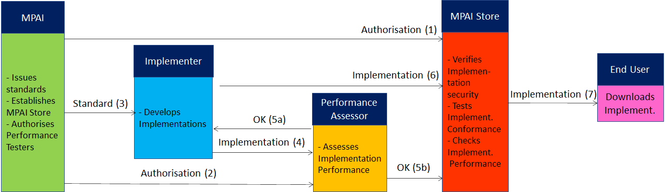
Figure 9 – The MPAI ecosystem operation

The Ecosystem operation allows for AIW and AIF Implementations to be:
- Proprietary: security is verified and Conformance to MPAI-AIF Tested (Level 1).
- Conforming to an MPAI Application Standard: security is verified and Conformance to the relevant MPAI Application Standard Tested (Level 2).
- Assessed to be Reliable, Robust, Fair and Replicable (Level 3).
and have their Interoperability Level duly displayed in the MPAI Store.

Annex 2 – Datasets for CAV research
nuScenes
The nuScenes dataset (https://nuscenes.org/) is a large-scale autonomous driving dataset with 3d object annotations. It features:

- Full sensor suite (1x LIDAR, 5x RADAR, 6x camera, IMU, GPS)
- 1000 scenes of 20s each
- 1,400,000 camera images
- 390,000 lidar sweeps
- Two diverse cities: Boston and Singapore
- Left versus right hand traffic
- Detailed map information
- 1.4M 3D bounding boxes manually annotated for 23 object classes
- Attributes such as visibility, activity and pose
- New: 1.1B lidar points manually annotated for 32 classes
- New: Explore nuScenes on SiaSearch
- Free to use for non-commercial use
For a commercial license contact nuScenes@motional.com

nuImages is a large-scale autonomous driving dataset with image-level 2d annotations. It features:
- 93k video clips of 6s each (150h of driving)
- 93k annotated and 1.1M un-annotated images
- Two diverse cities: Boston and Singapore
- The same proven sensor suite as in nuScenes
- Images mined for diversity
- 800k annotated foreground objects with 2d bounding boxes and instance masks
- 100k 2d semantic segmentation masks for background classes
- Attributes such as rider, pose, activity, emergency lights and flying
- Free to use for non-commercial use

Road Hazard data
Otonomo real-time Road Hazard data from connected passenger vehicles powers diverse road safety use cases, including mapping, accident predictions, smart cities and many more. The Otonomo Vehicle Data Platform secures, cleanses and normalizes the hazard data to make it more valuable and accessible for diverse use cases.

https://info.otonomo.io/hazard-data-datasheet-lp

Annex 4 – ETSI Technical Report
ETSI specifies the Collective Perception Service (CPS) in its Technical Report [6]. The CPS includes the format and generation rules of the Collective Perception Message (CPM).
The CPM message format is (H=header, C=container, M=mandatory, O=optional).

Table 18 – ETSI Collective Perception Message format

PDU header | H | M | protocol version, message ID and Station ID.
Management | C | M | transmitter type (e.g., vehicle or RSU) and position.
Station Data | C | O | transmitter heading, velocity, or acceleration etc.
Sensor Information | C | O | - transmitter (e.g., speed, heading, or acceleration)  - capabilities of the vehicle’s sensors.
Perceived Object | C | O | - detected objects (e.g., distance, speed and dimensions)  - time at which the measurements were done.  A CPM can report up to 128 detected objects
Free Space Addendum | C | O | free space areas/volume within the sensor detection areas

Every 0.1s a CPM is generated if one of the 3 conditions is satisfied
- no CPM has been generated in the last 1s
- a new object has been detected
- since last CPM sending info about a previously detected object (it must have an ID)
  - the following attributes have changed:
    - Absolute position ΔP > 4 m
    - Absolute speed ΔV > 0.5 m/s
  - more than 1s has passed (ΔT > 1 s).
ETSI makes use of a common coordinate system. A vehicle can communicate its absolute coordinates roll, pitch and yaw (Attitude).
Different CPM generation rules have been investigated [9].

Annex 5 – Some CAV Communication Technologies

The following categories of vehicular communication are part of the literature or industry effort:

V2V | Vehicle-to-Vehicle | communication between vehicles to exchange information about the speed and position of surrounding vehicles
V2I | Vehicle-to-Infrastructure | communication between vehicles and road infrastructure.
V2X | Vehicle-to-Everything | communication between a vehicle and any entity that may affect, or may be affected by, the vehicle
V2R | Vehicle-to-Roadside | communication between a vehicle and Road Side Units (RSUs).
V2P | Vehicle-to-Pedestrian | communications between a vehicle and (multiple) pedestrian device(s) and to other vulnerable road users, e.g., cyclists, in close proximity
V2S | Vehicle-to-Sensors | communication between a vehicle and its sensors on board
V2D | Vehicle-to-Device | communication between a vehicle and any electronic device that may be connected to the vehicle itself
V2G | Vehicle-to-Grid | communication with the power grid to sell demand response services by either returning electricity to the grid or by throttling their charging rate
V2N | Vehicle-to-Network | broadcast and unicast communications between vehicles and the V2X management system and also the V2X AS (Application Server)
V2C | Vehicle-to-Cloud | communication with data centres and other devices connected to the internet

Technologies exist that support at least some aspects of the communication types of the table:
Radio access, e.g., visible light communication, mmWave, Cellular-V2X, and 5G
Radio resource management (RRM) for vehicular communication using cellular technology
3GPP Release 14: air interfaces and core network technologies to support V2X communication.
Vehicular ad hoc network (VANET)
Dedicated Short-Range Communication (DSRC): 5.9 GHz band with a range of ~300 metres.
Software defined vehicular networks (SDVN)
Internet of vehicles (IoV)
Protocol stack of the intelligent transportation system (ITS)
Cooperative Awareness Messages (CAMs) messages related to the status of CAV’s sent via wireless broadcast in VANETs.
Cooperative or collective perception improve CAV’s perception beyond the sensors’ detection range.
Traffic situation can be extracted from Local dynamic map (LDM) that aggregates CAMs.

