Moving Picture, Audio and Data Coding
by Artificial Intelligence
www.mpai.community
Public Document
N379 | 2021/09/30
Source | Requirements (MCS)
Title | MPAI-MCS Use Cases and Functional Requirements WD0.2
Target | MPAI-12

1 Introduction 2
2 Scope of the Use Cases 3
3 Terms and Definitions 3
4 References 4
4.1 Normative references 4
4.2 Informative references 4
5 Use Cases 4
5.1 Use Case #1 – Local Avatar Videoconference (LAV) 4
5.1.1 Use Case description 4
5.1.2 AIW of “Participant TX” 5
5.1.3 AIW of Server 8
5.1.4 AIW of “Participant RX” 10
5.1.5 AI Modules 11
5.2 Use Case #2 – Virtual e-learning 12
5.3 Use Case #3 – Multipoint videoconference 13
5.4 Use Case #4 – Teleconsulting 14
6 AI Modules 15
6.1 AIMs and their data 15
6.1.1 Participant TX 15
6.1.2 Server 15
6.1.3 Participant RX 15
6.2 Data Formats 16
6.2.1 # of Participants 16
6.2.2 3D Audio Navigation Info 17
6.2.3 3D Audio Scene (O) 17
6.2.4 3D AV Object 17
6.2.5 3D AV Object Commands 17
6.2.6 3D Video Scene (O) 17
6.2.7 3D Visual Ambient Descriptors 17
6.2.8 Ambient Audio 17
6.2.9 Ambient Type 17
6.2.10 Avatar Model 17
6.2.11 Coded Message 17
6.2.12 Emotion (Speech) 17
6.2.13 Emotion (Video) 17
6.2.14 Encoded Speech 17
6.2.15 Face Descriptors 17
6.2.16 Final Emotion 18
6.2.17 Final Meanings 18
6.2.18 Gesture Descriptors 18
6.2.19 Head Descriptors 18
6.2.20 Head Model 18
6.2.21 ID’d Avatars Descriptors 18
6.2.22 ID’d Decoded Speech 18
6.2.23 Input Video 18
6.2.24 Meaning (Speech) 18
6.2.25 Meaning (Video) 18
6.2.26 Output Audio Scene 18
6.2.27 Output Visual Scene 18
6.2.28 Participant IDs 18
6.2.29 Recognised Text 18
6.2.30 Separated Speech 19
6.2.31 Speaker Descriptors 19
6.2.32 Visual Navigation 19
Annex 1 – MPAI-wide terms and definitions (Normative) 20
Annex 2 - Notices and Disclaimers Concerning MPAI Standards (Informative) 23
Annex 3 – The Governance of the MPAI Ecosystem (Informative) 25

Introduction
Moving Picture, Audio and Data Coding by Artificial Intelligence (MPAI) is an international Standards Developing Organisation with the mission to develop AI-enabled data coding standards. Research has shown that data coding with AI-based technologies is generally more efficient than with existing technologies. Compression and feature-based description are notable examples of coding.
In the following, Terms beginning with a capital letter are defined in Table 1 if they are specific to MPAI-MCS Standard and to Table 12 if they are common to all MPAI Standards.
MPAI Application Standards enable the development of AI-based products, applications and services. The MPAI AI Framework (AIF) Standard (MPA-AIF) [2] provides the foundation on which the technologies defined by MPAI Application Standards operate.
Figure 1 depicts the MPAI-AIF Reference Model. MPAI-AIF provides the foundation on which Implementations of MPAI Application Standards operate.
An AIF Implementation allows execution of AI Workflows (AIW), composed by basic processing elements called AI Modules (AIM).

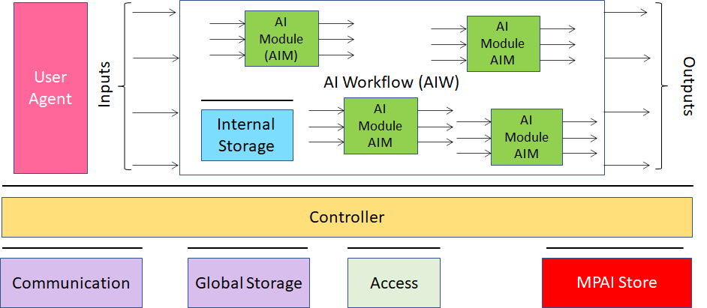
Figure 1 – The AI Framework (AIF) Reference Model and its Components

MPAI Application Standards normatively specify Semantics and Format of the input and output data and the Function of the AIW and the AIMs, and the Connections between and among the AIMs of an AIW.
In particular, an AIM is defined by its Function and Data, but not by its internal architecture, which may be based on AI or data processing, and implemented in software, hardware or hybrid software and hardware technologies.
MPAI defines Interoperability as the ability to replace an AIF, an AIW or an AIM Implementation with a functionally equivalent Implementation. MPAI also defines 3 Interoperability Levels of an AIF that executes an AIW that is:
- Proprietary AIW and is composed by AIM with proprietary functions using any proprietary data Format (Level 1).
- Composed of AIMs having all their Functions, Formats and Connections specified by an MPAI Application Standard (Level 2).
- Level 2 and with AIMs certified by an MPAI-appointed Assessor to holdthe attributes of Reliability, Robustness, Replicability and Fairness – collectively called Performance (Level 3).
MPAI is the root of trust of the MPAI Ecosystem [1] offering Users access to the promised benefits of AI with a guarantee of increased transparency, trust and reliability as the Interoperability Level of an Implementation moves from 1 to 3.

Scope of the Use Cases
Mixed-reality Collaborative Spaces (MPAI-MCS) is an MPAI standard project, comprising several identified candidate use cases.
The purpose of this document is:
- To collect and describe the identified use cases.
- To define the functions of the AIWs that implement the use cases.
- To identify the input and output data of the AIWs.
- To identify the AIMs required to realise the AIWs.
- To define the functions of the AIMs.
- To identify the input and output data of the AIMs.
Section 6.2 specifies the requirements that the data formats identified in points 3. and 6. above should satidfy. The companion MPAI-MCS Call for Technologies document requires technologies conforming to those of Section 6.2.
This document is expected to become an attachment to a future MPAI-MCS Call for Technologies once the process leading to that stage has been completed.

Terms and Definitions
The terms used in this document whose first letter is capital have the meaning defined in Table 1.

Table 1 – Table of terms and definitions

Term | Definition
Affordance | Quality or property of an object that defines its possible uses or makes clear how it can or should be used.
Ambient | The physical space of a participant and the shared virtual space.
Avatar | An animated 3D object representing a particular person in a virtual space.
Avatar Model | An inanimate avatar
Emotion | An attribute that indicates an emotion out of a finite set of Emotions
Face
Gesture
Identity
Meaning | Information extracted from the input text such as syntactic and semantic information
Navigation

References

Normative references
MPAI-MCS normatively references the following documents:
- MPAI Standard; The Governance of the MPAI Ecosystem; N341.
- MPAI Technical Specification; AI Framework (MPAI-AIF); N324.
- MPAI Technical Specification; Context-based Audio Enhancement (MPAI-CAE); N326.
- MPAI Technical Specification; Multimodal Conversation (MPAI-CAE); N328.
- ISO/IEC 10646; Information technology – Universal Coded Character Set (UCS)

Informative references

Use Cases

Use Case #1 – Local Avatar Videoconference (LAV)

Use Case description
Today’s videoconference falls short from being a satisfactory supplement to a physical meeting. Participants are able to hear the voice selected by the videoconference server and see the full screen face of a participant who is speaking but cannot have similar details for other speakers at the same time. Participants can hear the voice of the speaker, but are generally unable to hear what other participants are seeing.are unable to have an audio-visual experience of the participants comparable to the experience they would have at a physical meeting. In particular the experience is always chopped up in moments where one participant talks, while a meeting is in general a collective experience where one participant may well speak but the others have possibly micro-reactions, not necessarily vocal. the collections of all reactions is what makes a physical meeting irreplaceable.
At a typical meeting people are usually seating. If they move, it is for reasons that have little to do with the meeting. Someone leaving, maybe temporarily or someone joining. Coffee is brought in and people go to a table and have a coffee break. Nowadays, a blackboard is rarely used.
The Local Avatar Videoconference (MCS-LAV) Use Case is designed to offer conference participants the ability to enjoy the collective experience of a physical meeting represented by speech, facial expression, head and hands movement of participants.
Therefore, an MCS-LAV is attended by personae each representing a participants with:
- The actual speech.
- An avatar having:
  - A static body.
  - An animated head according to the participant’s head movement.
  - A face
    - Animated by emotion and meaning extracted from the participant’s face.
    - Corroborated by emotion and meaning extracted from the participant’s speech.
  - Animated hands according to the participants gesture.
Each participant uses:
- A “Participant TX” instance to
  - Communicate speech and its emotion and meaning.
  - Transmit emotion and meaning, and descriptors of face.
  - Trasmit descriptors of arm and hand.
  - Send special messages, e.g., I am leaving, I am joining
  - Transmit 3D AV Objects
  - Issue commands to act on 3D AV Objects
- A “Participant RX” instance to
  - Create their personal 3D visual space by using
    - The (static) visual descriptors of the Ambient of the virtual meeting.
    - The (dynamic) visual descriptors of the Avatars.
    - The 3D Visual Object resulting from actions
  - Create their personal 3D audio space by using
    - The participants’ speeches located at the corresponding Avatars’ positions.
    - The 3D Audio Object resulting from actions
  - Navigate the resulting personal virtual 3D AV space (without moving their Avatar).
It is worth noting that the MCS-LAV server
- Converts the information of all participants to 3D visual descriptors of the visual scene.
- Only sends the descriptors and not the 3D visual space to save bandwidth.
- Each participant creates their own 3D AV space moving/removing objects and avatars.
- Participants can only see and navigate their own virtual 3D AV space.
The AIW implementing this Use Case is distributed in the sense that there are:
- N AIW “Participant TX” AIW instances.
- One Server AIW instance.
- N AIW “Participant RX” instances.

AIW of “Participant TX”

Function
The function of the AIW is:
- At the start, to send participant’s:
  - Avatar model selection.
  - Head model.
  - 3D AV Objects.
- During the meeting, to continuously detect and send:
  - Speech Separated from Ambient Audio
  - Face Descriptors (for face recognition)
  - Speaker Descriptors (for speaker identification).
  - Emotion & meaning.
  - Head motion.
  - Coded messages (I have to leave etc.).
  - Real time 3D AV object.
  - Commands acting on 3D AV object.

Architecture
The architecture of “Participant TX” AIW is given by Figure 2.

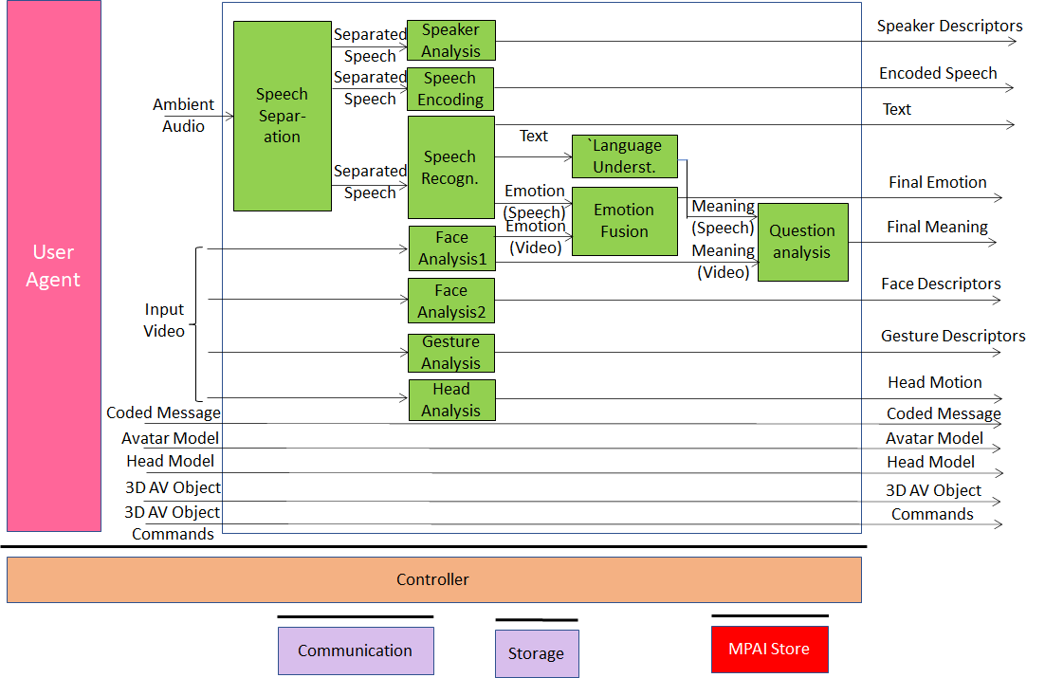
Figure 2 – Reference Model of the “Participant TX” client

Each participant (sending side)
- Has the following devices:
  - Microphone (array)
  - Camera (array)
  - An acoustic device capable to separate participant’s Speech from Ambient Aound and the 3D Audio field created by Participant Rx.
- Sends before the meeting:
  - Selection of the avatar body model.
  - Own avatar head and face of the model or selection of one head and face.
  - Files containing any 2D- or 3D audio-visual presentation.
- Sends during the meeting:
  - Face and Speech Descriptors for identification
  - Final Emotion and Meaning of face and speech
  - Text recognised from Speech
  - Movement of head and face
  - Gesture Descriptors
  - Encoded Speech
  - Real time 3D AV Object
  - Commands to act on 3D AV Object.

I/O data
The input and output data are given by Table 2:

Table 2 – Input and output data of “Participant TX” AIW

Input | Comments
Ambient Audio | Audio including participant’s Speech and other audio
Input Video | Video of participant’s torso
Coded messages | Each participants may send coded messages representing “I want to speak”, “I need to leave” etc.
Avatar model | The ID of the avatar model selected by the participant
Head model | Each participant sends their own head model or selects one from those offered by the videoconference service
3D AV object | Each participant may send a 3D AV objects to the server for real time distribution
3D AV object commands | The originator can and any participants may (if authorised) send commands that act on a 3D AV object (presentation of real time)
Output | Comments
Speaker Descriptors | For speaker identification by server.
Encoded Speech | The compressed Speech
Text | Recognised from Separated Speech..
Final Emotion | The Descriptors of Emotion.
Final Meaning | The Descriptors of Meaning.
Face Descriptors | For face identification by server.
Gesture Descriptors | The Descriptors of Gesture.
Head Motion | Head Motion Descriptors.
Coded Message | As in input.
Avatar Model | As in input.
Head Model | As in input.
3D AV Object | As in input.
3D AV Object Commands | As in input.

AI Modules
The AI Modules of “Participant TX” are given in Table 3.

Table 3 – AI Modules of Multimodal Question Answering

AIM | Function
Speech Separation | Provides Speech separates from non-speech Sound in Ambient Audio.
Speaker Analysis | Provides Speaker Descriptors.
Speech Encoder | Provides Speech in compressed format.
Speech Recognition | Provides Text and Emotion from Separated Speech
Face Analysis1 | Provides Emotion and Meaning from Input Video (face)
Face Analysis2 | Provides Face Descriptors from Input Video (face).
Gesture Analysis | Provides Gesture Descriptors from Input Video (gesture)
Head Analysis | Provides the movement of the head of a Participant.
Language Understanding | Provides Meaning from Recognised Text.
Emotion Fusion | Provides the Final Emotion from Speech and Face Emotion.
Question Analysis | Produces Final Meaning.

AIW of Server

Function
The function of Server AIW is:
- At the start:
  - Receives:
    - Ambient selection
    - Number of participants (N).
    - Avatar body selection (xN).
    - Avatar head model (xN).
    - 3D AV Objects.
  - Creates and sends Static Descriptors containing:
    - Ambient
    - Avatar bodies.
- Continuously:
  - Receives:
    - Speech (xN).
    - Face and Speaker Descriptors (xN).
    - Emotion and meaning (xN).
    - Coded Messages (xN).
    - 3D AV Objects.
    - 3D AV commands.
  - Performs:
    - Monitoring of participants’ identity using Face and Speaker Descriptors.
    - Creation of Avatar Descriptors: heads, faces, arms and hands.
    - Associates Participant IDs to Speeches and Avatars
  - Sends:
    - Descriptors of dynamic objects and IDs: faces, heads, arms, hands.
    - Speeches with coordinates of sources and IDs.
    - 3D AV objects.
    - 3D AV commands.

Architecture
The architecture of Server AIW is given by Figure 3.

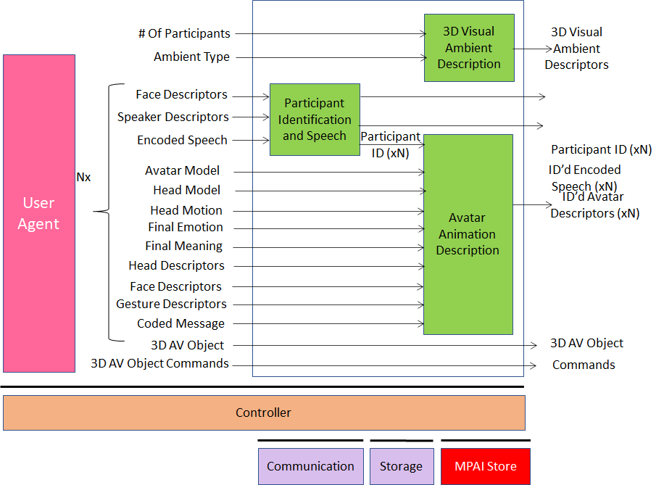
Figure 3 – Reference Model of the MCS-LAV Server

MCS-LAV Server
- Receives from conference manager
  - Selected Ambient.
  - Number if Participants (N).
- Receives from each participant:
  - Face and Speaker Descriptors (for identification).
  - Encodes Speech.
  - Head movements.
  - Fused emotion and meaning
  - Face and Gesture Descriptors.
  - 3D AV Objects.
  - Commands to act on 3D AV Objects.
- Creates Descriptors of:
  - 3D Ambient (table, chairs and avatar bodies) (one shot).
  - Avatars’ head, face, arms and hands.
- Sends
  - 3D Visual Ambient descriptors.
  - All Participant IDs
  - All Speeches with their IDs.
  - Avatar descriptors.
  - 3D AV Objects.
  - Commands to act on 3D AV Objects.

I/O data
The input and output data are given by Table 4.

Table 4 – Input and output data of MCS-AVL (Server) AIW

Input | Comments
# of Participants (N) | From Server manager
Ambient Selection | From Server manager
Face Descriptors (xN) | From all participants (for identification)
Speaker Descriptors (xN) | From all participants (for identification)
Rncoded Speech (xN) | From all participants
Avatar Model (xN) | From all participants
Head Model (xN) | From all participants
Head Motion (xN) | From all participants
Emotion & Meaning (xN) | From all participants
Face Descriptors (xN) | From all participants
Head Descriptors (xN) | From all participants
Gesture Descriptors (xN) | From all participants
Coded Message (xN) | From all participants wishing to do so
3D AV Object (xN) | From all participants wishing to do so
3D AV Object Commands (xN) | From all participants wishing to do so
Outputs | Comments
3D Visual Ambient Descriptors | Static descriptors of Ambient
Participant ID (xN) | Static participant IDs
ID’d Encoded Speech (xN) | Participants’ Speeches and IDs
ID’d Avatar Descriptors (xN) | Descriptors of Avatars with Participant IDs
3D AV Objects | Real time 3D AV objects
3D AV Object Commands (xN) | Commands to act on 3D AV objects

AI Modules
The AI Modules of “Server” are given in Table 3.

Table 5 – AI Modules of Multimodal Question Answering

AIM | Function
3D Visual Ambient Description | Collects all 3D Visual Ambient Descriptors.
Participant Identification and Speeches | Determines and associates Identity of all Participants to their Speeches
Avatar Animation Description | Collects and associates Identity of all Participants to Visual Descriptors of all Avatars.

AIW of “Participant RX”

Function
The Function of the “Participant RX” AIW is to:
- Create the 3D AV scene of the conference.
- Allow the participant to have the 3D audio-visual experience of the AV scene.

Architecture
The architecture of “Participant RX” AIW is given by Figure 4.

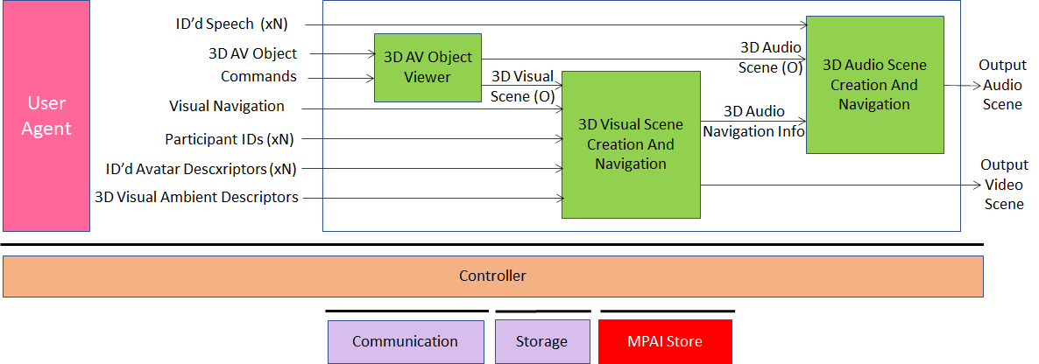
Figure 4 – Reference model of the “Participant RX” client

The “Participant RX” AIW
- Creates the visual 3D space using:
  - The 3D Visual Ambient descriptors.
  - The Avatars descriptors.
  - The visual output of the 3D AV Object Viewer.
- Allows participant to have an AV experience from a selected point in the virtual 3D AV space.
- Synthesises the 3D audio space with sound sources at:
  - Each Avatar position.
  - Location of 3D AV Object.
- Presents audio information congruent with the position of the Participant’s selected viewpoint in the virtual 3D Visual scene.

I/O data
The input and output data are given by Table 6

Table 6 – Input and output data of “Participant RX” AIW

Input | Comments
ID’d Encoded Speeches (xN) | Participants’ speeches with ID
3D AV Object | Real time 3D AV objects
3D AV Object Commands | Standard instructions to act on 3D objects
3D Visual Ambient Descriptors | Static Descriptors of Ambient
Participants’ IDs (xN) | Static participants’ IDs
ID’d Avatar Descriptors (xN) | Descriptors of Avatars bodies with participant IDs
Visual Navigation | Participant’s commands to navigate the 3D Visual scene
Output | Comments
3D Audio | To be reproduced with loudspeaker array
3D Video | To be reproduced with 2D or 3D display

AI Modules
The AI Modules of “Participant RX” are given in Table 3.

Table 7 – AI Modules of Local Avatar Videoconference

AIM | Function
3D Visual Scene Creation And Navigation | Creates 3D Visual Scene corresponding to the selected point in the virtual 3D AV space,
3D Audio Scene Creation And Navigation | Creates 3D Audio Scene congruent witht the 3D Visual Scene
3D AV Object Viewer | Creates Participant’s view and audio of 3D AV Object

Use Case #2 – Virtual e-learning
A teacher holds a lecture to N students (in the following called Participants). The teacher and the participants in the lecture reside at their own locations, in their cultural environments. The hosting organisation (e.g., school or cultural institution), under whose aegis the lecture is held, can arrange avatars classroom-style or with other different arrangements.
This is how such a virtual e-learning environment could be managed:
- The hosting organisation makes available, i.e., server supports:
  - Virtual spaces equipped with appropriate furnishings arranged as:
    - Classroom style.
    - An evocative place, e.g., the Stoa of Athens, a chemistry laboratory.
    - With an orderly or scattered arrangement.
  - Avatar models.
  - Other objects.
  - Ability to convert:
    - Speech, text and gesture; e.g., speech to gesture, text to gesture etc.
    - Input speech from a language to another language.
- The teacher selects
  - The language that will be used in the shared space.
  - The 3D AV objects used during the lecture.
  - The equipment providing 3D AV objects (e.g., a microscope).
- Participants provide/select and communicate their own “personae” to the server:
  - Avatar model capabilities and objects with their affordances.
  - Initial position and shape in the virtual lecture space.
  - Colour and style of synthetic voice or own voice.
  - Spoken language preference (e.g., EN-US, IT-CH) of participants.
- During the lecture
  - The cameras of each participant
    - Detects the participant’s body movements: head, torso, arms, hands
    - Extracts facial features and hand gestures
    - Send body movements, facial features/hand gestures to the server
  - The microphone set of each participant
    - Captures the 3D field of the participant’s Ambient
    - Separates the speech from the rest of the sound field
    - Extracts Speech Descriptors
    - Send 3D Audio field, separated speech, speech descriptors to the server
  - A participant sends teleportation command
  - (Each participant has an acoustic echo cancellation)
  - The server
    - Animates avatars at their assigned positions using their body motions, facial features, hand gestures and speech descriptors
    - Translates speech of a participant to the agreed common language
    - Merges and sends to participants all sound fields as specified by each participant
    - Sends participants an attendance table with metadata.
  - The teacher
    - Brings up and shares 3D AV objects, e.g.,
    - Calls a synthetic 3D object from a DB and use it in support of the lecture
      - Starts an experiment using a physical machine, e.g.,
        - Showing the principles of optics.
        - Showing gravity and its effects.
        - Docking molecules in chemistry.
        - Showing the inside of an atom.
      - Places objects on his/her desk for reproduction as (moving) 3D objects at participants’ locations and interactive engagement
  - Participants
    - Deal with different object types
      - 3D Visual Output of a microscope
      - 3D model of the brain of a mouse.
      - Molecules captured as 3D objects by an electronic microscope
    - Create and add metadata to a 3D audio-visual object
      - Define a portion of the object – manual or automatic
      - Assign physical properties to (different parts) of the object
      - Annotate a portion of the 3D AV object
      - Create links between different parts of the object
    - Enter, navigate and act on 3D audio-visual objects
      - Define a portion of the object – manual or automatic
      - Count objects per unit volume
      - Detect structures in a (portion of) the 3D AV object
      - Combine objects
      - Call an anomaly detector on a portion with an anomaly criterion
      - Follow a link to another portion of the object
      - 3D print (portions of) the 3D AV object

Use Case #3 – Multipoint videoconference
The N participants in the conference reside at their locations, in their cultural environment. Their avatars sit around a virtual conference table located in a virtual room in an agreed cultural environment. A relevant quote is Marshall McLuhan’s “the medium is the message”.
This is how such a virtual shared-cultural conference could be managed:
- The participants agree on and describe a shared cultural and/or context environment which can be real (representative of a physical space) or imagined (the components in the environment do not have a correspondence with the physical world):
  - Conference style (board meeting, conference meeting, MPAI meeting etc.)
  - Language that will be used in the shared space
  - Room setting, furnishing, table and chairs, a CAV, outdoor
  - Etc.
- The organiser selects the multiconference service provider implementing the agreed setting
- Participants provide/select and communicate to the multiconference service provider their own “personae”
  - Avatar model
  - Position in the meeting space
  - Voice colour and style or own/synthetic
  - Spoken language preference (e.g., EN-US, IT-CH) of the persona
- Participant ensures that their own personae are authenticated
- During the conference
  - The camera of each participant
    - Detects the participant’s body movements and extracts facial features and hand gestures
    - Sends body movements and facial features to the multiconference unit
  - The microphone set of a participant
    - Captures the 3D field of the participant’s environment
    - Separates the voice from the rest of the sound field
    - Extracts and sends the sound field with descriptors of the speech
    - Displays a choice of which sound field components should be preserved
  - The multiconference unit
    - Animates avatars at their assigned position using their body motions, facial features, hand gestures and speech descriptors
    - Translates the cultural/context setting (speech etc.) of a participant to the agreed common setting
    - Merges and sends to participants all sound fields as specified by each participant
    - Sends participants an attendance table with metadata
  - Participants
    - Use the attendance table to, e.g., mute or reduce the influence of a particular source
    - Place objects on their desks which are shown in front of them at the meeting or placed in the space for individual participants to engage, e.g., rotate etc.

Use Case #4 – Teleconsulting
An entrepreneur (E) offers teleconsulting services on a class of objects of particularly difficult use. A Customer (C) contacts E for advice on how to use a particular machine.
This is how the envisaged MCS teleconsulting service can take place:
- C contacts E
- E requests C to provide a 3D scan of the object
- C provides the requested scan
- E starts its MCS composed by
  - the virtual representation of the object placed, e.g., on a table, or movable
  - the avatar of E sitting in front of the object
  - the avatar of C sitting next to the avatar of E
- While speaking, the avatar of E manipulates the object
  - e.g., rotates it
  - touches a particular point of the object
  - uses a virtual tool to indicate a type of operation
- C and E see their own and the other avatars’ actions as if they were sitting in the virtual position of the avatar
- While speaking, C acts on the physical object and the actions are reflected on the avatar and the virtual object
- Avatars can move around the object (e.g., in the case of a large object)

AI Modules

AIMs and their data

Participant TX
Table 8 – AIMs and Data of Participant TX AIW
AIM | Input Data | Output Data
Speech Separation | Input Audio | Separatated Speech
Speaker Recognition | Separatated Speech | Speaker ID
Speech Encoding | Separatated Speech | Encoded Speech
 | Separatated Speech | Meaning (Speech)
 |  | Emotion (Speech)
Face Analysis1 | Input Video | Meaning (Video)
 |  | Emotion (Video)
Head Analysis | Input Video | Head Motion
Face Analysis2 | Input Video | Face ID
 | Coded Message | Coded Message
 | Avatar Model | Avatar Model
 | 3D AV Object | 3D AV Object
 | AV Object Commands | AV Object Commands

Server
Table 9 – AIMs and Data of Server AIW
AIM | Input Data | Output Data
3D Visual Ambient Description | 3D Visual Ambient Descriptors | 3D Visual Ambient Descriptors
Participant Identification and Speech | Speech IDs | Participant IDs
 | Face IDs | Encoded Speeches
 | Encoded Speeches
Avatar Animation Description | Final Emotions | ID’d Avatar Descriptors
 | Final Meanings
 | Head Motions
 | Head Models
 | Avatar Models
 | 3D AV Object | 3D AV Object
 | AV Object Commands | AV Object Commands

Participant RX
Table 10 – AIMs and Data of Participant RX AIW
AIM | Input Data | Output Data
3D AV Object Viewer | 3D AV Object | 3D Audio Scene (O)
 | 3D AV Object Commands | 3D Video Scene (O)
3D Visual Ambient Creation And Navigation | Participant IDs | Output Visual Scene
 | ID’s Avatars Descriptors
 | 3D Visual Ambient Descriptors
 | Visual Navigation
3D Audio Ambient Creation And Navigation | ID’d Encoded Speeches | Output Audio Scene
 | Navigation Command
 | 3D Visual Navigation Info

Data Formats
Table 11 lists all data formats whose requirements are contained in this document. The first column gives the name of the data format, the second the subsection where the requirements of the data format are provided and the third the Use Case making use of it.

Table 11 – Data formats
Name of Data Format | Subsection | Use Case
# of Participants | 6.2.1
3D Audio Navigation Info | 6.2.2
3D Audio Scene (O) | 6.2.3
3D AV Object | 6.2.4
3D AV Object Commands | 6.2.5
3D Video Scene (O) | 6.2.6
3D Visual Ambient Descriptors | 6.2.7
Ambient Audio | 6.2.8
Ambient Descriptors | 6.2.8
Ambient Type | 6.2.9
Avatar Model | 6.2.10
Coded Message | 6.2.11
Emotion (Speech) | 6.2.12
Emotion (Video) | 6.2.13
Encoded Speech | 6.2.14
Face Descriptors | 6.2.15
Final Emotions | 6.2.16
Final Meanings | 6.2.17
Gesture Descriptors | 6.2.18
Head Descriptors | 6.2.19
Head Model | Error! Reference source not found.
Head Motion | 6.2.21
ID’d Avatar Descriptors | 6.2.21
ID’d Encoded Speech | 6.2.24
Input Video | 6.2.25
Meaning (Speech) | 0
Meaning (Video) | 6.2.26
Navigation Command | 6.2.27
Output Audio Scene | 0
Output Visual Scene | 6.2.27
Participant IDs | 6.2.30
Recognised Text | 6.2.31
Separated Speech | 6.2.32
Speaker Descriptors | 6.2.31
Visual Navigation | 6.2.32

# of Participants
An integer corresponding to the number of Participants.

3D Audio Navigation Info
The coordinates of the Participant looking at the meeting from a particular viewpoint in the MCS.

3D Audio Scene (O)
The Audio component of 3D AV Objects.

3D AV Object
A description of a 3D Audio-Visual Object.

3D AV Object Commands
Instructions to navigate the 3D Audio-Visual Object.

3D Video Scene (O)
The Visual component of 3D AV Objects.

3D Visual Ambient Descriptors
The set of Descriptors required to represent the static components of the MCS: table, chair, walls, furniture etc.

Ambient Audio
The digital representation of the audio captured from a Participant’s site.
MPAI-CAE has defined a digital representation of a microphone set [4].

Ambient Type
An Identifier of a furnished MCS offered by the Service Provider.

Avatar Model
- An Identifier of a model of an avatar offered by the Service Provider or
- An avatar model provided by a Participant.

Coded Message
An Identifier of a message representing
- Join the meeting
- Ask for the floor
- Leave the meeting
- ...

Emotion (Speech)
An emotion for speech out of a set.

Emotion (Video)
An emotion set for a Face out of a set.

Encoded Speech
Streamed compressed Speech.

Face Descriptors
Descriptors for face recognition.

Final Emotion
Emotion resulting from the fusion of Emotion (Speech) and Emotion (Video).
MPAI-MMC has defined a digital representation of Emotion [4].

Final Meanings
Meaning resulting from the fusion of Meaning (Speech) and Meaning (Video).
MPAI-MMC has defined a digital representation of Meaning [4].

Gesture Descriptors
Descriptors suitable to
- Recognise sign language
- Recognise coded hand signs for navigation
- Animate arms and hands of a Participant’s avatar.

Head Descriptors
Descriptors suitable to animate the head of the Participant’s avatar to reproduce the movements of the Participant’s head.

Head Model
- An Identifier of a model of an animation-ready avatar head offered by the Service Provider or
- An animation-ready avatar model head provided by a Participant.

ID’d Avatars Descriptors
A set of avatar Descriptors composed of torso, head, face, arms and hads, associated to a Participant ID.

ID’d Decoded Speech
A continuous Speech stream associated to a Participant ID.

Input Video
The digital visual representation of the Participant’s torso.

Meaning (Speech)
MPAI-MMC defines how to digitally represent Meaning.

Meaning (Video)
MPAI-MMC defines how to digitally represent Meaning.

Output Audio Scene
The 3D Audio field generated by Participant RX.

Output Visual Scene
The 3D Visual field generated by Participant RX.

Participant IDs
Dynamic (session-by-session) Participant Identifier.

Recognised Text
Text should be digitally represented according to [3].

Separated Speech
Speech resulting from removal of non-speech information from Input Audio.

Speaker Descriptors
Descriptors for Speaker recognition.

Visual Navigation
Avatars participanting in a meeting are static, save for the specific coded messages that represent joining and leaving the meeting. Navigation Commands are used to define the viewpoint of the Participant in the 3D AV scene.

Annex 1 – MPAI-wide terms and definitions (Normative)
The Terms used in this standard whose first letter is capital and are not already included in Table 1 are defined in Table 12.

Table 12 – MPAI-wide Terms

Term | Definition
Access | Static or slowly changing data that are required by an application such as domain knowledge data, data models, etc.
AI Framework (AIF) | The environment where AIWs are executed.
AI Workflow (AIW) | An organised aggregation of AIMs implementing a Use Case receiving AIM-specific Inputs and producing AIM-specific Outputs according to its Function.
AI Module (AIM) | A processing element receiving AIM-specific Inputs and producing AIM-specific Outputs according to according to its Function.
Application Standard | An MPAI Standard designed to enable a particular application domain.
Channel | A connection between an output port of an AIM and an input port of an AIM. The term “connection” is also used as synonymous.
Communication | The infrastructure that implements message passing between AIMs
Component | One of the 7 AIF elements: Access, Communication, Controller, Internal Storage, Global Storage, MPAI Store, and User Agent
Conformance | The attribute of an Implementation of being a correct technical Implementation of a Technical Specification.
Conformance Tester | An entity authorised by MPAI to Test the Conformance of an Implementation.
Conformance Testing | The normative document specifying the Means to Test the Conformance of an Implementation.
Conformance Testing Means | Procedures, tools, data sets and/or data set characteristics to Test the Conformance of an Implementation.
Connection | A channel connecting an output port of an AIM and an input port of an AIM.
Controller | A Component that manages and controls the AIMs in the AIF, so that they execute in the correct order and at the time when they are needed
Data Format | The standard digital representation of data.
Data Semantics | The meaning of data.
Ecosystem | The ensemble of the following actors: MPAI, MPAI Store, Implementers, Conformance Testers, Performance Testers and Users of MPAI-AIF Implementations as needed to enable an Interoperability Level.
Explainability | The ability to trace the output of an Implementation back to the inputs that have produced it.
Fairness | The attribute of an Implementation whose extent of applicability can be assessed by making the training set and/or network open to testing for bias and unanticipated results.
Function | The operations effected by an AIW or an AIM on input data.
Global Storage | A Component to store data shared by AIMs.
Internal Storage | A Component to store data of the individual AIMs.
Identifier | A name that uniquely identifies an Implementation.
Implementation | - An embodiment of the MPAI-AIF Technical Specification, or  - An AIW or AIM of a particular Level (1-2-3) conforming with a Use Case of an MPAI Application Standard.
Interoperability | The ability to functionally replace an AIM with another AIM having the same Interoperability Level
Interoperability Level | The attribute of an AIW and its AIMs to be executable in an AIF Implementation and to:  - Be proprietary (Level 1)  - Pass the Conformance Testing (Level 2) of an Application Standard  - `Pass the Performance Testing (Level 3) of an Application Standard.
Knowledge Base | Structured and/or unstructured information made accessible to AIMs via MPAI-specified interfaces
Message | A sequence of Records transported by Communication through Channels.
Normativity | The set of attributes of a technology or a set of technologies specified by the applicable parts of an MPAI standard.
Performance | The attribute of an Implementation of being Reliable, Robust, Fair and Replicable.
Performance Assessment | The normative document specifying the procedures, the tools, the data sets and/or the data set characteristics to Assess the Grade of Performance of an Implementation.
Performance Assessment Means | Procedures, tools, data sets and/or data set characteristics to Assess the Performance of an Implementation.
Performance Assessor | An entity authorised by MPAI to Assess the Performance of an Implementation in a given Application domain
Profile | A particular subset of the technologies used in MPAI-AIF or an AIW of an Application Standard and, where applicable, the classes, other subsets, options and parameters relevant to that subset.
Record | A data structure with a specified structure
Reference Model | The AIMs and theirs Connections in an AIW.
Reference Software | A technically correct software implementation of a Technical Specification containing source code, or source and compiled code.
Reliability | The attribute of an Implementation that performs as specified by the Application Standard, profile and version the Implementation refers to, e.g., within the application scope, stated limitations, and for the period of time specified by the Implementer.
Replicability | The attribute of an Implementation whose Performance, as Assessed by a Performance Assessor, can be replicated, within an agreed level, by another Performance Assessor.
Robustness | The attribute of an Implementation that copes with data outside of the stated application scope with an estimated degree of confidence.
Service Provider | An entrepreneur who offers an Implementation as a service (e.g., a recommendation service) to Users.
Standard | The ensemble of Technical Specification, Reference Software, Conformance Testing and Performance Assessment of an MPAI application Standard.
Technical Specification | (Framework) the normative specification of the AIF.  (Application) the normative specification of the set of AIWs belonging to an application domain along with the AIMs required to Implement the AIWs that includes:  - The formats of the Input/Output data of the AIWs implementing the AIWs.  - The Connections of the AIMs of the AIW.  - The formats of the Input/Output data of the AIMs belonging to the AIW.
Testing Laboratory | A laboratory accredited by MPAI to Assess the Grade of Performance of Implementations.
Time Base | The protocol specifying how Components can access timing information
Topology | The set of AIM Connections of an AIW.
Use Case | A particular instance of the Application domain target of an Application Standard.
User | A user of an Implementation.
User Agent | The Component interfacing the user with an AIF through the Controller
Version | A revision or extension of a Standard or of one of its elements.
Zero Trust

Annex 2 - Notices and Disclaimers Concerning MPAI Standards (Informative)

The notices and legal disclaimers given below shall be borne in mind when downloading and using approved MPAI Standards.

In the following, “Standard” means the collection of four MPAI-approved and published documents: “Technical Specification”, “Reference Software” and “Conformance Testing” and, where applicable, “Performance Testing”.

Life cycle of MPAI Standards
MPAI Standards are developed in accordance with the MPAI Statutes. An MPAI Standard may only be developed when a Framework Licence has been adopted. MPAI Standards are developed by especially established MPAI Development Committees who operate on the basis of consensus, as specified in Annex 1 of the MPAI Statutes. While the MPAI General Assembly and the Board of Directors administer the process of the said Annex 1, MPAI does not independently evaluate, test, or verify the accuracy of any of the information or the suitability of any of the technology choices made in its Standards.

MPAI Standards may be modified at any time by corrigenda or new editions. A new edition, however, may not necessarily replace an existing MPAI standard. Visit the web page to determine the status of any given published MPAI Standard.

Comments on MPAI Standards are welcome from any interested parties, whether MPAI members or not. Comments shall mandatorily include the name and the version of the MPAI Standard and, if applicable, the specific page or line the comment applies to. Comments should be sent to the MPAI Secretariat. Comments will be reviewed by the appropriate committee for their technical relevance. However, MPAI does not provide interpretation, consulting information, or advice on MPAI Standards. Interested parties are invited to join MPAI so that they can attend the relevant Development Committees.

Coverage and Applicability of MPAI Standards
MPAI makes no warranties or representations concerning its Standards, and expressly disclaims all warranties, expressed or implied, concerning any of its Standards, including but not limited to the warranties of merchantability, fitness for a particular purpose, non-infringement etc. MPAI Standards are supplied “AS IS”.

The existence of an MPAI Standard does not imply that there are no other ways to produce and distribute products and services in the scope of the Standard. Technical progress may render the technologies included in the MPAI Standard obsolete by the time the Standard is used, especially in a field as dynamic as AI. Therefore, those looking for standards in the Data Compression by Artificial Intelligence area should carefully assess the suitability of MPAI Standards for their needs.

IN NO EVENT SHALL MPAI BE LIABLE FOR ANY DIRECT, INDIRECT, INCIDENTAL, SPECIAL, EXEMPLARY, OR CONSEQUENTIAL DAMAGES (INCLUDING, BUT NOT LIMITED TO: THE NEED TO PROCURE SUBSTITUTE GOODS OR SERVICES; LOSS OF USE, DATA, OR PROFITS; OR BUSINESS INTERRUPTION) HOWEVER CAUSED AND ON ANY THEORY OF LIABILITY, WHETHER IN CONTRACT, STRICT LIABILITY, OR TORT (INCLUDING NEGLIGENCE OR OTHERWISE) ARISING IN ANY WAY OUT OF THE PUBLICATION, USE OF, OR RELIANCE UPON ANY STANDARD, EVEN IF ADVISED OF THE POSSIBILITY OF SUCH DAMAGE AND REGARDLESS OF WHETHER SUCH DAMAGE WAS FORESEEABLE.

MPAI alerts users that practicing its Standards may infringe patents and other rights of third parties.

Users of MPAI Standards should consider all applicable laws and regulations when using an MPAI Standard. The validity of Conformance Testing is strictly technical and refers to the correct implementation of the MPAI Standard. Moreover, positive Performance Assessment of an implementation applies exclusively in the context of the MPAI Governance and does not imply compliance with any regulatory requirements in the context of any jurisdiction. Therefore, it is the responsibility of the MPAI Standard implementer to observe or refer to the applicable regulatory requirements. By publishing an MPAI Standard, MPAI does not intend to promote actions that are not in compliance with applicable laws, and the Standard shall not be construed as doing so. In particular, users should evaluate MPAI Standards from the viewpoint of data privacy and data ownership in the context of their jurisdictions.

Implementers and users of MPAI Standards documents are responsible for determining and complying with all appropriate safety, security, environmental and health and all applicable laws and regulations.

Copyright
MPAI draft and approved standards, whether they are in the form of documents or as web pages or otherwise, are copyrighted by MPAI under Swiss and international copyright laws. MPAI Standards are made available and may be used for a wide variety of public and private uses, e.g., implementation, use and reference, in laws and regulations and standardisation. By making these documents available for these and other uses, however, MPAI does not waive any rights in copyright to its Standards. For inquiries regarding the copyright of MPAI standards, please contact the MPAI Secretariat.

The Reference Software of an MPAI Standard is released with the MPAI Modified Berkeley Software Distribution licence. However, implementers should be aware that the Reference Software of an MPAI Standard may reference some third party software that may have a different licence.

Annex 3 – The Governance of the MPAI Ecosystem (Informative)

Level 1 Interoperability
With reference to Figure 1, MPAI issues and maintains a standard – called MPAI-AIF – whose components are:
- An environment called AI Framework (AIF) running AI Workflows (AIW) composed of interconnected AI Modules (AIM) exposing standard interfaces.
- A distribution system of AIW and AIM Implementation called MPAI Store from which an AIF Implementation can download AIWs and AIMs.

Implementers’ benefits | Upload to the MPAI Store and have globally distributed Implementations of  - AIFs conforming to MPAI-AIF.  - AIWs and AIMs performing proprietary functions executable in AIF.
Users’ benefits | Rely on Implementations that have been tested for security.
MPAI Store | - Tests the Conformance of Implementations to MPAI-AIF.  - Verifies Implementations’ security, e.g., absence of malware.  - Indicates unambiguously that Implementations are Level 1.

Level 2 Interoperability
In a Level 2 Implementation, the AIW must be an Implementation of an MPAI Use Case and the AIMs must conform with an MPAI Application Standard.

Implementers’ benefits | Upload to the MPAI Store and have globally distributed Implementations of  - AIFs conforming to MPAI-AIF.  - AIWs and AIMs conforming to MPAI Application Standards.
Users’ benefits | - Rely on Implementations of AIWs and AIMs whose Functions have been reviewed during standardisation.  - Have a degree of Explainability of the AIW operation because the AIM Functions and the data Formats are known.
Market’s benefits | - Open AIW and AIM markets foster competition leading to better products.  - Competition of AIW and AIM Implementations fosters AI innovation.
MPAI Store’s role | - Tests Conformance of Implementations with the relevant MPAI Standard.  - Verifies Implementations’ security.  - Indicates unambiguously that Implementations are Level 2.

Level 3 Interoperability
MPAI does not generally set standards on how and with what data an AIM should be trained. This is an important differentiator that promotes competition leading to better solutions. However, the performance of an AIM is typically higher if the data used for training are in greater quantity and more in tune with the scope. Training data that have large variety and cover the spectrum of all cases of interest in breadth and depth typically lead to Implementations of higher “quality”.
For Level 3, MPAI normatively specifies the process, the tools and the data or the characteristics of the data to be used to Assess the Grade of Performance of an AIM or an AIW.

Implementers’ benefits | May claim their Implementations have passed Performance Assessment.
Users’ benefits | Get assurance that the Implementation being used performs correctly, e.g., it has been properly trained.
Market’s benefits | Implementations’ Performance Grades stimulate the development of more Performing AIM and AIW Implementations.
MPAI Store’s role | - Verifies the Implementations’ security  - Indicates unambiguously that Implementations are Level 3.

The MPAI ecosystem
The following is a Error! Reference source not found.high-level description of the MPAI ecosystem operation applicable to fully conforming MPAI implementations:
- MPAI establishes and controls the not-for-profit MPAI Store (step 1).
- MPAI appoints Performance Assessors (step 2).
- MPAI publishes Standards (step 3).
- Implementers submit Implementations to Performance Assessors (step 4).
- If the Implementation Performance is acceptable, Performance Assessors inform Implementers (step 5a) and MPAI Store (step 5b).
- Implementers submit Implementations to the MPAI Store (step 6); The Store Tests Conformance and security of the Implementation.
- Users download Implementations (step 7).

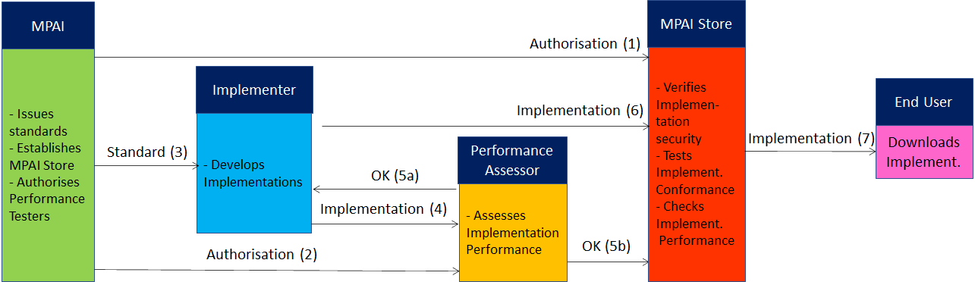
Figure 5 – The MPAI ecosystem operation

The Ecosystem operation allows for AIW and AIF Implementations to be:
- Proprietary: security is verified and Conformance to MPAI-AIF Tested (Level 1).
- Conforming to an MPAI Application Standard: security is verified and Conformance to the relevant MPAI Application Standard Tested (Level 2).
- Assessed to be Reliable, Robust, Fair and Replicable (Level 3).
and have their Interoperability Level duly displayed in the MPAI Store.

