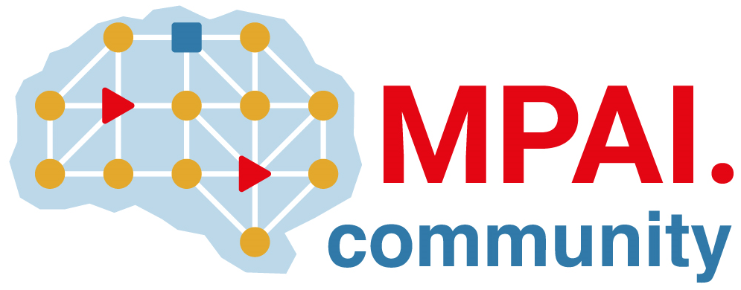 | Moving Picture, Audio and Data Coding by Artificial Intelligence  www.mpai.community

Public Document
N384 | 2021/09/30
Source | ISAC
Title | General licence for MPAI software WD0.1
Target | MPAI-12

The use of software pertaining to any MPAI standard generated inside MPAI, including Reference Software of MPAI Standards, shall comply with the following Modified Berkeley Software Distribution (BSD) Licence (further modified from the original licence known as “MXM Licence”), identified in Article 21 of Annex 1 of the MPAI Statutes.

The copyright in this software is being made available under the BSD License, included below. This software may be subject to other third party and contributor rights, including patent rights, and no such rights are granted under this license. Other third-party software referenced and links to their licences are listed below.
<OWNER> = Person releasing the software
<ORGANIZATION> = Organisation releasing the software
<YEAR> = Year of copyright
Copyright © <YEAR>, <OWNER>
All rights reserved.
Redistribution and use in source and binary forms, with or without modification, are permitted provided that the following conditions are met:
- Redistributions of source code must retain the above copyright notice, this list of conditions and the following disclaimer.
- Redistributions in binary form must reproduce the above copyright notice, this list of conditions and the following disclaimer in the documentation and/or other materials provided with the distribution.
- Neither the name of the <ORGANIZATION> nor the names of its contributors may be used to endorse or promote products derived from this software without specific prior written permission.
THIS SOFTWARE IS PROVIDED BY THE COPYRIGHT HOLDERS AND CONTRIBUTORS "AS IS" AND ANY EXPRESS OR IMPLIED WARRANTIES, INCLUDING, BUT NOT LIMITED TO, THE IMPLIED WARRANTIES OF MERCHANTABILITY AND FITNESS FOR A PARTICULAR PURPOSE ARE DISCLAIMED. IN NO EVENT SHALL THE COPYRIGHT HOLDER OR CONTRIBUTORS BE LIABLE FOR ANY DIRECT, INDIRECT, INCIDENTAL, SPECIAL, EXEMPLARY, OR CONSEQUENTIAL DAMAGES (INCLUDING, BUT NOT LIMITED TO, PROCUREMENT OF SUBSTITUTE GOODS OR SERVICES; LOSS OF USE, DATA, OR PROFITS; OR BUSINESS INTERRUPTION) HOWEVER CAUSED AND ON ANY THEORY OF LIABILITY, WHETHER IN CONTRACT, STRICT LIABILITY, OR TORT (INCLUDING NEGLIGENCE OR OTHERWISE) ARISING IN ANY WAY OUT OF THE USE OF THIS SOFTWARE, EVEN IF ADVISED OF THE POSSIBILITY OF SUCH DAMAGE.

