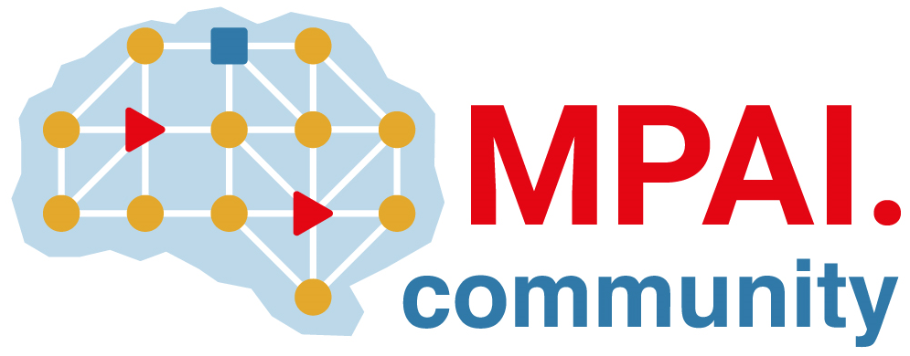 | Moving Picture, Audio and Data Coding  by Artificial Intelligence  www.mpai.community

N393 | 2021/10/27
Source | Leonardo Chiariglione
Title | Proposal for MPAI-13 Press Release
Target | MPAI Members

MPAI calls for comments on two more candidate standards

Geneva, Switzerland – 27 October 2021. After releasing 3 official standards at its previous monthly General Assembly, today the Moving Picture, Audio and Data Coding by Artificial Intelligence (MPAI) standards developing organisation has published 1 more draft standard for comments, the step before official release.

Comments are requested, by 20 November, prior to final approval at MPAI’s next 24 November General Assembly (MPAI-14) on:

AI Framework (MPAI-AIF) enables creation and automation of mixed Machine Learning, Artificial Intelligence, Data Processing and inference workflows, implemented as software, hardware, or hybrid software and hardware. MPAI-AIF is also an enabler of the MPAI Store part of the Governance of the MPAI Ecosystem (MPAI-GME) approved by MPAI-12.

MPAI-12 released the full set of the AI-based Compression and Understanding of Industrial Data (MPAI-CUI) standard – Technical Specification, Reference Software, Conformance Testing and Performance Assessment. As MPAI-12 only released the Multimodal Conversation (MPAI-MMC) Technical Specification, MPAI is currently developing the MPAI-MMC Conformance Testing specification to enable a user to verify the technical correctness of an implementation.

MPAI is currently working on several other standards, e.g.:
- Context-based Audio Enhancement (MPAI-CAE): adding a desired emotion to an emotion-less speech segment, preserving old audio tapes, restoring audio segments and improving the audio conference experience.
- Server-based Predictive Multiplayer Gaming (MPAI-SPG) uses AI to train a network that compensates data losses and detects false data in online multiplayer gaming.
- Connected Autonomous Vehicles (MPAI-CAV) uses AI in key features: Human-CAV Interaction, Environment Sensing, Autonomous Motion, CAV to Everything and Motion Actuation.
- Mixed Reality Collaborative Spaces (MPAI-MCS) creates AI-enabled mixed-reality spaces populated by streamed objects such as avatars, other objects and sensor data, and their descriptors for use in meetings, education, biomedicine, science, gaming and manufacturing.
- AI-Enhanced Video Coding (MPAI-EVC), a candidate MPAI standard improving existing video coding tools with AI and targeting short-to-medium term applications.
- End-to-End Video Coding (MPAI-EEV) is a recently launched MPAI exploration promising a fuller exploitation of the AI potential in a longer-term time frame that mPAI-EVC.

MPAI develops data coding standards for applications that have AI as the core enabling technology. Any legal entity who supports the MPAI mission may join MPAI if it is able to contribute to the development of standards for the efficient use of data.
Visit the MPAI web site and contact the MPAI secretariat for specific information.

