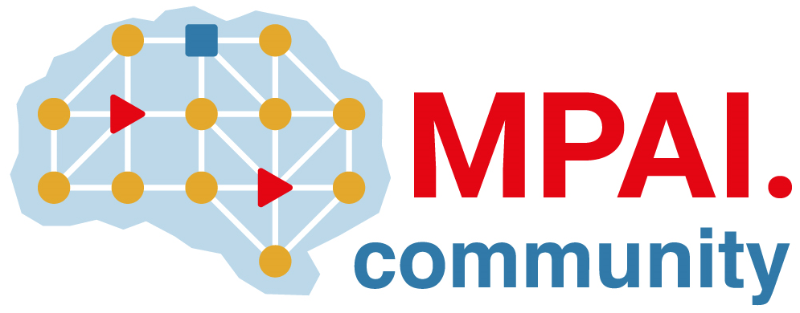 | Moving Picture, Audio and Data Coding by Artificial Intelligence  www.mpai.community

N400 | 2021/10/27
Source | ISAC
Title | MPAI: mission – achievements – plans
Target | MPAI Community

A concise expression of the mission of MPAI – Moving Picture, Audio and Data Coding by Artificial Intelligence – the one-year old international, unaffiliate, not-for-profit Standard Developing Organisation (SDO) is: to develop usable AI-based standards for data coding, i.e., the transformation of data from a format to another more suitable for an application.
The last 12 months have been an incredibly exciting ride summarised by the following achievements:
- A 5-phase rigorous standards development process implementing the mission: 1) anybody can participate in and contribute to define the functional requirements of a new standard, 2) Principal Members define the Framework Licence – the equivalent of the real world commercial requirements, 3) Members develop the standard, 4) the MPAI Community comments on the draft standard, and 5) Principal Members approve the standard.
- A practical approach at the development of data compression standards based on reusable standard components called AI Modules (AIM), organised in standard AI Workflows (AIW) and executed in a standard AI Framework (AIF). Standardisation is kept at the minimum that enables interoperability of components to be made available in a competitive market.
- The Governance of the MPAI Ecosystem composed of: 1) MPAI; 2) Implementers of MPAI standards; 3) Assessors of the Performance of MPAI standards assessing their Reliability, Robustness, Fairness and Replicability; 4) the MPAI Store, a commercial not-for-profit entity, verifying the security, conformance and performance of implementations, and publishing them with appropriate interoperability labels; and 5) End Users. The governance is implemented as specified by the Governance of the MPAI Ecosystem (MPAI-GME) standard.
- The implementation of the process for its first standards: 1) AI Framework (MPAI-AIF), currently open to Community Comments; 2) Context-based Audio Enhancement (MPAI-CAE), currently open to Community Comments; 3) Multimodal Conversation (MPAI-MMC), whose Technical Specification has been published; and Compression and 4) Understanding of Financial Data (MPAI-CUI), whose full set of Technical Specification, Reference Software, Conformance Testing and Performance Testing have been published.
- Application of the process for other standards: 1) applying of AI to new generations of video compression standards starting from an established standard (MPAI-EVC) and using the end-to-end approach (MPAI-EEV); 2) preserving the user experience in on-line gaming high-latency conditions using AI to predict missing data (MPAI-SPG); 3) accelerating the development of the Connected Autonomous Vehicle industry through the definition of standard AI-based components (MPAI-CAV); 4) enriching the user experience of the mixed-reality collaborative spaces through AI (MPAI-MCS); 5) supporting computation-intensive genomic data processing through AI (MPAI-GSA).
MPAI has demonstrated that the principles of the MPAI Statutes can be put to practical use: 1) it is the only SDO engaged in AI-based data coding across the full spectrum of data types open to corporate and academic members capable to contribute to the achievement of its mission, 2) it develops standards with a process that ensures timely access to essential Intellectual Property including the general public at appropriate times; 3) it governs an ecosystem offering End Users access to the promised benefits of AI by allowing user-selectable levels of transparency, trust and reliability.
MPAI calls on the industry to join and leverage their membership in MPAI to share their ideas about the most powerful tool to develop industry while serving humankind: timely usable standards powered by the best technologies.

Join the fun, build the future.

