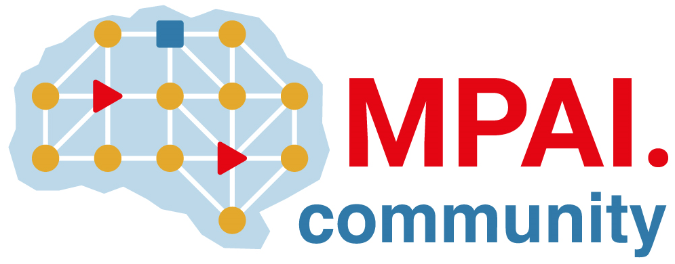 | Moving Picture, Audio and Data Coding by Artificial Intelligence  www.mpai.community

N413 | 2021/10/27
Source | Requirements (EEV)
Title | MPAI-EEV progress report and plans
Target | MPAI-13

MPAI-12 approved the request to investigate AI-based End-to-End Video based on Extending the scope of MPAI AI-based Video Coding standards (N376).
The MPAI-EEV project is a the Interest Collection (IC) stage.
One part of the activity was about communicating the project to interested parties. About 20 people, both MPAI Members and non-Members, joined the two meeting on the Wednesdays not occupied by MPAI-EVC meetings.
The project has the following plan of work:
- Survey E2E video coding SotA, including OSS implementations
- Develop reference model (RM)
- Define MPAI-EEV project
- Set up video data base
- Identify RM components
- Identify functions & interfaces
- Call for comments on RM
- Propose components
- Compare results
- Iterate components
- Iterate/evolve Reference Model
- Publish results on journals
The first two steps are in bold in the sense that the group is currently concentrating on those steps.
Currently the group is reviewing the state of the art. The following presentations and presenters have been identified
- Asfa (CYENC): paper
- Francesco & Antonio (Kebula): paper
- Alessandra (Sisvel): paper
- David (Hubtropolis): paper
- Chuanmin (PKU): paper
- Roberto (RAI): OSS implementation
The group intends to continue meeting on the Wednesdays not taken by MPAI-EVC.

