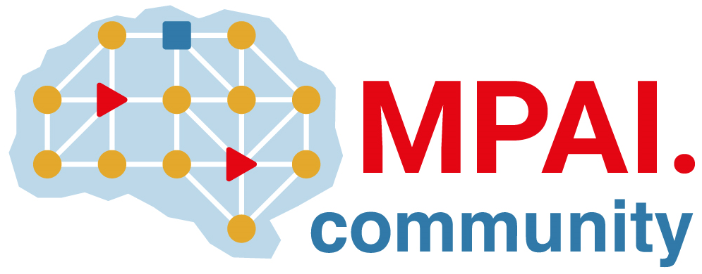 | Moving Picture, Audio and Data Coding  by Artificial Intelligence  www.mpai.community

Public Document
N417 | 2021/10/27
Source | 13th MPAI General Assembly (MPAI-13)
Title | Request for Community Comments on MPAI-AIF (N402)
Target | MPAI Members

Dear…
Established 11 months ago with the mission to develop Data Coding standards primarily using Artificial Intelligence, MPAI (https://mpai.community/) has approved 3 standards and is currently working on 10 projects of standard. For one of these standards:

AI Framework,

the text of the working draft is close to settled, and final approval is expected in a matter of weeks. The WD are publicly available at https://mpai.community/standards/mpai-aif/draft-standard/.
As a professional in this field we are inviting you send your comments on the drafts, especially on the suitability of the standards in their current form and suggestions for future work.
Please send your comments by email to Secretariat by 20 November 2021.
Your comments will not be shared outside MPAI but considered by the Development Committees in charge of the standards. An individual response provided to you.
Please note that comments shall not include any Intellectual Property matters. If any will be received, the Secretariat will return the email to you and not forward it to any MPAI member or Development Committee.
However, if you believe you have IP in the areas where MPAI develops standards, please read the MPAI Statutes (https://mpai.community/statutes/) and consider joining MPAI (https://mpai.community/how-to-join/join/).
Best Regards
The MPAI Secretariat

