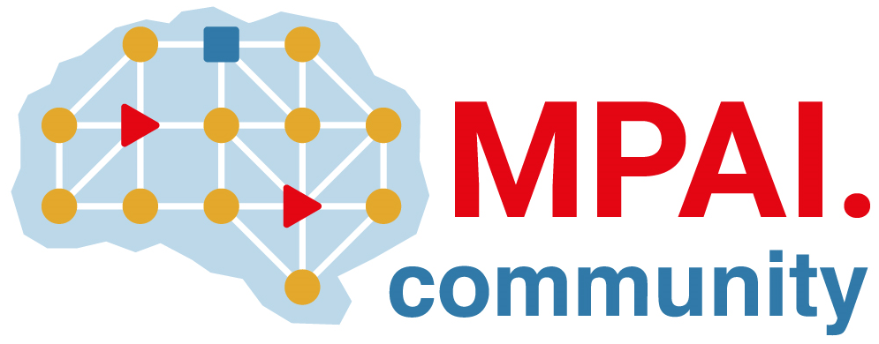 | Moving Picture, Audio and Data Coding  by Artificial Intelligence  www.mpai.community

N426 | 2021/11/24
Source | Leonardo Chiariglione
Title | MPAI-14 Press Release
Target | MPAI Members

MPAI approves AI Framework and calls for comments on Enhanced Audio standards

Geneva, Switzerland – 24 November 2021. After releasing 3 official standards, today the Moving Picture, Audio and Data Coding by Artificial Intelligence (MPAI) standards developing organisation has published one standard for final publication and one draft standard for community comments, the step before official release.

The standard approved for final publication is AI Framework (MPAI-AIF), a standard that enables creation and automation of mixed Machine Learning, Artificial Intelligence, Data Processing and inference workflows. The Framework can be implemented as software, hardware, or hybrid software and hardware, and is the enabler of the MPAI Store, a not-for-profit entity giving access to certified MPAI implementations.

The draft standard released for Community Comments is Context-based Audio Enhancement (MPAI-CAE). The standard supports 4 identified use cases: adding a desired emotion to an emotion-less speech segment, preserving old audio tapes, restoring audio segments and improving the audio conference experience. Comments are requested, by 15 December, prior to final approval at MPAI’s next General Assembly (MPAI-15) on 22 December 2021.

MPAI is currently working on several other standards, some of which are:
- Server-based Predictive Multiplayer Gaming (MPAI-SPG) uses AI to train a network that compensates data losses and detects false data in online multiplayer gaming.
- AI-Enhanced Video Coding (MPAI-EVC), a candidate MPAI standard improving existing video coding tools with AI and targeting short-to-medium term applications.
- End-to-End Video Coding (MPAI-EEV) is a recently launched MPAI exploration promising a fuller exploitation of the AI potential in a longer-term time frame that MPAI-EVC.
- Connected Autonomous Vehicles (MPAI-CAV) uses AI in key features: Human-CAV Interaction, Environment Sensing, Autonomous Motion, CAV to Everything and Motion Actuation.
- Mixed Reality Collaborative Spaces (MPAI-MCS) creates AI-enabled mixed-reality spaces populated by streamed objects such as avatars, other objects and sensor data, and their descriptors for use in meetings, education, biomedicine, science, gaming and manufacturing.

So far MPAI has published 4 standards in final form
- The Governance of the MPAI Ecosystem (MPAI-GME) establishing the process and rules that allow users to select and access implementations with the desired interoperability level.
- The Compression and Understanding of Industrial Data (MPAI-CUI) standard giving the financial risk assessment industry new, powerful and extensible means to predict the performance of a company.
- The Multimodal Conversation (MPAI-MMC) standard allowing industry to accelerate the availability of products, services and applications such as: multimodal conversation with a machine; requesting and receiving information via speech about a displayed object; translating speech using a synthetic voice that preserves the features of the speaker.

MPAI develops data coding standards for applications that have AI as the core enabling technology. Any legal entity supporting the MPAI mission may join MPAI if able to contribute to the development of standards for the efficient use of data.
Visit the MPAI web site and contact the MPAI secretariat for specific information.

