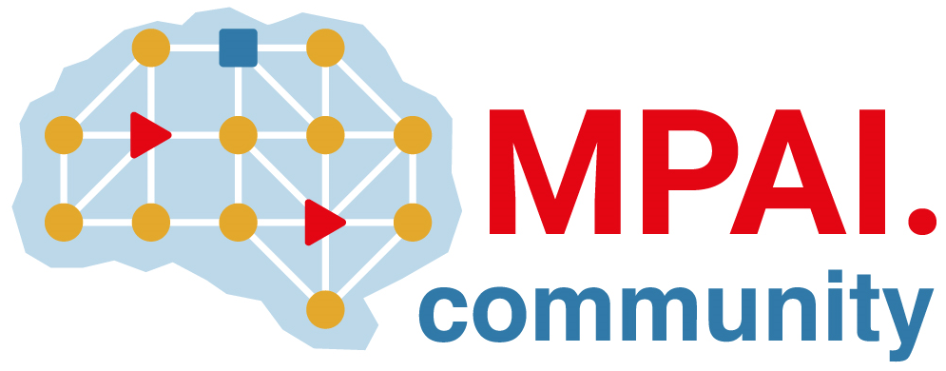 | Moving Picture, Audio and Data Coding by Artificial Intelligence  www.mpai.community

N456 | 2021/11/24
Source | 14th MPAI General Assembly (MPAI-14)
Title | 10 reasons to join MPAI
Target | MPAI Community

- Standards accelerate technology exploitation into products.
- Artificial Intelligence has the highest potential to yield high-performance solutions to data coding.
- MPEG has shown that standards should be developed by applying technology across the board and MPAI is the only standards organisation doing so for AI-based data coding.
- MPEG has shown that industry is well served by increasing accessibility to standards and MPAI makes available Framework Licences to accelerate access to its standards.
- MPAI has solid foundations: with its experience and rigorous standards-development process.
- MPAI addresses high-profile data coding areas: AI framework, audio enhancement, human-machine conversation, prediction of company performance, video coding, online gaming, autonomous vehicles and more.
- MPAI is productive: in 15 months it has developed 4 standards (governance, human-machine conversation, company performance prediction and AI Framework), by end of year it will complete another standard (audio enhancement) and has 7 more standards in the pipeline.
- MPAI standards are viral: products conforming to MPAI standards are already present on the market.
- MPAI develops methods to assess the level of conformance and reliability of standard implementations, including methods ensuring that implementations are bias-free.
- MPAI plans on establishing the MPAI Store, a not-for-profit commercial organisation with the task to test implementations for security and conformance, and verify they are bias-free.

Join the fun, build the future!

