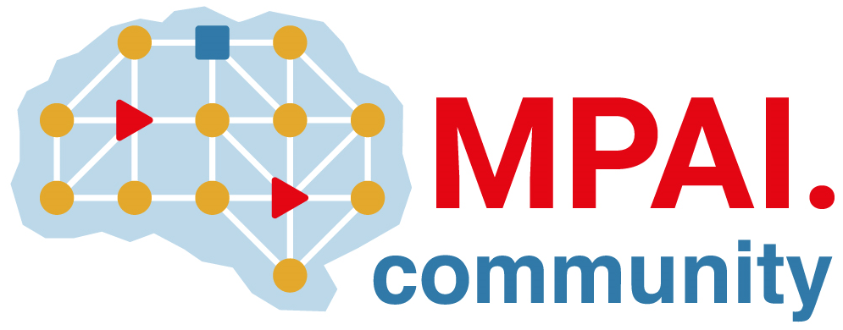 | Moving Picture, Audio and Data Coding  by Artificial Intelligence  www.mpai.community

N465 | 2021/11/04
Source | Board of Directors
Title | “Basic Framework Licence for Collaborative Explorations”
Target | MPAI Members

Coverage

MPAI promotes collaborative investigations under the auspices of MPAI of new areas suitable for MPAI standardisation (“Explorations”). To facilitate the migration of Exploration results into the formal MPAI standard process, MPAI requests that all contributions submitted to the Exploration contain the following text:

<Company/Member> declares that, in case the Exploration to which this submission is made will become part of the MPAI Work Plan per Annex I of the MPAI Statutes and deliver a Technical Specification, <Company/Member> submitting this contribution or its successors will make available the terms of the Licence related to its Essential IPR in the Technical Specification in accordance to the “Basic Framework Licence for Collaborative Explorations” [N465] and will endeavour to make its Licence in accordance with the Framework Licence of the Technical Specification, alone or jointly with other IPR holders, after the approval of the Technical Specification by the MPAI General Assembly and in no event after commercial implementations of the Technical Specification become available on the market.

Definitions
Term | Definition
Data | Any digital representation of a real or computer-generated entity, such as moving pictures, audio, point cloud, computer graphics, sensor and actuator. Data includes, but is not restricted to, media, manufacturing, automotive, health and generic data.
Development Rights | Licence to use the Essential IPRs of the Technical Specification to develop Implementations of the Technical Specification.
Enterprise | Any commercial entity that develops or implements the Technical Specification.
Essential IPR | Any Proprietary Rights, (such as patents) without which it is not possible on technical (but not commercial) grounds, to make, sell, lease, otherwise dispose of, repair, use or operate Implementations without infringing those Proprietary Rights.
Exploration | The collaborative investigation under the auspices of MPAI of new areas suitable for MPAI standardisation.
Framework Licence | A document, developed in compliance with the generally accepted principles of competition law, which contains the conditions of use of the Licence without the values, e.g., currency, percent, dates etc.
Implementation | A hardware and/or software reification of the Technical Specification serving the needs of a professional or consumer user directly or through a service.
Implementation Rights | Licence to reify the Technical Specification.
Licence | This Basic Framework Licence or the Framework Licence for the standard project, to which values, e.g., currency, percent, dates etc., related to a specific Intellectual Property will be added. In this Basic Framework Licence, the word Licence will be used as singular. However, different IPR holders may issue different Licences.
Profile | A particular subset of the technologies that are used in the Technical Specification and, where applicable, the classes, subsets, options and parameters relevant to the subset.
Technical Specification | The eventual outcome of an Exploration.

Conditions of use of the Licence
- The Licence will be in compliance with generally accepted principles of competition law and the MPAI Statutes.
- The Licence will cover all of Licensor’s claims to Essential IPR practiced by a Licencee of the Technical Specification.
- The Licence will cover Development Rights and Implementation Rights.
- The Licence for Development and Implementation Rights, to the extent it is developed and implemented only for the purpose of evaluation or demo solutions or for technical trials, will be free of charge.
- The Licence will apply to a baseline profile of the Technical Specification and to other profiles containing additional technologies.
- Access to Essential IPRs of the Technical Specification will be granted in a non-discriminatory fashion.
- The scope of the Licence may be subject to legal, bias, ethical and moral limitations.
- Royalties will apply to Implementations that are based on the Technical Specification.
- Royalties will apply on a worldwide basis.
- Royalties will apply to any Implementation, with the exclusion of the type of implementations specified in clause 4.
- An Implementation may use other IPR to extend the Implementation or to provide additional functionalities.
- The Licence may be granted free of charge for particular uses if so decided by the licensors.
- A Licence free of charge for a limited time and a limited amount of forfeited royalties will be granted on request.
- A preference will be expressed on the entity that should administer the pool of holders of IPR Essential to the Technical Specification.
- The total cost of the Licences issued by IPR holders will be in line with the total cost of the Licences for similar technologies standardised in the context of Standard Development Organisations.
- The total cost of the Licences will take into account the value on the market of the <name of exploration project> technology Standardised by MPAI.

