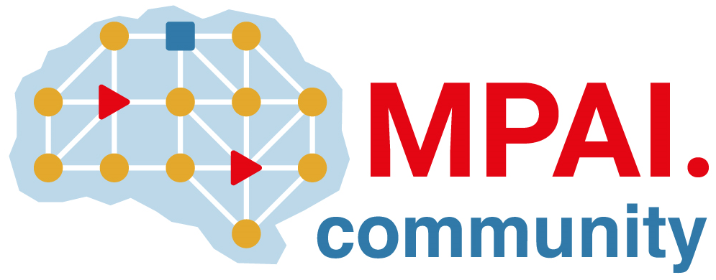 | Moving Picture, Audio and Data Coding by Artificial Intelligence  www.mpai.community

M477 | 2021/12/22
Source | Requirements (CAV)
Title | MPAI-CAV progress report and plans
Target | MPAI-15

The group is working on the impact of the final version of the MPAI-AIF V1 Technical Specification on the V2X Susbsystem. This is no longer needed as communication is done directly by the Autonomous Motion Subsystem.
The cav.mpai.community web page has been created, populated with content and promoted.
WD0.7 has been produced

