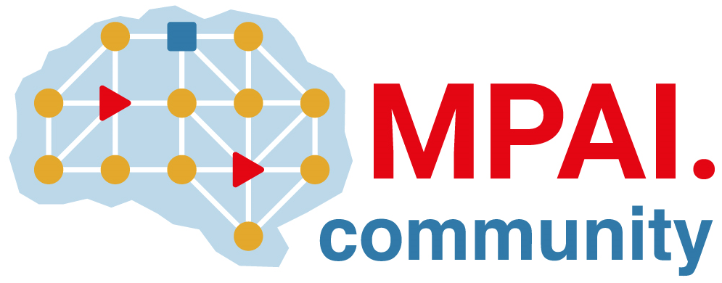 |  | Moving Picture, Audio and Data Coding  by Artificial Intelligence  www.mpai.community
N479 | 2021/12/22
Source | Chuanmin Jia
Title | MPAI-EEV progress report and plan
Target | MPAI-Members

MPAI-EEV progress report
There are two MPAI-EEV meetins since the last general assembly meeting. And the main progress of them is to provide comprehensive review of the EEV coding methods by several reports and kick-off the draft that describing the state-of-the-art end-to-end video coding methods. The detailed presentation and the corresponding reported papers are listed in Table 1.
Table 1 The presentations during MPAI-EEV meeting
Presenter | Title
Antonio | ELF-VC: Efficient Learned Flexible-Rate Video Coding
Alessandra | End-to-End Learning for Video Frame Compression with Self-Attention
Asfa | An End-to-End Learning Framework for Video Compression
Giovanni | Neural Video Compression Using Spatio-Temporal Priors
Giovanni | Learning_for_Video_Compression_With_Recurrent_Auto-Encoder_and_Recurrent_Probability_Model
Chuanmin | DAST-NVC: Dual Attentional Spatial Transformer Inspired Neural Video Compression
Roberto | End-to-End Learning of Video Compression Using Spatio-Temporal Autoencoders
Roberto | Learning for Video Compression with Hierarchical Qualityand recurrent enhancement
Roberto | On the OpenDVC

The correspond papers have been uploaded to the next-cloud. Those who wish to access the area can click on https://experts.mpai.community/live/nextcloud/index.php/apps/files/?dir=/MPAI-EEV&fileid=111592 . One will be asked to register and the secretariat will authorise your access.
The MPAI EEV is currently discussing the development routine of the project. The starting point has been agreed by the participants that the OpenDVC should be adopted and further investigations needs to be done on top of it. In addition, the original authors of DVC and OpenDVC have submitted their authorization documents to the MPAI that they agree with the basic license of MPAI.
The very first coding tool under discussion for MPAI-EEV project is the enhanced motion compensation prediction (MCP) network. The participants have commented on this tool that it is necessary to use more complex version motion compensation network in OpenDVC. But there is no agreement on the network structure and how to design a reasonable network for MCP. As such, further discussion and analysis should be made. Ideas also arise that the image sequences should be treated as volumetric data and deploy the higher dimensional convolution to ensure the temporal consistency and motion transparency.

Plan
The MPAI-EEV project should have the following program of work with two distinct phases, the first of which focuses on the short-term targets such as studying the state of the art solutions in E2E video coding from both academic and industrial societies, generating the summarized written draft to give a comprehensive understanding of related research. The following efforts might be paid to discuss and determine the license for the MPAI-EEV, which is similar to other projects in MPAI. The reference model of MPAI-EEV and the corresponding test conditions including the training/testing/validation datasets should be defined and all of the subsequent efforts are collaboratively conducted based on the further discussed core experiments by the whole community. Such that the comparisons and progress could be aligned in the context of common test conditions of EEV. Thus the reference model as well as the core experiments could be iteratively updated. Then the requirements and evidence are further explored to justify the needs for MPAI-EEV standard. The second phase of this project is relatively a long-term goal regarding the current status. While the MPAI-EEV standard is expected to be developed following several typical procedures such as requirements study, call for evidence, call for technologies, proposal evaluation, and text specification preparation with aligned reference model.

