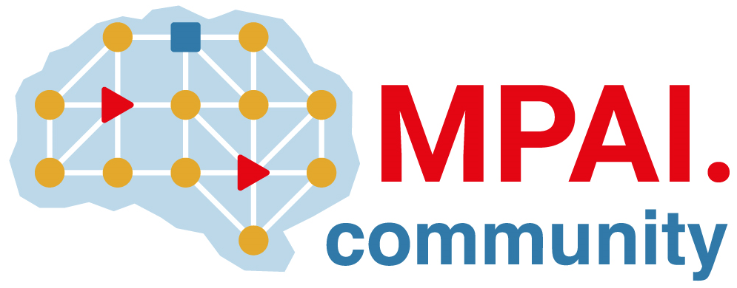 | Moving Picture, Audio and Data Coding by Artificial Intelligence  www.mpai.community

N483 | 2021/12/22
Source | Requirements (MCS)
Title | MPAI-MCS progress report and plans
Target | MPAI-15

The Use Cases and Functional Requirements WD has benefitted from a review by MMC-DC,
The group is now working on refining the scope of MPAI-MCS and the functional requirements of the MPAI-MCS technologies.
The mcs.mpai.community web page has been created, populated with content and promoted.
MPAI-CAV Use Cases and Functional Requirements WD0.5 (N486) proposed

