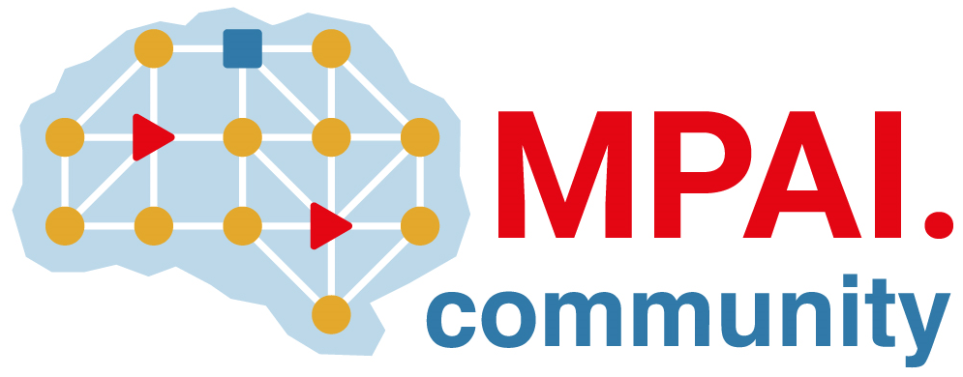 | Moving Picture, Audio and Data Coding by Artificial Intelligence  www.mpai.community

Public Document
N499 | 2022/01/26
Source | General Assembly #15 (MPAI-16)
Title | MPAI Timeline
Target | MPAI-15

NB1 | Dates in italic indicate estimated dates mm/dd where mm/dd=2020, mm/dd=2021 and mm/dd=2022
NB2 | ... in a date indicate that only the month is estimated

V | Std | IntCo | UseC | FunRq | ComRq | CfT | StdDv | TchS | RfSw | ConfT | PerfA
1 | AIF |  |  | 10/21 | 11/18 | 12/16 | 02/17 | 11/24 | 04/20 | 03/23 | --/--
1 | MMC |  |  | 10/21 | 12/16 | 02/17 | 04/14 | 09/30 | ??/?? | 02/23 | 03/23
1 | CAE |  |  | 10/21 | 12/16 | 02/17 | 04/14 | 12/22 | ??/?? | 03/23 | 04/20
 | SPG |  |  | 10/21
 | CAV |  | 06/09 | 07/19
 | MCS |  | 07/19 | 08/25
 | EVC |  |  | 10/21
 | GSA |  |  | 10/21
 | OSD |  |  | 05/12
 | EEV | 09/30
 | ARA | 01/26
 | NNW | 01/26

Acronym | Title
MPAI-AIF | AI Framework
MPAI-CAE | Context-based Audio Enhancement
MPAI-MMC | Multi-Modal Conversation
MPAI-ARA | Avatar Representation and Animation
MPAI-CAV | Connected Automotive Vehicles
MPAI-EVC | AI-Enhanced Video Coding
MPAI-EEV | AI-based End-to-End Video Coding
MPAI-GSA | Integrative AI-based Analysis of Genomic/ Sensor Experiments
MPAI-NNW | Neural Network Watermarking
MPAI-OSD | Visual Object and Scene Description
MPAI-SPG | Server-based Predictive Multiplayer Gaming

General Assemblies

# | 0 | 1 | 2 | 3 | 4 | 5 | 6 | 7 | 8 | 9 | 10 | 11 | 12 | 13 | 14 | 15 | 16 | 17 | 18
d | 30 | 21 | 18 | 16 | 21 | 17 | 17 | 14 | 12 | 09 | 19 | 25 | 30 | 27 | 24 | 22 | 26 | 23 | 23
m | 09 | 10 | 11 | 12 | 01 | 02 | 03 | 04 | 05 | 06 | 07 | 08 | 09 | 10 | 11 | 12 | 02 | 03 | 03
y | 20 | 20 | 20 | 20 | 21 | 21 | 21 | 21 | 21 | 21 | 21 | 21 | 21 | 21 | 21 | 21 | 22 | 22 | 22

