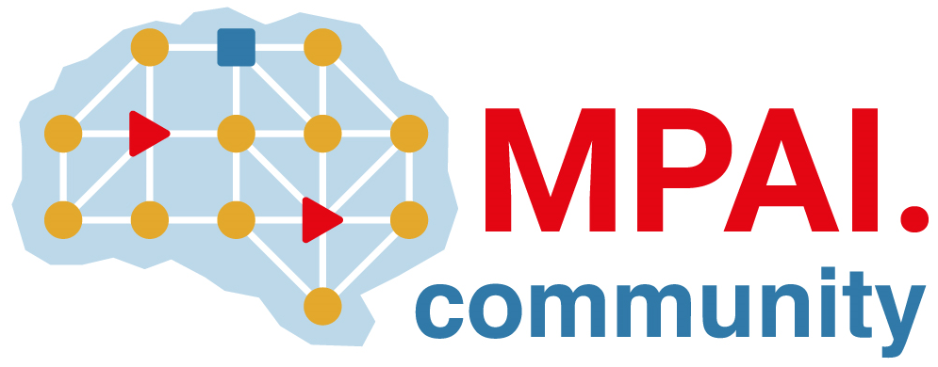 | Moving Picture, Audio and Data Coding by Artificial Intelligence  www.mpai.community

N518 | 2022/01/26
Source | Requirements (EEV)
Title | Requirements (EEV) progress report and plans
Target | MPAI-16

Requirements (EEV) has built on its decision to adopt OpenDVC ([1]) as starting point of its next phase of work because 1) it offers the best performance among the documented papers providing training and inference software and 2) two necessary Basic Framework Licence declarations have been received (M705 and M709).
Requirements (EEV) has agreed to explore the replacement of the current OpenDVC Motion Compensation Predition (MCP) with a more powerful alternative ([2]). The Requirements (EEV) coordinator is contacting the authors to obtain Basic Framework Licence declarations.

References
[1] R. Yang, L. Van Gool, R. Timofte, OpenDVC: An open source implementation of the DVC video compression method, arXiv preprint arXiv:2006.15862, 2020.
[2] Y. Zhang, K. Li, K. Li, B. Zhong, Y Fu, Residual non-local attention networks for image restoration, arXiv preprint arXiv:1903.10082, 2019.

