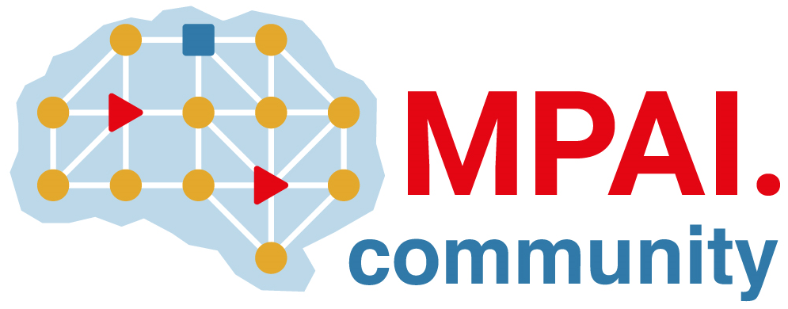 | Moving Picture, Audio and Data Coding  by Artificial Intelligence  www.mpai.community

 | Public document
N523 | 2022/01/26
Source | Requirements (GSA)
Title | MPAI-GSA Status report
Target | MPAI Members

Project status
The month was devoted to
- testing the infrastructure to create data, useful to train neural networks
- tuning the hyperparameters of LSTM (Long Short-Term Memory) neural networks for game state prediction, using the available data created so far.
Figure 1 - Pong game

This kind of NN was developed to resolve some problems of the RNN, like explosive and vanishing gradient. This kind of NN is very good to make forecasting predictions, and we use them to predict the following N+1 game state given N previous game states. We made a comparison with a Multiplayer Perceptron Architecture and (given the same training set), the LSTM returns better prediction results.

We also developed script representing:
- the Collector, it takes all the prediction results
- the Dispatcher, it takes info from the Game State.

We tested performances on the Offline version of Pong then we integrated the prediction system into the Online Version.
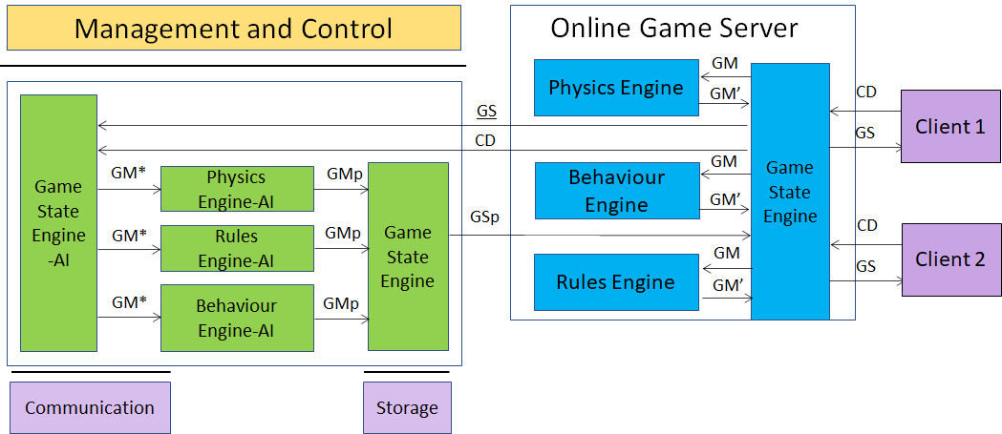
Figure 2 - MPAI-SPG Architecture
Legenda:
Green: new improvements
Red: TODO
Black: general status of the project

Both clients and server use Unity 3D as core game engine.

Features implemented so far:

- Client:
  - Process C can send controller data to Process S
  - Defined a CSV template to make the client log file
  - Process C can obtain the ownership of one paddle sending an explicit request to the Process S.
  - Process C can send notifies to Process S through the so-called “RPCs” (Remote Procedure Calls), to specify some actions or some sort of communication
  - Process C implements Client-side Prediction related to his paddle.
  - Process C implements interpolation (paddle position fixed with Lerp function)
  - Process C implements server reconciliation (tick number for each data request)
- Server:
  - Data exchange explanation between Game State Engine and game engines (Physics, Rule and Behavior)
  - Defined a CSV template to make the server log file (game messages and game states)
  - Game Server use the Photon architecture as space to instantiate each game
  - Process S is a service program, running in “Batch/Headless mode” as Unity instance
  - Process S can receive data from process C and acknowledge receipt of this data
  - Process S instantiate both paddles and ball, then send (through RPCs) their ID to the clients so that they have a reference to those object
  - Process S can handle the data (CD) sent by the process C in order to update the GS
  - Process S is able to manage the physics both of the ball and the client paddles, sending the resulting data (GS) to both clients.
  - Process S is able to synch both ball and client paddles.
  - Better management of lag compensation
  - Process S has
    - Game State Engine (GSE)
    - Physics Engine (PE)
    - Behaviour Engine (BE)
    - Rules Engine (RE)
  - Game State Engine can send data to other three engines (PE/BE/RE)
  - The three engines process the data correctly and send data to GSE

- AI:
  - ML Agents developed, to simulate games in order to train the Neural Networks, using two techniques:
    - Imitation Learning
    - Reinforcement Learning
  - Imitation learning Idea:
    - Build a Demo with human input (Teacher)
    - Define config.yaml with hyperparameters specifics (GAIL = GAN like learning)
    - Start learning. Agent acts as student and learns how to behave as similar as his Teacher. Time required is significantly shorter than other methods (in terms of minutes not hours)
    - NN produced will be the brain of our Client in Pong Game Online
  - Integration of “ml-agents” framework inside Pong online version. This way will be possible to move paddle in an automatic way using inference
  - Game simulation tests produce coherent data (log file) usable in any Neural Network
  - Reinforcement Learning Idea:
    - A set of observed data is chosen (player position, opine position, ball velocity…)
    - Using its NN under development and observed data as input, the player executes an action and gets a reward. The reward is positive if it is correct in order to win the game, negative if is wrong.
  - After multiple matches executed, paddle will be able to hit the ball
  - Learning optimization (both Imitation and reinforcement learning) in terms of:
    - Physics accuracy
    - Hyperparameters selection
  - Introduction of a raycasting system in order to improve Reinforcement Learning:
    - When the ball collides with a paddle, a series of rays is drawn on the game field representing ball trajectory ending on the opponent’s side of the field. This way the opponent will know where the ball will go and will been able to execute the correct action
  - Introduction of a refined architecture (see the following chapter) that assigns “Divider” and “Composer” roles to Game State Engine AI
  - Choice of the “Long Short-Term Memory” Neural Network Architecture to develop the 3 Simple Engines inside the MPAI-SPG Architecture (Physics Engine, Rules Engine, Behavior Engine) and we started the first training of them, using a small dataset of real game states taken from a Pong simulation
    - Made a comparison with the MLP (MultiLayer Perceptron) to analyze performances
  - Creation of the Prediction System and application on the Pong Offline version:
    - Integration using Barracuda Framework
  - Creation of Collector and Dispatcher for input and prediction data management
  - Design of hardware requirements and availability at the end of December 2021 of the virtual architecture to create data and to train neural networks
  - Received the hardware resources of Computer Science Department, University of Torino (CSD-UniTo).
  - Collection of logs using CSD-UniTo hardware:
    - Using the trained AI Pong paddles, able to automatically play Pong, we collected around 15 millions game states
  - Neural Networks training:
    - A first set of training experiments was made in order to find a suitable predictive architecture using the 15 millions records dataset generated at the previous step
    - The experiments were executed testing different kinds of architectures and changing network hyper parameters, like learning rate, batch size, optimizers, number of nodes inside LSTM layers
  - Prediction System integration into Pong Online version:
    - To make inference using trained neural networks, a set of scripts representing the “refined architecture” was implemented using the Unity Barracuda Framework. In this way we were able to use Physics, Behavior and Rules Predicted engine inside the Pong Online game
    - This system is primarily used to test the trained neural networks previously described.

- PLANS:
  - Experiment different kind of neural network architectures to find a setup able to correctly predict game states.
  - Network Latency simulation inside Online Version to the prediction system.

MPAI-SPG VIRTUAL ARCHITECTURE

Once the software solution was consolidated, the atomic structure for producing and processing the data that will train the neural networks was also formalized.

Since December 2021 in collaboration with the Department of Computer Science of Turin, the architecture is available and it uses the set of virtual machines shown in the drawing below.

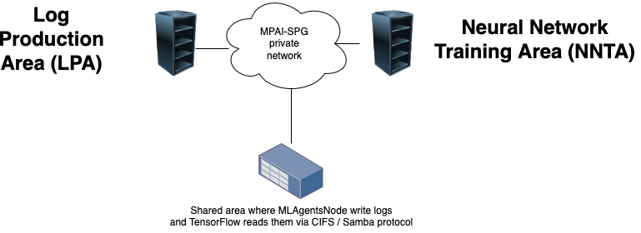

Fig.1 : MPAI-SPG Virtual Architecture for Pong prototype

We setup two steps to complete the process:
- Creation of the log files by the LPA machine, which runs multiple instances of the Unity project. At the end of the operation, we will have a set of log files generated.
- Using the log files to learn the neural network on the NNTA machine, which runs a python program with TensorFlow.

To better describe this atomic setup, we report the minimum requirements of the architecture, starting with physical servers:

LPA: Intel Core i7-11700KF, 16 GB RAM, hard disk space 2TB SSD, Windows 10 Pro, Unity 2020.3.4f1, MLAgents 2.0, Nvidia GTX 1660

NNTA: Intel Core i7-11700KF, 32 GB RAM, hard disk space 2TB SSD, Ubuntu Server 20.04.3 LTS, Python 3.7.9, Tensorflow 2 (pip version - Python > 19.0), Keras (Python API, it would be included in the Tensorflow installation)

The requirements will be translated in virtual requirements, comparing benchmarks of PassMark (I.E. https://www.cpubenchmark.net/)

