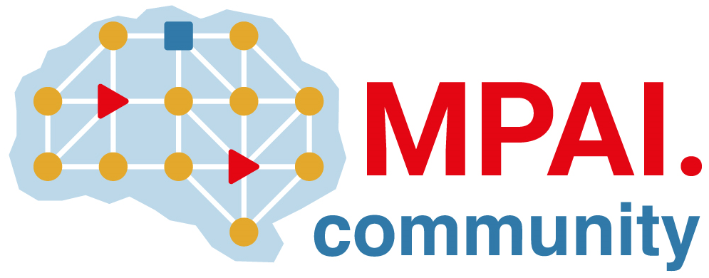 | Moving Picture, Audio and Data Coding  by Artificial Intelligence  www.mpai.community

Public document
N534 | 2022/02/23
Source | 17th MPAI General Assembly (MPAI-17)
Title | MPAI-17 Press Release
Target | MPAI Members

MPAI outlines plans for the MPAI Store Foundation

Geneva, Switzerland – 23 February 2022. Today the Moving Picture, Audio and Data Coding by Artificial Intelligence (MPAI) standards developing organisation has concluded its 17th General Assembly. Among the outcomes are: progress towards the establishment of a patent pool for its published standards and a roadmap to establish the MPAI Store Foundation.

The MPAI Statutes define a standard development process whereby holders of standard essential patents (SEP) select their preferred patent pool administrator. The General Assembly was informed that SEP holders in approved MPAI standards are currently engaged in this activity.

The Governance of the MPAI Ecosystem (MPAI-GME) standard envisions an “MPAI Store” tasked with receiving submissions of implementations, verifying their security and conformance, and making them available to other implementers and consumers. Because of the specific characteristics of AI technologies, the MPAI Store coordinates with MPAI-appointed performance assessors that guarantee that implementations are reliable, robust, replicable and fair. The MPAI Store will be a not-for-profit commercial entity where both MPAI members and associations representing the society at large are present.

The General Assembly approved a set of documents guiding the development of use cases and functional requirements for Neural Network Watermarking and the publication of a series of short videos with the title “MPAI talks to industry” illustrating the various aspects of MPAI activities.

MPAI develops data coding standards for applications that have AI as the core enabling technology. Any legal entity supporting the MPAI mission may join MPAI, if able to contribute to the development of standards for the efficient use of data.

MPAI is currently engaged in extending some of the already approved standards and developing other 9 standards (those in italic in the list below).

Name of standard | Acronym | Brief description
AI Framework | MPAI-AIF | Specifies an infrastructure enabling execution of implementations and access to the MPAI Store.
Context-based Audio Enhancement | MPAI-CAE | Improves the user experience of audio-related applications in a variety of contexts.
Multimodal Conversation | MPAI-MMC | Enables human-machine conversation emulating human-human conversation.
Compression and Understanding of Industrial Data | MPAI-CUI | Predicts the company performance from governance, financial and risk data.
Governance of the MPAI Ecosystem | MPAI-GME | Establishes the rules governing submission of and access to interoperable implementations.
Server-based Predictive Multiplayer Gaming | MPAI-SPG | Trains a network to compensate data losses and detects false data in online multiplayer gaming.
AI-Enhanced Video Coding | MPAI-EVC | Improves existing video coding with AI tools for short-to-medium term applications.
End-to-End Video Coding | MPAI-EEV | Explores the promising area of AI-based “end-to-end” video coding for longer-term applications.
Connected Autonomous Vehicles | MPAI-CAV | Specifies components for Environment Sensing, Autonomous Motion, and Motion Actuation.
Avatar Representation and Animation | MPAI-ARA | Specifies descriptors of avatar impersonating real humans.
Neural Network Watermarking | MPAI-NNW | Measures the impact of adding ownership and licensing information in models and inferences.
Integrative Genomic/Sensor Analysis | MPAI-GSA | Compresses high-throughput experiments data combining genomic/proteomic and other.
Mixed-reality Collaborative Spaces | MPAI-MCS | Supports collaboration of humans represented by avatars in virtual-reality spaces called Ambients
Visual Object and Scene Description | MPAI-OSD | Describes objects and their attributes in a scene and the semantic description of the objects.
Visit the MPAI web site, contact the MPAI secretariat for specific information, subscribe to the MPAI Newsletter and follow MPAI on social media: LinkedIn, Twitter, Facebook , Instagram and YouTube.
Most important: join MPAI, share the fun, build the future.

