Moving Picture, Audio and Data Coding
by Artificial Intelligence
www.mpai.community

N545 | 2022/02/13
Source | AIF-DC
Title | Introduction to MPAI-MMC
Target | MPAI Members

The Moving Picture, Audio and Data Coding by Artificial Intelligence (MPAI) communityis an international, unaffiliated, non-profit organisation with the mission to 1) develop standards for a) Artificial Intelligence (AI)-based data coding and b) integration of data coding components into systems, and 2) to attach clear Intellectual Property Rights licensing frameworks to its standards. AI promises to offer superior efficiency in data coding – for example, for data compression or feature-based description – as compared with other current coding technologies.
The role of standards is to enable implementations to interoperate. By providing the means to verify interoperability, standards create ecosystems underpinning the steps of a standard life cycle: specification, implementation, security verification, conformance testing, distribution and consumption.
The particular nature of AI standard, however, should also include the means to assess the degree of reliability, robustness, replicability and fairness of an implementation.
The Governance of the MPAI Ecosystem (MPAI-GME) system standard identifies the MPAI Store as the actor in charge of verifying security, testing conformance, and distribution of implementations and the Performance Assessors as the actors in charge of assessing that implementation are reliable.
MPAI application standards are components-based in the sense that a full application is typically implemented as a set of basic processing elements called AI Modules (AIMs) connected to form AI Workflows (AIWs) executed in an AI Framework (AIF).
The AI Framework (MPAI-AIF) standard specifies architecture, interfaces, protocols and Application Programming Interfaces (API) of the AI Framework depicted in Figure 1.

Figure 1 – The AI Framework (AIF) Reference Model and its Components

MPAI defines interoperability as the ability to replace an AIW or an AIM implementation with a functionally equivalent implementation. Three interoperability levels of an AIW executed in an AIF are defined:
Level 1 – Implementer-specific and conforming with the MPAI-AIF standard.
Level 2 – Specified by an MPAI application standard.
Level 3 – Specified by an MPAI application standard and certified by a Performance Assessor.
The AIF is especially designed for execution of AI-based implementations, but is also suitable for mixed AI and traditional data processing workflows. MPAI-AIF possesses the following main features:
- Is independent of the Operating System.
- Has a component-based modular architecture with specified interfaces.
- Abstracts the interfaces encapsulating components from the development environment.
- Interfaces with the MPAI Store to enable access to validated components.
- Enables implementations of components that are:
  - Software only, from MCUs to HPC.
  - Hardware only.
  - Hybrid hardware-software.
- Offers the following system features:
  - Workflow execution in local or distributed Zero-Trust architectures.
  - Interaction of Implementations operating in proximity.
  - Direct support of Machine Learning functionalities.
MPAI develops its standards through a rigorous process combining openness to all interested parties (when requirements for a new standard are identified), confidentiality (when technology employing a standard is integrated) and sharing of draft standards (when drafts are mature).

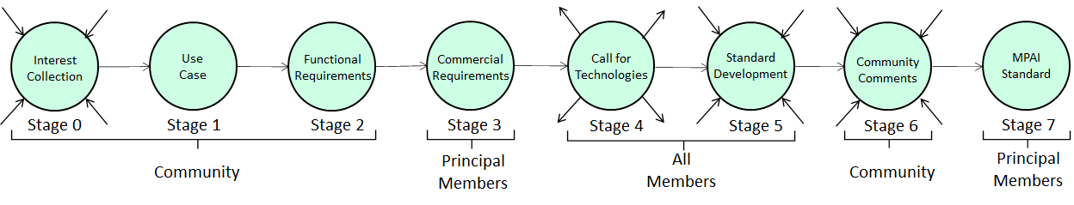
Figure 2 – The stages of the MPAI standards development process

Through its MPAI-AIF standard, MPAI offers users access to the promised benefits of AI with a guarantee of increased transparency, trust and reliability as the interoperability level of an Implementation moves from 1 to 3.

