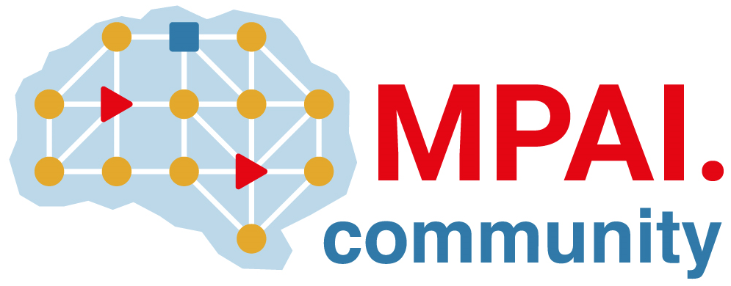 | Moving Picture, Audio and Data Coding  by Artificial Intelligence  www.mpai.community

N553 | 2022/02/23
Source | Leonardo Chiariglione
Title | Introduction to MPAI-GME
Target | MPAI Members

The Moving Picture, Audio and Data Coding by Artificial Intelligence (MPAI) community is an international, unaffiliated, non-profit organisation 1) developing standards for a) Artificial Intelligence (AI)-based data coding and b) integration of data coding components into systems, 2) attaching clear Intellectual Property Rights licensing frameworks. Research has established that AI-based technologies may offer superior efficiency in data coding – for example, for data compression or feature-based description – as compared with other current coding technologies.
The role of standards is to enable implementations to interoperate. By providing the means to verify interoperability, standards create ecosystems underpinning the steps of a standard life cycle: specification, implementation, security verification, conformance testing, distribution and consumption.
The particular nature of AI standard, however, should also include the means to assess the degree of reliability, robustness, replicability and fairness of an implementation.
MPAI application standards are components-based in the sense that a full application is typically implemented as a set of basic processing elements called AI Modules (AIMs) connected to form AI Workflows (AIWs) executed in an implementation of the MPAI-specified AI Framework (MPAI-AIF) system standard.
MPAI defines interoperability as the ability to replace an AIW or an AIM implementation with a functionally equivalent implementation. Three interoperability levels of an AIW executed in an AIF are defined:
Level 1 – Implementer-specific and conforming with the MPAI-AIF Standard.
Level 2 – Specified by an MPAI application standard.
Level 3 – Specified by an MPAI application standard and certified by a performance assessor.
The Governance of the MPAI Ecosystem (MPAI-GME) standard identifies 1) MPAI Store as the actor in charge of security verification, conformance testing, and distribution of implementations and 2) Performance Assessors as the actors in charge of assessing that implementation are reliable, robust, replicable and fair.
The MPAI Ecosystem is depicted in Figure 1.

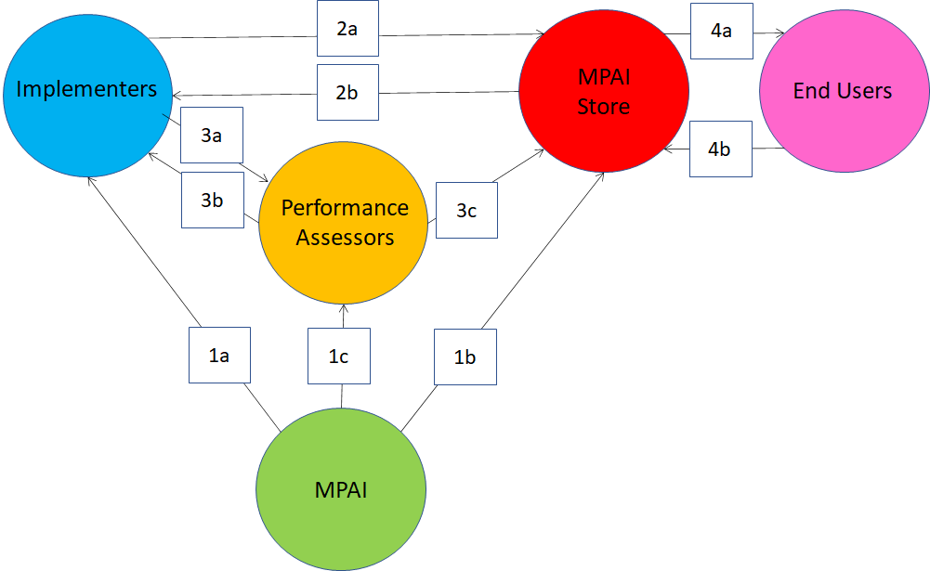
Figure 1 – The MPAI Ecosystem
The functions of the MPAI ecosystem are described by the following steps:
- Establishment of root of trust. MPAI enables the Ecosystem by
  - Making standards available to implementers.
  - Establishing the non-profit commercial MPAI Store.
  - Appointing Performance Assessors.
- Submission of level 1 and level 2 implementation.
  - Implementer submits implementation to MPAI Store for security verification and conformance testing.
  - MPAI Store notifies result to implementer.
- Submission of level 3 implementation.
  - Implementer may submit implementation to a Performance Assessor for performance assessment.
  - Performance Assessor informs implementer of result.
  - Performance Assessor informs MPAI Store of result.
- Implementation download. End User:
  - Downloads implementation.
  - Notifies MPAI Store’s reputation system of their user experience.
AI can offer great new benefits to humankind. MPAI standards offer the way to practically promote and disseminate use of AI. The Governance of the MPAI Ecosystem assures implementers that the Store holds interoperable implementations and end users that the implementations they enjoy have undergone different levels of scrutiny.

