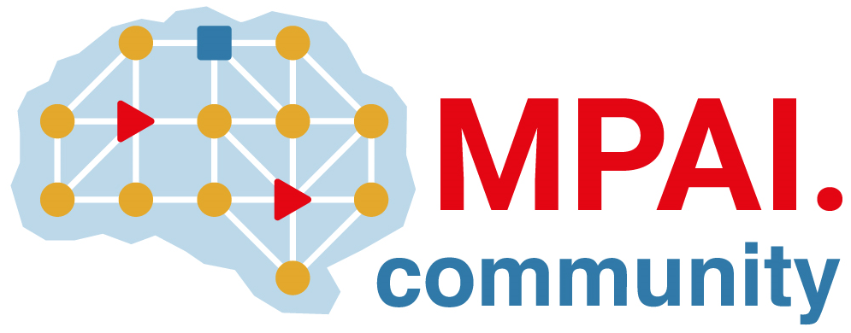 | Moving Picture, Audio and Data Coding by Artificial Intelligence  www.mpai.community

N561 | 2022/02/23
Source | Requirements (EEV)
Title | Requirements (EEV) progress report and plans
Target | MPAI-17

Requirements (EEV) has completed the industrial presentation and made it public available for the participants of MPAI. In addition, the shared common test conditions are discussed by both EVC and EEV, including tests sequences, training dataset, prediction structure, metrics, and other data that are needed to be reported. The corresponding document has been delivered. The reference software coordinator has been determined, who is Haifeng Guo, Ph.D. student from Peng Cheng Laboratory. The estimated timeline for the reference software development and integration is defined and planned.

The Requirements (EEV) coordinator is expecting the first coding tool development and its coding performances.

