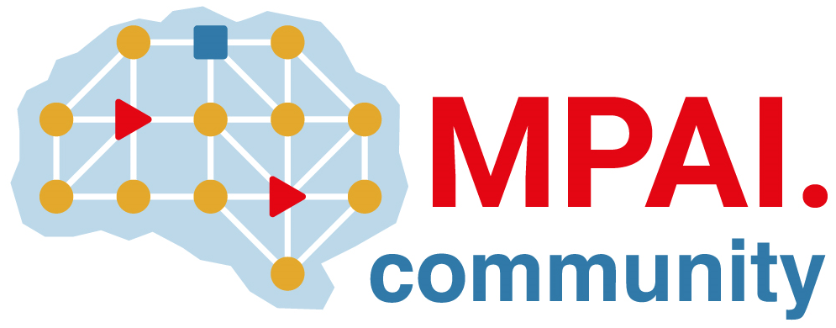 | Moving Picture, Audio and Data Coding by Artificial Intelligence  www.mpai.community

N578 | 2022/02/23
Source | ISAC
Title | MPAI Patent Policy
Target | MPAI Members

Term | Definition
Associate Member | A Member who does not have the right to vote
Call for Technologies (CfT) | An open request directed to any party interested in proposing for standardisation by MPAI technology(ies) that satisfy certain requirements.
Essential Patent | A patent which, without a valid license, is infringed by a compliant implementation of the Technical Specification. The evaluation of essentiality is made by an independent chartered patent attorney who never worked for the owner of an Essential Patent.
Framework Licence (FWL) | The conditions of use of a licence without the values, e.g., currency, percent, dates etc. A Framework Licence is developed in compliance with the generally accepted principles of competition law.
Intellectual Property (IP) | Intangible property that is the result of creativity, e.g., patents, copyrights, and trademarks.
Licence | A Framework Licence to which values, e.g., currency, percent, dates etc., related to a specific Intellectual Property have been added.
Principal Member | A Member who has the right to vote.
Technical Specification | The collection of normative clauses for Data Coding implementing which a user can interoperate with other users employing a conforming implementation of the Technical Specification. A Technical Specification may include additional informative clauses for better understanding and implementation of normative clauses.

MPAI develops its Technical Specifications based on a sequential process involving the following steps:
- Proposal and collection of interest, and development of Use Cases and Functional Requirements, open to non-members, unless a proposing member requests member-only attendance.
- Principal Members (Associate Members may become Principal Members at any time) develop the FWL of the Technical Specification, taking into account the following elements:
  - The FWL is developed in compliance with the generally accepted principles of competition law and contains the conditions of use of a Licence without the values, e.g., currency, percent, dates etc.
  - As a minimum, the FWL states that
    - use of the Technical Specification to make implementations will be granted in a non-discriminatory fashion.
    - the total cost of the licenses issued by IPR holders will 1) be in line with the total cost of the licenses for similar data coding/decoding technologies and 2) take into account the value on the market of the specific standardised technology.
  - The Framework Licence may cover informative part(s) of a Technical Specification (e.g., Supplemental Enhancement Information (SEI) and Video Usability Information (VUI)) that could be needed for implementations of various systems.
- Some non-technical documents may be developed, approved and published without an FWL.
- A Call for Technologies is issued making reference to both Functional Requirements and FWL. Anybody is allowed to respond to the Call considering the following:
  - Responses shall contain a declaration that the respondent will make available the terms of the Licence related to their Essential Patents according to the FWL, alone or jointly with other IPR holders after the approval of the Technical Specification by the General Assembly and in no event after commercial implementations of the Technical Specification become available on the market.
  - If a FWL does not require that IPR holders make available the terms of the Licence related to their Essential Patents on condition that all IPR holders agree to allow use of their Essential Patents without a Licence and until certain events specified in the FWL happen, the FWL shall specify the terms of the Licence that IPR holders will make available in case such events happen.
  - Each Member shall declare it will enter into a Licencing agreement for the SEPs held by other Members, if used, within one year from the publication by IPR holders of their Licensing terms. If the FWL does not require that Members enter into a Licensing agreement for the SEPs held by other Members on condition that all IPR holders agree to allow use of their SEPs without a Licence and until certain events specified in the FWL happen, Members shall enter into a Licensing agreement for the SEPs held by other Members, if used, within one year from the publication by IPR holders of their Licensing terms, if one or more of such events happen.
  - A non-member whose response for a Call for Technologies has been accepted shall join MPAI, otherwise their response will be rejected.
  - Any subsequently submitted document shall state that the submitting member or its successors will make available the terms of the Licence related to the Essential Patents in the submitted document at the conditions of 4.a and 4.b.
- Each Member shall inform the Secretariat of the result of its best effort and transparent identification of IP that it believes is infringed by a Technical Specification that is being or has already been developed.
- Non-Members are obligated to acquire Licences to use MPAI standards as mandated by the legislations of the territories in which they use the MPAI standards.
- By submitting a document to MPAI, a Member allows use of the text submitted and its derivatives, for any purpose related to the Technical Specification, such as requirements, the text of the Technical Specification in all its versions and any other MPAI Technical Specification.
- During the development of the Technical Specification, additional requirements related to the TS may be developed. These will be communicated to the General Assembly who will decide by 2/3 majority vote of the Principal Members Present whether the additional requirements demand a new FWL or the new Call for Technology can be issued with reference to the original FWL. The new Call for Technology may be made open to MPAI Members only.
- When a draft has achieved sufficient maturity and is supported by the consensus of members involved in the development, it is approved by the General Assembly. The Secretariat issues a Call for Patent declarations to Members. Those Members who believe they hold SEP reading on the Technical Specification should inform the Secretariat using a form derived from the text used in the relevant Call for Technologies.
- The IPR Support Advisory Committee forms a group composed of representatives of Members who have responded to the Call for Patent declarations. The Members of the group should express their preference, with a 2/3 qualified majority, of the entity that should administer the patent pool of holders of Patents Essential to the TS considering the technical skills of the entity to be selected.
- Only Licensees of the Essential Patents used in a product or service to which the MPAI Name and/or the Logo apply are entitled to use the MPAI Name and/or the MPAI Logo.

